BELARUS COLOR PROJECT FROM THE SCHOOLERS IN CANADA December, 2005
LEARNING CIRCLES - PPM-1
Page 1- 4 - Joseph - Provinces of the Maritimes in Canada
Page 5 - Gaelan - The Canadian Flag
Page 6 - Maia - Coat of Arms of Canada
Page 7 - Maia - Province of Quebec Flag
Page 8 - Gaelan - Flag of the Province of Nunavut
Page 9 - Gaelan - Province of Saskatchewan Flag
Page 10 - Slater - Flag of the Province of Newfoundland & The Union Jack
Page 11 - Flags of the Provinces of Alberta and British Columbia

LANGUAGES OF COLOUR

THE MARITIMES

BY: Joseph Hyland - November 26, 2005

- How I interpret colour
Black ~ dark & mysterious
Red ~ the Canadian flag
White ~ winter
Green ~ spring
Blue ~ the spelling blue
Violet ~ royalty
Yellow ~ smiley face balls
What poets say What is Orange?
By Mary O’Neill
Orange is a tiger lily, a carrot, a feather from a parrot,
A flame, the wildest colour you can name.
Orange is a happy day.
Saying good-by in a sunset that shocks the sky.
Orange is brave. Orange is bold.
It’s bittersweet and marigold.
Orange is zip. Orange is dash
The brightest stripe in a Roman sash.
Orange is an orange. Also a mango.
Orange is music of the tango
Orange is the fur of the fiery fox
The brightest crayon in the box.
And in the fall when the leaves are turning
Orange is the smell of a bonfire burning…
(2) Colors of Maritime flags
New Brunswick
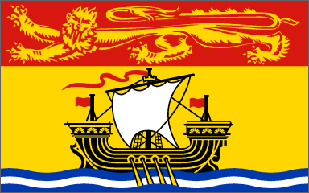
The gold lion on a red background represents the Duchy of Brunswick, a possession of Britain's King George III who ruled in the year of New Brunswick's creation in 1784. The galley, with oars in the water, represents New Brunswick's early seafaring industrial history.
The passant lion is associated with England.
http://www3.sympatico.ca/goweezer/canada/flagNB.htm
Nova Scotia
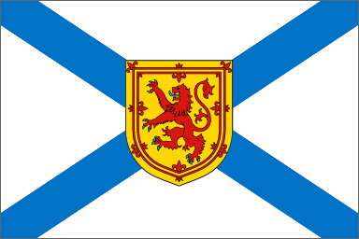
Nova Scotia means ‘‘new Scotland’’.
The flag is based upon the Ancient Arms of Nova Scotia, granted by King Charles I in 1625, the background of the flag is an extended blue cross on a white background, a reversal of the colours found on the Cross of Saint Andrew, symbolizing Nova Scotia's links to Scotland. The flag is three-quarters as high as it is wide. In the centre of the flag is a Royal Lion set within a double red border on a yellow or gold background. This was the first flag to be flown in the Commonwealth outside of Great Britain.
The rampant lion is associated with Scotland.
http://www3.sympatico.ca/goweezer/canada/flagNS.htm

Prince Edward Island

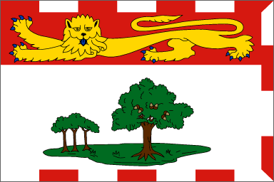
Based upon the Armorial Bearings of Prince Edward Island, the flag contains a gold Heraldic Lion, which also appeared on the Coat of Arms for Prince Edward, Duke of Kent (for whom the Province was named) and on that of King Edward VII, who granted the Bearings. Beneath the lion is a single plot of grass representing PEI and England, both of which are islands. Upon the mound of grass stand a mature Oak tree (the official tree of Prince Edward Island), which represents England and three smaller saplings on the left, representing the 3 counties into which Prince Edward Island has been divided since 1767. Framing the flag on the three sides away from the mast are alternating bands of red and white, the official colours of Canada.

http://www3.sympatico.ca/goweezer/canada/flagPEI.htm

Sources

Provincial flag images from http://canflag.ptbcanadian.com/html/provincial.flags.html

“What is Orange?” poem from The Random House Book of Poetry for Children,
selected by Jack Prelutsky, Random House, New York, 1983

Provincial Flag descriptions from http://www3sympatico.ca/goweezer/canada

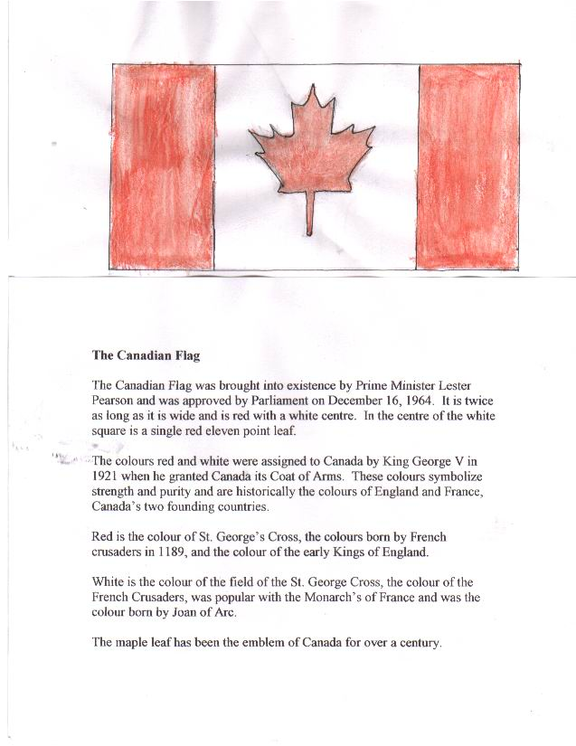

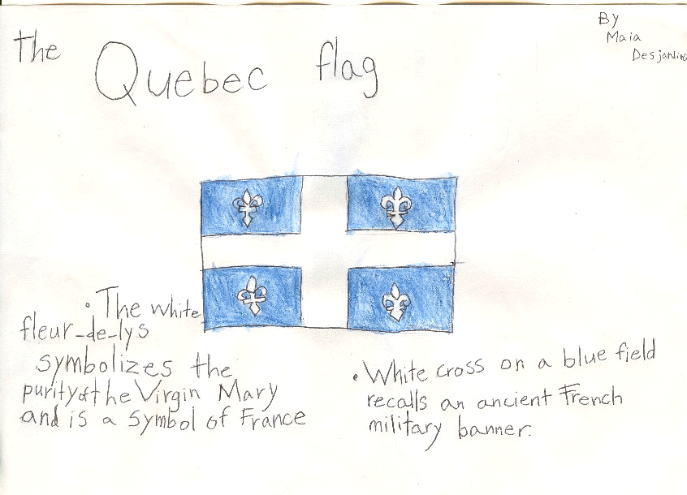

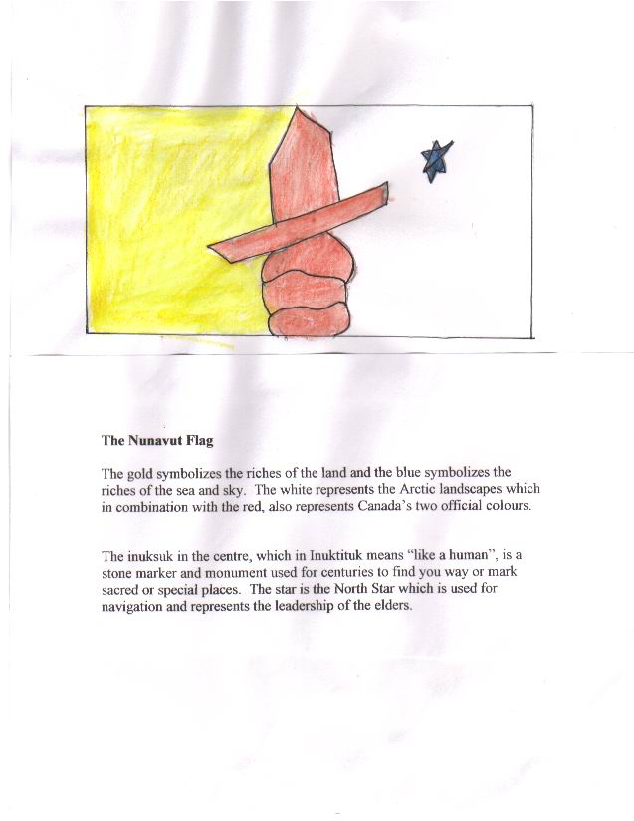

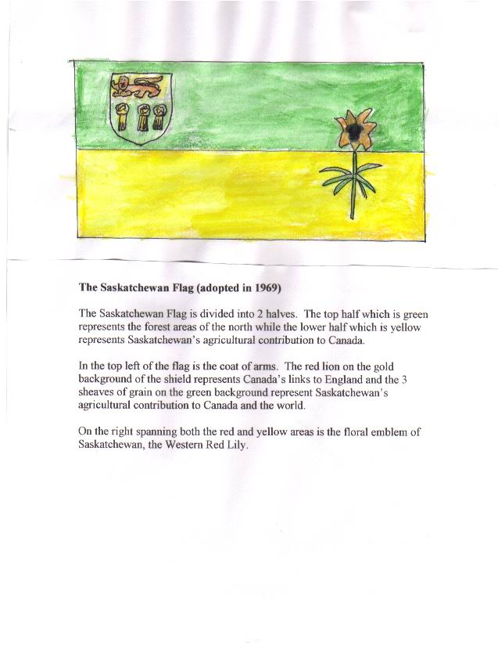

Flags of Canada by Slater

The Newfoundland Flag
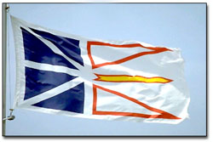

'White is representative of snow and ice;
Blue represents the Sea,
Red represents human effort and
Gold, our confidence in ourselves.'

Thirty years after joining the rest of Canada, the official flag still remained the Union Jack. England's official flag. It remained the Union Jack because Canada was a common wealth country of England.
In 1979 however, a commission was formed to select a new flag.
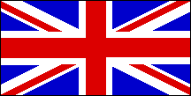
The Union Jack

One year later, one of six designs submitted by Newfie Christopher Pratt was chosen as the new provincial flag.


The Alberta Flag

The flag was adopted on June 1, 1968 and the coat of arms was adopted in 1907 and modified in 1980. Alberta joined the confederation of Canada on Sept. 1, 1905.
The flag of Alberta consists of a blue base with the shield from the provincial coat of arms in the center. The shield consists of a cross of St. George and below it there is a landscape with mountains, hills, a prairie and a wheat field.

The British Columbia Flag
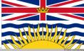

The flag of British Columbia was officially adopted in 1960.
The flag is in essence an armorial banner of the Arms of the Province (granted in 1906) and topped by a Union Jack. The sun represents the glory of the province, while the wavy blue lines represent the Pacific Ocean and the province's position on the western coastline of Canada.

