A Learning World

Theme: Prejudice

School : Algemene Middelbare School
Students : Moreno, Fallon, Shanta
Grade : 11
Country : Suriname

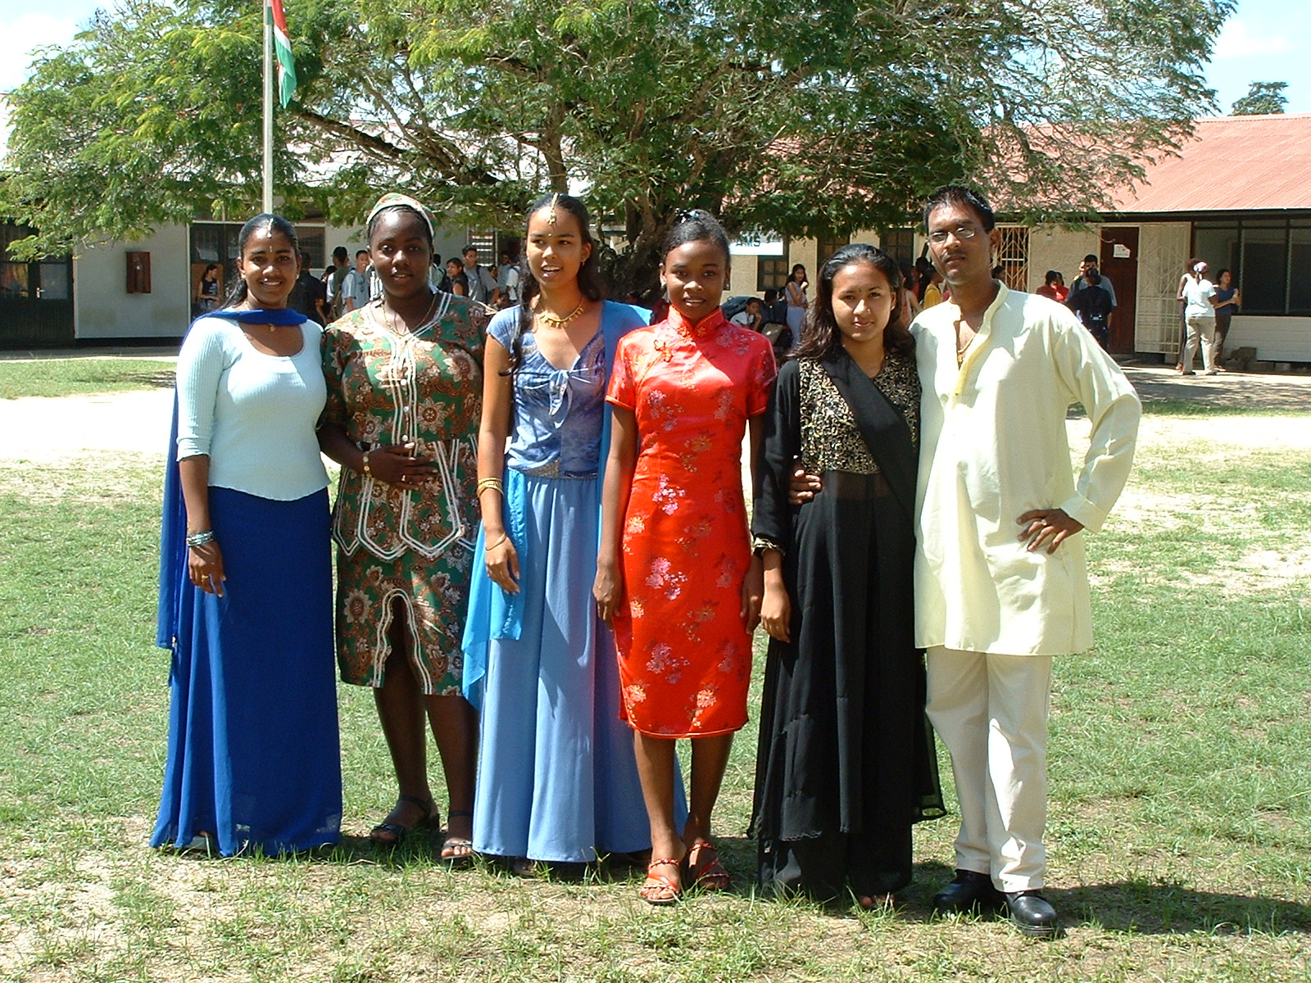

Project from Suriname

Part of the curriculum of our sociology classes is the discussion on the Milennium Development Goals (MDG) of the United Nations. One of these goals is the eradication of HIV/AIDS which is a very big problem in the world. Millions of people have been infected and despite information and education, the problem keeps increasing. These infected people have to live in a world where they are not treated with respect, where they are neglected once it is known they are HIV positive or have AIDS. People are prejudiced and this makes living in a communtiy only more difficult for the victims of HIV/AIDS. However, prejudice not only extends to these victims but is found in every aspect of life like religion, culture, race etc.

Our project theme will be 'prejudice'.

We would like you to respond to this theme by writing poems, essays, stories.

Please do not send answers to the questions but use them as guidelines to write your essay, story or poem.

1 What is prejudice?
2 Why are people prejudiced?
3 What advantages/ disadvantages does 'being prejudiced' have?
4 What important role do parents and family play?
5 What important role do schools and teachers play?
6 Should schools teach a special subject called 'moral values'?
7 Have moral values in your country declined as well and what may be the reason?
8 What can you learn from 'prejudice'?
9 Do you think it influences your life in any way?
10 Do you think that you are prejudiced in any way?
11 How can you as a teenager help to get rid of this problem?
12 Have you ever experienced prejudice of any form?
13 How did you feel and what did you do?
14 Is violence an answer to prejudice?
15 What advice do you have for the world?

We are eagerly looking to your work and we are sure we will learn a lot from you . That is the essence of this whole project "A Learning World".
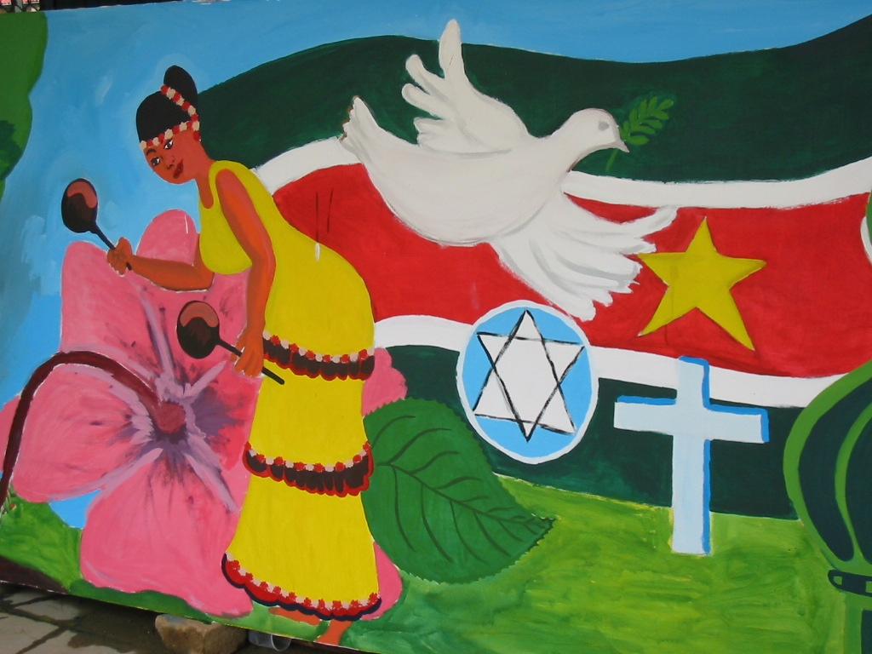

Responses to our project

Dear Students from Suriname,
This is my answer to your project. I hope you like it!
When there are two groups of people who are differentiated by a character,
the equilibrium of their given rights may change. One group may benefit more or one group may lose its rights.
People may think about a character in a wrong way and they may zoom on the effects of that character, so they would justice unfairly which means
prejudice. If the prejudice lead to an increase of the given rights, it is
an advantage for a part of society which doesn’t disturb others rights. Butif prejudice decreases the rights of the people, it is a disadvantage for them.
Family is the first model of the society and parents are its organizers who children know. The second one is school and its teachers. If the children face any kind of prejudice in these models, they would generalize it in the real society.
Of course learning moral values is useful, but these values should be
defined on the basis of a universal agreement to prevent international
prejudice. The freedom which is a gift of new world for new generation needs a responsibility to improve the moral values, but unfortunately people have lost the basis for accepting this gift and this cause a decline of moral values.
Some of prejudices are well known in the society, but some of them are not
known at all. For example when the age of a person is a reason for a justice or giving a right, I think it’s a kind of prejudice too. I think the abilities and real powers of the person should be considered, not age!
Every one must object to prejudice. But violence is not good way for this
objection. Because it would just lead to a war. Since the prejudice has
rooted in wrong knowledge, its solution is in making a right knowledge. And this is possible just by a powerful mind.
Talking and relating to each others’ minds is a good way to obtaining a
right knowledge. This is what our previous president, Mr. Mohammad
Khatami suggested in every international congress. We all hope that his
advice be respected.
Regards,
Roghieh Javer
Farzanegan Zeynab Educational Center
Tehran, Iran

What is prejudice?
Prejudice is an undeniable force within most societies. It causes a group of people live in bad conditions and a group of people live in complete welfare.
Prejudice is a problem that is very important for the people of the world. Nowadays most of people live in the bad conditions because of the prejudice.
Prejudice is privilege that given to some people iniquitously.
I think we, the youth all over the world, should join hands and diminish prejudice so that all people live in better conditions. For example, in every part of the world all people must have hospitals or all children must have schools.
Bye!
Fatemeh kanani
Farzanegan Zeynab Educational Center
Tehran, Iran

GOOD & BAD
Once we had a very bloody war in our country ;the enemies was killing many defemsless people,children in the schools,workers in factories and the farmers in their farms .If there was not prejudice in the mind of the people with empty hands and inough equipment it might be we saw the enemy`s victory. This in maybe the advantages of the prejudice. But often prejudice don`t let the mind to choose the best ways freely ...
Unfortunatly,prejudice is something that exist inside of all human biengs,but the level or the grade of this feeling would be different in different poeple.Sometimes it is very high and sometimes is very low.
I believe that poeple should change their attitudes toward different subjects.if they would not like to change their opinions it would never get better.Also societies can help to their own poeple to change their views,by providing some advertisements or some programs in media.
Thank you.
Saba High School.
Iran,Tehran.

Hi Moreno!
Race, culture and religion are very general words. May be our first level of knowledge about some one is provided by these words, but to know some one completely, they seem so little and insufficient and with an insufficient knowledge. We have no right to judge about someone. If we do that, our judgment would be uncertain and may be wrong. But judgment should be certain and right. The advantage of a wrong judgment differ depend on the position of the jury. For example, when someone is suffering from a disease like AIDS that could be ceased from different ways, his or her disease could not be a reason for
our judgment at all. But if we know about the reason of his or her disease, our judgment could be about his or her past, not about his or her at present.
Any way we humans are responsible about each others. We should support each
other. But we could not help someone that does not help himself. If the patient who has made mistakes in the past, continue to make mistake, who could save him!
Roghieh
Farzanegan Zeynab Educational Center
Tehran, Iran

Dear friends from Suriname & all,
My students have prepare the following questionnaire and given it to people of different ages to find out their attitude to HIV infected people and how prejudiced it is. We will send you the result as soon as it gets ready.
A. Sex
A. Male
B. Female
B. Age
A. Less than 20
B. More than 20
C. Marriage condition
A. Single
B. Married
1. Does your behavior towards those who have AIDS depend on the way they have been infected?
A. Yes
B. No
2. If you had AIDS, would you keep your physician, dentist or hairdresser informed about your situation?
A. Yes
B. No
3. Would you inform them if you knew they offer you no services when they learn about your situation?
A. Yes
B. No
4. Let's imagine you are a physician and providing services for an AIDS patient diminish the flourish of you job. Do you accept them?
A. Yes
B. No
5. How will you react if you hear one of your friends has AIDS?
A. I'll try to help him / her
B. I'll avoid him / her
C. I'll have no reaction
D. Other (Please specify)
6. How do you feel about those who have AIDS?
A. I'm afraid of them
B. I hate them
C. I'm indifferent to them
D. I feel sympathetic towards them
7. How do you feel about haemophiliac and Thalassemic patients who have got AIDS through blood transfusion?
A. I sympathize with them, but I avoid them
B. I'm indifferent to them
C. I sympathize with them and try to help them
D. Other (Please specify)
8. What is the base of spread of AIDS in our country?
A. Intravenous drug use
B. Sexual contact
C. Blood transfusion
D. Other (Please specify)
9. How will you react if you hear someone in your family has AIDS?
A. I'll sympathize with him/her and try to help him /her
B. I'll avoid him / her
C. I'll be frightened
D. My reaction depends on the way he/ she has been infected
10. How will you react if an AIDS patient asks for your help?
A. My reaction depends on that person's relation to me
B. I won't help them
C. I'll try to help him/ her
D. My reaction depends on the way he/ she has been infected
11. How will react if you hear you have AIDS?
A. I wish to die right away
B. I'll inform others
C. I'll think of vengeance upon the society
D. I'll think wisely and go AIDS counseling and care centres
12. If you were an AIDS patient, which reaction would you expect from others?
A. They would be right if they avoided me
B. I would expect them to behave me reasonably
C. Others' reaction wouldn't be important to me
D. Other (Please specify)
Please feel free to use this questionnaire. It will be very interesting to compare findings in different countries!
Enjoy your work!
Minoo

Hi dear friends,
I extremely feel sorry for babies who get Aids from their mother as these children have to pay for the mistakes of their parents. I also sympathize with haemophiliac and Thalassemic patients who have got AIDS through blood transfusion. And if an HIV infected patient asks for my help, I’ll do my best to help him/her. The way he/ she has been infected isn’t important for me.
Bye,
Zohre
Farzanegan Zeynab Educational Center
Iran

Our responses to the projects of the participating schools

Learning for All
from Farzanegan Zeynab Educational Center

If I compare myself who lives in the era of the wolrd wide web with somebody who doesn't, then that person misses out on all the opportunties the web has to offer. That doesn't mean that this person doesn't know anything because he can get his information from books, tv, newspaper, radio. But the fastest way to get information is the world wide web/ internet. He misses out on the opportunity to work on collaborative projects as we are doing, he cannot make friends all over the world. He doesn't have the world in his home.
So how can this person become like me? The first step is the computer and the internet. Schools, communties, organizations (national and international), governments should bring this important device within the reach of everybody. We believe that computer education is essential in every school so that there is 'learning for all' and not only for those who can afford to go on the internet.

Moreno, Fallon, Shanta
Suriname

To the students of Farzanegan Zeynab educational Center, Iran
Gender Inequality

There is inequality in opportunities given to boys and girls all over the world. In some countries girls are deprived and boys allowed to go to school and in this way the girls are oppressed and they become submissive and dependent on their husbands later on.
In Suriname it is completely different. Statistics have shown that more girls than boys go to school, more girls attend university and other higher education. The boys drop out because they don't want to study, they want to earn money the easy and fast way so many boys end up as drug dealers and smugglers. This is a sad prospect for our country's future and economy.
You need both boys and girls to study if you want to develop a country. But in some cases due to poverty, girls and boys don't go to school or girls stay at home while boys are allowed to go to school. In some countries culture plays a crucial role, because people believe that if girls are educated they will be superior to boys. We think that this inequality should be banned. Everybody should be given equal opportunity for education and it is up to the individual how far he/she gets. The world always focuses on the men, but without the women the men are nowhere. They both need each other to make a home, to take care of their chlidren, to support each other and to contribute to the development of their community and country.
Governments have an important role in the process. They should see to it that there are enough schools, teachers and books. In Suriname, in certain remote areas, children don't go to school because there are no teachers who are willing to go so far. There is poor accomodation for the teachers and the salary is so low that teachers are not motivated to work in such remote areas where this no telephone or electricity. There are areas where there is no school, so children have to travel by boat from one village to another. Usually the boys are sent to school and the girls stay at home to look after their baby brothers and sisters. Some of these boys come to the city to continue their education, the grils , however, get none.
So if we want education for all and no gender inequality, the government with the help of other international organizations should build schools and make it attractive for teachers to go to remote areas so that students can get schooling. Parents should be taught how important it is that their girls get education and that they become educated and independent women later on.

Moreno, Fallon, Shanta
Suriname

Dear students from Behpooyan High School, Iran,
We have thought about your project and this is what we think about 'learning motivation'.

Learning Motivation

Nowadays, with so many distractions like tv, internet, dvd, it is very difficault for young people to really give themselves for 100% to their studies. Although we know that education is very important for our future, we often neglect this. The result is that we fail and that is even more demotivating.
Many students complain that the way teachers present the learning material is very boring. This is true. If students are involved in the learning process they feel that they are really part of it and it gives them confidence to do their best. We learn constantly, not only from books but from our friends, family, the surroundings, from tv and the media. We learn positive things and negative things. However, the negative things like violence, war, crime seem to be dominating. Our elders complain that moral values have declined because of all the negative influence on us. We believe that that is true as well. But much depends on our upbringing and ourselves.
Our teachers always say to us that we have our future and our lives in our own hands. And that we need the guidance from our parents and teachers to become responsible citizens. If young people are praised for their achievements, no matter how small, it motivates them to reach higher. If young people's opinions are valued, if grown ups give them a chance to speak their minds, they will become confident and this will motivate them to become critical. In this way they can be an example for other youngsters.
Young people are not stupid. They want to do a lot if they are given the chance and if people believe in them. This sounds so simple but still it doesn't happen. We think that if youngsters get involved in community work, like cleaning up a neighbourhood, they will become aware of their capacities and this will booster their egos and self- respect. In this way motivation comes automatically.
By doing this project we are motivated to write in English. English is a foreign language for us and quite difficult. But just the fact that we don't get a mark for it, motivates us to write and the fact that you , our peers, have the same problem, so we don't feel shy.

Fallon, Shanta, Moreno

Hello students from Saba High school, Iran

Making the Internet a Safe Place for Children

This is not so easy. We believe the following:

The internet brings the world in our home. Look at us. We are doing this project on the internet. We have read somewhere that the internet can be a vice and a virtue. How can we see to it that it always remains a virtue? We are not sure that this will be safe for 100% because the world consists of people with a twisted mind, who are only interested in doing harm.
If you don't want children to visit certain websites, you can block that website. Some websites ask for parental permission, so without permission of the parent the child cannot go on that website. Children should be protected because they are not strong enough yet to resist the temptation. Children are curious so they want to see more and more and without knowing or being aware of they can get caught in something terrible.
Nowadays chatting is very popular. We like chatting. We chat with our friends every day. In this way we feel that our friends who are living abroad are close to us. But chatting can be very dangerous when a pervert or sick person pretends to be a friend and lures you into doing something bad. That is why you should never use your real name when you are chatting so the person doesn't know who you are. On the other hand chatting is nice because you learn so much about somebody's culture or country or religion.
We have expereinced a sad incidence in our school some years ago. A student committed suicide by hanging himself to a tree. Later on we heard that this student had become totally obsessed with a certain website on the internet where they promote satanic practices. All the teachers and students were shocked when they heard what had happened. Even today nobody has forgotten this incidence and teachers always use him as an example to point out what the dangers of the internet can be.
So although the internet has countless opportunities to get information and to learn about everything, parents should be alert and should know what their children are doing, whom they are chatting with and what they are chatting about. This is the only way to protect them. Communication with their children is also important, because if a child senses a ceratin danger on the net, he/she should not be afraid to discuss this with his/her parents.

Fallon, Shanta, Moreno
Suriname

From Farzanegan Zeynab
Tehran, Iran

Hello Zohre,

In our country women have the same rights as men. We have many women in Parliament who are doing a very good job. They are working very hard to improve the position of women and children in our country. Minimizing poverty and ecucation for children in remote areas are top priorities in their policy. We haven't had a female president yet but in the last elections there was a female presidential candidate. However, it's still a man's world and eventhough women are highly educated and have high class jobs, people tend to look at women as if they are not capable for certain positions. So there is still discrimination towards women in this field.

I think the fact that more girls go to school than boys is a global problem because every country struggles with the same issue. It is probably part of the way boys and girls are perceived. Boys should carry the responsibility of the family, they should bring in the money, they should put a roof over the head of the family. Since we are living in a time of recession, it is very difficult for boys to do these things. So they quit school and start working . Girls, on the other hand, have been trained or are being trained to become independent and not wait for their husbands so that they can support themselves and their children if something happens to their husband.

So we think that education at home and at school is very important to boys as well, so that they get a different view about their role in life and within their family. In these enlightened times boys cannot boss it over women. Together they should work towards their goals and in this way there will be a healthier society. The time to oppress is gone!

Moreno, Shanta, Fallon
Suriname

Hello Zohre,

The media uses the internet to provide us with information. If you have the availabiilty of a pc and internet connection, you have access to information every minute of the day and you don't have to wait for the media and other institutions.

The internet has made the huge a world a very small world now. It has become a global village and we are all living in this global village, so we are a global family. Don't you think a family should live in harmony with each other despite their skin colour, race or religion? Learning for all can be achieved faster than we realize if we all understand this important aspect. We all contribute to the global village. If you give peace, you get peace, if send signals of war, you will get war. So through internet we can teach the world about the advantages of peace and harmony in our global village. Don't you think this is learning for all? And you don't need to have a pc at home to achieve the goal of learning for all. One pc at school is a start or at a cyber cafe.

Shanta, Fallon, Moreno
Primary Education for All (after a disaster)

Hello students from Australia,

Although Suriname has never had any natural disasters (thank God), we have had wars among tribes in our interior. These wars were started by political parties to cause unrest and chaos in the country so that they could seize power. Thus, we had a war some 10 years ago between two ethnic groups: the Amer Indians and the Bush Negroes. Villages were burnt down and many people were killed in cold blood. The survivors fled their villages and came to live in the city but this led to other problems. They had problems adjusting to city life, they could't find jobs and this in its turn led to crime which is still a very big problem in our country. Most of these youngsters ended up selling and using drugs, so we have many drug addicts now. Children were deprived of schooling for along time. Human rights organizations, the government and other non-governmental organizations have been trying ever since to bring education to these areas where the people have suffered from the war.

When the government wanted to take the displaced people back to their home villages, they encountered many problems. The schools in the interior had been burnt down, so schools had to be built. For this money was needed, which had been provided partly by the NGOs, partly by the government and Unesco. When the schools had been built, furniture and books had to be bought for the students. Teachers had to be found who were willing to work in the interior under difficult circumstances. Some three years ago the first primary schools were started. To this day there is still not enough furniture and books. The building has not been completely finished. Sometimes snakes and other animals enter their classrooms. But the most important thing is that the deprived children get primary education, no matter how poorly this takes place. Because of this development, many of the displaced people went back to their villages, so the problem in the city is a liitle less.

Moreno, Fallon, Shanta
students from the Algemene Middelbare School
Suriname

In a time of gender equality I think it is a good development that women share responsibilities like men. In this women feel that they are being neglected or seen as second class. They are as important as the men in vevry way. What do you think? Do you think that women should remain in the underdog position as they have alwys been? Would you want your daughter to be treated this way? In our age of information technology are becoming aware of their potentials and I think they should be given equal opportunity to develop these potentials. Don't you think the world will be different then?
From Moreno to Zohre

Dear Nazanin & Sarvenaz,

We think that like everything in life, chatting also has advantages and disadvantages. It is up to us what we do with it. Of course there are bad people in the chat room who want to trick us, but there are good people like you and us as well who want to communicate with others than their own friends alone. The good people want to share their stories and experiences with the world, they want to learn more about the world than their own country and people alone. WE don't see any harm in this. The big question is: how do you know who has good intentions and who has bad intensions? We think that the moment your chat partner becomes personal, you should be on the look out and even stop chatting. Or if you feel uncomfortable somehow, stop immediately. It is said that your intuition is your best friend, so the moment you get the queezy feeling something is not right.
To answer your question about who invented the chat room, we have to go on the internet to search for this information. Just type in your question and click search on MSN or Google.

Greetings,
Shanta & Fallon

Hello everyone,

We agree that education for girls/women is the key to development in all aspects of life. Women give life, they give birth to their children, so if they have the required knowledge and training they can take care of their children as well as themselves. In Suriname there are many families without a father at home. The mothers are completely responsible for their children. Statistics have shown that educated single mothers raise their children differently than uneducated mothers. Families where the mother is uneducated have a lot of problems. Their own daughters don't go to school or drop out, there is teenage pregnancy, drug abuse, and it has been shown that the rate of Hiv/Aids within such families is high. So these people live in a circle and cannot get out; the problems keep increasing and it seems as if they are passed on from mother to daughter.
Do you have the same situation in your country?

Shanta, Moreno, Fallon (Suriname)



