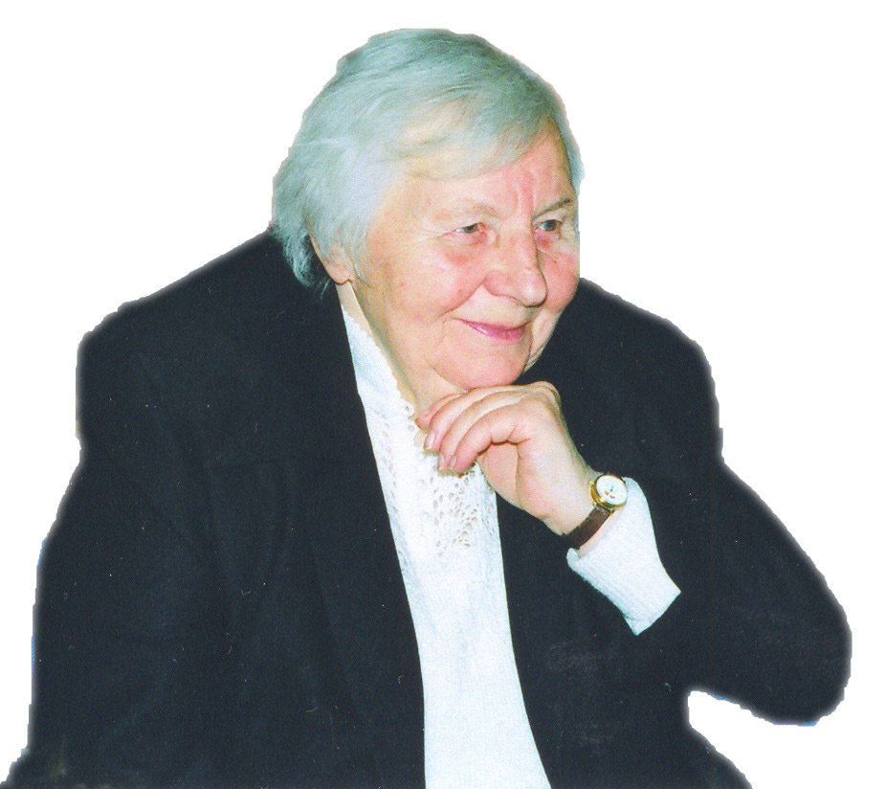
Galina Leonidovna Stuchinskaya

Galina Leonidovna Stuchinskaya is a former prisoner of the concentration camp. She told us about what had happened to her during the Second World War.

Galina Leonidovna was born in Minsk in 1924. When the WW II began, the Germans caught her and sent to the concentration camp Oswiecim (Auschwitz).
People were taken to the camp by train. They were given neither food nor water for four days. When they came to Oswiecim, all of them were divided into sections. On their arms fascists drew numbers. Galina Leonidovna said that one girl was very small and her arm was short, then the fascists tattooed a number on her leg. The number from Oswiecim can be still seen on her leg.
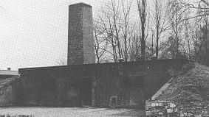
In Germany they got up very early and were lined. Then they were all counted. If one of the prisoners wasn’t among them the Germans searched all the camp and the prisoners were standing, while the Germans were searching the camp. It might continue for a very long time.
Then they went to drain swamps. They were given little food and even less they were allowed to sleep. People were completely exhausted and seemed to have only skin and bones.
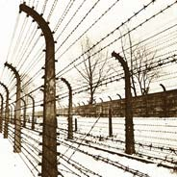
The most horrible thing was that the camp was intended to be a death factory. No man who got there was supposed to survive. The Germans also burnt people in a special place. The place was named crematorium. In Oswiecim fascists burnt alive people.
Some of the prisoners tried to run away, but around the camp there was a barbed wire with high voltage. When a prisoner touched it, he was beaten by voltage and always died.
Then she fell ill with typhus two times but she was lucky to recover. Later she was sent to a factory, where she made details for German planes.
But in the German factory she helped to fight against fascist Germany, because she made faulty products. One of their mottos was: “Even three quotas, but defective.”
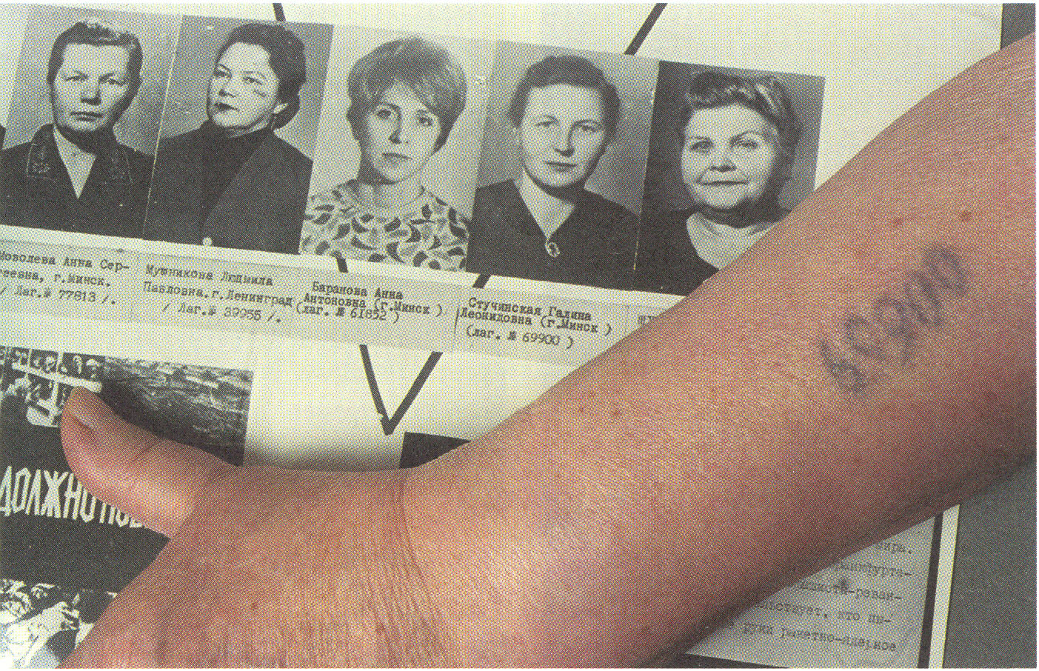
Once, an impossible thing happened to her. When English planes bombarded Dresden (factory where Galina Leonidovna “made” details was situated there), all Germans hid in a bomb shelter, but the prisoners, who worked on this factory were left closed in the building of the factory.
The bombing began. It had been bombing for a long time. Galina Leonidovna fell asleep. And she had a dream that four angels came down the roof of that factory. When she woke up, she said about her dream to all. People cheered up, they said that God helped them. And all of them survived. But the entire town was ruined except the factory. Galina Leonidovna believes that God saved her life to tell people about the awful pages of the human history in order not to let it happen again.
When the WW II was over Galina Leonidovna came back to Minsk. She hoped that in Minsk everybody would be glad to meet her, but Soviet authorities considered her to be a German spy.
Some years ago prisoners of concentration camps were given money as compensation from Germany. But now Germans begin to forget about WW II. Galina Leonidovna looked through some German school textbooks on history and the only thing she found there about WW II was when it was started and finished.
Now Galina Leonidovna lives in Minsk, and she goes to Germany, where she is invited to tell about the WW II. “I forgave Germans for all they did but I didn’t forget. It mustn’t be forgotten.” – she says.

Ales Ivanov
Grade 8 G,
Polytechnical Gymnasium,
Minsk, Belarus

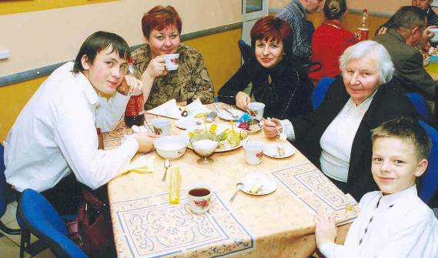

Galina Stuchinskaya with her relatives
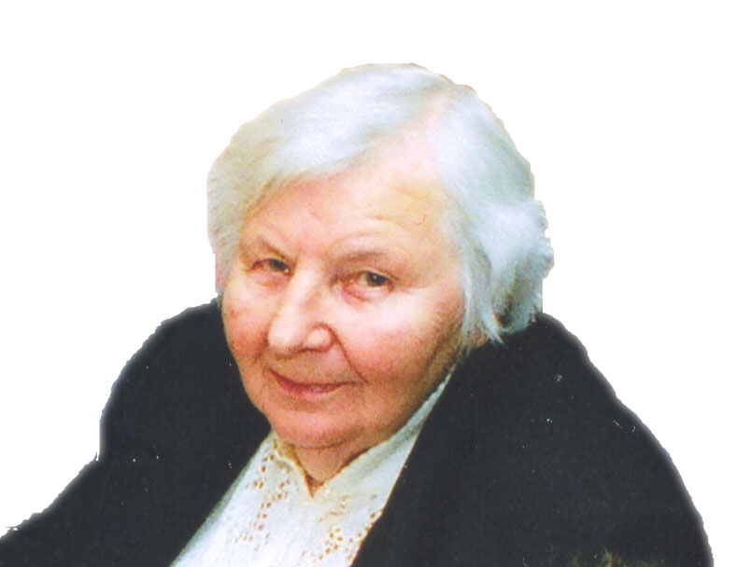
Galina Leonidovna Stuchinskaya

Our story is about Galina Leonidovna Stuchinskaya,
a former prisoner of the “death camp” where four million people died

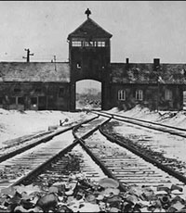
It all began in July, 1941, when fascist Germany attacked the USSR and occupied the territory of Belarus (Belarus was a part of the USSR at that time and was called the BSSR). Galina L. Stuchinskaya took part in a resistance group that made anti-fascist leaflets and collected the data about the location of German armed forces, airports. She was arrested in Minsk by Gestapo, a horrible police like organization. The long six months spent in captivity badly affected her health. She was kept in prison up to December, 1941. The severe December came, and our story-teller was sent into the concentration camp Oswiecim (Auschwits). Many people died during the trip with no food, water and warm things.
In the camp she had to survive in the most terrible conditions. The prisoners worked 14 hours a day. There was no time left to sleep. They drained the marshes to expand the territory of the camp.
“One day in July, - she says, - young men working in the crematorium made up their mind to escape. Rushing up to us, they suggested running away with them. I refused as I knew that the escape meant a definite death and it came true. The camp stretched for a long distance and there were only swamps around it. All from the group who tried to escape were shot no further than some kilometres from the camp.”
Later Galina L. Stuchinskaya was sent to the plant. She had to produce details for German airplanes. There was an agreement between the prisoners to work but to make faulty production.
Soon the city where there was a plant was bombed. During that she saw a dream that a man dressed in magnificent red clothes embroidered with gold was descending the steps over the plant. He was followed by angles who were taking the cover to protect the plant. Till now Galina Leonidovna believes that only God helped the people working at the plant to survive.
After that fascists decided to send the prisoners to another camp. This time Galina Leonidovna was lucky to escape. “We were to run away when the watchman turned his back, reach the forest, break in twos and run into different directions”.
But on reaching their countrymen, she had another disappointment. The runaways were not met as heroes in their Motherland. Soviet authorities considered those who were captured or got in a concentration camp to be traitors. In those faraway days Galina had to go to the NKVD, a security service station, and report every week about her whereabouts.
Now she is not just an ex-prisoner. She does a noble deed: she supports the prisoners of the former concentration camps; attends schools and colleges of Germany with sad but true stories about the war. Galina Leonidovna sees her mission in telling the present generation about that dreadful time and their grandparents’ mistakes which led the world to the 6 years of the bloody and cruel war. She believes that this mustn’t happen again.

Vlad Kobraev,
Grade 8 B, Polytechnical Gymnasium,
Minsk, Belarus

Flag and Symbol of Minsk

In 1499 Minsk received the rule of self-government according to the Magdeburg law.
On January12, 1591 the city received the confirmation of the Magdeburg law that said: “Give them the emblem for the city seal with the image of the mother of God in the sky background.”
The symbol appeared in the city seals and flags on the buildings belonging to the government.
It was the symbol of Minsk from 1591 to 1790 on the seal of the city government.



It looked like that: on the shield there is the Virgin Mary with cherubs in the sky background. The blue background must mean the Heaven.
The flag and symbol of the city was approved by the Minsk government on March 27, 2001.
The symbol of our city is peaceful and Christian. There are no arms or any sign of threat. The Virgin Mary was chosen a saint patroness of Minsk to protect the city because it suffered many times from invasions from the West and from Russia.
Now the symbol and flag of Minsk look like that:



By Vitya Markusenko
Grade 8 B,
Polytechnical Gymnasium, Minsk
My Hero
Francisk Skaryna.

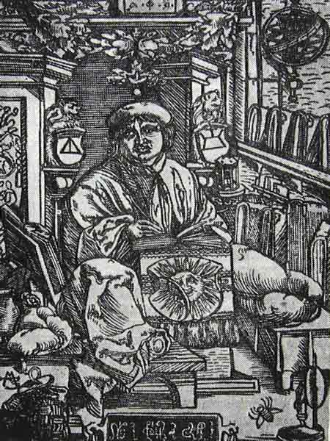
There are a lot of people in Belarus, who have done many great things for our country and who can be our national heroes. In many opinions one of them is Francisk Skaryna. I have chosen him as my hero because he was one of the greatest scientists of Belarus.
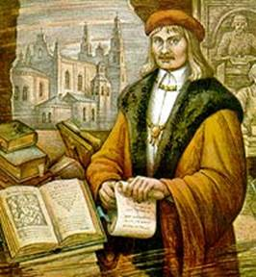

He was born in Polatsk in 1490 in the family of a Polatsk merchant. In 1504 he entered the university in Krakow where he got his bachelor's degree in philosophy, and in 1512 at the University of Padua, he was conferred a degree of the Doctor of Medicine.

Francisk Skaryna was the man who printed first books in Eastern Europe.
The first book printed by him was ‘’The Bible’’. It was printed on the 6-th August 1517.
Francisk Skaryna wanted to make knowledge available to the people in their own language: “I vow it shall become a language of books, not only of speech"


He published 23 books of the Bible in the Belarusian version of the Church Slavonic language, in 1517-1519, at a printing-house founded in Prague. About 1520 he founded a printing-house in Vilnya, a historic Belarusian capital, and in about 1522 and 1525 he published "The Small Travel Book" in 1522 and "The Apostle" in 1525. The prefaces and epilogues of his editions expounded many advanced ideas on state sovereignty, patriotism, equal rights, religious and moral freedom and responsibility, "natural law," self-value of the human life on the earth. Skaryna believed the service to the society to be equal to the service to God; hence he interpreted his translating, writing and publishing activities as a spiritual sacrifice to his Motherland. The creative work of Skaryna accounts to a great extent for the specificity of the Belarusian culture of the 16th-17th centuries, it promoted the book printing, humanism and Reformation. The great citizen of Polatsk has been commemorated in various countries of the world, for instance, there is a monument to him in Polatsk, memorial plaques in Vilnya, Krakow and Padua.

Francisk Skaryna made a lot for book printing and education in Eastern Europe. He died in 1551, but every person in Belarus nowadays knows his name and remembers him.
By Ales Ivanov Grade 8 G,
Polytechnical Gymnasium, Minsk
My Hero Project
Steven Sigal


There are a lot of people whom we can admire. They can be actors, sportsmen, scientists and even our friends and relatives. As for me I’m fond of sports and especially fighting and of course I like to watch thrillers and action films on TV and video.

So I can say that my hero is Steven Sigal because his shows us a real fighting in his film and he does it very professionally. In spite of the fact that he is just an actor he does all his tricks by himself, without any help. He goes in for sports and I am sure that he is a very brave man. His wife goes in for sports too and she is very good at fighting. It was she who advised her husband to go in for fighting.

I think that Steven Sigal is a really great actor and his films are always very successful. I like them very much especially such films as “The Siege 1, 2” and “The Beast Hunting 1, 2”.

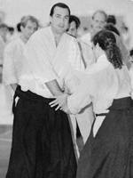
By Max Doubinin
Grade 8 G,
Polytechnical Gymnasium, Minsk

