
Sports Prodigies from Taiwan

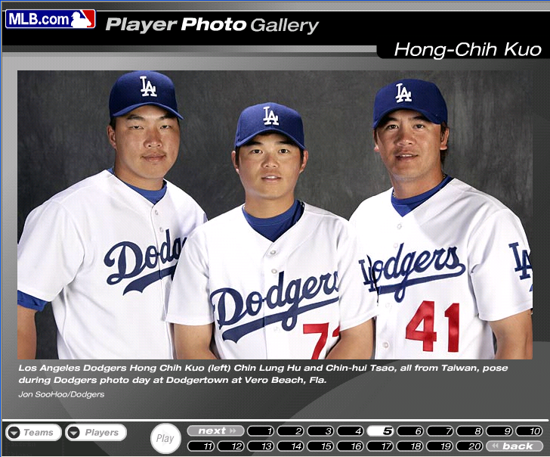

Pitchers
5/03/07

One of the most popular sports in Taiwan is baseball. Now, the three men from the same country to MLB and were traded into the same team, the Los Angels Dodgers.
Hong-Chih Kuo(郭鴻志) pitched for Taiwan in many international baseball games and his great performance enabled him to enter MLB. He became the third Taiwanese pitcher to play in Major League following Colorado's Chin-Hui Tsao(曹錦輝) and the New York Yankees' Chien-Ming Wang(王建民). Hong-Chih Kuo’s baseball talent has been noticed in his teens; however his career is not all smooth. He has had three operations. He was worried if he could stand on the Pitcher's Plate anymore but he still proved he could.
Kuo has underwent a surgery for his left arm. When he got hurt, everyone is afraid of he could not pitch anymore. Fortunately, his arm gets better through the therapy. He can pitch for his team now. In his career, he went 1-6 with an 4.43 ERA. Everybody has high expectation for him and so do Taiwanese fans.
Similar to Kuo, Chin-hui Tsao(曹錦輝) represented Taiwan in five major competitions, including the 2004 Olympic Games in Athens, Greece.
He missed all the games in 2006 due to surgery. He went 4-3 with an 5.80 ERA before.

Taiwanese players in Los Angels Dodgers

Batter

Chin-Lung Hu(胡金龍). He is different from the other two; he is a batter. He did not play well in recent games so he is in Non-Roster invitees for the time being. The Dodgers expects him to play better and face MLB powerful pitchers.

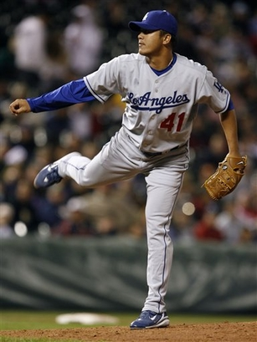
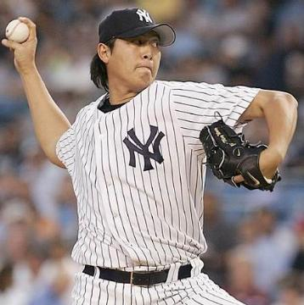
Chin-Hui Tsao in Dodgers

Chien-Ming Wang is also playing hard in New York Yankees'

Written by 楊中銘
THE GLORY OF TAIWAN
2007/05/03//21023黃冠瑋

Taiwan’s golden collocation

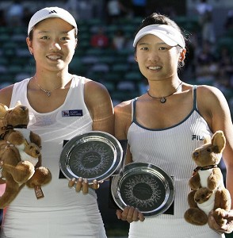
Taiwan’s golden collocation Zhuang
Jia Rong and Zhan Yong Ran won the
runner-up in Australia open. It’s the
new record of Taiwan in international
tennis tournament.
After the tournament, they said they
were very nervous in the games, so they
couldn’t play with might and main.
They also let everyone on earth know
more about Taiwan; they also showed
Taiwan’s flag to everyone through the broadcast on TV. When they came back to Taiwan, a lot of their relatives and fans came to the airport to greet them. Even Zhan Yong Ran’s favorite writer, Dai Chen Zhi came, too. He encouraged the two new tennis stars to move on in the career, and said “There are usually many obstacles in our life, but we should believe in ourselves. “ Their excellent performance not only needed family’s support but also needed their own confidence. If you trust yourself, any dream will be easier to achieve.

INTRODUCTION

Zhan Yong ran was born on 1989/08/17 in Taichung. The 921 earthquake changed her life, she moved to Taipei with her family. The earthquake made her become composed.
On the court she is pressure-resistant and calm and persistent.
Out of the court she is slender, considerate and upright.
Zhuang Jia Rong was born on 1985/01/10 in Kaohsiung

FUTURE

They are very young now; they have many opportunities to show their potential. Although they just won the runner-up this time, this is a good beginning of their career. I hope they will perform excellently in the international sport circle in the future.

Yankee’s ACE!!!!

By Ting Chow

2007/5/3

A baseball star from Taiwan

Wang was born in Taiwan, He was a baseball star, the proud of Taiwan. Most of the Taiwanese loves him and admires him, but he has a very humble person. He will
never become pompous because of other’s praise. He is a
hard-working person.
Wang never give up until the last time. In fact, he was not born to be a baseball player. He was very tall when he was young, so their basketball coach in elementary school made him play basketball. As time went by, he was found to have more baseball talent than basketball talent. So after he graduated from elementary school, he joined the baseball team in junior high school. He played
very well and everybody thought that he might be successful if he keeps practicing. I am sure he is on the way to success.
Now he has played in MBL for three years, he had proved to Americans that baseball is not only American’s sport, People from Taiwan also play good baseball. He was my hero before, now he is everybody’s hero in Taiwan.

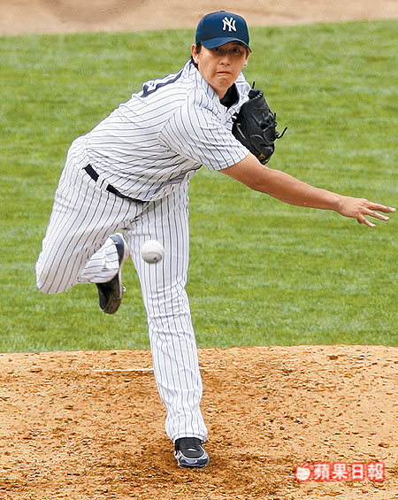

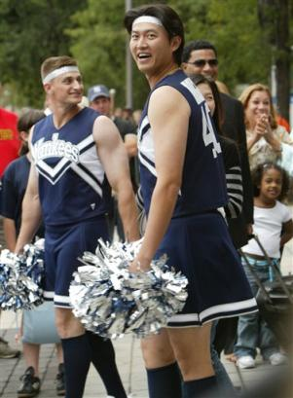

C.K. Yang —- the Greatest Athlete

It is not accidental for an athlete to be successful. He is our proud, the best athlete in the world. As a student, he pursued the dream to become the world's greatest athlete. He practiced every day. At the 1960 Olympics in Rome, C.K represents Taiwan to take part in the Olympics. C.K. lost Rafer by only 67 points in the race, the 1500m. If he could have beaten Rafer by more than 10 seconds, he would have won the first gold medal for Taiwan. C.K.’s chances looked good; his 1500m was faster than Rafer's. However, Rafer ran so fast on that day, and finished only two seconds slower than C.K. Finally, Rafer won the championship.C.K. warmed up for his 1960 competition with Rafer by winning his first Mt. SAC title. He returned to Mt. SAC in 1963 with a performance that broke the record. His World Record score of 9121 forced a revision in decathlon scoring tables, with points now more evenly events. Although he passed away, his World Record score at Mt. SAC remains Taiwan's national record, by far the oldest record still in existence.
He is our pride, we won’t forget him-our Asian Iron man



