Miass  Russia
School 7
September - December 2007(PPM1)

GETTING TO KNOW EACH OTHER

Sponsoring class 6th grade students
Sponsoring teacher Rimma Zhukova

We started this project because we wanted to find out similarities and differences in relations between students of different countries of different races and beliefs. We wanted to know what traits of character are valued by middle school students, if they care about their appearance, if they have a dress code at school, bullying problems. It turned out that we living apart, with oceans dividing our countries have more similarities than differences. Isn’t it surprising?

Contributions

countries teachers
India Vijaya Modali
Kansas, the USA Meagan Higgins
Seattle, the USA Mark Cullen
Egypt Gaber Hassan
Korolev, Russia Margarita Astakhova

We received responses to our questions from

- Kothari International School, Noida, India
- Mohamed Elsayed Experimental Languages School – Port Said, Egypt
- School #7, Korolev, Russia
- Hadley Middle School, Wichita, Kansas – USA
- University Prep Seattle, WA, USA

A DRESS CODE AND FAVORITE CLOTHES

Students have a dress code at their schools but as usual not all of them like wearing a school uniform because they find it boring. To school they usually wear:

Hadley Middle School students - shoes, blue jeans, and colorful shirts and some people wear hoodies and shorts

Kothari International School students -casual clothes
Mohamed Elsayed Experimental Languages School students- a black shirt and blue trousers
University Prep students - We dress within the guidelines of the dress code. We dress according to the occasion – gym clothes for physical education, clothes that can get dirty when we do community service at a local park, and casual but nice clothes for classes every day

Korolev School #7 students - plain shirts or blouses and dark trousers or skirts.

. 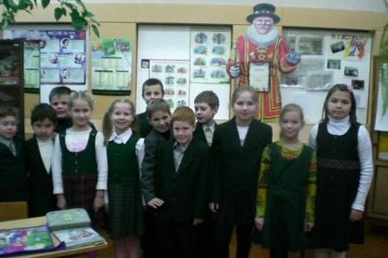 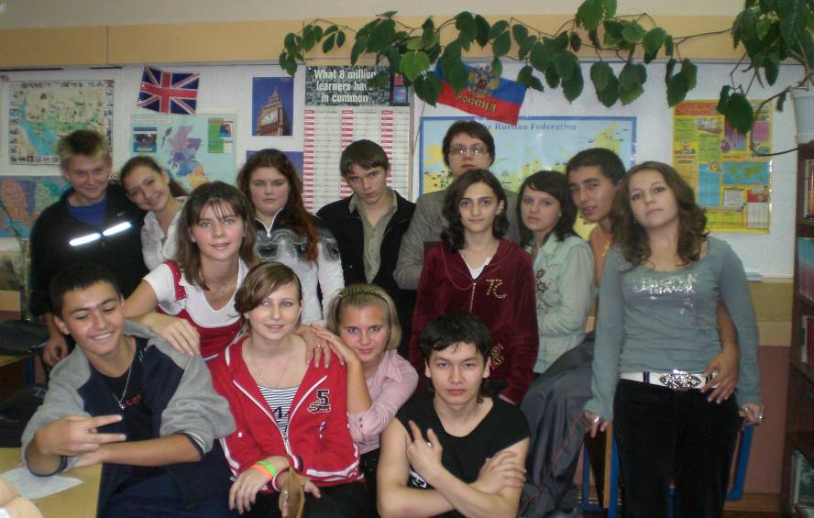
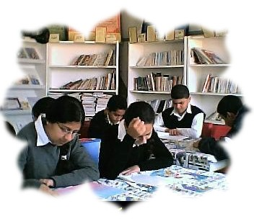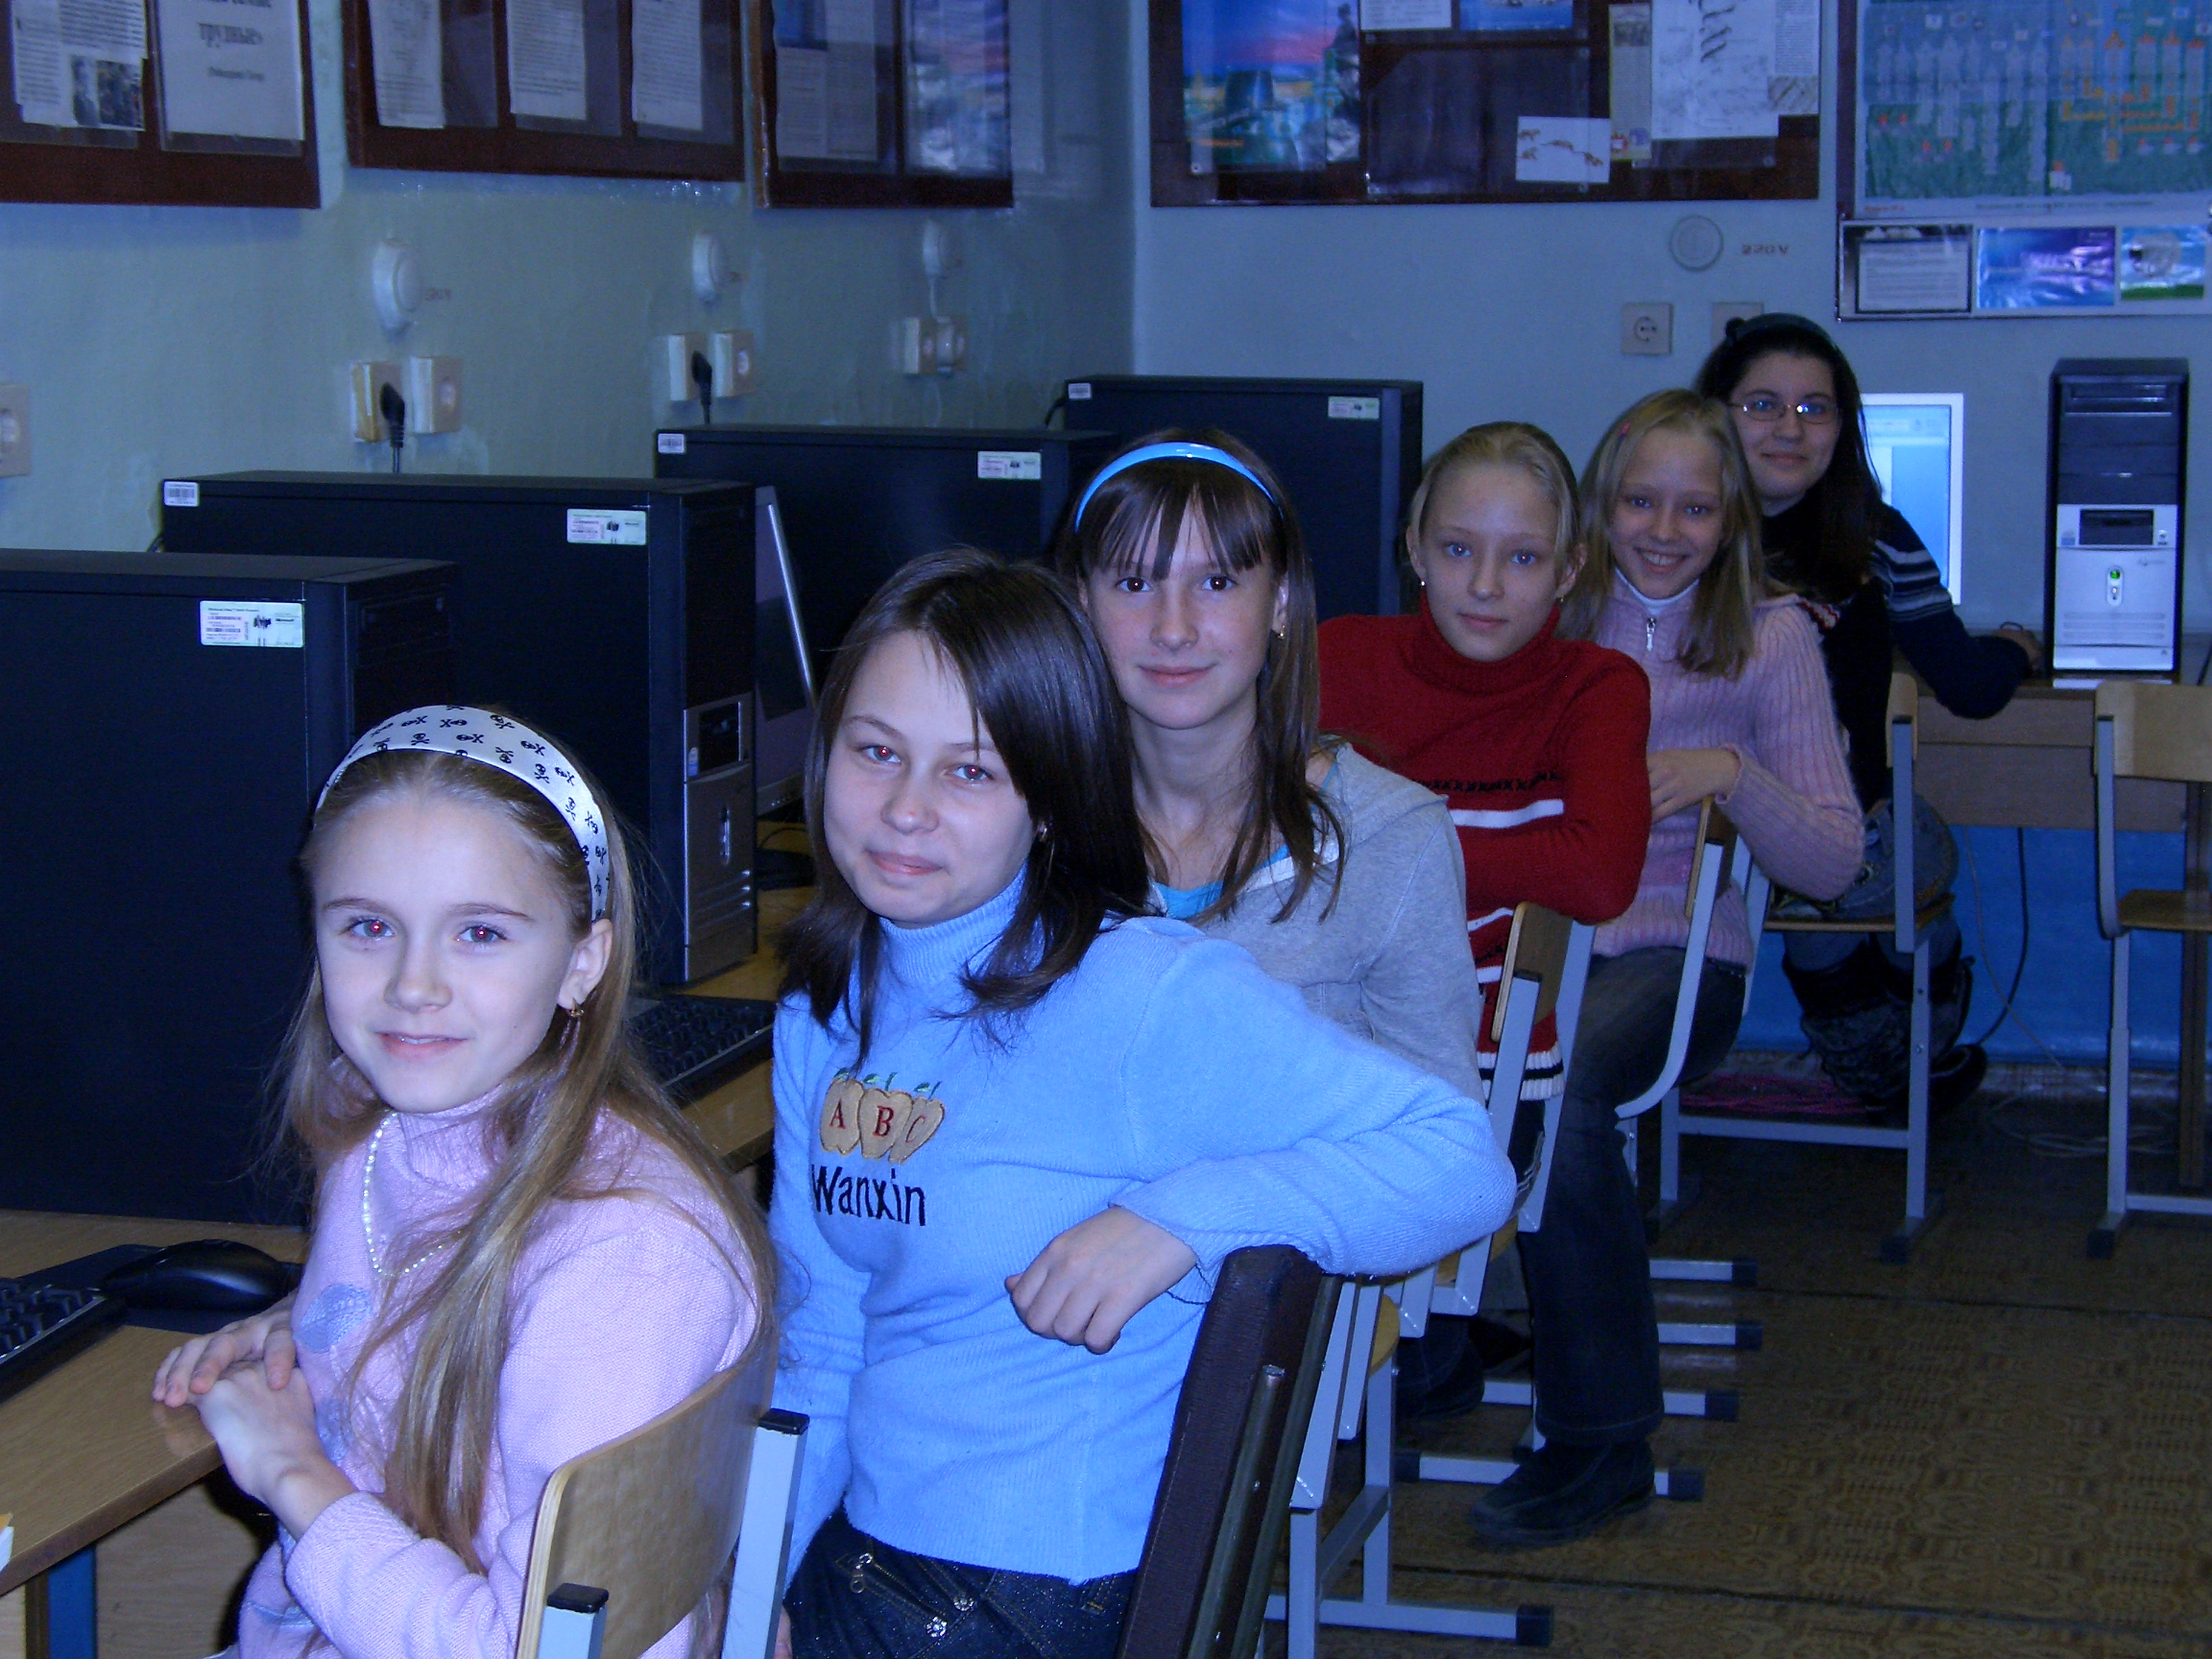

Students in different countries have common favorite clothes:
- Polo jeans, with a South Pole hoody and a Polo shirts.
- Sweatshirts (especially ones with hoods), t-shirts, baseball caps, blue jeans.

2. Do you care about how you look like?
Who would you like to look like? (May be any star)
Why?

Having done our survey we found out that there are two opinions. Dereck and
Bleys from Hadley Middle School don’t’ care what they look like. All other students care much about their appearance:
Girls from Hadley Middle School - Yes we care about how we look because we care about what other people think of us, sometimes people feel bad about themselves when they know that other people think that they are weird. Sometimes you want to be liked to make friends, and making friends is sometimes based on how you dress, how you act, and who you hang out with.

If you wore clothes like these to my school everyday then you would probably be liked by a lot of people. We would like to look like Jessica Alba, because she is really famous and pretty!
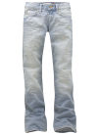
Kothari International school students - We don’t want to look like anyone.

A Mohamed Elsayed Experimental Languages School student - I would like to be a star such as Tom Cruze because he is smart guy, the girls love him too much.
University Prep students - we do care about how we present ourselves to each other, and we want to look nice. However, no one in our classes said that they spend a lot of time picking out clothes or looking at themselves in the mirror.

Korolev School #7 students - We very much care of how we look. We wish to look as rock stars because we wish to look fashionable and stylish.

3. Speaking about traits of character valued in friends all the students want their friends to be loyal, kind, trustworthy, understanding, honest, funny and reliable.

4. Boys should be trustworthy, honest, courageous, not abusive, has a purpose in life.
Girls should be kind, clever, polite, respectful and honest.



5. Very seldom but bullying problems take place in some classes. Will you read students’ advice to avoid bullying?

A Hadley Middle School student -To stop bullying you have to fix it. If they are bullying you physically you have to tell someone. If they are calling you names you need to tell them how you feel and maybe just tell someone. I handle bullying by just saying “yep” to everything and once and awhile I’ll tell them to grow up. Always tell a teacher. We don’t think there is any bullying in this class. But I’m sure there is in many other classes.

Kothari International School students - No bullying problems

Mohamed Elsayed Experimental Languages School students - Bulliers must be punished

University Prep students - We don’t’ have bullying problems. Our advice to combat bullying is to ALWAYS TELL AN ADULT if you encounter bullying. We agreed that even if it isn’t happening directly to you, if you see it, you must report it.

Korolev School #7 students - Bulling sometimes happens in our class. When somebody tries to bully you ignore them and don’t be afraid to ask your teachers for help.

6. Though it is not common to elect a class president in some schools most circlers are sure that character is more important for a class president. It’s more important because if you are nice, caring and have good ideas you’ll be successful.

- Playing sport games – soccer, football, basketball, tennis.
- playing computer games
- swimming, fishing, hunting
- playing board games
- watching television
- hanging out with friends
- reading
- shopping

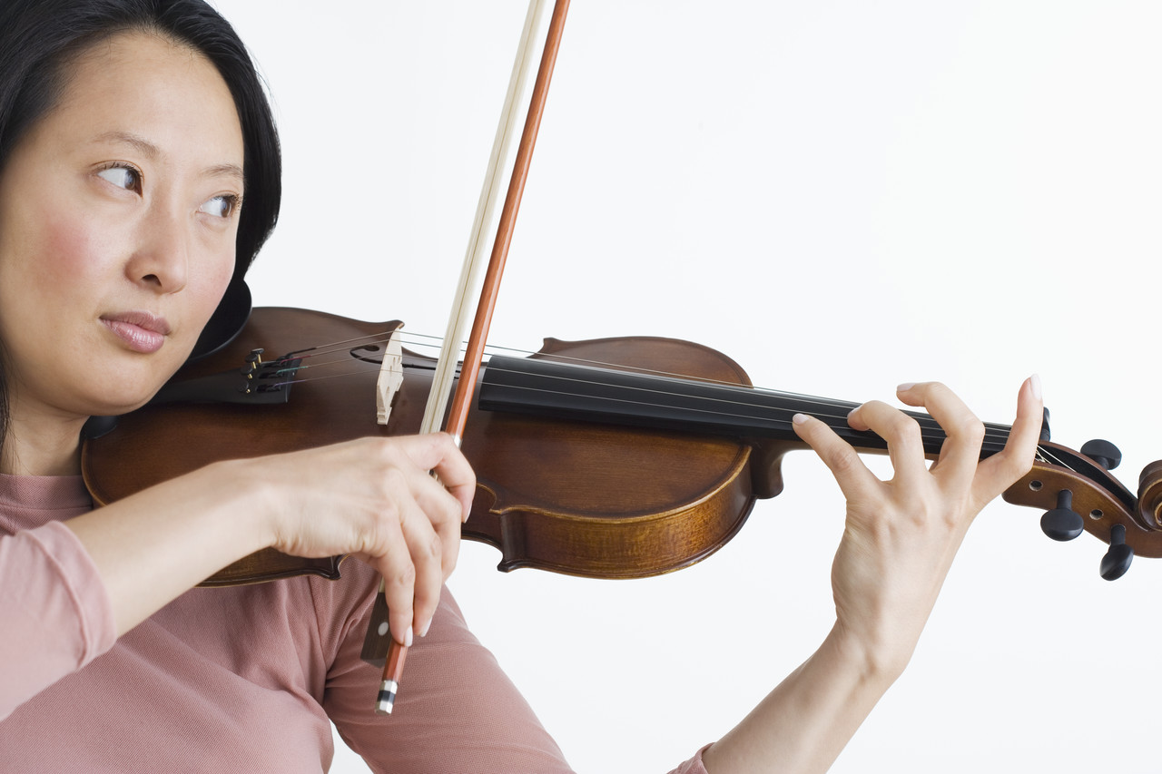

We are greatly thankful to the teachers and students for having been together in Learning Circles-2007. We have learned a lot about each other. Though we come from different countries we can communicate because there is so much in common in our inner world which gives us hope to make the world a better place.

