iEARN Learning Circle Project
PPH1
Spring 2008
Farzanegan Zeynab Educational Center
Teacher: Minoo Shamsnia

Participants:
Nine grade students at Farzanegan Zeynab Educational Center, Iran
Circle participants from around the world:
Ghana, Belarus, United States, Iran, Turkey, South Africa, Syria, Azerbaijan, Pakistan and Slovenia
Project Idea: Environmental Issues
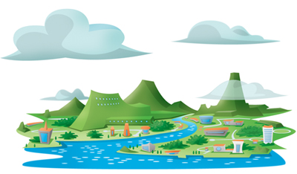
Tehran is usually enveloped in a cloud of smog and, in recent years, due to the increase in the population, the pollution problem has worsened.
The government has announced different steps to fight the problem, but none so far have been effective. Cars are mainly to blame for Tehran's heavy pollution. the geographical position of the city, which sits in a basin surrounded by mountains, worsens the pollution.

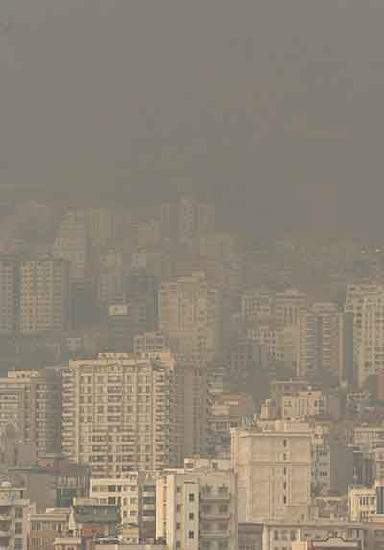
In addition to the air pollution, pollutant substances, drinking water and purification of the water resources flowing in the sewage system and inter-city transportation are among the issues that should be dealt with in Tehran and other major cities of Iran.
Sara,
Farzanegan Zeynab Educational Center
Iran
*******************
Dear all,
All around the world, people are becoming more concerned about the air pollution, a
leading cause of Asthma, lung cancer and allergies.
Many industrial companies, our cars, and some tools that we use, pollute the air.
Many health problems are because of pollution, and specially air pollution.
So we have to find some useful solutions for this really big problem. We can make a
difference by driving our cars less than past and make our pollutant tools less.
We have done a little to help this matter. Some of the activities my friends and I have
done at school so far are:

Protecting our natural environment (beach clearing)
Sometimes our school arranges us camping trips. One of them was a one day trip to
Lavasan. There is a beautiful lake there , but it is so polluted by rubbish and other
pollutants that we got really heartbroken when we reached the beach. We worked
hard and cleaned some parts of the beach and removed a lot of rubbish from the
water.
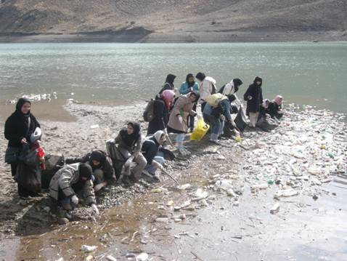
We also distributed some bags among people there and asked them not to throw their rubbish into the water or on the beach.
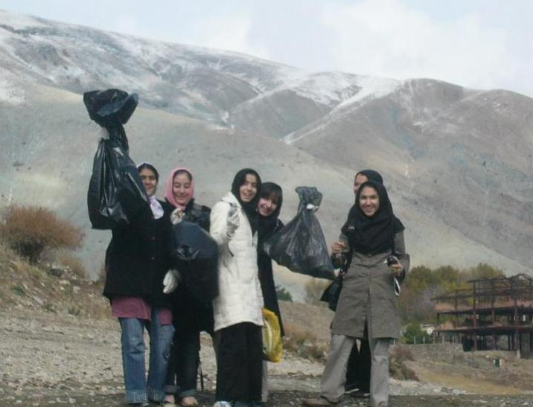

Planting some flowers trees
We made plans for creating a garden in our school and planting some daffodil & tulip bulbs in it. Later we faced some difficulties due to lack of suitable place in our school. So we had to prepare a number of pots and plant 40 daffodil and 20 tulip bulbs in pots.
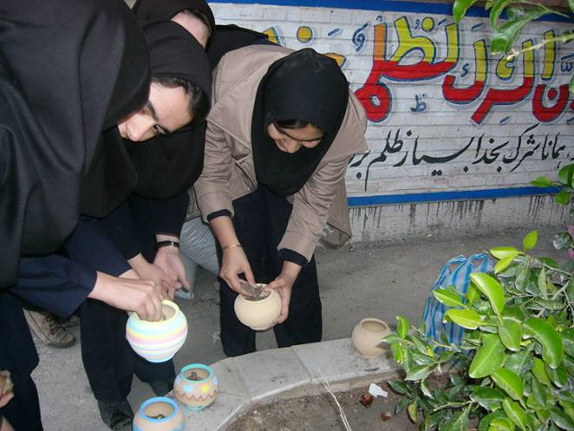

We regularly take care of our daffodils and tulips until they bloomed.
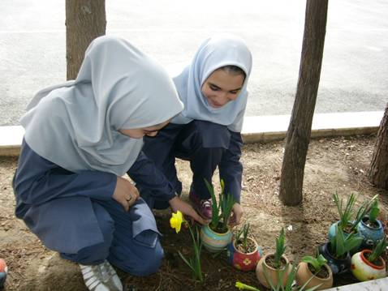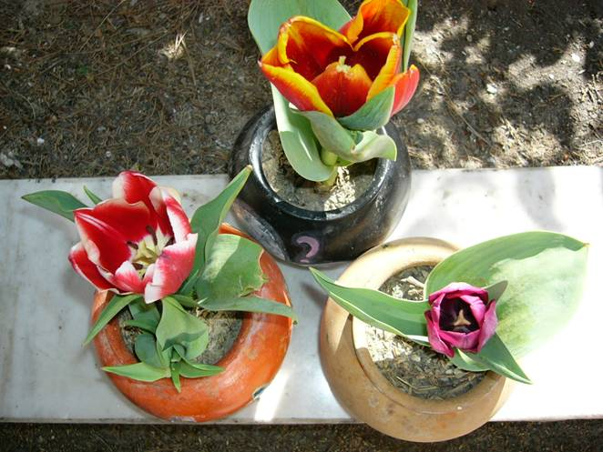
March5 is Planting Tree Day in Iran. Iranian respect this day by planting trees all
over the country. We planted some trees and rose bushes in our school garden on
this day.

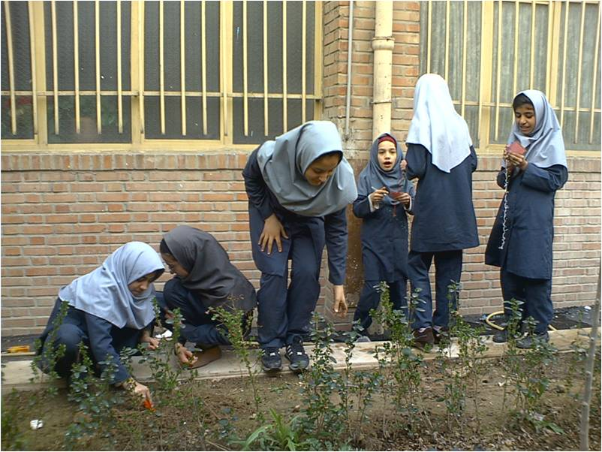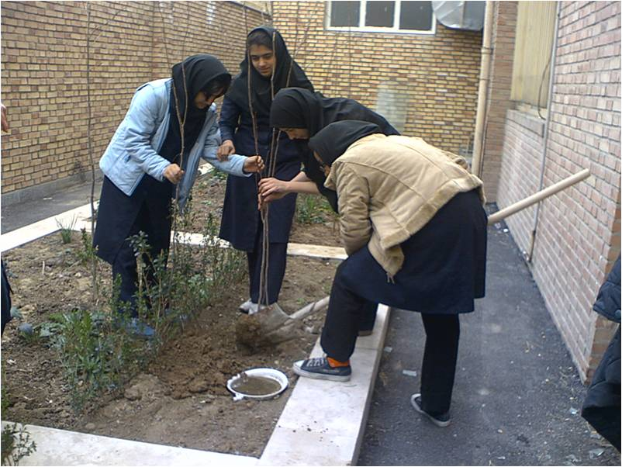

Making solar cookers and solar powered machines
It is estimated that one billion people suffer from hunger. Solar cookers can reduce
the amount of people who go hungry. It gives people another alternative, a new
choice with many advantages. UNICEF estimates that solar cooking could help over
200 million households.
So we have designed and built several kinds of solar cookers and other solar
powered machines such as a machine for distilling water and a machine for
drying fruits. We’ve used aluminum foil and recycled boxes to build our solar
powered machines.
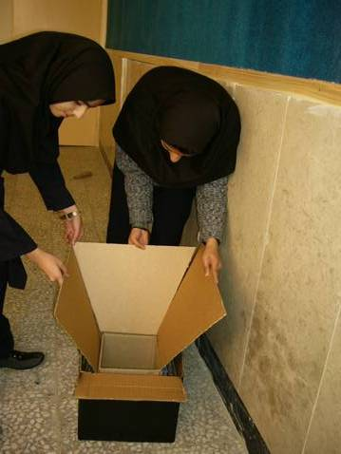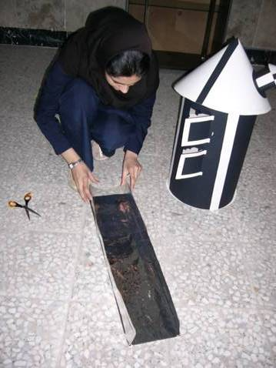

We displayed our machines in annual exhibition and environment conference held by our school and Clean Energy Symposium in Saee Park in Tehran.

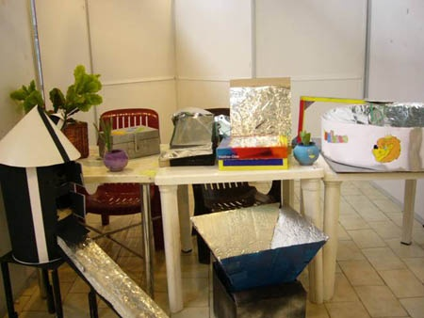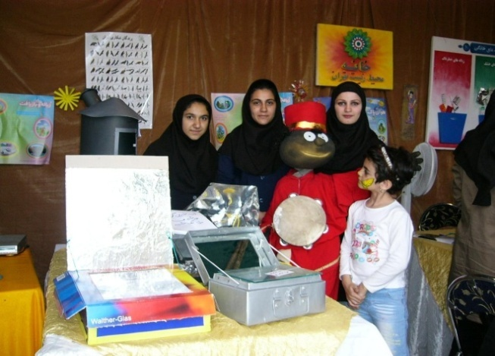

Learning about water pollution sources
Water pollution is a serious problem in Iran. In order to learn about this and make
others aware we made a small model of water pollution sources. In our model we
showed leaks of oil, power stations, waste from houses, hospital trashes, acid rain and farm manures as sources of water pollution. We will display our model in our
school annual exhibition next month.
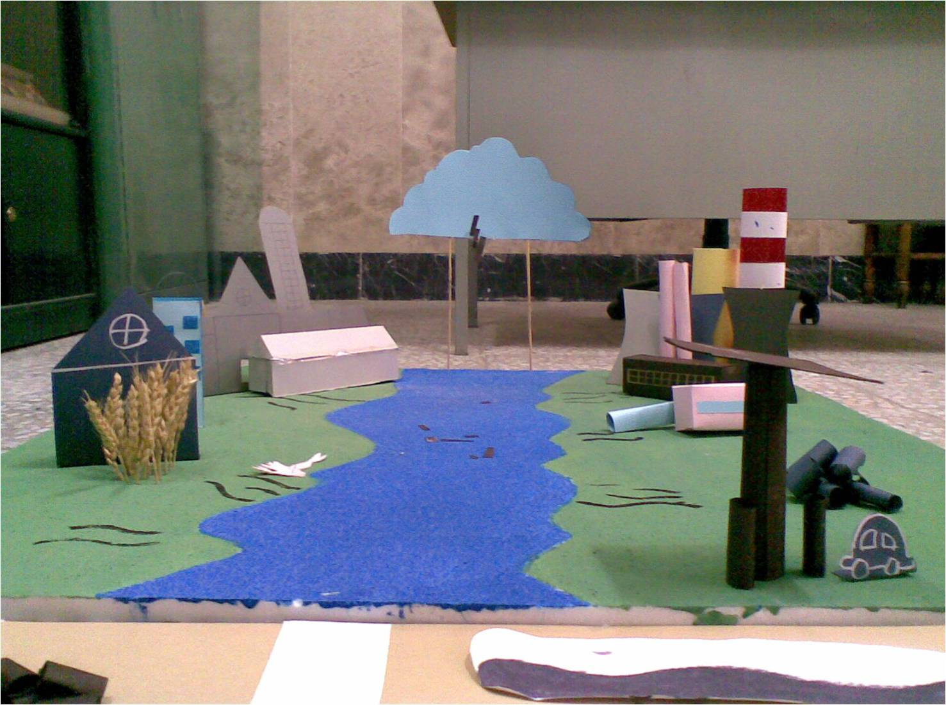

Hosting conferences on environmental issues
Up to now our school has held 2 conferences on environmental issues. Next month
we are going to hold our third conference. The participants are all the students and
teachers of our school, students and teachers from other schools, students’ parents,
experts on environmental issues and local officials. The students presents all the
environmental activities and projects they have done throughout the year. In addition
to presentations and exhibition of the students' works the school invite an expert to
talk us about environment and answer our questions. These annual conferences are
very interesting and beneficial.

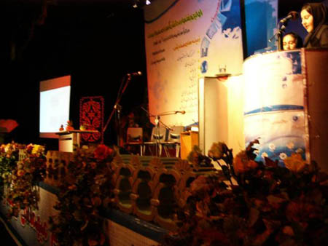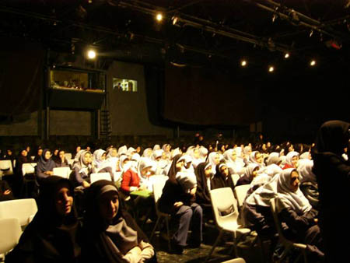

We are working on better solutions, too. Because it is an extremely important matter
to have a clean air to breathe and enjoy of it.
The air pollution can also destroy the ozone layer and make holes in it.
The ozone layer is a type of oxygen (O3) which is at the distance of 15-50 kilometers
from the earth and protects it from the ultraviolet radiation of the sun.
So, the air pollution can cause global warming, too.
Hope that you have understood the importance of this matter. Thank you in advance
for helping us with this matter and its solution.
Sincerely,
Kimia.
Farzanegan Zeynab Educational Center
Tehran, Iran
*****************************

Hello Minoo and friends,
Hope you are doing well.Here is my students' project work.
Learning Circle Group:PPH1
Teacher:Huri Cinar
School:Cahit Elginkan Anadolu Lisesi
City:Kocaeli
Country:Turkiye
We are eleventh grade students at Cahit Elginkan Anatolian High School.We are seventeen years old.Our Projectwork is about environment pollution.
How is the environment changing?
Environment is changing due to industry so we can say that industrializing causes pollution.Population is getting higher so ecomadation isn’t enough for people.The houses are built on green areas.
How is it different from the environment 50 years ago?
50 years ago agriculture was more important than today.We didn’t have many industry foundations and we didn’t have so many vehicles as today.Today almost everyone has got a vehicle.Population was less than today.We could swim in the sea but now we can’t swim.So 50 years ago environment was much better than now.
What problems are there in the environment today, do you think?
People don’t care much about our environment pollution.They pollute where they live and they don’t mind.
Are there environmental problems where you live?
İzmit is a industry city so we have many industrial foundations.Industrial foundations pour
their waste in the sea so we can’t swim in the sea.We have air pollution because of industrial foundations fumes.
What government and private campaigns are there in your country to protect and improve the environment?Are these campaiggns motivated by concern for the lives and habitats of species other than our own?
Some schools are planting tree with TEMA. Factories have to fix filtres. Waste treatment facilities are working to clear our sea. Vehicles are banned from the city center during certain hours. Poeple are trying to use the public transport as much as possible.

*********

I am no expert on environmental issues but I believe that there are many issues in regards to climate that are more cyclical in nature rather than an issue of global warming. I recently read a book entitled "Issac's Storm" and it was historical fiction regarding a large hurricane that hit Galveston, Texas right around 1900. Normal weather patterns show that hurricanes do not normally hit that are but for the next few years there was hurricane after hurricane and then nothing for the next 50 years or so. There was a few year period recently where quite a few hurricanes hit Florida, one after the other and all I could think of was the seemingly cyclical pattern in "Issac's Storm"! Again, this is just my conservative opinion and I have not gathered enough data to make a realistic hypothesis.
Now, I do feel like smog and pollutants in the air have increased the number of asthmatic people, in particular, children. Smog is a big problem in Atlanta in the summer when the air is stale and very hot (90+ degrees Fahrenheit).

Kim
USA

