RUSSIAMIASS
SCHOOL 7

WHATEVER THE WEATHER PROJECT

Sponsoring class 6th grade students
Sponsoring teacher Rimma Zhukova

Goal Of The Project: We would like to collect information and compare what the weather is like in different countries in different seasons as well as students’ feelings towards good/bad weather.
- What is the average temperature in every season?
- What is the weather like in your region in different seasons (summer, autumn, winter and spring)?
- What is good/bad weather for you? Describe your feelings, mood.
- Does your mood depend on weather much?
- What do you usually do in different kinds of weather in different seasons (spring, summer, autumn, winter)? Describe your activity, playing sports games, etc.
- What do you usually wear in different weather?

Contributions

countries teachers

USA Christine Hockert
USA Anne Lambert
USA Barry Cramer
Canada Jennifer Saban
Romania Ecaterina Rupesac

Whether the weather is fine,
Or whether the weather is not,
Whether the weather is cold,
Or whether the weather is hot,
We’ll weather the weather
Whatever the weather
Whether we like it or not.
WHATEVER THE WEATHER

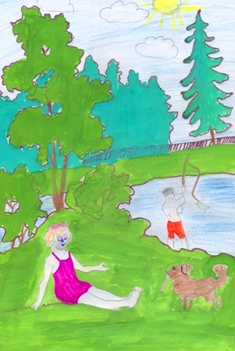
In summer it is sometimes 30 degrees above zero. The weather is sunny and sometimes hot. In simmer my friends and I like to go on a picnic and to the forest. I often ride a bike. In the summer my friends and I go to the lake to swim. I go there very often, almost every day because I live near the lake. There are many bright flowers: roses, daffodils, tulips, gladioluses, irises, lilies, and chamomile. In summer I wear light clothes: a t-short, a shirt, shorts, a jacket. I like this season because there are no lessons, no school and it is warm.
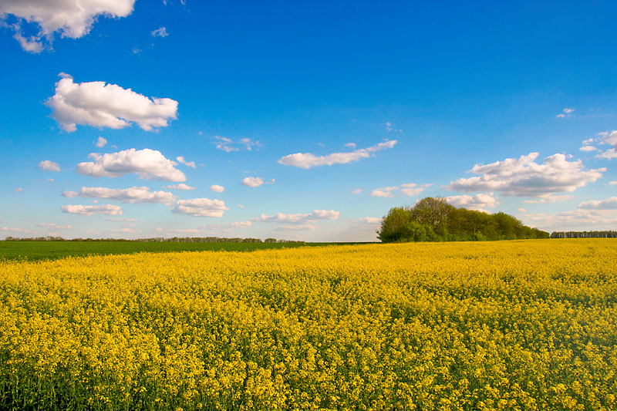
Dima Kozyryv. 6b grade
school 7, Miass, Russia.
WEATHER

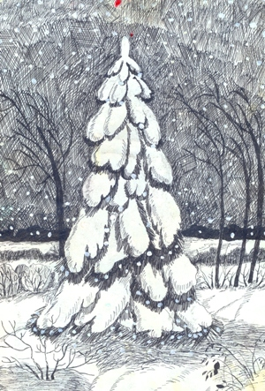
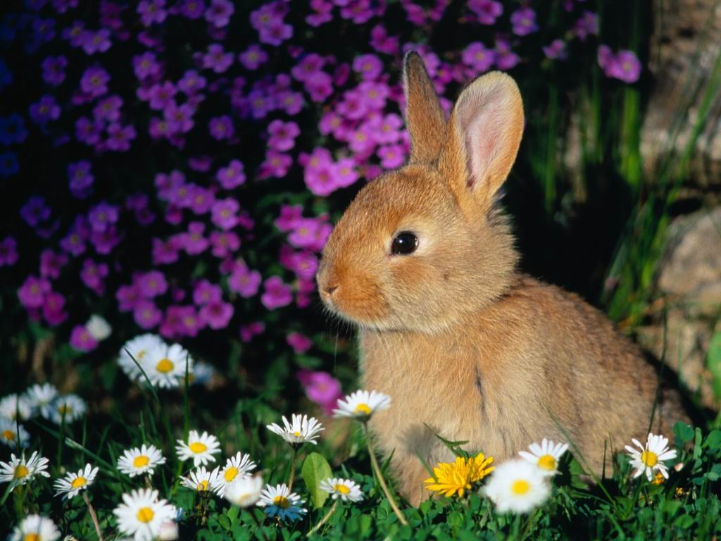
My favorite seasons are summer and winter, because they are cool! In summer I like playing volleyball, I often swim and go for a walk with my friends, a dog and my parents. I like riding a bicycle and roller – blading. It is sometimes 25 above zero in summer. I usually have a good time!
I would love winter but for the cold winds and wet snow. I hate wearing warm clothes. But in winter I like to go skiing and skating as much as I want! In winter I play snow balls WITH my friends! I like to make a snowman very much! I like these seasons! My mood never depends on weather.
Alyona, 6 grade,
school 7, Miass, Russia
My favorite season is . It is so wonderful to see the new spring leaves, grass and flowers. My birthday is in spring. Snow melts in spring , sometimes it rains and snows, sometimes it’s very warm and sunny. The weather is unpredictable and very changeable in the Urals.
spring
Katya Gilyova, 6 a grade,
school 7,Miass, Russia

WHATEVER THE WEATHER
My favorite season is summer! Because it is very cool. There are many bright and nice flowers in summer.
It is sometimes 30 degrees above zero. It is very seldom 15 degrees above zero.
I like to go to the garden, go shopping with my parents. I like walking with my friends very much. I like going on picnics. It is very sunny and hot; it seldom rains in the summer. I like to go roller blading and play volley ball outside with my friends!!! I usually wear shorts, t-shirts and sandals.
SUMMER IS A BEAUTIFUL SEASON!!!
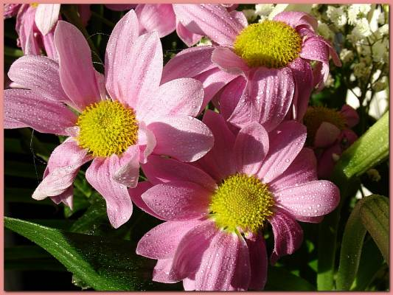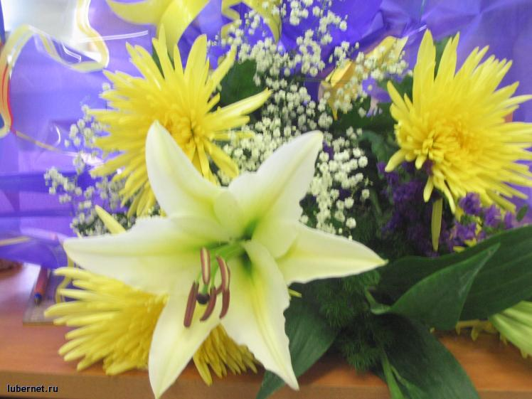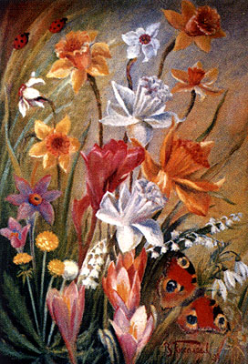
Dasha Shipilova, 6 b grade, school 7.

WHATEVER THE WEATHER
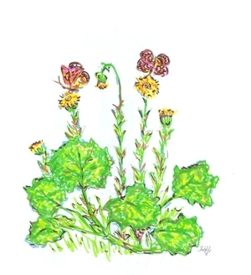
My favorite season is spring. Because it`s beautiful, amazing and wonderful in spring. I like very new spring leaves, small green grass and attractive bright flowers. In the Urals the weather is unpredictable. The spring can be windy, sunny, rainy, foggy and even frosty and snowy! I wear light clothes: a blouse, jeans, boots and a dress. I like walking with my friend Alyona, go shopping and do shopping in spring. I like watching DVD films, listen to music and read a book in spring evenings. This spring I`m having a good time too!
Tanya Korabelnikova,
6B grade, school 7, Miass
WHATEVER THE WEATHER
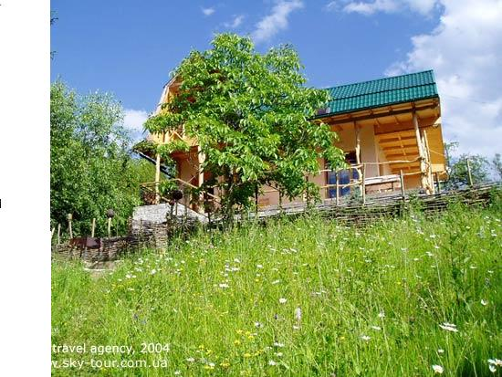
In summer it is 25 degrees above zero. Sometimes it rains and there is fog. But usually it is hot and sunny. You can do different activities: go for a ride on a bicycle, play badminton, sunbathe on the beach. You can wear light clothes: shorts, a T-shirt and sandals in the summer. Whatever the weather in summer I always have nice mood.
Kristina Odnodvortseva, 6 b grade,
School 7, Miass, Russia.
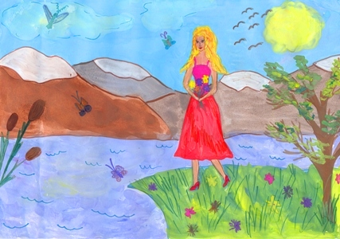
My favorite season is summer, because in summer it’s often sunny. I like the sun very much, because when it’s sunny I swim in the lake, lay in the sun. When it’s cold, I watch TV and help my mother. When it’s windy but not sunny, I ride a bike and go roller-blading. In summer I also walk with my friends and sisters. When in summer it’s cold, I wear jeans, a jumper and trainers. When in summer it’s hot and sunny, I wear shorts, a T-shirt, a top, a skirt and a dress. I like wearing light clothes and I hate wearing warm clothes. My mood is very high in summer.

I like summer very much. Summer is a cool, wonderful and amazing season!!!!
Nastya Trofimova, 6 b grade,
School 7, Miass, Russia.
WHATEVER THE WEATHER
In summer the weather is usually 25-30 degrees above zero. It is hot and sunny. Sometimes it can rain. My favorite season is summer, because we don`t have school, lessons and homework. In summer my friends and I like riding a bicycle. I like swimming in the lake with my parents and friends. I like to play badminton, volleyball and go shopping with my friends. I wear a top, a T-shirt, jeans, shoes, shorts and trainers. I like summer very much and I always have nice mood!!!
Nastya Poluboyarova , 6-b grade, school № 7
Miass, Russia.
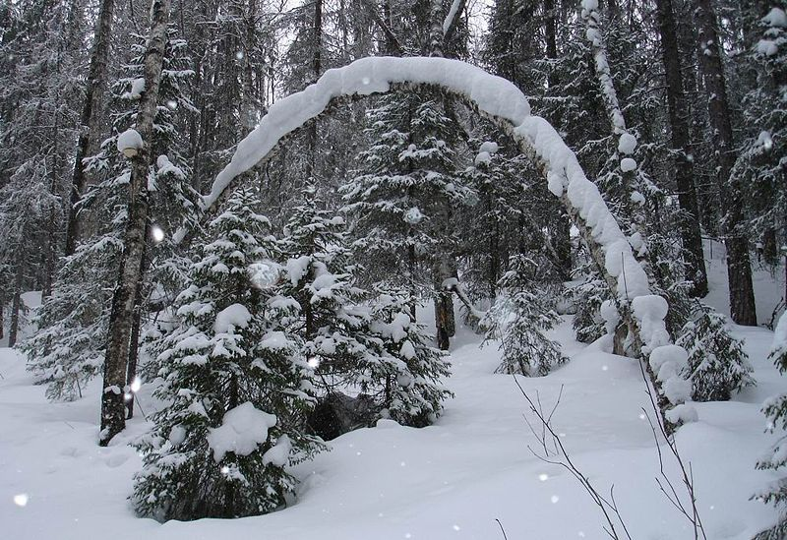
My favorite season is winter. In winter the weather is cold and frosty. It often snows. It is often cloudy and windy. The sun doesn’t shine very much. It is 20 below zero sometimes. Winter is the coldest season. I like when it is windy and snowy and when it freezes. I like when I am cold. In winter I wear warm clothes: boots, trousers, a jumper or pullover, a jacket and a warm cap.
Vlad, 6B grade, school 7 Miass.
San Diego weather is great.
Mar 28, 2008 by grade 2
Usually it is 72 degrees in summer. In the winter it is around 68. I've seen hard rain. It was at school. We had to wear jackets and we had wear hoods. We stayed inside at recess. I've seen a fog where you really can't see anything except where you are.
I dislike the earthquakes. Everything starts to shatter, and things fall to the ground. I dislike when it is sunny. It's cold and then I get sweaty if I have a long-sleeved shirt on.
Allan, Gr. 5
In winter the temperature is like almost 50 degrees in summer it's like 85 degres.I saw heavy rain when I was at my house there was a big flood and the next day it was better.About 2 weeks ago I coudn't see anything.A lot of plants grow here.
The weather
by:Sadie Mar 28, 2008
We have 75 in the summer and 58 in the winter. I hate the summer because i am so hot. We have had some bad rain. I have only seen snow once. Some of the fog we can't even see through. We have a lot of plants that grow here. I love the weather sometimes. I hate that it is so hot here.
Andrew Apr 3, 2008
It’s always hot over here.
Weather
by: Alexis Mar 28, 2008
In summer the temperature is in the mid 80's. In winter the temperature is in between the 40's and 50's.I haven't seen any snow in my whole life.
By: Jasmine2016 Mar 28, 2008
The temperature in summer is about 85 degrees. The temperature in winter is about 57 degrees. I saw heavy rain in school. We had to stay inside for recess. I saw fog outside my window. You could not see anything.
I have seen a lot of rain in San Diego. I have not seen any snow. In fog you cannot see anything except where you are standing.

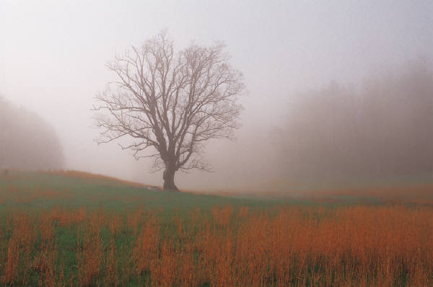
In winter the weather is horrible. It's so cold. There's no snow but there is rain. Fogs are very thick. You can’t see anything. The plants here are weird.
by:michael_
Summer is 72 degrees in winter it is 58 degrees. The rain is hard and we have no snow. The weather in San Diego is great in the summer. That’s when I want to go to the beach.
Timothy, Grade 4
Whatever the Weather
Submitted by R.J. Hawkey Elementary School
Airdrie, Alberta
I’ll tell you about spring first because here we have spring right now. It is really warm except today; it’s kind of colder today than any other day this week. I got to put on shorts and a spaghetti strap shirt two days ago. It rained yesterday.
Now I’ll tell you about summer. Summer is between spring and autumn I love summer so much; it is really hot in Alberta! I like to go swimming in an outdoor pool. Sometimes you just want to stay inside where it is cooler.
Winter is cold but we do get Chinooks. Chinooks are when one day it is really cold and over night it gets really warm. This weather pattern is created because we are so close to the Rocky Mountains. Sometimes when it snows, the snow comes up to my knee. I really like to build snowmen when we get a lot of snow.
By: Cheyanna
Whatever the Weather
Submitted by R.J. Hawkey Elementary School
Airdrie, Alberta
In the summer, the weather is usually hot and sunny, but sometimes there is rain. In the spring it is warm, sunny, sometimes rainy, and sometimes very windy and chilly. In the fall it is cloudy and windy and chilly and sometimes warm and sunny. In the winter it is usually freezing, snowy and cloudy.
Good weather for me is warm and sunny so that I can climb trees and play outside. When it is warm and sunny I am usually in a good mood because there is more to do than sit on the couch watching T.V. Bad weather for me is cloudy, rainy, stormy, windy or snowy. When it’s bad weather I’m usually in either a bad mood, a very bad mood, or a casual mood. Sometimes my mood depends on the weather, but not usually. In the spring I usually play outside and climb trees. In the summer I spend almost all my time outside every day. In the winter usually I build snow forts outside in our backyard. In the fall I usually climb trees outside, watch T.V or play on the computer.
By: Cooper
Whatever the Weather
Submitted by R.J. Hawkey Elementary School
Airdrie, Alberta
The weather in Airdrie, Alberta is very hot in the summer and it rains in the spring. In the fall it can be very windy and the leaves fall off the trees. In the winter it is very cold and snowy. I enjoy winter because I can build a snow fort and have snowball fights. I like summer because I can play soccer and volleyball. I like spring because I can run around in the rain and get wet and play in the puddles. I enjoy fall because I like the breeze blowing in my face.
By: Drake
Whatever the Weather
Submitted by R.J. Hawkey Elementary School
Airdrie, Alberta
In winter it is usually quite cold. Spring is sometimes cold, chilly, warm and hot. Sometimes it even snows! Summer can be really hot. Fall is windy and cold; it is often quite chilly.
My mood is usually good when the weather is hot and sunny. I seem to always not be in a good mood when the weather is cold and icky.
By: Sarina

Whatever the Weather
Submitted by R.J. Hawkey Elementary School
Airdrie, Alberta
In the summer it can go up to 30 degrees. In the summer we can definitely go outside and ride our bikes. In autumn it gets sort of cold. In autumn the leaves start to fall. In the winter it gets really cold; it can go to minus 20 but it gets hotter so we get to go outside and make a snowman. In the spring, the snow starts to melt so we get to go outside and play street hockey and ride bikes. In the summer if it’s hot out I wear shorts and a tee shirt. In the winter I wear snow pants and a winter jacket. In autumn I wear jeans and a sweater. In spring I wear a long sleeve tee shirt and jeans.
By: Jared

Whatever the weather I am usually either playing outside with my brother, my cats, a friend, or just playing by myself.
In winter…… My brother and I will go outside and play in the snow. Sometimes he will just run back inside when we start to have fun. I get really mad at him, but I mow get the snow all to myself! We are sometimes sledding and he will just get up and run inside and leave me sitting there.

Alison
Fifth Grade
Franklin Township School
Quakertown, New Jersey, USA

Whatever the Weather
Whatever the weather we are always playing inside or out. But we are never in front of the TV all day we are always being ACTIVE!!!! If you don’t move or play you will get in the habit of being in front of the TV all day and that is a very BAD habit. You need to be playing a few hours a day because you will be out of shape and not able to run at all for long.

Fifth Grade Student
Franklin Township School
Quakertown, New Jersey, USA

Rain, rain, go away
Come again another day.
Little Johnny wants to play.
Rain, rain, go away.
Not for me! I love rain! Most people say, “Ugh! It’s going to rain on Saturday! Now I can’t have my soccer game,” or “I was going to play outside with my cousins,” and all sorts of other whine, but the only whines you’ll hear from me is not wanting to get up in the morning when it rains. I love to just stay in bed and read, and even if you like to play outside you can still just get boots and a coat on and run around in the rain and splash in the puddles, and come in the house after you get tired and cold and take a bath, have soup, and watch your favorite movie over and over again.
Rain is not only a mood for people, but, say, if you have a garden, it would eventually need rain water and not just water from your hose. Even if you don’t have a garden, all the plants, and people, need water!
It’s going to rain today. My soccer game is canceled.




Paige
Fifth Grade
Franklin Township School
Quakertown, New Jersey, USA

Weather

The weather in our lives is very important to us because we need weather so we know how to dress one example is that if it is cold outside you would probably want to wear a winter jacket and pants. If it was warm outside and it was in the summer you would probably wear shorts and a t-shirt. The weather affects us every day. People all over the world watch the weather channel every day to see what to wear that day or the next day. People that are on the weather channel aren’t always 100% accurate because sometimes the weather channel will say that there is going to be a very sunny and warm day but it can turn out to be a very rainy day! That is why we are always depending on the weather!
Harlee
Fifth Grade
Franklin Township School
Quakertown, New Jersey, USA

Whatever the Weather

Ah! The weather! Sunny, snowy, rainy, or cloudy, any day can be just as good! Our weather is usually sunny, some cloudy days. Lately, our weather is warm and bright, but lots of rain has been coming’ down too! We used to get a lot of snow, but last, and this year, no snow has been coming. Sure, we got a few snow days; most of it was ice or mush. Anyway, here is the average weather in our seasons:
- Winter- Cloudy, icy, mushy, some sunlight
- Summer- Hot, humid, bright, rain
- Spring- Warm, bright, clouds here and there, rain
- Fall- Cold, warm, cloudy, rain
The average temperature here is usually 50°F and up. Winter can be lower, but never below freezing. Now, let’s talk about clothes. Here is a little chart on what we wear in different seasons:
- Winter- Warm clothes (like a sweater), hat, gloves, scarf
- Summer- Tank tops, shorts, caprice, short sleeve shirts, crocs, flip-flops
- Spring- Crocs, short sleeve shirts, jeans, caprice, shorts on hot days
- Fall- jeans, long sleeve shirts

In winter, my friends and I play in the snow, glide on the ice, and smash the ice with hammers (It really is fun). In the spring, we play outside and ride our bikes. In the summer, we play in pools, ride our bikes, and have outdoor fun. Lastly, in the fall, we play in leaves and do some outdoor fun on warm days. My family and I play badminton and have barbeques.

Bad weather for me is thunderstorms. Big thunder claps and the bright flashes of lightning that seem to look really look right next to you frighten me and I’m not very fond of it. In this bad weather, I tend to stay indoors, hide in my covers in my bed, and play my Nintendo DS, because if the power goes out, I have a small light source and the power doesn’t go out.

Well, thanks for reading about our weather!

Jillian
Fifth Grade
Franklin Township School
Quakertown, New Jersey, USA
Weather

The weather in Quakertown, New Jersey has cold and also dry winters. In summer it is warm and humid. In spring the weather varies from cold and rainy to warm and dry. In the fall it is usually a range from 70 to 55 degrees Fahrenheit. We have verified weather in Quakertown.

Bryan and Josh
Fifth Grade
Franklin Township School,
Quakertown, New Jersey, USA
What ever the Weather

The weather here can be very bad. The thunderstorms are so bad they knocked down trees and we sometimes get out of school because the power goes out for a day or two. I’ve had an experience where lightning struck one of the trees in my backyard and it fell and crush my pool. The weather in the winter can be really, really snowy or there is sometimes no snow at all. For us the summer is brutally hot. To cool off I go in my pool for hours at a time. As you can see our weather changes rapidly throughout the year.

Ben
Franklin Township School
Quakertown, New Jersey, USA

Weather in New Jersey

In New Jersey, the weather is very different in all the seasons. Here we have four seasons, winter when it is very cold, in the spring when it is cool and sometimes cool and warm. In the summer it is very hot and in the fall it is mostly warm and breezy. Our favorite seasons are summer, fall, and winter. For some reason we don’t really like spring of all the blooming flowers, which makes us have a lot of allergies. Also even though the weather is sometimes nice it rains a lot. The average weather for spring is rainy and about 60º F and sometimes cooler and warmer. Sometimes it rains and the weather just suddenly changes! My favorite season is summer because you can spend almost all your time outside. My favorite season is the fall because you can see all the beautiful leaves! My favorite season is winter and summer because in the winter there is snow, which I really love. Also, my birthday and Christmas are in the winter, too.
Phyllis and Paige
Fifth Grade
Franklin Township School
Quakertown, New Jersey, USA

McConnell Elementary School
The following website will provide information about the average temperature and precipitation for Chattanooga, TN.
http://www.weather.com/outlook/travel/businesstraveler/wxclimatology/monthly/graph/USTN0084?from=weekend_bottomnav_undeclared
The average high temperature is from 49-90 degrees Fahrenheit and the low is 30-69 degrees Fahrenheit. Chattanooga receives the most rain during March and the least amount in October.
Our weather has four seasons. In the summer it is hot and sunny. It can get above 100 degrees Fahrenheit. The autumn months are the nice and warm. We do have some trees that change color and people come here to take Color Cruises along the Tennessee River. Winters are fairly mild because we are protected by mountains. It does get cold and can drop into the teens but not for long. Spring is very pleasant except for the pollen. Sometimes our cars are all yellow because they are covered in pollen. The spring temperatures are in the 70’s.
My mood does not change due to the weather. I just do what I need to do and don’t worry about the weather. During the summer I swim a lot and play outside. In the fall we play sports and in the spring we play baseball. During the winter we watch basketball and football. We rarely get snow but when we do we have to put on gloves, mittens, and hooded jackets to play out in the snow.
I hope you come and visit our scenic town, we love it here.
Cameron
We are now going into our spring season. The weather can be cold one day and warm the next. Sometimes the weather changes so fast that we have tornados and severe thunderstorms during the spring. The temperatures in the spring are nice and range between 45-70 degrees. In the summer it gets very hot. Many days are in the 90’s and sometimes can get over 100. Fall is very cool and nice. It is pretty because the trees change colors. Winters are mild. Sometimes it gets very cold but it doesn’t last long.
I think the weather does make me happy, sad, or gloomy.
Katy
2ND GRADE D,
“DAN BARBILIAN” SCHOOL
CONSTANTA
ROMANIA
Hi! My name’s Ioana and I’m 8! I live in Constanta, a beautiful city of Romania, on the Black Sea coast. I’ll hereby roughly present the weather in Constanta (Dobruja region) and in Romania.
In Constanta, the summer is very hot and there is not too much rain. However, we have the sea breeze which is cooling us on our crowded beaches. Sometimes, the breeze becomes a strong wind which is tormenting the sea. The Black Sea is famous for the storms which suddenly set in summer season and in the winter season all the same. During the winter season it’s cold enough, we have the blizzard blowing almost all the time and sometimes we even have abundant snow for short periods of time.
In the rest of the country it is hot during summer season, with rainfalls in the mountains regions mostly. The winter season is cold and very cold and there is a lot of snow on the hills and mountains regions.
Come visit Romania
and you’ll see it by yourself!
IOANA ADRIANA TOPLICEANU
The weather is a element of nature. I like it when it’s sunny because I can play with my dogs and I it’s hard less to win a tennis competition. The weather changes every season. In the summer the sun shines and everything it’s colorful and I love it.
Mara Oprea

WE SAY HUGE THANKS TO
McConnell Elementary School Students
Franklin Township School Students
John Muir School Students
R.J.Hawkey Elementary School Students
“Dan Barbilian” School Students
and to their wonderful teachers
Christine Hockert (USA)
Barry Kramer (USA)
Anne Lambert (USA)
Jennifer Saban (Canada)
Ecaterina Rupesac (Romania)

