iearn projects
from Mme. Okenge's class
Ottawa, Ontario

Table of Contents:

Page 2 - 6 Advice columns
Page 6 – 7 Teen trends
Page 7 – 14 Languages of Canada
Page 15 – 21 Canadian sports
Page 21 - 26 Traditional and Modern Life in Canada
Page 27 - 31 Comics and Games
Page 31 – 36 Music Reviews
Page 36 – 39 Book Reviews
Page 40 - 42 Video Game Reviews
Page 42 – 47 Movie Reviews
Page 47 – 50 TV Show Reviews

Advice columns
Dear K.R.Y.M.S,
I am a 15 year old dude who is extremely good at online games. My absolute favourite game in fact is World of War craft. World of War craft is a super nifty game were you are a Warrior that depends upon War craft to survive! This game is really neat it cost $ 80 for the disk and $15 per month. I am not able to get a job because I spend too much time on the computer. I am going bankrupt and to make things worst my mom is yelling at me to get of the computer and go outside and make some friends. I don’t want to make friends! I am a social reject! I think I’m getting addicted! MY SOUL IS LEAKING AWAY!!! I no longer live a life! I live WORLD OF WARCRAFT!!! HELP ME K.R.Y.M.S!!!

desperately,
Warcraft addict

Dear online game geek,
CHILL OUT! I know you are addicted and lots of kids like you are addicted to online games just like you! I feel very sorry for you but do not fear, I have a solution for you!
Now most kids who want to stop playing have too lock themselves in there room with a bunch of books ore something so you should be happy you do not have to do that, we have put our best physiologists to work for you and they have atlas found a solution.
K.R.Y.M.S has sent you a virus that will stop you from using the computer! Hooray!

Dear K.R.Y.M.S,
I have am the professional skier who lives in the Rocky Mountains. I am really good at skiing but I have a problem, GLOBAL WARMING!!! Global warming is warming up Canada and The Vancouver Olympics are being cancelled! I ski for a living, I can’t have the Olympics cancelled ore I will go broke and end up snow 2hoveling for a living because I don’t have a University degree in any thing else! HELP ME K.R.I.M.S!!!

Dear pro. Skier,
Wow that is very sad. I was looking forward to the Olympics in Canada! So too help you I have a couple of options.
- Give up all hope. Become a snow shoveller.
- Go skiing without any snow.
- Stop global warming bike everywhere vote for green party, hold in you’re farts, tell others to do the same.

Dear K.R.Y.M.S
I owned a beaver tail shack until the ice on the Rideaux Canal broke because of global warming. I was not able to swim so now I am on the roof of my shack waiting for the ice to freeze again. You may think that it is stupid of me not to call the R.C.M.P but I am Phonaphobic*. And can only email ore text. Help me K.R.Y.M.S! What should I do?

Dear guy stuck on a roof
Wow that must really suck. It’s too bad you’re Phonaphobic* and can’t call 911 but I think we can help. I have done serious research and have found a couple solutions to you’re problem. Here are some solutions:

- Drop your Blackberry into the canal and electrocute the fish, get arrested for over fishing,
- Use maple syrup to stick all you’re pastries together to make a raft.
- The Rideaux canal is 2 feet deep...

*Phonaphobic: someone terrified of using a telephone.

Dear K.R.Y.M.S.,
I am 14 years, and my parents STILL won’t let me stay home alone even for 1 minute. No matter how much I ask, they refuse. I feel they are being over-protective. What should I do?
Signed, Responsibility-rooter.

Dear Responsibility-rooter,
This is a perfectly natural concern with parents nowadays. Try to put yourself in there shoes. Maybe they are concerned that you are not quite ready. Try to prove yourself to them by taking a home alone course or something like that.

Ask Kryms

Dear Kryms,
I don’t come from a very rich family, and so I can’t get much fancy clothes. Most of my clothes aren’t very cool or “in” fashion. I try to make the best of my things, but everyday when I go to school, I get made fun of because of my clothes. These girls always say things to me such as “Nice hair” and sneer or “What an ugly shirt!”. I keep my cool, but I can’t take it anymore! What do I do I do?
Need New Clothes.

Dear Need New Clothes,
Since new clothes costs money, why don’t you try to get an after-school job? Try working at a clothes store, so you can get a discount as well as get some money. When you have some free time, try babysitting some kids or walking dogs if you like animals. And remember, don’t lose your cool.
Good luck!
Kryms.

Dear Kryms,
My best friend has gone through a lot lately. Recently, her mom passed away from cancer and her Grandma passed away just before that. Now, she’s really upset, and depressed. She lives with her dad and his girlfriend, but his girlfriend treats her really badly. My friend gets sworn at a lot, and gets called things like fat, ugly, and stupid. I’m really worried about her, and I think she’s doing something really bad to herself. How can I help her?
Worried.

Dear Worried,
Whoa! Sounds like she’s been through a lot lately! She probably hasn’t been loved or encouraged at all. You can cheer her up by loving her and doing everything she needs to feel like her old self. What did her mom do to help her? Maybe try doing the same things and reassuring her that she isn’t any of the things her dad’s girlfriend calls her. Try talking to her dad, and talk some sense into him. Keep talking to her. Do something nice for her so that she knows she is still loved by some people. Even if her dad’s girlfriend may treat her that way, don’t give up on her. If you really care about her, don’t give up, and good luck!
Kryms.
Dear Kryms,
My best friend and I like the same guy. I’m not really sure if he likes me, but he always looks at me. My friend always flirts a lot with him, and when she does, I feel very jealous. I’ve always read about these problems, but I never imagined it would happen to me. I know it’s wrong to fight with my friend for him, but I can’t help it. I’ve heard rumours that he likes me and that causes a lot of problems between me and her. What should I do?
Jealous.

Dear Jealous,
You seem to like this boy a lot! You’re right that a boy isn’t worth ruining a friendship between you and your friend. Why don’t you talk it out with your friend? Maybe she’s just playing around with you, or she actually likes him. Or just let the guy pick who he wants. And if he likes you, that’s great, right? If he doesn’t then, just get over with it. He isn’t the only boy at your school, right?
Kryms
Dear Kryms,
A few weeks ago, I got myself a new boyfriend, Austin. He’s really cute and nice, but the only problem is that he’s my best friend’s ex. Since she’s jealous, she doesn’t want to be my friend anymore. She also makes up rumours about me and Austin. Now I hang out with people who also like Austin, but they don’t talk to me or Austin! I tried talking to them, and again, and again, but they still ignore us! What should I do?
Torn

Dear Torn,
There’ll be more chances to have boyfriends. You wouldn’t want to lose a friend because of a silly boy (well, maybe not silly but still...), because friends are to be treasured, and boys can just break up with you any time. There will be more boys in your life, and rumours will always be bound to be there. Don’t let the rumours get to you, because you know they aren’t true. Hang out with Austin all you want, but as friends, not boyfriend/girlfriend. Have fun, and remember there will be more boys!
Girls rule, boys drool!
Kryms
Dear Kryms,
My older brother has won so many awards from school. Every time anyone comes to our house they marvel at his awards and tell him how proud they are of him. No one believes in me and I don’t even exist! My older brother is better in school subjects like science and math. I’m better in the arts. I love to draw and play music. I like to sing too. Do my parents or relatives see that? No. What am I supposed to do?
Useless.

Dear Useless,
First of all, before I give you some real advice, no one is useless. We all have our own talents and weaknesses, and if everyone was the same, the world would be sooo boring. You are special in your own way. Maybe people don’t treat you as talented, but you are. Even if nobody recognizes that. Just because other people don’t believe in you, you have to believe in yourself. If you become a famous musician, laugh in your parents’ faces. Now, why don’t you talk to your parents? Maybe they just don’t know how you feel. They may not know, but you can show them what you mean. Remember, there is always someone out there who recognizes your talents. Like me. Remember, you are talented.
Kryms

Ask KRYMS
the best advice column ever
By:Sophie Fu
Dear Kryms(pronounced: crims),
I have a really hot boyfriend who I went on a date with just a minute ago but I caught him calling my best friend and saying : “See you in 10 minutes my love” And he made an excuse to leave early!!! He said that he forgot to feed his dog but he doesn’t even have a dog!!!! So now I know that he is cheating on me and its because of my best friend. So Kryms if you could answer me ASAP I would really appreciate it.
Sincerely,
Averyverysadgirl
Dear Averyverysadgirl,
Well I know it can be hard to solve a problem when it’s your best friend, because you have probably known your best friend for about maybe your whole life and you don’t want to get in a fight for the first or second time!!! But it is necessary to tell her your feelings so the next time you see her or you could maybe call her as soon as you are done reading this letter to the so called “Averyverysadgirl” After you call her you will be known as “Aververyhappygirl” Because your best friend will understand your feelings and if she really was your best friend she would let you have this guy. So go call your best friend now!!!!!!!!
The advice column that everyone trusts,
Kryms

``````````````````````````````````````````````````````````````````````````````````

Dear Kryms(pronounced: crims),
It is NOT fair at all!!!! Humph!!!!Today when I went to school, my so called best friend was surrounded by a bunch of guys!!!!!!.. well to be more specific, my guys!!!!.......hlep me!!!!! I need my guys back or it’ll look like that I’m not popular!!!!Ew!!
Eeek,
Crymyeyesoutofwater
------------------------------------------------------------------------------
Dear Crymyeyesoutofwater,
I know people can feel bad about being not popular but it’s your best friend!!!!!!!!!!!you can let her have this just this once but talk to her about your feelings and maybe she will let you have “your guys” back or you guys can just share “the guys”. It’s no biggie!!!!! I mean just get new”guys”!
The advice column that everyone trusts,
Kryms

Ask Kryms!

Dear Kryms,
Last night I overheard my parents deciding to leave my hometown and immigrate to Canada! It’s so unfair! I can’t bear leaving all my friends! I’ll have to leave everything! Even go to a new school and make new friends. We’re leaving next week! I’ve talked to my parents again and again but their still not even listening to what I have to say. It’s like they don’t care about me anymore. Whenever I try bringing up the subject, they get so frustrated that they start ignoring me! What can I do?
Sincerely,
Travelling Crisis

Dear Travelling crisis,
Things can get so frustrating between parent and child! So many teens have the exact same problem! Try finding a time when your mom or dad aren’t busy or annoyed and try to talk to them cooperatively about what’s bothering you. You should understand that part of your parents decision is to help you too. Things might not be that bad anyway. You might make I of new friends and join new clubs. Trust me, everything will be all right.

Dear kryms,
Okay, I’ve listened to your advice. Now what???? I’ve agreed to travel all the way to the other side of the world! Today was my second day at school and guess what happened? Everyone’s ignoring me and I have no friends at all! Even my teacher thinks I’m a fool! My classmates spread all kinds of rumours about me since I can’t speak English very well and they think I won’t understand what their saying. They also make fun of me since my clothes aren’t designer ones. Oh kryms, What can I do?
Sincerely,
Aproblemchild

Dear Aproblemchild,
Don’t worry, soon you’ll get used to living in Canada. You’ll definitely make new friends! It might just take a few days or even weeks for your classmates to get used to you. English is a very easy language to learn as long as you set your heart to learn it. Good Luck!
Sincerely,
Kryms

+++++++++++++++++++++++++++++++++++++++++++++++++++++==
Teens Favourite Trends
Hi, this is Celina and Yolanda. This article is about what trends are on the top of the list this summer season.
The clothes and shoes that girls wear are like definitely pretty and fashionable with the best styles, unlike boys, who wear baggy pants and shirts.
Most liked shirts that girls wear are:
Purple t-shirt, light blue blouse and dark purple skort.
Light emerald green tank top and dark green shorts.
Lavender t-shirt and violet ruffled shorts.
Most liked shirts that boys wear are:
Green t-shirt jeans
Blue t-shirt and cargo pants
Green t-shirt and baggy jean
Some of these teens get their clothing from stores for everyone and others go to places that are just for teens. Stores like Lasenza Girl catch girl teen’s eyes while other stores such as Areopostale, American Eagle and Holister are for both genders.
If teens need winter wear or sportswear, they usually go to the same stores as most of us do. Some of those stores are Sportscheck and Adidas.
Shoes, is another problem. Where do teens go? Girls look for high heels,sandals , flip-flops and running shoes. Three of our personal favourites are Jessica,Natrualizer and Payless shoe store, but boys go for runners. They also wear running shoes like girls too.
If you want to see a girl’s room, or a boy’s one, you might want to be prepared to make some good moves when you look at them. Yolanda is a complete neat freak so her room is really clean but Celina doesn’t care about neatness that much. Teens rooms only depend on their personality.
Eye shadow and lip gloss are popular for girls who want to be pretty normal girls would wear blush and lip gloss. Girls do not like when their lips chap. Really girly girls wear lipstick.
Many girls who have long hair wear ponytails, pigtails, braids or even just wear their hair down. They can also use a curler or a straightener for special events.
Boys can either cut their hair very short or leave it long. Most boys have very short hair, but some boys who want to be different can keep there hair long. If a boy has short hair it could be up to his ear or up to his neck.
Cellphones, I-pods, I-phones etc. are electronics. There is usually no difference from boys and girls. Sometimes girls can have pink or purple. Boys can have just plain, black, gray and brown.
Now you know what the basic teen trends in Canada are. It is probably different from your trend so bye for now!
++++++++++++++++++++++++++++++++++++++++++++++++++++++
Languages in Canada:
German or Deutsch

German is a West Germanic language. Therefore, related to English and Dutch. German is overall the third most learned language worldwide. 128, 350 or 0.4% of Canadians speak German.

Three hundred and fifty five people in Yukon, 1,985 people in Nova Scotia, 790 people in New Brunswick, 37,290 people in Manitoba, 11,185 people in Saskatchewan and 40,445 people in Alberta speak German.

According to the 2006 Canadian census put the number of Canadians of German ethnicity at 3,179,425.

Only a small fraction of German Canadians are descendants of immigrants from what is today Germany.

It is also spoken in the Czech Republic, Hungary, Poland, Romania, Russia, Kazakhstan, Greece, Israel, Italy, Morocco, Netherlands, Portugal, Scandinavia, Spain, Turkey, United Kingdom, the former Yugoslavia, and of course Germany.

How to count in German!
eins, zwei, drei, vier, fünf,
sechs, sieben, acht, neun,
zehn!

French language in Canada By Simona K.

22.7% of people in Canada speak French, which is about 6.7 million people. Although French is the native language of just over half a million Canadians in Ontario, French Ontarians represent only 4.4 percent of the province's population.(Ontario is were ou’ school is located) Here is a French-Canadian flag.



This is the flag of Quebec. Quebec is right beside Ontario. The flag of France is really different from the flag of Quebec. Here is the French flag.



French Words

Some of you might Know some words in French like “bonjour” (hello) , “ami” (friend) or “maison” (house) but, you probably don’t know the word “hyposynthesis”. pronounce hyposynthesis. It sounds the same in both English and French. Here is another example of a word like that “ code” it is the same in English and French.

French people put accents on some of their words to change the sound of the word. Like è, ê or ç. The French use accents for words like “même” (same) or “ÉTÉ” (SUMMER)



The End

Italian language in Canada
Italiano.
170,330 people speak Italian in Canada, which is approximatly 0.6% of the poplutation. 70 million people in the world speak it, so Canada has just about one percent of the Italian poplutation in the world. As of the 2006 census, 1,445,335 Canadians (4.6% of total population) consider themselves to be of Italian origin. Newfoundland and Labrador has .27% of their population covered by Canadians of Italian descent. For Ontario, 7.2% of the population is of Italian descent, which is the highest percentage of all the provinces and territories. Italian is the 5th largest ethnic group in Canada. It’s now the fourth most common language in Canada and can also be found in Switzerland, San Marino, Vatican City, Malta, Slovenia, Croatia, Eritrea, Somalia, France, Greece and, of course, Italy. In Ontario and Quebec, Italian is among the top five spoken languages. Unfortunately, Italian doesn’t make it for the other provinces and territories. There are some words that can be found in English and in French. That is because French is 87% related to Italian, Catalan with 85% and Sardinian with 82%. There is also Spanish, Rhaeto-Romance and Romanian.

 This is the Italian flag, as you probably already know. It is a common sight in Ottawa.

There is a section of Ottawa that has been devoted to the Italian culture, so Italian is present all the time there. As you can see, the Italian language and culture is a large part of the Canadian society.

This is a picture of a street name in Ottawa. As you can see, even the Italian signs are made differently. ‘Corso ITALIA’ means ‘Italy road’.

Dutch
(Nederlandse)
In Canada, Dutch is one of the most frequently spoken languages. Approximately 159,440 (0.6%) of the people here speak it.
Dutch is one of the official language of Netherlands (Holland), Belgium, Suriname, and Aruba. It is used in many other countries as well.
It is similar to and often mistaken for German. For example, in German, one is ein, and in Dutch, one is een. In German, it is pronounced “ine”. However, in Dutch it is pronounced “ain”.
Dutch spelling is very different from English. The most consonants in a row in an English word is, as far as I know, six, in the word ‘catchphrase’. In Dutch, there are nine in a row in ‘slechtstschrijvend’.

This is the Dutch flag. It is similar to many other flags. Here are some: , the flag of Yugoslavia; , the flag of Luxembourg; and, the flag of Russia.
How to count to ten in Dutch! Een, twee, drie, vier, vijf, zes, zeven, acht, negen, tien!
Fun Fact!
During World War 11, Queen Juliana of the Netherlands stayed at Stornaway in Ottawa which is now the home of the leader of opposition in the House of Commons.

The Chinese Language in Canada

BY Melanie Vanderpol
1,346,510 people speak Chinese here in Canada, which is about 3.9%of Canada's population, though more are st’ll coming from China every day, mostly to the coast of British Colombia, to Vancouver. There are different varieties of Chinese; some primary ones include Mandarin, Wu, Cantonese, and Min. Other varieties are, Jin, Xiang, Hakka, Gan, Hui and Ping.
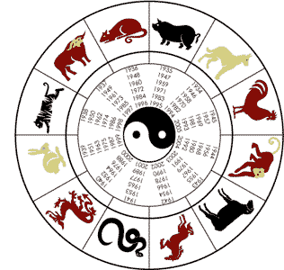
This is something that we call a Chinese zodiac. Depending on what year in which you are born, you can be one of the following animals: a rabbit, a tiger, an ox, a rat, a pig, a dog, a rooster, a monkey, a ram, a horse, a snake, or a dragon. 2010 is the year of the tiger, followed by the rabbit, and then the dragon etc.
Chinese also have a different way of writing. Instead of letters, symbols represent words. Here is an example.
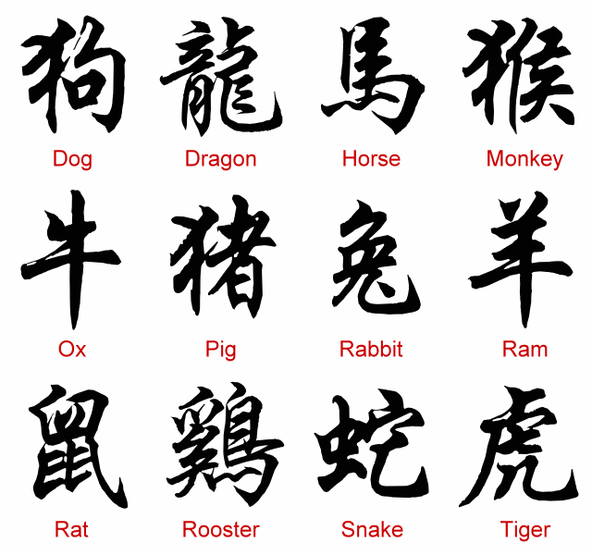
The Chinese calendar is also very different from ours. It is based on the moon and every new moon is a new month. Chinese New Year is usually sometime in February, and it’s normally a different day than the year before.

Chinese tradition
Chinese also have different traditions, for example, on Chinese New Year, it is traditional to shoot off firecrackers, to send out the old year and welcome in the new. On the stroke of midnight they open doors and windows to allow the old year to flow out. Many people also abstain from eating meat on the first day of Chinese New Year, as it is believed that it will ensure a long and happy life. Whole fish represent togetherness and abundance, and chicken with legs and head still intact represent prosperity. One other Chinese tradition and belief is that the entire house must be cleaned before the New Year’s Day. They must put away all cleaning equipment on New Year’s Eve. The house must not be swept on New Year’s Day for fear that the good fortune be swept out.
Red clothing is normally worn for special occasions, as it is the Chinese lucky colour.
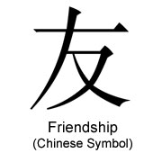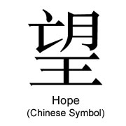

THE END
+++++++++++++++++++++

Sports in Canada

Hockey

There many sports in Canada that are very popular but the MOST popular sport is hockey! In Ottawa there is a hockey team called the Ottawa Senators. The Ottawa Senators are 1 of 30 National Hockey League (NHL) teams. These teams are in Canada and the United States of America. There are six Canadian teams and twenty-four teams in the United States of America (USA).

Team Canada hockey logo Ottawa Senators logo

In 2010, Canada will host the Olympic winter games! There are many questions on who will make the Canadian Olympic team? There are 2 candidates from Ottawa one is Jason Spezza and another is Mike Fisher!


Mike Fisher Jason Spezza

Some hockey rules are:
1. You shouldn’t take a penalty. Some penalties are hooking, boarding, and high-sticking.

2. You cannot have a kicking motion or/and throw the puck into the net.

3. There are many positions such as centre forwards, right wings, left wings, right defense, left defense and goalies.

4. When you shoot the puck into the opponent’s end when you are at your own side and it doesn’t go off of anyone and the opponent touches the puck before you do it is icing and you cannot have a line change.

5. You cannot be offside.

Thank you for reading my iearn project☺

Soccer

Soccer is a very fun sport. The equipment required is shin pads, cleats, long socks, shorts and a shirt with short sleeves. This sport requires some good ball control. The point of the game is to score more goals on the other teams net.

I will tell you some rules to play soccer and prevent yourself from getting fouls.

- At the start of the game, both team captains go to see the referee at the middle of the field. The referee will flip a coin and then ask you if you think it is heads or tails. If you guess correctly you get to choose your side of the field.
- One of the teams start with the ball in soccer you can only use your feet if you touch the ball with your hands you get a foul. A foul is when the other team gets to have a free kick.
- You must play in the field because if the ball goes out of the field the other team gets a throw in.
- When your team has the ball, you try to score on the other teams net. If you score on the other teams net your team gets a point. At the end of the game, the team with the most points wins!
- If your team doesn’t have the ball you try to defend your net from getting scored on.

In soccer there are many positions that you can play such as striker, right wing, left wing, centre mid, right defense, left defense and goalie.
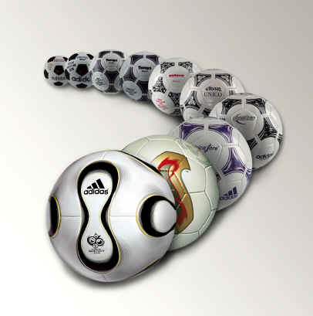 Soccer ball getting kicked. Some soccer balls lined up. Soccer ball shot on net.

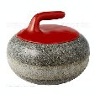
Curling

Curling is more than 500 years old. The earliest written record of curling are groups of people sliding stones on frozen ponds in competition. They are found in Scotland and date back to 1541. Curling is also the official sport of Saskatchewan.


At the Olympic Winter Games, curling consists of two events: a women’s tournament and a men’s tournament. Each tournament starts with 10 teams. Two teams play against each other at a time. The game is played on ice, and the two teams take turns sliding (called throwing) 19.1-kilogram stones, called rocks, towards a series of rings or circles, called the house. The white spot at the center is called the button.

Each team consists of four positions: lead, second, third, and skip. The skip is the leader, and calls the shots. The leads flip a coin at the beginning of a game to determine which team gets the advantage (last rock). The thirds replace the skips when they throw and post the score at the end of each end. Each position throws twice in a row, and in that order. Whoever not skipping (calling the shots) or throwing will sweep for their own team.

Usually the teams are Red and Blue or Red and Yellow.

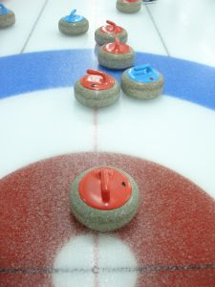
The object is to get the stones as close to the center of the rings as possible. One game consists of 10 ends. During each end, each team throws eight rocks, two per person and 16 altogether. They take off of black things called hacks. Team members sweep the ice in front of each stone to control the stone’s direction, known as its curl, and its speed. The team with the most points: more stones closer to the center of the rings than the other team, at the conclusion of the game, is the winner.

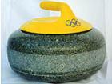
In the picture above, red scored 2 points, with a blue blocking any rocks behind it. Amongst the rocks behind the blue and still in the house are 2 rocks. One is a biter, meaning that it is touching the edge of the house. Behind them are guards. They don't count for points, but they are in play.

Wheelchair curling is about the same, but there are no sweepers or hacks and eight paralympic ends.

There is an inter-provincial curling tournament in Canada that recently got completed. Here is news about the final teams:

Nova Scotia, skipped by Mark Dacey of Halifax, claimed first place after the completion of the round robin on Friday morning to advance to the final of the 2010 Canadian Mixed Curling Championship. Ontario, which completed its round robin last night, goes to Friday's semi-final, to meet the winner of a third-place tiebreaker between British Columbia and Manitoba. Manitoba beat Saskatchewan 7-6 while British Columbia was a 6-4 winner over Alberta, both having 8-3 records.

The host province, Ontario, has won the championship twice - in 1986 by skip Dave Van Dine in Kamloops and by skip John Epping at the 2006 edition in Whitehorse, while Nova Scotia has won six Mixed titles since the championship began, 1964 in Toronto. They most recently won in 2003 by skip Paul Flemming in Abbotsford, British Columbia.

Friday afternoon, at the Burlington Golf and Country Club, British Columbia, skipped by Jason Montgomery of Duncan, managed a 10-9 extra end win over Manitoba, skipped by Dave Boehmer of Selkirk.

The first two teams will battle for the title, in the 47th edition of the Canadian Mixed Curling Championship. Ontario, skipped by Mark Bice of Sarnia, had no trouble disposing of British Columbia, 12-3
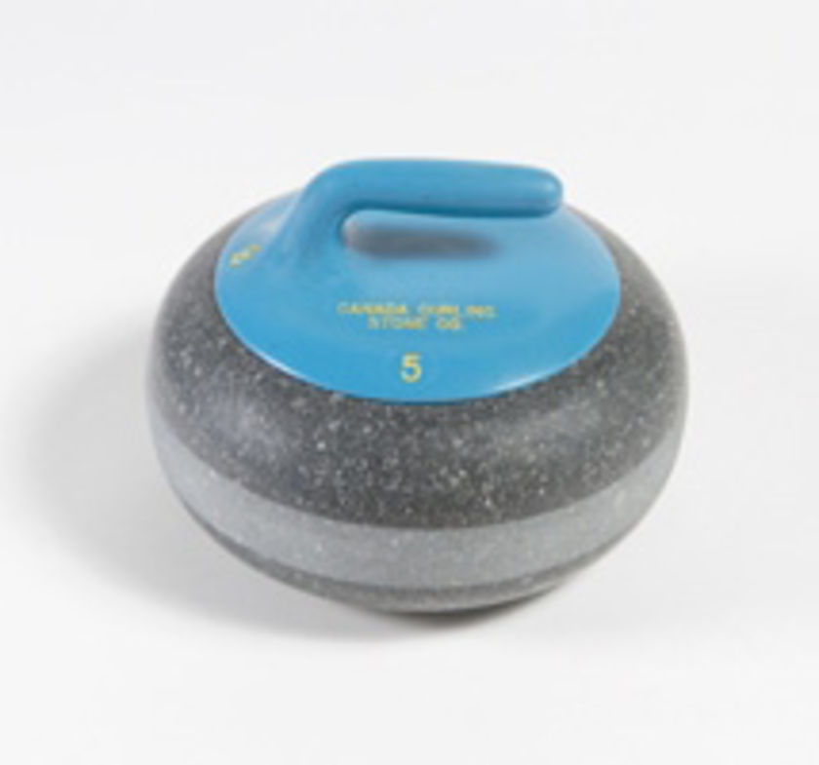
The 47th edition of The Mixed was a exiting game, as proved by shooting percentages. Nova Scotia fired 86%, while Ontario came in at 78%. The lead changed hands on four occasions, with a deuce in the eighth end by Dacey.


Two players from the Nova Scotia team will also represent Canada at the 2010 World Mixed Doubles Championship, slated for April 16-24, 2010 in Chelyabinsk, Russia. Dacey confirmed shortly after the finals that he and Heather Smith-Dacey will be Canada's representatives. Kevin Martin and Cheryl Benard will be Canada's representatives at the 2010 Olympics.

DOWNHILL SKIING

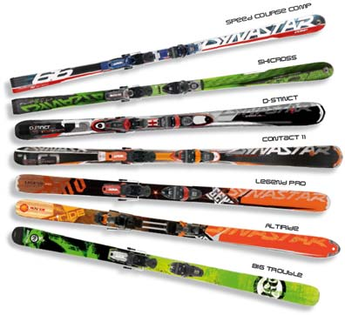
Downhill skiing is the sport of sliding down snow covered hills on skis.

Skiing was originally a practical way of getting from one place to another in packed or crusted snow. In Norse Myth, skiing was invented by Skadi, the snowshoe goddess. The word "ski" entered the English language from Norwegian in 1890. Previous to that time, English speakers considered skiing to be a type of snow shoeing. In countries where loose snow dominates, the indigenous population developed snowshoes that did not slide rather than skis which do.

Some people like to ski at ski resorts where you’ll be safe from avalanches while others like to ski on powder snow where avalanches CAN happen. If you ask me, I prefer skiing on powder snow. 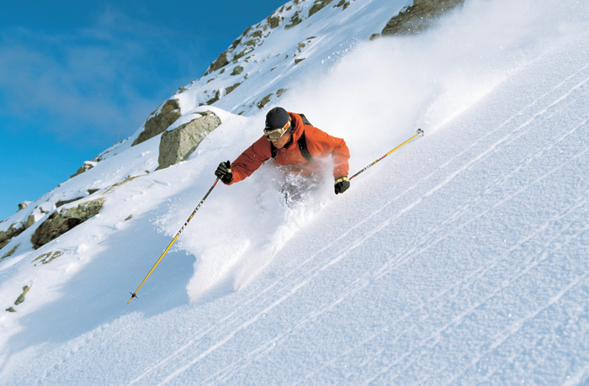(Not me☹)

This year in 2010, there will be the Olympic Games in Vancouver. Assuredly, there will be alpine skiing. I hope you cheer for Canada! Hope you liked my skiing information☺.

BASKETBALL

Basketball is a very popular sport in many parts of the world. However in Ottawa, the MOST popular sport is still hockey. Basketball requires very good mind control, quick reflexes and speed. And that is why I like playing Basketball.

There are many rules, very complicated ones but for kids playing, below are the basic Basketball rules:
- The player must dribble the ball with one hand while moving both feet.
- If the player touches the ball with both hands therefore, he or she can only move with 1foot.
- Once a player stops dribbling they cannot start another dribble.
- The ball must stay in bounds or else the other team gets the ball.
- When a player dribbles, his hand must always be on top of the ball.
- Once the offensives team crosses half court, they cannot go back to there own court.

If your team fouls, your team may receive the penalties below:
- The other team gets one or more free throw(s).
- The player can be suspended and sent out of the whole game☹.

Basketball is an easy and fun sport. But I do not like to play competitive basketball, too much pressure, stress and pushing around! I like to play with friends at nearby parks. Sometimes, we do NOT follow the rules and just have fun and laugh. We just need 3 friends to play basketball though the more people the better. We split into 2 teams and we shoot to the same net. After an hour or the game, we take a break and drink a can of cold soft drinks. Nothing is better than that☺.

There is also a NBA (National Basketball League) Tournaments every once in a while.

So there is no surprise that my favorite basketball team is the Harlem Globetrotters (http://www.harlemglobetrotters.com/) because they play entertaining basketball game. They perform worldwide tours and I am looking forward for them to come to Ottawa soon…☺

My favorite team The Harlem globetrotter’s ball Amazing move-Slam Dunk

++++++++++++++++++++++++++++++++++++++++++

Traditional and modern life in Canada

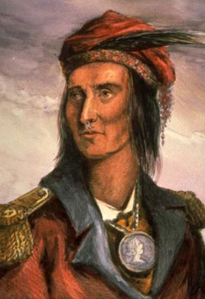
Native Americans
Tecumseh was a native chief who fought to defend Canada during the war of 1812.


By A. Mihailov

Canadians do not have any particular cultural or visual distinction from other countries or cultures because we are a country of immigrants. There is few ‘traditional’ dress or food These days there are increasing numbers of immigrants to Canada have given us a colorful face and many traditions and customs to make us a very multicultural country. Because Canada is kind of multicultural country we can’t list all the modern customs or the column would be way too long. Therefore, I am only going into detail about the Native Americans.

Native Americans were the people who inhabited North America. They first crossed into our continent from Asia and modern day Russia to Alaska United States because of a land bridge connecting our two continents during the most recent ice age, or at least that’s the theory. From there they trickled into the inland. They believed that a number of gods controlled there world, like the Egyptians they had gods of harvest, a god of sun a god of rain…etc. These Native Americans divided themselves into tribes, like the Iroquois or the Sioux, some tribes were warlike, others were more focused on agriculture, some were constantly on the move and some built cities with many people. They started out trying to survive but they began to flourish into a diverse culture. Some lived in places like Nunavut in the arctic, some lived on the great plains of Alberta and Saskatchewan, and some lived on the western shores of Canada in British Colombia.

Native Americans were scattered all over the continent in the Arctic they lived in igloos that where made of ice and snow. The arctic was a hard place to live, mostly a vast tundra and freezing cold. This was a treeless world, in the summer there was enough heat for some shrubs and lichen but other than that, this place was as barren as a desert. The people there where called the Inuit and the Inuvialuit. They relied on hunting to supply them with food, they hunted animals like Caribou and Seals and many small animals like ground squirrels these they hunted with great art, they developed a type of harpoon called a Toggle Head Harpoon it was destined so that the head of the harpoon entered the body of the seal the main body of the harpoon pulled away the tension on the cord it lodged the harpoon into the animal’s body by turning it sideways. They hunted the caribou in whole herds, a group of them would wait near the end of a trail marked by small stone statues called Inukshuks that where meant resemble human profile (they don’t really look anything like humans but they were supposed to fool caribou who can’t really tell the difference) the other group would chase the caribou down through the Inukshuks. When the caribou are in sight the men waiting near the end get out of the way of the caribou, then throw their spears. They ate what they hunted down, sometimes they left food caches (hiding places) behind, these caches where in case they happened to come that way again they would be able to eat the food. They used the skin of the animal to make warm clothing, wich they certainly needed in their climate. Both men and women wore a warm shirt with pants and special boots called mukluks, in winter they added a parka too keep extra warm, in the winter survival depended on staying warm, the clothing was made with caribou skin that had two lairs of thick hair to keep them warm. In the summer they used the same things with one exception, it was generally made with sealskin, because of the oil in the skin it was water repellant, the skin was ideal for kayakers who wanted to stay dry.

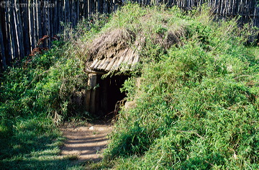
The Iroquois and the Algonquin were two other types of Native Americans that lived in Canada. They lived from southern Ontario to the Maritimes. The Iroquois lived in large villages in houses called longhouses that held five or six families, in some large villages there would be up to one hundred of them. The Iroquois were strategists. They would build their towns out of the enemy’s reach. It would be placed on a hilltop or in a swamp, but always near good farmland. Surrounding the houses there would be three layers of walls fashioned from pointed sticks palled palisades. Most often there would be one entrance to a village so that it could be easily guarded. They were skilled farmers, they harvested an abundance of food which included beans, squashes and most of all maize, this was a type of corn harvested in abundance by the Iroquois. They developed a complex government, their where 11 tribes including the Erie, Huron, Wendat, Tionontati, Haudenosaunee, Tuscarora, Mohawk, Oneida, Onondaga and Seneca. They were probably most famous for the league of six nations. Long before Canada’s confederacy in 1867 five of the Iroquois tribes allied in a military and political alliance. These tribes where the Mohawk, the Cayuga, the Oneida, the Seneca, and the Onondaga. This alliance, started in the fourteenth or fifteenth century then in the seventeen hundreds the Tuscarora joined the alliance. Each of the nations chose a sachem or chief to represent them. Although the sachems it was the matron or the clan mother who put them in power thus the women’s opinion mattered, the league was a lot like our house of commons here in Canada, the representative was chosen to represent an area and then all the representatives meet to discuss a matter of important to the who group or in this case league. The council was held in Onondaga just south of Lake Ontario near what is now New York. The most amazing thing about the Iroquois was the Gayanashagowa or great law of peace, this is a story in which there was a time of constant war, in this time to men managed to unite five nations to come to the great law of peace. The Algonquin lived near lake near Lake Superior and Lake Huron and moved a little bit into Manitoba very much like the Iroquois they planted plants like corn beans and squash but most survived on the food they could hunt or trap in the wild. Wild rice was very important in the diet of some groups. The Ojibwe people harvested rice, a grass that grows in marches or lakes. They hunted as well, animals like moose, caribou, elk and deer, they also gathered food like berries. The women would make the clothing out of the hides of the hunted animals, they would first remove the hair on the skins and then scrape off the leftover fat, then they would soak the hide, stretch it out and smoke it to tan it and then sew it all together.
DID YOU KNOW?!
One of the Algonquian tribes was named Ottawa, that is the city where our school is build in.

Next are the people of the west coast. They lived on the coast of British Colombia. They lived in rough climate, the cost was broken up into bays, inlets, deep channels and islands. Food, and building resources were abundant in this area so they build large houses out of wood they are most famous for the totem poles that they carved out f trees, there was a different design for each family. Some of the houses in which these families resided were up to 160m x 20m in size. They ate things like Goats and deer, bears, beavers but most of all fish, living on the coast gave them an abundant supply. Raccoons and waterfowl were common to, also they hunted seals whales sea lions sea otters…etc. they built canoes by hollowing out tree trunks. They were very artistic and accomplished at making boxes, making rope, weaving and carving ornate trinkets like hats or carvings. They had parties called potlatch in which they would give away gifts to show their power, they did this instead of fighting.

Next are the people of the plains or plains Indians, they lived on the prairies of the modern day provinces of Alberta, Manitoba and Saskatchewan. They were Nomadic, constantly on the move, they followed the buffalo herds (the former was their main food source). They lived in tipis, a wooden frame with animal skin stretched over top, the tipis were made, owned and setup by the women. They ate primarily buffalo or Bison, they ate the flesh and made many things with the rest, as you will see they were truly dependant on buffalo; they used the buffalo to make their homes, their weapons, containers, pots, pans and clothing. they wore headdresses made of feathers that they wore in battle, the rest of the clothing however was made of buffalo hide.

Well as you can see even in the past we all were unique. And we will continue to be far into the future…

Modern life clothing by Athena

In Canada there are four seasons: winter, spring, summer and autumn.
In Canada, many people wear lots of different styled clothing because we all come from different places. Many people wear sweaters in winter if they come from hot places like Singapore and China. This is because they are used to hot weather around and feel more comfortable in heat. Typically sweaters in Canada are knitted from wool and very simple, but there are some variations in neckline shapes etc. (all in dark colours to absorb what little heat there is). Other people from colder places can just wear a thin shirt with pants, no sweater needed; to them it is not as cold as where they lived before. Thin shirts here are the same basic shape, long sleeves and a round neckline. To lessen the bore, girls buy sparkled, embroidered and beaded shirts while boys get shirts with gory signs and images.
In the summer, we wear t-shirts and tank tops with shorts, skirts and skorts (skirts with shorts underneath), usually in light colours to avoid absorbing a lot of heat.
In the spring we wear thinner sweaters with a tank top or t-shirt underneath, and pretty much the same in autumn.

Modern foods by:Flora
In Canada, we eat many different types of foods from caribou meat to Saskatoon berries. That's because we are from different countries and we have different cultures. For example chinese people eat a lot of rice.

So people in Canada eat lots of types of foods like seafood, savoury food, game birds (?!) , sweets, prepared food and beverages.

People who like seafood often come from countries by the sea such as Japan who like to eat fish, shrimp, lobster, crab, and mussels. To make it simpler, some people eat sushi. Sushi is usually made of seaweed, rice, and fish or any other seafood. Lots of people like to eat seafood.

Savoury food, basically means meat and subsitutes. Many canadians eat savoury food, unless you are a vegetarian. Savoury food consists of roast beef, roast turkey, montreal smoked meat (it's true, it's good!), tourtière (meat pies), chicken, and other subsitutes. Savoury food is very popular and almost everyone eats meat.

Game birds (people shoot them and then cook and eat them), in my opinion, should be illegal because I think it's mean to kill birds. But First nation cultures, they eat venison. Seal meat is even eaten in provinces like Newfoundland and Labrador, the Canadian north, and some maritime propvinces (the east coast of Canada)! Partridges and ptarmigan are regularly hunted too. I hope someday it will be illegal to hunt these animals.

Sweets are very much eaten at this time of the year because on October 31st, called Halloween. On this day, many kids go door to door to ask for candy. They dress up into different costumes on Halloween. After going trick-or-treating, they get lots of candy, it could last the whole year! But through out the year, many people still eat litte treatslike beaver tails (yummy!), pies, maple syrup, and candy apples. Many people like to loose weight though.

Prepared food are for people on the go. For example, we buy pizza that we just have to heat up in the stove for about 10 min, it's done and dinner has finished. Coffee, cereal, anything that can be done in a couple of min, could be prepared food. Even chocolate bars are considered prepared food, because we just have to unwrap the wrapper. Prepared food are popular if you look at the size of th population, so many people like to just to eat prepared food.

So, you can see that today in Canada we eat many types of foods, way out of your imaginations. Some attract chinese, others, french. Hope you learned something and try some Canadian foods!

Traditional Lives By Melinda

Elders pass on their knowledge of spiritual and historical stories, medicine and teach important lessons in life.
The children would do their share of work, sorting seeds and peeling corn. They would also help care for the elders, bringing them food and obeying their wishes. Other times they just had to humour them, listening to their stories and helping them remember irrelevant things.
Able adults would work in fields, hunt for food, maintain the house, lay out animal hides to dry, repair everything.

Modern Lives
Now elders still pass on their stories, but they teach less. They fetch their own food and sometimes work. A lot of the times they just go live in a retirement home and do pretty much nothing except for the occasional walk and talk. They would receive visitors like grandchildren and children, but are mocked when telling a story or concern.
Children go to school, do homework and sports on the weekdays for the most part, and then they play computer or video games the whole day on weekends. Sometimes they make ‘play dates’ with other children, but most of the time they play by themselves or with a sibling.

How life has changed

By Sheena: Over the last 500 years, Canadian life has changed a lot. 500 years ago, there were trees everywhere, and life was very hard. The people who came to Canada hoped for a better life, or were fleeing prosecution from the English crown, yet they were sometimes disappointed. Many people were used to going to stores for their things and having lots of neighbours. They were used to houses made of bricks, and plenty of food for the winter, yet the reason they came was to start a new life as someone other than a peasant.

When they received letters about a new land, they rushed to Canada. The journey was harsh, and the weather rocked the boat. Since the journey took a few weeks, many people got sick. The reason they got sick was because most of the people on the boats were peasants, and they brought many illnesses on the boat. Since the space was very crowded, a lot people had to sleep on the floor. Finally, when they reached Canada many people rushed off the boat.

Some people tried to make their lives the same, but in Canada there are harsh winters, and many people weren't used to it. They made toys for their children, so that the children would be happy.

Their toys were simple. Instead of the electronics we have now, they had wooden toys. The children thought they were awesome, but if they saw the toys we have now, they wouldn't be so thrilled getting their toys.Kids couldn’t enjoy toys that much though, because kids had to work.

Pioneers had many different tasks. They had to sew their own clothes, make their own food, soap, beds, etc. The boys were responsible for catching food, cutting down trees, and shaping them. The girls were responsible for making butter, food, clothes, picking berries, etc.

They worked a lot. Most boys couldn’t go to school because they were needed at home. They would also have to go to many fairs and sell their animals. They often got sick at the fair, and they didn’t have the medicine we have now. Many types of illnesses we think are minor now, back then they thought were dangerous. Many people died, and the conditions they were in didn’t help much. It would be too cold in the winter, too many bugs in the fall, too wet in the spring, and too hot in the summer. They had to wear just the right amount of clothing.

Back then, the girls wore big puffy dresses, and usually wore a bonnet. The boys wore things that look like what we wear today, like trousers and shirts. The clothing was very itchy, and they got dirty easily.

Many of the pioneers would probably love living the life we are now.

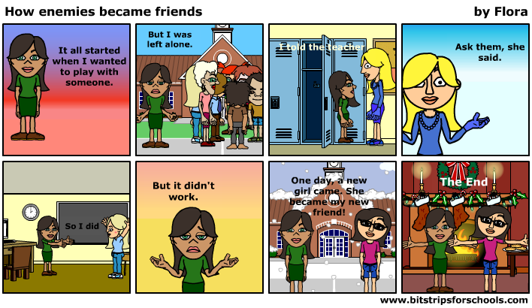
+++++++++++++++++++++++++++++
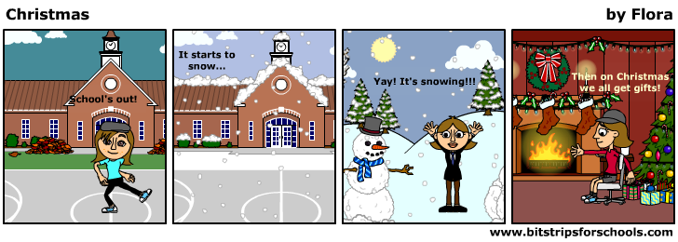
Comics and games
By: Flora Maze


Holidays
X | D | U | Y | T | P | P | H | L | W | C | B | Z | F | G | W | W | T | G | G
U | E | Q | H | K | T | H | Q | M | E | K | A | V | P | F | P | H | M | V | C
A | A | Q | B | H | R | R | G | L | O | G | H | N | M | C | I | N | G | O | X
A | K | I | F | N | V | I | E | R | N | R | N | H | D | I | E | F | B | M | X
I | G | J | Z | H | F | B | N | E | W | Y | E | A | R | L | V | E | S | H | W
E | G | L | H | T | R | A | D | I | T | I | O | N | S | F | E | D | V | C | K
G | U | P | S | A | M | T | S | I | R | H | C | U | N | W | E | F | U | Y | A
R | R | N | T | E | N | N | D | B | V | U | D | K | C | I | T | Y | I | U | E
M | A | I | N | R | O | G | G | F | Q | P | L | K | L | T | D | A | Y | T | M
U | O | T | E | W | W | I | U | E | H | S | G | A | I | M | I | W | I | B | F
N | S | W | S | P | P | X | X | I | G | T | I | H | M | Z | G | W | S | N | V
S | X | I | E | Y | S | I | L | V | G | C | H | W | G | W | B | S | S | V | E
S | X | R | R | O | O | Y | J | B | L | L | M | B | N | C | E | H | D | Q | W
W | Y | W | P | O | X | T | S | F | N | B | M | P | T | N | S | F | D | C | C
Y | M | Q | E | Y | A | P | O | F | G | B | D | U | Q | S | V | X | B | L | F
P | B | S | R | H | S | T | X | B | M | K | D | S | L | U | I | K | U | S | Z
J | K | S | Q | W | Z | C | H | N | C | L | K | Y | T | D | W | H | Y | H | I
I | V | Y | V | V | S | J | O | Y | Q | T | Z | C | C | C | F | V | V | J | M
G | E | T | B | K | N | P | F | D | X | Z | S | A | C | Z | H | T | R | D | M
O | O | Z | S | Y | R | Z | O | U | A | S | O | O | P | D | S | Y | G | K | V
Word Bank
ANGEL | CANDLE | CELEBRATION
CHRISTMAS | DINNER | EVE
GIFTS | HANUKKAH | NEWYEAR
ORNAMENTS | PRESENTS | SNOW
STAR | TOYS | TRADITIONS
TREE | WREATH

CHRISTMAS


G P D H O C S
I R E P R H N
N E C L N R O
G E E O A I W
E N M D M S R
R A B U E T E
B C E R N M E
R Y R N T A D
E D S E S S N
A N Y E E T I
D A A R N R E
N C Y G U E R
R E D T F E S

FUN
YAY
SNOW
CANDYCANE
CHRISTMASTREE
DECEMBER
GINGERBREAD
GREEN
ORNAMENTS
RED
REINDEER
RUDOLPH

__ __ __ __ __ __ __ __

 | - |  | +
+ |  | + |  | +
 | - |  | -
X |  | + |  | -
 | X |  | +

Try to fill in the missing numbers.
Use the numbers 1 through 9 to complete the equations.
Each number is only used once.
Each row is a math equation. Each column is a math equation.
Remember that multiplication and division are performed before addition and subtraction.

++++++++++++++++++++++++++++++++
Music Reviews

It's a Party in the USA!(or Canada)
By Melanie
Miley Cyrus, star of the hit Disney Channel show Hannah Montana released her latest song, Party in the USA in August (2009). It is about most likely her own experience in her Hollywood career, first arriving in Hollywood, California and being swept away by the craziness of it all, especially compared to her home in Tennessee. It shows how exciting it was to see all the stars and actually be one of them and how she felt so far from home in a busy, chaotic city.
Party in the USA is not inappropriate nor does it have any swearing, so it could be recommended to anybody who likes the kind of fast-paced “modern” music, mostly girls since most boys do not like Miley Cyrus, or, at least pretend not to. Of course if you like some of Miley's and/or Hannah Montana's songs you would probably enjoy this song; it's very “Miley”, it's hard to imagine anyone singing it but her, as she kind of has her own style.
This song caught everyone's attention from the very beginning, especially when Miley sang it at the Teen Choice Awards for the very first time on August 10, 2009. Some Canadians would say that the USA part kind of makes them dislike the song, though they like it anyway. Some would say they like it, period. Despite the fact that it's a party in the USA it was in the top ten songs in Canada for quite some time. Miley probably gets her musical talents from her dad, Billy Ray Cyrus, a hit country guitarist. It's hard to believe that she is only 18!

Song: Replay
Artist: I.Y.A.Z
Type: Pop

By: Athena
The song Replay is about this guy who saw this really pretty girl at the mall but he was scared to talk to her. Then she started getting closer so the guy hoped that she would give him a chance if they saw each other. Then she started talking to him and so now they’re “together”, even if the girl has to go all the around the world, they still talk to each other on the phone. When the guy thinks of her it’s like the girl is a song and his ipod is stuck on replay and just keeps on playing on and on again. When the girl steps into the guy's life, he starts different things and starts cooking all sorts of things for the girl.

This song has a very catchy and interesting tune, that is why many people like this song. All the words are appropriate so people from the ages grade 4 and up would probably like this song. Replay is not really a heavy metal song so people who like soft, flowing songs that have a beat would like this song, other people who prefer songs from an orchestra wouldn't really like this song. Some people don't like this song because they don't like romance songs. At first, if you listen to this song you might not find it very interesting but once you listen to it more you will like it a lot more than you liked it before. You should listen to this song right away!

Here are the lyrics to sing to:

I.Y.A.Z.

Replay lyrics

Artist: I.Y.A.Z. lyrics
Album: Other Song Lyrics
Title: Replay

Lyrics to Replay :
(Prod by J.R. Rotem)
Shawty's like a melody in my head
That I can't keep out
Got me singin' like
Na na na na everyday
It's like my iPod stuck on replay, replay-ay-ay-ay (2x)
Remember the first time we met
You was at the mall wit yo friend
I was scared to approach ya
But then you came closer
Hopin' you would give me a chance
Who would have ever knew
That we would ever be more than friends
We're real worldwide, breakin all the rules
She like a song played again and again
That girl, like somethin off a poster
That girl, is a dime they say
That girl, is a gun to my holster
She's runnin through my mind all day, ay
Shawty's like a melody in my head
That I can't keep out
Got me singin' like
Na na na na everyday
It's like my iPod stuck on replay, replay-ay-ay-ay (2x)
See you been all around the globe
Not once did you leave my mind
We talk on the phone, from night til the morn
Girl you really change my life
Doin things I never do
I'm in the kitchin cookin things she likes

We're real worldwide, breakin all the rules
Someday I wanna make you my wife
That girl, like somethin off a poster
That girl, is a dime they say
That girl, is the gun to my holster
She's runnin through my mind all day, ay
Shawty's like a melody in my head
That I can't keep out
Got me singin' like
Na na na na everyday
It's like my ipon stuck on replay, replay-ay-ay-ay (2x)
I can be your melody
A girl that could write you a symphony
The one that could fill your fantasies
So come baby girl let's sing with me
Ay, I can be your melody
A girl that could write you a symphony
The one that could fill your fantasies
So come baby girl let's sing with me
Ay, na na na na na na na
Na na na na na na
Shawty got me singin
Na na na na na na na
Na na na na na na na
Now she got me singin
Shawty's like a melody in my head
That I can't keep out
Got me singin' like
Na na na na everyday
It's like my iPod stuck on replay, replay-ay-ay-ay (2x)

“Fifteen” by Taylor Swift is a song that describes the first day of high school. The song is a true story about her first day. The music video is just plain awesome, it shows all of the things that she sings about. Like when she sings about a redhead named Abigail it shows a real redhead. The song is incredible because it is all true. In the song she sings about Abigail breaking up with someone. But the real incredible thing is that she sings that part with feeling and she even had tears in her eyes. Taylor Swift did me a favor by writing and singing that song because…well…that ☺ ☺ ☺ ☺ ☺
by Simona Kobrinsky.

You belong with me
You belong with me is a popular song in Canada even though it’s old everybody still likes it a lot. You belong with me is by Taylor Swift who wrote a lot of other songs to. Some of the songs she wrote are: Love Story, Teardrops on my guitar, Breathe, Fifteen, Forever and Always, I’d Lie and a lot more.
Here is the lyrics for you belong with me:
You're on the phone with your girlfriend, She's upset
She's going off about something that you said
She doesn’t get your humour like I do
I'm in the room, its a typical Tuesday night
I'm listening to the kind of music she doesn’t like
And she'll never know your story like I do
But she wears short skirts, I wear t-shirts
She's cheer captain and I'm on the bleachers
Dreaming bout the day when you'll wake up and find
That what you're lookin for has been here the whole time
If you could see that I'm the one who understands you
Been here all along so why can't you see?
You belong with me
You belong with me
Walkin the streets with you in your worn out jeans
I cant help thinking this is how it ought to be
Laughing on the park bench thinkin to myself
Hey isnt this easy?
And you've got a smile that could light up this whole town
I havent seen it in awhile, since she brought you down
You say you find I know you better than that
Hey, Whatcha doing with a girl like that?
She wears high heels, I wear sneakers
She's cheer captain and I'm on the bleachers
Dreaming bout the day when you'll wake up and find
That what you're looking for has been here the whole time
If you could see that I'm the one who understands you
Been here all along so why can't you see?
You belong with me
Standin by, waiting at your back door
All this time how could you not know that?
You belong with me
You belong with me
Oh I remember you driving to my house in the middle of the night
I'm the one who makes you laugh when you know you're about to cry
I know your favorite songs and you tell me about your dreams
I think I know where you belong. I think I know it's with me.
Can't you see that I'm the one who understand you?
Been here all along so why can't you see?
You belong with me
Standing by or waiting at your back door
All this time how could you not know that
You belong with me
You belong with me
Have you ever thought just maybe
You belong with me
You belong with me
You belong with me is by taylor swift. This song is about a normal girl. She has a crush on her friend boy, but her friend has very girly and very pretty girlfriend. She is keeping this a secret. In her thoughts she always thinks : “you got the wrong girl.” Finally her friend boy realizes she is the one for him and breaks up with his girlfriend. This song is appropriate for Kids from grade 5 – 8 would be appropriate to listen to this song.

I know this because the title of this song is you belong with me.That means she likes him.
In the lyrics it says: “Hey what are you doing with a girl like that.” That means you have the wrong girl. In the lyrics it says: “ Do you know who you belong doyou know its with me ” That means she wants him.

The best part is the tune, the voice of Taylor swift, and the words. Basically everything is the best part. A person my age would sing along with me, and would like it. A boy would still like but a girl would love it.An older person would say nothing or say: “turn it down” or maybe they would say: “Turn that racket down.” This song is not to fast or to slow. The words in you belong with me are meaningful, there not just any random words in you belong with me.

Tik Tok
By: Celina Chen

Tik tok on the clock! This song is a blast on the radio. Kesha Spears is the artist
and she is super extraordinary. She was born on March 1st, 1987 and lives in Los Angeles, California. Tik Tok is her first single in her life.

The lyrics of this song is here:

Wake up in the morning feeling like P Diddy
(Hey, what up girl?)
Grab my glasses, I'm out the door
I'm gonna hit this city (Lets go)
Before I leave, brush my teeth with a bottle of Jack
Cause when I leave for the night, I ain't comin back
I'm talking - pedicure on our toes, toes
Trying on all our clothes, clothes
Boys blowing up our phones, phones
Drop-topping, playing our favorite cd's
Pulling up to the parties
Trying to get a little bit tipsy
(Chorus)
Don't stop, make it pop
DJ, blow my speakers up
Tonight, Imma fight
Till we see the sunlight
Tick tock, on the clock
But the party don't stop, no
Woah-oh oh oh
Woah-oh oh oh (x2)
Ain't got a care in world, but got plenty of beer
Ain't got no money in my pocket, but I'm already here
And now the dudes are lining up cause they hear we got swagger
But we kick 'em to the curb unless they look like Mick Jagger
I'm talking about - everybody getting crunk, crunk
Boys trying to touch my junk, junk
Gonna smack him if he getting too drunk, drunk
Now, now - we goin' till they kick us out, out
Or the police shut us down, down
Police shut us down, down
Po-po shut us -
(Chorus) (x2)
DJ, you build me up
You break me down
My heart, it pounds
Yeah, you got me
With my hands up
You got me now
You got that sound
Yeah, you got me
DJ, you build me up
You break me down
My heart, it pounds
Yeah, you got me
With my hands up
Put your hands up
Put your hands up
Now, the party don't start until I walk in
(Chorus) (x2)

This song has been around for about a month or two but on www.youtube.com it is a real hit. It makes you feel joyful when you are depressed or it can be your entertainment when you are fed up with something that makes you sorrowful in a way. Kesha likes when you have spirit and not when you are lethargic or inactive.

Now what did you think of that? Probably somewhat tipsy or fascinated by this perfect song. Well now that you know the song, you might as well go on the computer a listen to TIK TOK!

++++++++++++++++++++++++
Book Reviews

The Lightening Thief by Rick Riordan
Reviewed by Georgie Kourkopoulos.
Today, I am going to review the book “The Lightening Thief” by Rick Riordan. I hope that after reading this review, you are encouraged to read this book.
It’s about a twelve year old boy called Percy Jackson who leads an abnormal life. One day on a field trip, one of his teachers attacks him and as it turns out, she’s not even human. Percy finds himself taken away to a special camp for demi-gods, children of the Olympian gods. He is the son of one of the 'Big Three' (Zeus, Poseidon and Hades) who aren't supposed to have kids! And what's worse, he's getting framed for stealing Zeus's symbol of power, the Master Bolt. Percy and his friends are taken to the Underworld on a quest to find the Master Bolt before the gods can declare war against one another. It's a thrilling journey through the modern USA, with ancient monsters at every turn.
The main idea in this book centers on 'trust'. Since Percy is still trying to fit into his new life, he has to trust people to help him and accept him. Many stories center on trust as well, because it is necessary to bring people together as friends. At some points in this book, trust is misplaced, and Percy nearly dies . . . again.
The book has just enough action to keep you entertained, and a small enough amount not to dominate the book, making it perfect for any kind of reader.
The characters are likable, and very believable. Their personalities mix together to bring the book to be an interesting story, filled with real life problems, and new ones, like whether you should take a taxi or a bus to get somewhere, and which one would make it harder for a monster to track you down and kill you.
The suspense will keep you reading until the very end, with questions that come from confusing answers. The story never lets you get bored, constantly taking things you thought you were sure about and twisting them so you aren't quite so sure anymore.
It's also written in a younger person's perspective, so teens can relate to the text better.
It is a fantastical blend of myth and modern life. Young teens would enjoy the scenes that Riordon weaves in his tales of Percy and his friends, making the reader really question their certainty about whether the Olympian gods exist because of the way the author incorporates real places and legendary monsters into one way of life. You'll find yourself looking for things that you never believed could be there before you read this book.
Finally, we come to my point: this book is a very good book, for all this and more. It’s guaranteed to be fun and entertaining! Hope you decide to read the book after this review.
~Georgie Kourkopoulos

The Hunger Games
Review by Jennifer Cross
There are many great books in the world's literary history. Harry Potter, The Chronicles of Narnia, Charlotte's Web. But world has readied itself for some newer ones. One of the best is The Hunger Games. It has practically no faults. Any reader from preteen to adult and who's the type for a rush of suspense and surprises will be intrigued by this mesmerizing literary masterpiece by Suzanne Collins.
A great place to start is at the story of Panem, the capital of the future. After a devastating World War lll, the world was in total chaos. But finally, out of the rubble, rose the shining city of Panem, along with the twelve ridiculed districts. Each year, Panem holds The Hunger Games. The Games are played by two tributes, a boy and a girl from ages twelve to eighteen from each district. It is a fight to the death in an arena on live TV. There can only be one winner.
Katniss Everdeen lives in district twelve, the lowest ranked of the bunch. And this year she has entered her name 28 times to gain food for her family. Luckily she is not chosen to be a tribute. No. But her sister, Primrose, the weak one, the joy of her life, the one who she only allowed to enter in one time, a one out of thousands chance, is.
Will she have stay at home and have to watch her sister's defeat in the arena? Will she take her sister's place in the arena? If she does, will she learn to survive in the wild with bloodthirsty teens after her? This enthralling book will have your eyes glued to the pages the whole way through, and all the harried questions racing through your head will be answered favourably. You will crave for the sequel.

Three cats. Two powers. One prophecy.
Calling all cat lovers! If you like to read about cats, then this is the book (and series) for you (I suggest you start at the beginning of the series). The Sight, by Erin Hunter, is the first book of the Power of Three series. It is an exciting book about you guessed it! Cats!

There will be three, kin of Firestar’s kin, who will have the power of the stars in their paws
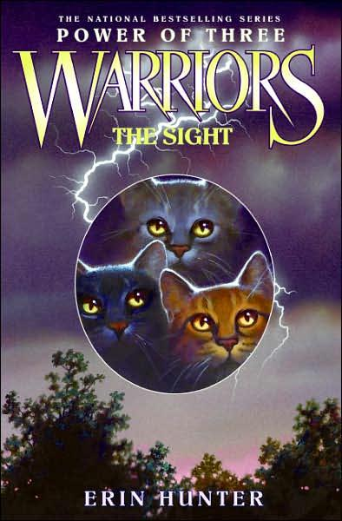
Wild cats have always lived in the forest. But when humans (Twolegs) destroyed the forest, the cats were forced to move away. They have now settled near a lake where there is plenty of prey, and little trouble. Their lives are back to normal. The four Clans (ThunderClan, RiverClan, WindClan, and ShadowClan) are all healthy and strong once more because of all the new kittens (kits). It is time for three of ThunderClan’s kits to become apprentices (when they train to become warriors). Kits of Squirrelflight and Brambleclaw, Hollykit, Lionkit and Jaykit have finally become apprentices after six long months (moons). With Firestar’s (leader of ThunderClan) blood in their veins, the three are sure to be strong warriors. All three are talented with special powers (or are they?) because of the prophecy. Dark secrets swirl around the trio and if ThunderClan is to survive, they much learn to cope with the prophecy. But unexpected arrivals and trouble with others stand in their way...

The book was wicked! If you have a pet cat, you’ll never look at him/her the same way ever again! In the series, the cats share dreams with StarClan, where cats go after they die. StarClan gives the Clans advice, warnings, the nine lives of a leader... and more. Don’t you ever wonder what cats dream of? Erin Hunter has a funny and mythological explanation for it all!

The cats are so human-like! Or as the cats call us, “Twolegs”. While reading, you’ll forget the cats are even cats! They have problems we have such as being blind or being treated differently. You can easily recognize yourself as one of the cats and connect yourself with him/her. They’re practically us, but in cat-form!

Throughout the book, many messages appeared. One of them was that even if you are blind, it doesn’t mean you’re useless or you need to be treated differently. Jaypaw is blind. But even though he can’t become a warrior, he becomes one of the best medicine cats in ThunderClan. Jaypaw’s mentor, Brightheart, treats Jaypaw as if he is as fragile as glass. But, Jaypaw has an incredible sense of smell, and isn’t fragile at all... no matter what Brightheart thinks. Another message was that as long as you set your heart on it, you can do it. In the book, Hollypaw wants to be a medicine cat at first, but later changes her mind. She set her heart on being a warrior, and she catches up with the rest of the apprentices as thought she has been an apprentice since the beginning of six moons (months) when she became an apprentice.

Omen of the Stars: The Fourth Apprentice

Omen of the Stars: The Fourth Apprentice is an enthralling book by Erin Hunter.

This book is about three cats called Lionblaze, Jayfeather and Dovepaw. All these cats have special powers. Lionblaze can’t get hurt in battle, Jayfeather can go into other cat’s dreams and read their mind and, Dovepaw can see and hear things from far away. In the forest where the cats live, there has been a drought. The lake is usually full, but now it is really small. Dovepaw figures out that a brown animal with a flat tail is blocking the stream leading to the lake. She tells Firestar, the leader of Thunder Clan this, and at the gathering he tells the other leaders. They decide to send out scouts, two cats from each clan, to get the stream unblocked. Dovepaw and Lionblaze are chosen, but will they come back alive?

Omen of the Stars: The Fourth Apprentice is a really suspenseful book. It is really interesting and exciting.

This book is an adventure book. This is because the cats from the four clans go on a quest to save the other, by bringing back the water. On their quest they have to explore new territory, so that is an adventure for them.

I would recommend this book to anyone between the ages of nine and fifteen, who like animals and/or adventure stories.

By: Chloe Worthington
++++++++++++++++++++++++++++++++++
Video Game Reviews
Super Mario Galaxy
Rating: E for everyone

CAUTION! MAY CONTAIN EXTREME ENTERTANMENT!

This game is the top rated of 2009. It is definitely the best rated game for Wii ever invented! The game is about a little person with a red hat and an Italian accent named Mario. After Princess Peach is kidnapped by the lord of evil, Bowser, Mario sets off to rescue her and destroy Bowser’s great Galactic Empire along the way. The next three paragraphs will give you proof of why Super Mario Galaxy is top rated in controls, originality and most of all challenge.

One reason that this is the best rated game of to 2009 is that the controls of Super Mario Galaxy are extremely simple. You move around with the Wii remote and collect stars by traveling to galaxies. Sounds pretty simple right? Well, actually the controls are simple not the game. You need to have a pretty good brain for problem solving because to beat some of the bosses you need to do a lot more than just jumping on mushrooms. This game also requires and improves your perseverance. A lot of people spend a whole month trying to beat Bowser and even when they succeed this task they’re about 3% finished.

One of the things pretty much everyone likes so much about this game is the exclusive freedom of it. Unlike almost all the other Super Mario games which are all 2D this Super Mario Galaxy gives you complete control because it is 3D! Because of this you can do almost anything, instead of just jumping on mushrooms over and over and over again, which gets REALLY BORING, it has different galaxies to travel too, different enemies to fight, different abilities to unlock and different environments to get used to. In Super Mario Galaxy you are as free as a class with a supply teacher.
Another reason this game is the top selling game in Canada is the levels. In super Mario Galaxy there are not stages like stage 1-1, stage 1-2, etc. like all the other Super Mario Games but instead there are countless amounts of planets and galaxies to travel to and to conquer. That is another reason that Super Mario Galaxy is the best rated game of 2009.

But the real reason that Super Mario Galaxy is the top rated game is the challenge of it. Super Mario Galaxy is one of the only games in game history that is some how challenging, and some how also exciting and not frustrating at the same time. You can see this because there is pretty much no one out there that has not spent at least a month on super Mario Galaxy.

So, this game is obviously the best game of 2009 but you still have challenges to overcome in the game. Can you defeat the endless waves of enemies, save Princess Peach, and bring the fall to Bowser’s cruel galactic empire? Do you have the skill, the timing and the brains to do it? Find out. Battle the environments, take down your enemies, and step up to the challenge…hopefully you’re not a wimp like so many others that have failed.

Runescape game review

Runescape is an adventure/combat MMORPG, available in almost every country and in multiple different language in wich you can do pretty much anything you want, from fishing to woodcutting to fighting monsters to doing quests.
The game Runescape is completely open ended, so you can pick what you want to be. In other words, you will be seeing everything, from lightly armoured archers to bulky, mithril covered warriors. Start out with nothing more than a weak wooden shield, bronze short sword, and a few magic runes, but soon, you'll develop into archer, warrior, wizard, or witch. If you ever need help, just go to a town center and ask for it. There will be lots of people waiting to help, buy from, sell to, and even assassinate others. Don't like fighting the computer controlled monsters? No problem. Just go into the wilderness, where the Runescape laws are nonexistent. There you can fight against anyone in whichever way.
This game is a very enjoyable game with so many things to do that you'll never get bored. It is a great game for everybody between the ages of 10 and 16.

4/5
Maplestory
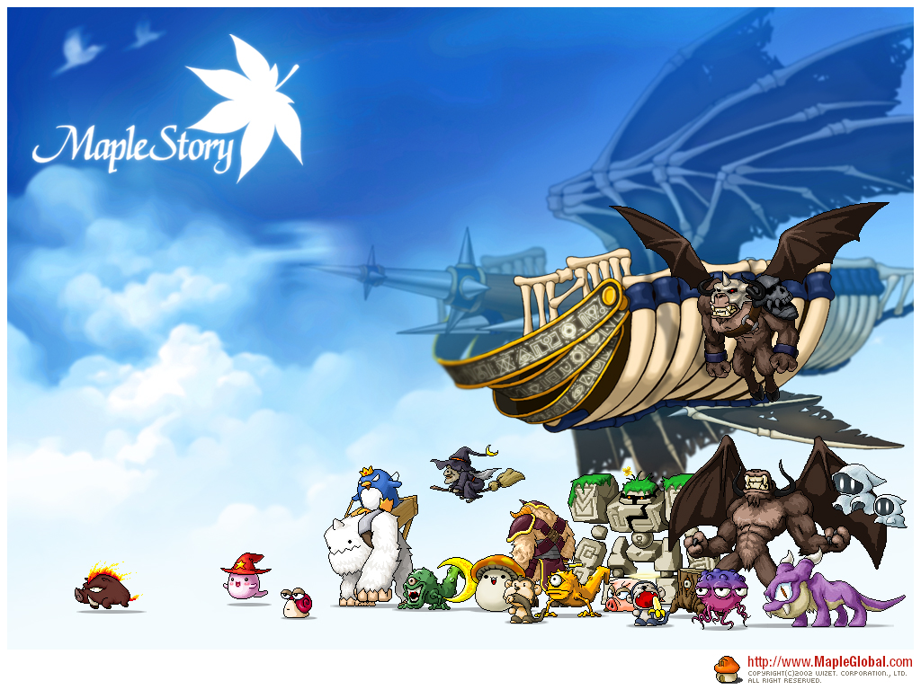

Maplestory is a fun combat/platform jumper MMORPG. In it, you control your virtual customizable character traveling around the world of Maplestory. There is no goal to the game except have fun! You can make friends, chat with them and team up to fight stronger monsters that you could never have fought before.

Maplestory is made fun and unique with these features:
1- Customizable controls
2-Skills/Jobs
3- Multiplayer feature

Let’s look at the controls first. Most of the popular MMORPGs have simple controls like clicking. Well not Maplestory. In this game you have the default controls (arrow keys to move ctrl to attack alt to jump etc.) but if you don't like them why keep them? You can change all your controls and hot keys to whatever suits you best, this is important because you'll be controlling your character faster thus giving you faster respond time to whatever your doing. When you unlock new skills you can customize their controls too!

That leads to the second feature, the jobs and skills. Now a job in Maplestory isn't an actual job but a class you can choose from. Most RPGs/MMORPGs have the basic magician, warrior or bowman option. Not Maplestory. This game has a lot more options to choose from (the adventurers, magician, warrior, bowman, pirate, thief, and then the Cygnus Knight's version, Blaze Wizard, Dawn Warrior, Night Walker, Wind Archer, and Thunder Brawler). Each job has their very own skills, pros and cons. Even after this you might get bored of your job, don't worry, once you reach a certain level you can make a job advancement. There are 4 job advancements in total, in the 1st one you make the most important decision because you chose what type of adventurer you want to be, in the 2nd one you chose what type of job you want out of the type of adventurer you are (magician: ice lightning wizard, fire poison wizard or cleric or warrior: spearman, fighter or page). The 3rd and 4th are just stronger versions of the 2nd.

The difference between and RPG and an MMORPG is the multiplayer feature. Playing with a friend is a lot more fun because you can do stuff together and chat and help each other out. Also they can show you places and features in the game you have never known about before and who knows it may be the most important thing in the game.

This is a great game but I rated it 4/5 stars because it could have better graphics, less hackers and it could be 3D rather than 2D . It may not be for everyone because of its flaws but the unique features more than make up for it. So depending on your expectations this may not be the game for you. Although it is definitely worth checking out when you’re bored and may turn out to be your favorite game of all time!

Review for Mario Kart Wii
Mario kart wii is a game for the wii, it is a fun game once you know how to play it. . You can also race with your friends on two, three or four players! It’s a very popular wii game (over 18.36 million people have bought it).

The point of the game is to race alone against computer players and win races to unlock new people to race with and new karts to drive in.

It is really cool that you can ride in other karts and use different people. People will probably enjoy racing against other people and unlock better karts to use. I recommend this game to kids of all ages because this game isn’t really hard to play once you know how to play.

If you like racing against others this is a good game to play.
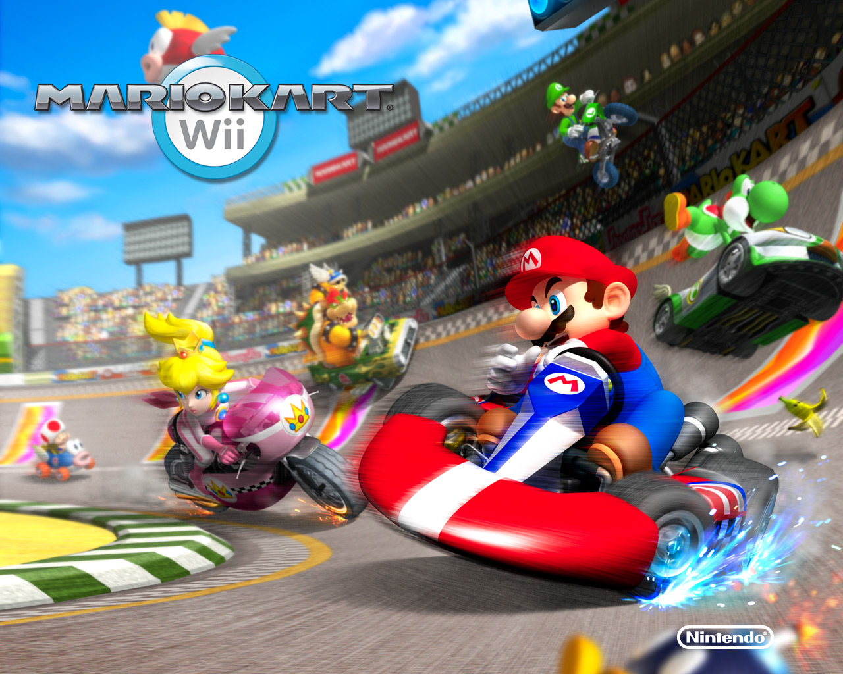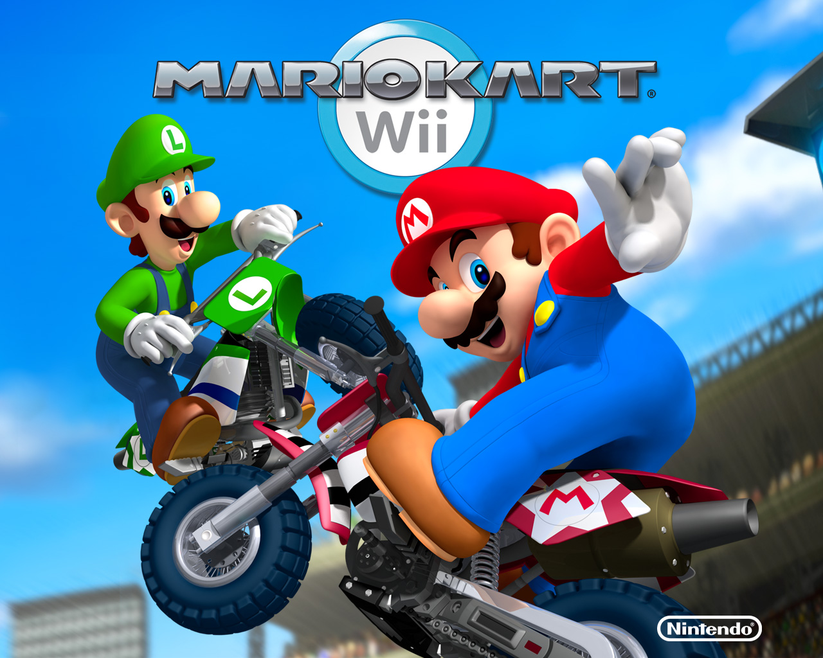

+++++++++++++++++++++++
Movie reviews
The Professional

At first when I looked at the title I thought maybe it was about a professional soccer player or something so I watched the movie. The below is about the movie and a summary of what I watched.
The main characters of The Professional are Léon, Stansfield, Mathilda and Tony. Their real names are Jean Reno, Gary Oldman, Natalie Portman and Danny Aiello. The purpose of this movie is to show that even if you’re hard core and mean and sour, you can still accept people because everybody has a sweet side. Show yours.
The plot of this movie is about Léon (Jean Reno) is a hitman (or "cleaner" as he would rather be known) living a solitary life in New York City's Little Italy. Most of his work comes from a Mafioso named Tony (Danny Aiello), who operates from the "Supreme Macaroni Company" retail store. Léon spends his idle time engaging incalisthenics, nurturing a houseplant that early on he describes as his "best friend”, and (in one scene) watching old Gene Kelly musicals.
On a particular day on his way home, he sees Mathilda Lando (Natalie Portman), a twelve-year-old girl with a black eye and smoking a cigarette, living with her dysfunctional family in an apartment down the hallway. Mathilda's father (Michael Badalucco) attracts the ire of corrupt DEA agents, who have been paying him to store cocaine in his residence, after they discover that he has been stealing some of the drugs for himself. A cadre of DEA agents storm the building, led by a ragged and drug-addicted Norman "Stan" Stansfield (Gary Oldman), murders Mathilda's entire family, missing her only because she was out shopping when they arrived. When she returns with the groceries she was sent to buy and notices the carnage, she calmly continues down the hallway past the open door of her family's apartment, and receives sanctuary from a reluctant Léon.
Mathilda, who soon discovers that Léon is a hitman, begs him to become her caretaker, and to teach her his skills as a "cleaner": she wants to avenge the murder of her four-year-old brother, the only member of her family that she actually loved. In return, she offers herself as a maid and teacher, remedying Léon's illiteracy. Léon hesitantly accepts her offer and the two begin working together, slowly building an emotional attachment, with Léon becoming a friend and father figure. As they work together, Mathilda admits to Léon several times that she is falling in love with him, but he says nothing back.
As Mathilda increases her confidence and experience, she locates Stansfield, follows him to his office in the DEA building in an attempt to kill him, only to be ambushed by Stansfield in a bathroom. Léon, discovering her intentions after reading a note left for him by Mathilda, rushes to the building and rescues her, shooting two of Stansfield's men in the process.
Stansfield is enraged that what he calls the "Italian hitman" has gone rogue and is killing his men. He confronts Tony and threatens him, eventually beating him into surrendering Léon's whereabouts. Later, as Mathilda returns home from grocery shopping, an NYP ESU team, sent by Stansfield, takes her hostage and attempts to infiltrate Léon's apartment. Léon ambushes the ESU team and takes one of the member’s hostage, rapidly bartering him for Mathilda's freedom. As they slink back into the apartment, Léon creates a quick escape for Matilda as he reassures her and tells her that he loves her moments before they come for him.
In the chaos that follows, Léon sneaks out of the apartment building disguised as a wounded ESU officer, almost unnoticed save for Stansfield who recognizes him and silently sneaks up and shoots him from behind. Looming over the dying Léon, Stansfield jeers him haughtily. However, just before he gives out, Léon places an object in Stansfield's hands, which he explains is "from Mathilda". Opening his hands, Stansfield recognizes it as the pin from a grenade and rips open Léon's vest to discover several grenades on his chest. Stansfield lets out a brief and final quip "Oh, shit" right before a massive explosion devastates them both.
Mathilda heads to Tony's place as she was instructed to do by Léon. Tony will not give Mathilda more than a few dollars of the fortune Léon had amassed, which was being held by Tony. His reasoning is that she is not old enough to receive the large amount of money and that school should be her priority until she's older. When Mathilda asks Tony to give her a 'job', and insists that she can 'clean' as Léon had, Tony sternly informs her that he 'ain't got no work for a 12-year-old kid!' Having nowhere else to go, she is then seen going to Roosevelt Island using the Roosevelt Island Tramway. The next day, she returns to school in NJ. Seemingly readmitted to the school, Mathilda walks into a field in front of it with Léon's houseplant in hand; she digs a hole and plants the houseplant in the grounds of the school, as she had told Léon he should, "to give it roots."

After I watched the movie, I realized it had NOTHING to do with a soccer player. At least, not a professional one.
I liked this movie because of the action and adventure. I know this because in the movie it says that Léon starts alone but teams up with Mathilda so that’s the adventure part. The action… well its pretty obvious there’s LOTS of action. I also disliked some parts of it because of its ending. I didn’t really understand that part. But other than that, I’d give this movie a 9/10.
Thanks for reading my move review and I hope you get to watch the professional☺.

2012

The movie 2012 is directed by Roland Emmerich, also the director of Independence Day and The Day After Tomorrow. The main characters are Adrian Helmsley, Jackson Curtis, Kate, Yuri Karpov, Noah, Lily, Gordon Silberman, and Carl Anheuser.

In the beginning of the movie, Adrian goes to India to visit his friend Dr Santam Tsurutani. Santam discovers that the temperature of the Earth's core is increasing rapidly. Then Adrian returns back to the United Sates to inform the White House Chief of Staff and after the President. Afterwards, they go to Vancouver to discuss this with the G8’s.

In the middle of the movie, many cities are reporting that there are immensely large earthquakes or lava. Luckily, Jackson, Kate, Noah, Lily and Gordon found a plane and got away to safety.

At the end, Jackson, Kate, Noah, Lily and Gordon eventually got to China were they were building gigantic contraptions that will save mankind. You have to watch the movie to find out what they were building.

The movie had a lot of action and the plot was amazing. On the other hand, the beginning was a tad bit boring.

Do you believe that on December 21, 2012 the world will come to its end???

Review for movie Eragon

The movie Eragon is good movie. It is about a poor farmer named Eragon that finds a mysterious blue stone. The mysterious stone hatches into a dragon that eventually turns into a strong dragon named Saphira. Eragon is destined to become a dragon rider and conquer King Galbatorix.

The movie offers great visual effects. Saphira and the other dragons look very real. The monsters are very ugly. The characters like, Eragon Brom (Eragons Mentor), Saphira and Arya (the warrior maden), are simple and easy to understand. The plot of the movie is too familiar which the good fights the evil and a boy is destined to be the hero. This is not a movie for very young viewers because there is a lot of fighting between the good and the evil and the monsters are scary. There are some scenes that there are no action and too much talking.

No movie is perfect and this one is no exception. If you are a dragon movie lover, then this is a movie you should watch! 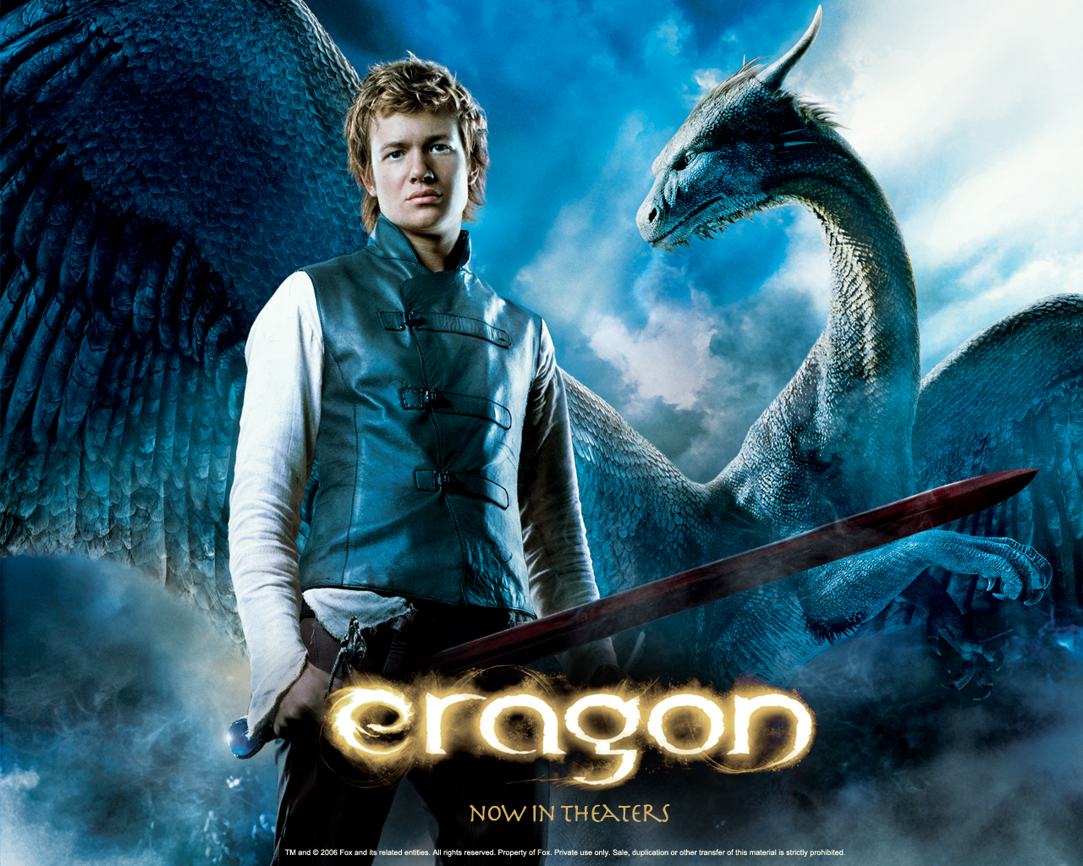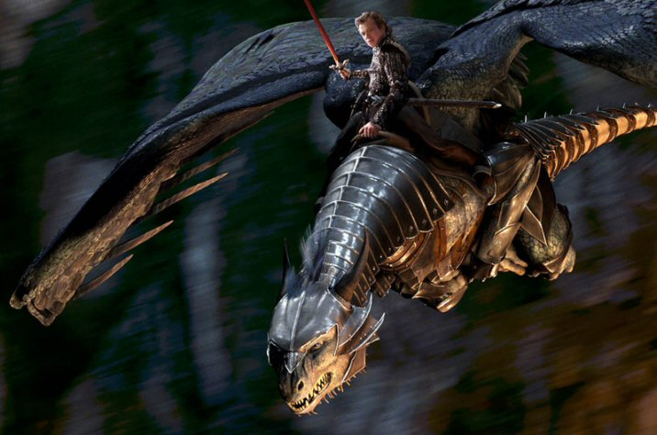

Cloudy with a chance of Meatballs
By Melinda Meng
The movie Cloudy with a chance of Meatballs is about a boy, Flint Lockwood, who lives in Chewandswallow.
Ever since he was a little boy, Flint wanted to be an inventor and fix people’s problems. His inventions always messed up, but he persevered. Flint was a little kid, he made an invention that messed up (again) and was stuck with it. He wanted to run away, but his mom showed her support and belief in him by giving him a lab jacket. This gesture of belief was really important because if Flint’s mom hadn’t done anything, he would have quit inventing. After all, he actually did succeed in making something to help the people of Chewandswallow. You see, the people of Chewandswallow were falling on hard times. The only thing that people could afford to eat was SARDINES! But Flint had a solution and a formula: A machine designed to transform water into food. Coincidentally, the mayor had been planning to open a fun park the same day that Flint was going to launch his machine, and a reporter, Sam Sparks, had come to check things out. When the machine works and it starts raining food, the whole situation turns around. Suddenly, Flint’s popularity is sky high, and even the mayor is taking an interest in him! Then things turn around just as suddenly: he’s stuck in an awkward romance with Sam and the mayor has somehow broken into his lab and is ordering too much food! And those aren’t his worst problems! The food machine is currently overloading and the small food rain is turning into a PLANE-SIZED FOOD EARTHQUAKE!!!
The main idea of the movie could be to believe in yourself and others and persevering when it comes to fixing your problems. In the movie, a lot of good things would not have happened if Sam and Flint’s mom had not shown their belief in Flint, and a lot of bad things could have happened.
This movie is hilarious to the average child and is action-filled. There isn’t too much suspense, only a little here and there, which some children may prefer to a movie with suspense around every corner. It is perfect for entertaining younger children since it is filled with bizarre inventions in a normal town with a funky inventor stuck in an awkward pre-romance stage. The inventions add an amusing twist to the story that makes some children laugh their guts out. The sole thing that might make children shift in their seats are the occasional family moments with Flint and his dad and the ‘revolting’ (to some people) romance situation with Flint and Sam. 95% of people love the movie and it is appropriate for all ages.

+++++++++++++++++++++++++++++++
TV Show Reviews

T.V. REVIEWS
By :Yi Yang, Sophie Fu, Charlene Peng and Wynnie Zhao
Every now and then, Everyone needs a good T.V. show to watch. The problem is, there just aren’t that many interesting ones out there. Either they seem boring to you, or the content just doesn’t appeal to you. Don’t worry, the past is the past, Get ready for the present!

This stack of papers isn’t any ordinary one, so don’t even think about throwing it in the garbage. Here, we have the top three T.V. shows voted by students in are class. Each show has different characteristics so you’re bound to love at least one of them.
Have fun reading them!

The Wizards of Waverly Place
Do you like comedy shows? Or perhaps slightly scary movies?? If so, you should definitely watch “The Wizards of Waverly Place”. This funny and humorous (that’s sometimes scary) TV show will always have you laughing.
The Wizards of Waverly Place (created by Todd J. Greenwald) is about a family of wizards. The Russo family consists of Alex M. R. (played by Selena Gomez), Justin R. (played by David Henrie), Max R. (played by Jake T. Austin), Jerry R. (played by David Deluise) and Theresa R. (played by Maria C. Barrera). Theresa is the (very responsible) mom of Alex, Justin and Max. Although she isn’t a wizard, she knows all about them and their magical powers. Alex is the only daughter and is 16 years old. She is very sassy, fashionable and full of spunk. She is the “lounging around watching TV instead of doing homework” type of gal. When her dorky brother, Justin does something…well dorky, She ALWAYS has a clever insult to say. As you already know, Justin is slightly dorky, but also very smart. He is the best wizard in the family and is 18. Max is a 12-year old boy and has a very out-going personality. He will believe basically anything you say and sometimes doesn’t think very logically. Jerry is the dad and teaches Alex, Max and Justin about their magic powers. Another character would be Alex’s best friend, Harper Finkle (played by Jennifer Stone). Harper is very loyal, trust-worthy and like to get very( and by very I mean VERY)creative when choosing her outfits. She is also the only one not in the Russo family that know the wizards secret.
All the episodes in the shows are all very different, but the main focus is on keeping the wizard secret…a secret. Almost every episode will have a challenge based on that.
Besides being entertaining and fun to watch, each episode of WOWP has a moral/message to it. The scriptwriters worked really hard to make sure of that. There is also an overall moral of the whole show, which would be on family conflict. Alex, Max and Justin fight on a regular bases over silly stuff (e.g.: who does the dishes). But, in the end of all of their fights, they realize that they actually love each other and if one of them left, they would miss the person that left very much . In one episode, Alex experienced that she got mad at Justin and he went to camp because he got annoyed with her. Alex felt lonely and apologized to Justin. Another moral would be to trust people. When Harper first found out about wizards, Justin and his dad did not trust Harper. But, as time went by, they started to believe Harper with their secret. This show is hilarious and makes things that don't exist sound perfectly normal and believable. You may also be able to relate to some things that happen in the show (like crushes, jealousy, friendship problems...etc).All the characters have such different and unique personalities, so you will never get bored with them. Watching Wizards of Waverly Place is like being in a different world full of magical beings and mysterious powers...hope you like it!; )

PHINEAS AND FERB

YAWN!!!! You’re sitting on the couch all day and watching boring infomercials. Boring! Especially boring when you could be watching Phineas and Ferb!! In each episode, there isn’t a single day that’s normal! They either build a bridge to France, or build the biggest and most scary roller coaster in the whole wide world or climb the Effel tower!! And that’s just three examples out of a million!!

In Phineas and Ferb, there is about 6 main characters that absorb the adventure in everything Phineas and Ferb make or do. There’s Phineas there’s Ferb and Candace and Isabelle who’s in love with Phineas (But Phineas doesn’t know…….yet). Phineas is the person who always thinks of the idea and tells Ferb (his brother) his idea. He is the one who always says: “Hey Ferb, I know what where going to do today!” That line is in every episode of Phineas and Ferb. Ferb is Phineas’s silent brother. He is the really smart one who as you already know doesn’t talk (not because he is mute). Candace is Phineas‘s and Ferb’s older sister who always tries to “Bust” them. But every time she tries, she fails. By the time she tells someone, the structure that Phineas and Ferb build self destructs of something like that. Isabelle is in love with Phineas and wants to marry him. Everytime she sees him, she goes away in PhineasLand.
This show will make you cry tears out of your eyes! It's hilarious! I don't know what show could be better!! So today at 2:00, turn on the TV and watch Phineas and Ferb!!!!

American Idol

Do you like competition? Or maybe keeping track of the latest singers? If so, then American Idol (the reality show for all ages) is the show for you!
It is a reality competition show where solo artists compete for the grand prize: a one million (US) dollar record deal! How exciting is that?
A lot of the hottest singers debuted from American Idol. Like Kelly Clarkson, for example. There’s also Carrie Underwood, Jordin Sparks, and last year’s winner, Kris Allen!
But of course, neither of the winners couldn’t have done it with much ease. There’s the first audition, the semi-finals, and then the finals. All votes were submitted by telephone voting. But if the judges feel that the voting audience is making a mistake, since the eighth season, they’re now allowed to “save” one of the contestants that should have been voted off.
As you’ve noticed, the judges have an important role in the show. Since the first season, Randy Jackson, Paula Abdul, and the always-cranky, Simon Cowell have been one of them. But as for the eighth season, a new fourth judge (Kara DioGuardi) has been added.
With the judges getting ready and the singing contestants working hard, the ninth season (expected to come out soon sometime next year) will surely be thrilling! Be sure to watch!

Well, what did I tell you? Great eh? I bet you can’t wait to get home and switch on the T.V. I am certain these shows won’t let you down.

