This survey project examined the current household solid waste management (SWM) in Otukpo with a case study of residents around Wesley High School. Data collection involved face-to-face questionnaire administration to different household waste generators. A total of 100 households were interviewed using the WRSQS Questionnaire which was randomly administered among the different households. The results indicated that majority of the residents are very much concerned about the poor current state of the environment due to improper and inappropriate SWM in Otukpo township. Very few of the residents knew little about recycling and composting. The residents are clearly dissatisfied with the services of the Environmental Health Protection Authorities with regard to SWM in Otukpo. Some locally-effective SWM strategies have been suggested.
WESLEY HIGH SCHOOL OTUKPO, BENUE, NIGERIA
(+234) 7032941147
--------------------------

iEARN GEN 1 ENVIRONMENT-GLOBAL ISSUES (WESLEY HIGH SCHOOL OTUKPO, BENUE STATE NIGERIA)
2011
A SURVEY OF HOUSEHOLD SOLID WASTE MANAGEMENT IN OTUKPO: A CASE STUDY OF RESIDENTS AROUND WESLEY HIGH SCHOOL OTUKPO, BENUE, NIGERIA

PROJECT RESUME

AUTHOR- iEARN GEN 1 ENVIRONMENT-GLOBAL ISSUES (WESLEY HIGH SCHOOL OTUKPO, BENUE STATE NIGERIA)

TITLE- A SURVEY OF HOUSEHOLD SOLID WASTE MANAGEMENT IN OTUKPO: A CASE STUDY OF RESIDENTS AROUND WESLEY HIGH SCHOOL OTUKPO, BENUE, NIGERIA

ABSTRACT-

This survey project examined the current household solid waste management (SWM) in Otukpo with a case study of residents around Wesley High School.
Data collection involved face-to-face questionnaire administration to different household waste generators.
A total of 100 households were interviewed using the WRSQS Questionnaire which was randomly administered among the different households.
The results indicated that majority of the residents are very much concerned about the poor current state of the environment due to improper and inappropriate SWM in Otukpo township. Very few of the residents knew little about recycling and composting. The residents are clearly dissatisfied with the services of the Environmental Health Protection Authorities with regard to SWM in Otukpo.
Some locally-effective SWM strategies have been suggested.

KEY WORDS- NATURAL ENVIRONMENT; WASTE MANAGEMENT; RECYCLING; REUSE; COMPOSTING; HOUSEHOLD GARBAGE

- INTRODUCTION

Goal 7 of the 8 Millennium Development Goals is to ‘ensure environmental sustainability’ (UNESCO, 2011). A very important issue that is crucial in realizing this goal is that of the need to develop and adopt effective strategies for solid waste management (SWM) and more especially in densely populated urban areas. The main purpose of SWM is to provide hygienic, efficient and economic collection, transportation, treatment and/or disposal of solid wastes, without polluting the atmosphere, soil or water resources. The environmental and public health risks that arise due to inadequate waste disposal have been well documented: surface and groundwater are contaminated by leachate; the soil by direct waste contact or leachate; the air by burning of waste; the spread of diseases by different vectors such as birds, insects and rodents; and the uncontrolled release of methane from anaerobic waste decomposition (Schertenleib & Meyer, 1992).

Recent high levels of economic growth and consumption have led to increasing pressures on the environment in Otukpo town. On closer observation it would be observed that many areas in the town are now covered with refuse dumps. This current situation is sharply in contrast to what the town used to be many years back when many trees blossomed and the streets were a beauty to behold. The huge waste that collects almost in every street corner is a clear indication that there is a lack of proper and efficient SWM.

As informed and concerned citizens of the community, we the JETS CLUB Health team of Wesley High School decided to investigate the problem. We started out by arranging an excursion to the Environmental Health Office in order to learn about the scope of their work, how frequently they did them, the extent of successes they recorded and to know what challenges they experienced in the course of their work.

The feedback from the excursion to the environmental health office clearly showed that the staffs are determined and willing to do their work which they always did. However they mentioned several challenges that prevented the smooth and effective delivery of their services. These include: insufficient work vehicles; inadequate number of personnel; inadequate Government funds and lack of technical facilities such as ICT. These challenges are in agreement with research reports, for example, Golit (2001) have identified financial and technological constraints as impediments to appropriate and organized SWM. Since these constraints are also peculiar to many other urban centres in Nigeria (see for example, Adedibu, 1983; Egunjobi, 1986, 1992; Akintola, 1987; Ogu, 1987; Ipadeola, 1988; Nwude, 2006; Ukpong, 2006 and Osse, 2006) there is therefore a reasonable need to devise alternative ways of waste disposal and better still, devise effective ways of waste reduction. It is this latter need that propelled us to embark on this survey project on household solid waste management in Otukpo with a case study of residents surrounding Wesley High School and with the objective of recommending strategies for effective SWM in the Local Government.

1.1 DEFINITION OF KEY WORDS
- Waste Management: this is the collection, transport, processing, managing and monitoring of waste materials;
- Household Garbage: commonly known as trash or rubbish, is a waste type consisting of everyday items we consume and discard. It predominantly includes food waste yard waste and other miscellaneous inorganic wastes from residential, commercial, institutional and industrial sources.
- Natural Environment: this encompasses all living and non-living things occurring in nature on earth or some region thereof.
- Composting: this is the aerobic decomposition of biodegradable organic matter producing compost.
- Recycling: this is processing used materials (wastes) into new products to prevent waste.
- Reuse: this is to use again especially in a different way or after reclaiming or reprocessing.

2.0 THE STUDY AREA
The study area lies in the coordinates 7°13′N 8°9′E. The land area is. 24,461 square kilometres (9,444 sq mi).The city population stands at 2,843,105 with 453 people per square mile.

3.0 METHODOLOGY
The Waste Reduction Study Questionnaire Survey (WRSQS) that was employed for this project was adapted from that of Post (2007) (see Appendix). A total of 100 survey questionnaires were randomly administered among households surrounding Wesley High School. Four groups of students (10 each) conducted face-face interviews. Each student group were limited to interview a total of 25 households. One member of each household who was within the age bracket of 18-74 years was selected to be interviewed. The questionnaire design consists of seven sections: Natural Environment; Household Solid Waste Management; Concerns about Solid Waste Management; Willingness to participate; Solid Waste Management Attitude Scale; Environmental Health; and Demography.

4.0 RESULTS
The results are simultaneously presented in tables in the order of the respective sections of the WRSQS questionnaire.
 | Correct definition (%) |  |  | Wrong definition (%) |  |  | No idea (%)
1. Ability to define the term Natural environment | 23.3 |  |  | 3.3 |  |  | 73.4
 | Concerned (%) |  |  | Not Concerned (%) |  |  | No opinion (%)
2. Concern about the current state of the environment | 80 |  |  | 10 |  |  | 10
 | Automobile exhaust (%) | Sewage pollution (%) |  |  | The individual person (%) | Factories (%) |  | Household garbage (%) |  | Cutting down trees (%)
3. What is being considered as the major issue that affects the environment | 6.7 | 36.5 |  |  | 6.7 | 6.7 |  | 36.7 |  | 6.7
 | No effect (%) |  | Some effect (%) |  |  | A lot of effect (%) |  |  | No opinion (%)
4. Individual effect on the environment | 3.4 |  | 23.3 |  |  | 60.0 |  |  | 13.3
TABLE 1: THE NATURAL ENVIRONMENT

It is obvious that a great number of respondents (80%) are concerned about the current state of the natural environment but have a shallow knowledge on what constitutes the natural environment. A majority (73.4%) of the respondents had no idea of what the Natural environment entails. A greater percentage of respondents (36.7%) considered household garbage to be the major issue that affects the environment. This was closely followed by sewage pollution (36.5%). The individual person was believed by majority of the respondents (60%) to have the most effect on the environment.

TABLE 2: HOUSEHOLD SOLID WASTE MANAGEMENT

1. Method of household garbage storage |  | Closed container (%) |  |  | Open container (%) |  |  |  | Plastic bags (%) |  |  |  | Other (pile in the yard) (%)
 |  | 43.3 |  |  | 26.7 |  |  |  | 10.0 |  |  |  | 20.0
2. Method of household garbage disposal |  | Burn  (%) | Bury  (%) | Dump  In river /gully (%) |  | Dump in yard  (%) | Dump on road  (%) | EHO  Dumpsite  (%) |  | Garbage truck  (%) | Recycle  (%) | Reuse  (%) |  | Compost  (%) | Other  (%)
 | Food waste | 16.7 | 3.3 | 10.0 |  | 3.3 | 3.3 | 40.0 |  | 6.7 | 0.0 | 6.7 |  | 10.0 | 0.0
 | Yard trimmings | 53.4 | 3.3 | 3.3 |  | 0.0 | 3.3 | 23.4 |  | 0.0 | 0.0 | 13.3 |  | 0.0 | 0.0
 | Paper/cardboard | 73.4 | 3.3 | 0.0 |  | 0.0 | 0.0 | 13.4 |  | 3.3 | 0.0 | 3.3 |  | 0.0 | 3.3
 | Plastic | 40.0 | 6.7 | 3.3 |  | 0.0 | 0.0 | 26.7 |  | 0.0 | 6.7 | 13.3 |  | 0.0 | 3.3
 | Metals | 13.4 | 3.3 | 3.3 |  | 3.3 | 0.0 | 26.7 |  | 3.3 | 30.0 | 0.0 |  | 0.0 | 16.7
 | Glass | 6.7 | 6.7 | 10.0 |  | 6.7 | 0.0 | 43.3 |  | 3.3 | 16.6 | 0.0 |  | 0.0 | 6.7
 | % AVERAGE | 33.9 | 4.4 | 5.0 |  | 2.2 | 1.1 | 28.9 |  | 2.8 | 8.9 | 6.1 |  | 1.7 | 5.0

Majority of the respondent (43.3%), reported that most of their household garbage are stored in a closed container, while some (26.7%) store theirs in an open container, few (10%) in plastic bags and others (20%) pile garbage in the yard. Burning constituted the major method of household garbage disposal by respondents (33.9). Many others (28.9%) make use of the environmental health office (EHO) dumpsite and very few of the respondents made use of other methods such as: composting, recycling, reuse, use of garbage truck, etc.

TABLE 3: CONCERNS ABOUT SOLID WASTE MANAGEMENT

S/N | Issue for concern | Concerned (%) | Not concerned (%) | No opinion (%)
1 | Health risk related to burning garbage | 96.7 | 3.3 | 0.0
2 | Illegal dumps polluting water bodies | 80.0 | 6.7 | 13.3
3 | Diseases related to improper storage and disposal | 100.0 | 0.0 | 0.0
4 | Flooding due to garbage blocking drains and gullies | 93.4 | 3.3 | 3.3
5 | Reduction of natural resources we buy and use | 90.0 | 6.7 | 3.3
6 | Services provided by garbage truck | 60.0 | 3.3 | 36.7
7 | Litters | 83.4 | 3.3 | 13.3
8 | Illegal dumping | 90.0 | 3.3 | 6.7
9 | Presence of rats | 86.7 | 0.0 | 13.3
10 | Garbage in Otukpo local government | 80.0 | 6.7 | 13.3

Generally the majority of respondents showed concern about issues of solid waste management. All respondents (100%) were concerned about the diseases related to improper waste storage and disposal and only a few (3.3%) were not concerned about the health-risk related to burning garbage.

TABLE 4: WILLINGNESS TO PARTICIPATE

S/N | Willingness | Yes (%) | No (%) | Don’t know (%)
1 | Composting | 70.0 | 16.7 | 13.3
2 | Recycling | 73.3 | 20.0 | 6.7
3 | Willingness to separate material for collection | 86.7 | 13.3 | 0.0
4 | Willingness to pay for pickup for recycling materials | 66.7 | 26.6 | 6.7
5 | Willingness to participate in composting programs | 83.3 | 16.7 | 0.0
6 | Willingness to return plastic bottles to stores | 76.7 | 23.3 | 0.0
7 | Willingness to purchase less throwaway products | 83.3 | 16.7 | 0.0
8 | More information on the reduction of garbage | 90.0 | 6.7 | 3.3
9 | Willingness to carry garbage to skiff | 90.0 | 3.3 | 6.7
10 | Willingness to build skiff for the community | 86.7 | 0.0 | 13.3
11 | Willingness to maintain skiff | 80.0 | 6.7 | 13.3

It is obvious that generally a greater percentage of respondents are willing to participate in efforts aimed at reducing waste, recycling and composting of household garbage and were willing to get more information on how to reduce garbage.

TABLE 5: SOLID WASTE MANAGEMENT ATTITUDE SCALE
S/N | Statement | Agree (%) | Disagree (%) | No opinion (%)
1 | I play an important role in garbage management in Otukpo community. | 66.7 | 23.3 | 10
2 | Environmental education should be taught in schools. | 90 | 10 | 0.0
3 | The Purchase decisions that I make can increase or decrease the amount of garbage my household must get rid of (dispose of). | 83.3 | 13.3 | 3.4
4 | I don’t care that burning garbage can be bad for my health and the health of others. | 13.3 | 83.3 | 3.4
5 | People throw garbage on the streets and in the drains and gullies because they have no other means of getting rid of (disposing of) their garbage. | 26.7 | 66.7 | 6.6
6 | The Local Government is not doing enough to fix the garbage problem. | 93.3 | 6.7 | 0.0
7 | Correct garbage management should not be taught in schools. | 10 | 90 | 0.0
8 | Other personal issues (like crime, unemployment, and cost of living) are more important to me than a garbage-free community. | 26.7 | 66.6 | 6.7
9 | Regular collection of garbage is the only solution to garbage problem. | 83.3 | 13.3 | 3.4
10 | Picking up garbage around my community is my responsibility as an Otukpo resident. | 50 | 43.3 | 6.7
11 | Public education about proper garbage management is one way to fix the garbage crisis. | 90 | 6.7 | 3.3
12 | It is very important that the Otukpo Local Government put recycling laws and programs in place. | 83.3 | 13.3 | 3.4

While most of the respondents (66.7%) agreed that they individually play important roles in garbage management, a greater percentage of the respondents (93.3%) believed that the local government is not doing enough to fix the garbage problem. A greater number of respondents (83.3%) agreed that: recycling laws and programs should be put in place in Otukpo Local Government; that purchase decisions should be controlled; and that regular collection of garbage is the only solution to the garbage problem. The majority of respondents (90%) also agreed that environmental education should be taught in schools and that public education about proper garbage management is a way to fix the garbage crises. When asked about whether other personal issues were more important than a garbage-free community, a greater percentage (66.6%) disagreed. Majority of the respondents (83.3%) were against the burning of garbage.

TABLE 6: ENVIRONMENTAL HEALTH
1.Type of toilet facility used | Water closet linked to sewer main (%) | Water closet not linked (%) | Pit latrine (%) | None (%)
 | 13.3 | 30.0 | 50.0 | 6.7
 |  | Yes (%) |  |  |  |  | No (%)
2. Location of toilet facilities on premises |  | 86.7 |  |  |  |  | 13.3
 |  | Exclusive use (%) |  |  |  |  | Shared (%)
3. Usage of toilet facilities |  | 73.3 |  |  |  |  | 26.7
4. Main source of drinking water | Public supply (%) | Private tank (%) |  |  | Public stand pipe (%) |  | Way side tank (%) |  | Well (%) |  | Others (%)
 | 13.3 | 26.7 |  |  | 6.7 |  | 10.0 |  | 23.3 |  | 20.0
5. Presence of disease vectors and breeding sites | Yes (%) |  |  |  |  |  | No (%)
 | 83.3 |  |  |  |  |  | 16.7
6. Main material of the house | Wood (%) |  | Zinc (%) |  |  | Concrete (%) | Concrete and zinc (%) | Wood and zinc (%) |  |  |  | Others (%)
 | 6.7 |  | 6.7 |  |  | 13.3 | 46.7 | 16.6 |  |  |  | 10.0
7. Type of tenure | Owned (%) |  |  |  |  | Rented (%) |  | Rent free (%)
 | 60.0 |  |  |  |  | 30.0 |  | 10.0
8. Household-grown food for consumption | Vegetables (%) |  |  | Fruits (%) |  | Animals (%) |  | Others (%) |  | No (%)
 | 43.3 |  |  | 13.3 |  | 6.7 |  | 10.0 |  | 26.7

Most of the respondents use pit latrine facilities (50%). Most of the toilet facilities are privately used by the household members (73.3%) while few are being shared. Most of the houses are owned by the household members (60%), which made it possible for them to grow various kind of crop and animal for household consumption, such as; vegetables, fruits, poultry , etc.

TABLE 7: DEMOGRAPHY
1. Age range (%) |  |  |  |  |  |  |  |  |  | 2. Gender (%) |  |  |  | 3. Educational level (%)
18-24 | 25-34 |  | 35-44 |  | 45-54 |  | 55-64 | 65-Above |  | Male |  | Female |  | Primary |  | Secondary |  | Tertiary |  | No school |  | Don’t know
20.0 | 26.7 |  | 23.3 |  | 16.6 |  | 6.7 | 6.7 |  | 33.3 |  | 66.7 |  | 13.3 |  | 36.7 |  | 40.0 |  | 6.7 |  | 3.3
4. Employment (%) |  |  |  |  |  |  |  |  |  |  |  |  | 5. Income range per month (%)
Employed |  | Unemployed |  | Student |  | Retired |  |  | Not of working age |  | Don’t know |  | No income |  | Less than N 20000 |  | N 20000- N 40000 |  | N40000 or more |  | No response
26.7 |  | 36.7 |  | 20.0 |  | 6.7 |  |  | 3.2 |  | 6.7 |  | 46.7 |  | 13.3 |  | 6.7 |  | 3.3 |  | 30.0

Most of the respondents are literate and with a greater percentage (40%) who have received a tertiary education. Majority of the respondents (36.7) were unemployed. A large percentage (30%) did not disclose their income range and majority (46.7%) had no source of income.

5.0 DISCUSSION AND RECOMMENDATIONS
The results reveal that many residents do not have complete knowledge of what constitute the natural environment (Table 1). This means there is need for more public environmental education in the public schools.
The typical indigene of Otukpo and the other idoma speaking areas are generally clean people and this is why the respondents considered household garbage and sewage to be the major environmental issues for concern. Many of the residents complained that the EHO dump sites were insufficient and was rarely cleared by the sanitary workers, a situation which has prompted them to resort to the burning of wastes (Table 2). The burnt wastes gradually accumulate and usually lead to the blockage of drainages because the burning usually takes place close to such drainages. These serves as breeding site for disease vectors as have been identified by the respondents (Table 6). Since many respondents depend on well water (Table 6) they stand the risk of leachate contamination. The use of waste carts should be introduced in Otukpo community. Casual workers should be employed to push such waste carts to collect household garbage from house to house. The households will have to pay a small token for such services. This survey has revealed that many respondents are willing to pay for such services (Table 4).
Although many respondents have toilet facilities in their homes they have identified sewage as an environmental issue. This means that there are many residents that do not have toilet facilities in their homes or if they do, they are poorly constructed. More rigorous sanitary house inspections are required in order to identify those houses without decent toilet facilities or that do not have any at all and appropriate penalties issued.
The Local Government Authority has been blamed by many of the respondents for not fixing the garbage problem (Table 5). Many of the respondents believed that there was need for more frequent removal of garbage by the sanitary workers and that recycling laws and programs should be put in place by the Local Government. Many of the respondents were willing to participate in recycling and composting programs if they were given adequate orientation. Some residents are already involved in composting and recycling (Table 2) as many had house-grown food (Table 6). This means that waste collection centres need to be erected by the Local Government specifically for the purpose of waste recycling and composting. The environmental health officers will also need to increase their efforts in public education on ways of reducing and reusing wastes and on what wastes should be brought to the recycling and composting centres. Since the demographic data (Table 7) reveals that many of the respondents are literate and may afford to own a radio, more radio programmes about the environment should feature on the radio broadcasts of Joy FM Radio Station Otukpo.
There is a great need for the private sector such as commercial banks to collaborate with the Local Government in the solid waste management efforts. It is the corporate social responsibility of the private sector to partner with the Local Government in the smooth delivery of government functions.
It is obvious that the environmental health department of the local government is handicapped in the areas of personnel, work vehicles, ICTs and funding. All these need to be adequately provided for effective environmental health services to be delivered especially in solid waste management.

6.0 CONCLUSION

This survey project has being able to provide an indication of the current household solid waste management in Otukpo by focusing on the residents surrounding Wesley High School as a case study.

The residents are generally concerned about the environment but are not doing enough to reduce, recycle and reuse the household garbage they generate. It is clear from their responses that they are ready to help fix the garbage problem in Otukpo if given the appropriate support from the local government as have been identified in this survey report.

The natural environment requires protection in order to remain healthy for all of its inhabitants. To protect and bring about a healthy and sustainable environment requires the collective efforts of the public, the environmental health authorities and the private sector. Let us all remember these three big words about ‘waste’: REDUCE, RECYCLE, REUSE.

REFERENCES

Adedibu, A.A (1983). Solid waste Characteristics in Ilorin. Journal of the Nigeria Institute of Town Planners, Vol. 3, No. 1.
Akintola, F.O. (1987). Prospects of Solid Waste Management in Ibadan City. Seminar paper, Department of Geography, University of Ibadan
Egunjobi, L. (1986). The Solid Waste Management Problem, Urban Growth and Urban Management in Nigeria with Particular Reference to Public Utilities and Infrastructure, Ibadan: NISER.
Egunjobi, L. (1992). Perception of Urban Environmental Problems: A pilot Study centered on the City of Ibadan, Nigeria. African Urban, Vol. 4, No. 1 and 2, Jan and May (pp. 59- 69).
Golit (2001). Sustainable Cities and Benefits. Regional Policy and Development, Series 9. London: Mitshire Kingsley publishers.
Ipadeola, S.F. (1988). Solid Waste Generation Management: Towards an Environmental Sanitation Policy. Environmental Issues and Management in Nigeria Development (pp 77-87).
Nwude, M.O (2006). A Sustainable Option for Solid Waste Management in Kaduna Metropolis. Unpublished MSc Thesis.
Ogu, B.C. (1987). Solid waste Management in Imo State Urban Centres: The Case Study of Aba. Unpublished MURP Dissertation. Ibadan: Centre for Urban and Regional Planning, University of Ibadan.
Osse, F.O (2006). Characterization of Abuja Federal Capital City Solid Waste for Appropriate Management Strategy. Unpublished MSc Thesis.
Post, J .L. (2007). Solid Waste Management in Jamaica: An Investigation into Waste Reduction Strategies. Unpublished MSc Thesis.

Schertenleib, R., & Meyer, W. (1992). Municipal solid waste management in DC’s: Problems and issues; need for future research. IRCWD News (No. 26).

Ukpong ,B ( 2006). Strategy for Sustainable Solid Waste Management in the Federal Capital Territory (Garki, Wuse, and Karu). Unpublished MSc Thesis.
UNESCO (2011). UNESCO and Education :“Everyone has the right to education”. Paris: United Nations Educational, Scientific and Cultural Organisation.

APPENDIX 1
Waste Reduction Study Questionnaire Survey(WRSQS) employed in Otukpo Township (Wesley High School Surroundings)

Date of the interview: -----/-----/------- (Day/Month/Year) Questionnaire No.: _____________________

Name of Community: __________________________ Estate Address: _______________________

Interviewer: __________________________________

Total time of interview: hours: ________ minutes: _________

Number of times household visited: ________
Respondent Selection: We need to speak with member of the household between the ages of 18 and 74 years.

Introduction
o “Hello. My name is ________________________________ and I’m part of the health team from JETS Club Wesley High School Otukpo conducting a questionnaire survey on waste management within Otukpo Township. This questionnaire survey focuses on garbage and other public health issues.
o The purpose of this survey is to gather more information from residents like you about your current practices, concerns, and opinions. The survey will take about 10 minutes.
o Will you participate in the questionnaire survey? You are not required to give your name, so you will not be connected to the answers provided.
o The answers you provide to the following questions will be able to direct the Health Department in its effort to serve you, so please answer as accurately as possible. Thank you very much for your time.
o Let’s begin…”
Section One - The Natural Environment
1. What do you understand by the term “natural environment”?
(Interviewer: If the respondent takes a long time to respond, assume that the person does not understand the term “environment” and write
“doesn’t know” on the lines below, and then read the definition provide below, to enable them to answer the following 4 questions.)
____________________________________________________________________________________________________________________
Definition: The environment may be defined as the whole world around us: the air, water, and land, forests, wetlands, and the sea,
and all animals and plants about us.
2. Knowing what the natural environment is, are you concerned or not concerned about the current state of the natural environment?
1 | I am not concerned
2 | I am concerned
0 | I have no opinion
3. What do you personally say is the major issue currently affecting Otukpo’s natural environment? (one answer)
1 | Automobile exhaust | 6 | Household garbage
2 | Sewage pollution from pits and toilets | 7 | Cutting down trees
3 | Fishing | 8 | Mining (Bauxite)
4 | The individual person | 9 | Dangerous solid waste like chemicals, waste from factories,  and medical waste
5 | Factories | 10 | Pesticides and herbicides used in farming

4. What other issues concern you about Otukpo’s natural environment? (Choose as many as you like from the list above)
_________________________________________________________________________________________________________________
5. How much effect do you think you have on the natural environment, do you have: no affect, some affect, a lot of affect, or no opinion?
1 | I have no effect
2 | I have some effect
3 | I have a lot of effect
4 | I have no opinion

Section Two - Household Solid Waste Management
6. Please describe how your household stores the garbage from your house.
(Interviewer: Do not provide the choices, but select the choice below that best fits the respondent’s description)
1 | Closed Container, please describe:
2 | Open Container, please describe:
3 | Plastic bags
4 | Pile in the yard
5 | Other, specify:
6 | Don’t Know

7. Please describe how your household gets rid of the following types of garbage from your house.
(Interviewer: Select the choice below that best fits the respondent’s description. Include any additional comments made by the respondent in the space provide)
Types of Garbage | Burn | Bury | Dump |  |  |  | Garbage  Truck | Recycle | Reuse | Compost | Other  (Specify)
 |  |  | River/  Gully | In yard | On road | EHO  Dump  site
 | 1 | 2 | 3 | 4 | 5 | 6 | 7 | 8 | 9 | 10 | 11
Food waste
Yard trimmings
Paper/cardboard
Plastic
Metals
Glass
Comments regarding Question 7:________________________________________________________________________________________
8. Can you think of any ways of reducing the amount of garbage that your household must burn, bury, dump, or leave for the garbage truck?
____________________________________________________________________________________________________________________

Section Three - Concerns about solid waste management
To the following 5 questions, please tell me whether you are:  Concerned, Not Concerned, or you have No Opinion. | Concerned | Not concerned | No option
 | 2 | 1 | 0
9. How concerned are you about health risks related to burning garbage?
10. How concerned are you about illegal dumps polluting rivers, streams, and wells?
11. How concerned are you about diseases that are related to improper storage and disposal methods, like leptospirosis and malaria?
12. How concerned are you about flooding due to garbage blocking drains and gullies?
13. How concerned are you about the reduction of natural resources that are used to make the products we buy and use (such as, oil for plastic bottles and trees for paper)?
To the following 5 questions, please tell me whether you are:  Concerned, Not Concerned, or you have No Opinion. | Concerned | Not concerned | No option
 | 2 | 1 | 0
14. How concerned are you about the service provided by the garbage truck in this area?
15. How concerned are you about litter in this area?
16. How concerned are you about illegal dumping in this area?
17. How concerned are you about the presence of rats in this area?
18. How concerned are you about garbage in Otukpo as a Local Government?
19. Do you have any suggestions for improving the managing of garbage in this area: ________________________________________________
___________________________________________________________________________________________________________________

Section Four - Willingness to participate
To the following 11 questions, please answer with either:  yes, no, or don’t know. | Yes | No | Don’t Know
 | 2 | 1 | 0
20. Have you ever heard about composting?
21. Have you ever heard about recycling?
22. If a recycling program was set up, that collected materials like plastic, paper, metals, etc, would you
be willing to separate these into separate bags for collection purposes?
23. Would you be willing to pay for pickup of these recycling materials from your home?
24. Would you be willing to participate in a program to compost food and yard waste?
25. If you were paid for every plastic bottle that you returned to the grocery store, would you participate
in a program to return the plastic bottles?
26. Would you be willing to purchase less throwaway products (such as, plastic bottles) to help reduce
the amount of garbage you get rid of, if an alternative product of the same cost was provided?
27. Would you like more information about how and what types of garbage you can compost, reuse,
and recycle in order to reduce the amount of garbage that you need to get rid of?
28. If a skiff was located in your community, would you be willing to carry your garbage to it?
29. Would you be willing to participate in building the skiff for your community?
30. Would you be willing to participate in the maintenance of this skiff?
Refer to the following definitions if the respondents are unfamiliar with the terms in questions 20 and 21.
Recycling involves the collection of materials and products that humans are done using, then processing these materials and making them into new products, for example,
collecting plastic bottles to make other bottles or other things.
Composting is a natural process of breaking down organic garbage (like vegetable peelings) into a soil like material which can be used for farming and gardening.
Reuse is the practice of using an item more than once, for example, using a glass jar to store supplies, or using scandal bags as trash bags.

Section Five – Solid Waste Management Attitude Scale
31. For the following statements, please tell me whether you agree, disagree, or you have no opinion. | No. | Agree | Disagree | No opinion
I play an important role in the management of garbage in my community. | 1
Environmental education should be taught in schools. | 2
The purchase decisions that I make can increase or decrease the amount of garbage my  household must get rid of (dispose of). | 3
I don’t care that burning garbage can be bad for my health and the health of others. | 4
People throw garbage on the streets and in the drains and gullies because they have no other means of getting rid of (disposing of) their garbage. | 5
The Local Government is not doing enough to fix the garbage problem. | 6
Correct garbage management should not be taught in schools. | 7
Other personal issues (like crime, unemployment, and cost of living) are more important to me than a garbage-free community. | 8
Regular collection of garbage is the only solution to the garbage problem. | 9
Picking up garbage around my community is my responsibility as an Otukpo resident. | 10
Public education about proper garbage management is one way to fix the garbage crisis. | 11
It is very important that the Otukpo Local Government put recycling laws and programs in place. | 12

Section Six - Environmental Health
32. What kind of toilet facilities does your household use?
1 | Water closet linked to sewer main
2 | Water closet not linked:  Absorption pit  Septic Tank  Other
21
22
23
3 | Pit Latrine:  Conventional  VIP  VIDP
31
32
33
4 | None
5 | Other, specify:
6 | Don’t Know
Yes 1 | No 2
33. Are the toilet facilities located on your premises?
34. Are the toilet facilities used only by your household, or do your share the facilities with other households?
Exclusive use 1 | Shared 2
Please specify the number of other households using the facility_______________________
35. What is the main source of drinking water for your household?
1 | Water piped directly into house or yard (public supply) | 5 | Well
2 | Water piped directly into house or yard (private tank) | 6 | River, lake, spring, pond
3 | Public standpipe | 7 | Rainwater (tank, drums)
4 | Wayside tank | 8 | Other, specify:
36. If the main source is ‘public standpipe’ or ‘wayside tank’, approximately how far from this dwelling is the source? _________________
37. Are disease vectors or breeding sites present or observed (like, rodents and mosquitoes)?
Yes 1 | No 2
38. Which of the following best describes the main material of your house?
1 | Concrete
2 | Wood
3 | Zinc
4 | Concrete and Wood
5 | Concrete and Zinc
6 | Wood and Zinc
7 | Other, specify
39. How many rooms are in this house (including bedrooms)? _______________________
40. What type of tenure do you have on your home?
1 | Owned
2 | Leased
3 | Rented
4 | Rent free
5 | Squatted
6 | Other
41. Does your household grow any food for household consumption?
1 | Vegetables
2 | Fruits
3 | Animals
4 | Other
5 | No

Section Seven – Demography
42. Please provide the following information for the occupants in the household.
Household member  No. | Age at last  birthday | Gender  1 Male  2 Female | Education level  (last school  graduated)  1 Primary/All age  2 Secondary  3 Tertiary  4 Other  5 No school  6 Don’t Know | Employment  1 Employed  2 Unemployed  3 Student  4 Retired  5 Not of  working age  6 Don’t Know | Income Range  per month  1 No Income  2 Less than N10000  3 N10000 to N20000  4 N20000 to N30000  5 N30000 to N40000  6 N40000 to N49000  7 N 49000 or more  8 No response/DK
Respondent
Household Head (if
different than respondent)
1st
2nd
3rd
4th
5th
6th
7th
8th
43. Which person is responsible for taking care of the garbage from your house? (Please indicate on the above table)
“That concludes the survey and thank you so much for your time. Would you be willing to provide your phone number in case we need to follow-up for clarification?”
Respondent’s Phone Number: __________________________ Address of Dwelling: ________________________________________

APPENDIX 2
Here are some pictures taken when the iEARN student health team visited the Environmental Health Office Otukpo on an excursion and some extras:
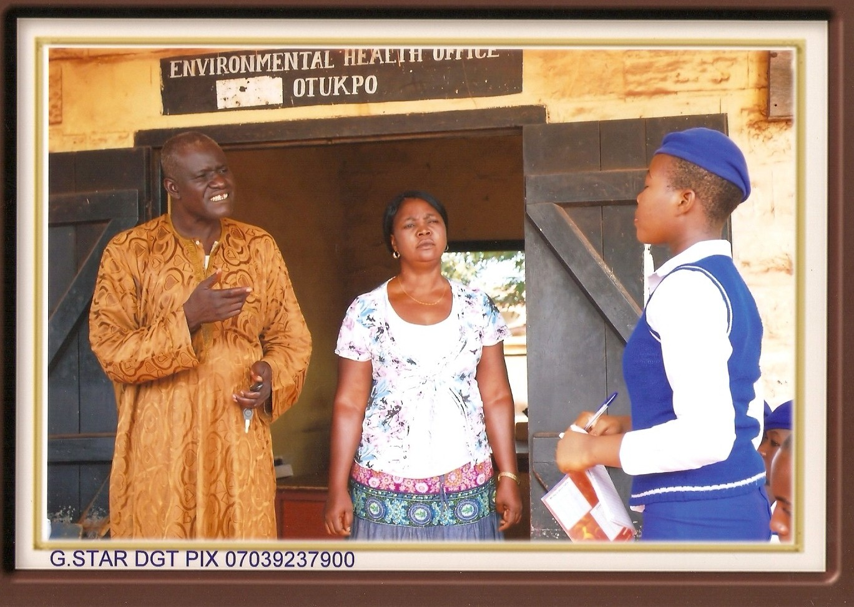
Image 1: Chief Environmental Health Officers respond to student questions.
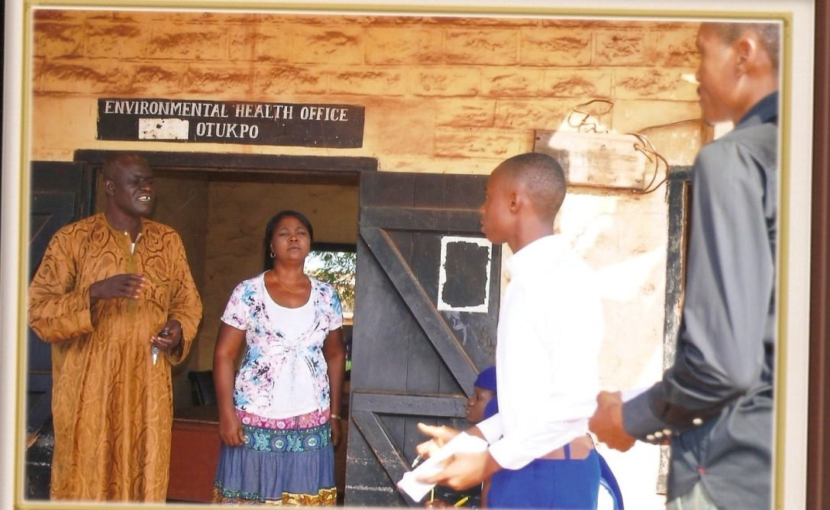
Image 2: Chief Environmental Health Officers respond to student questions.
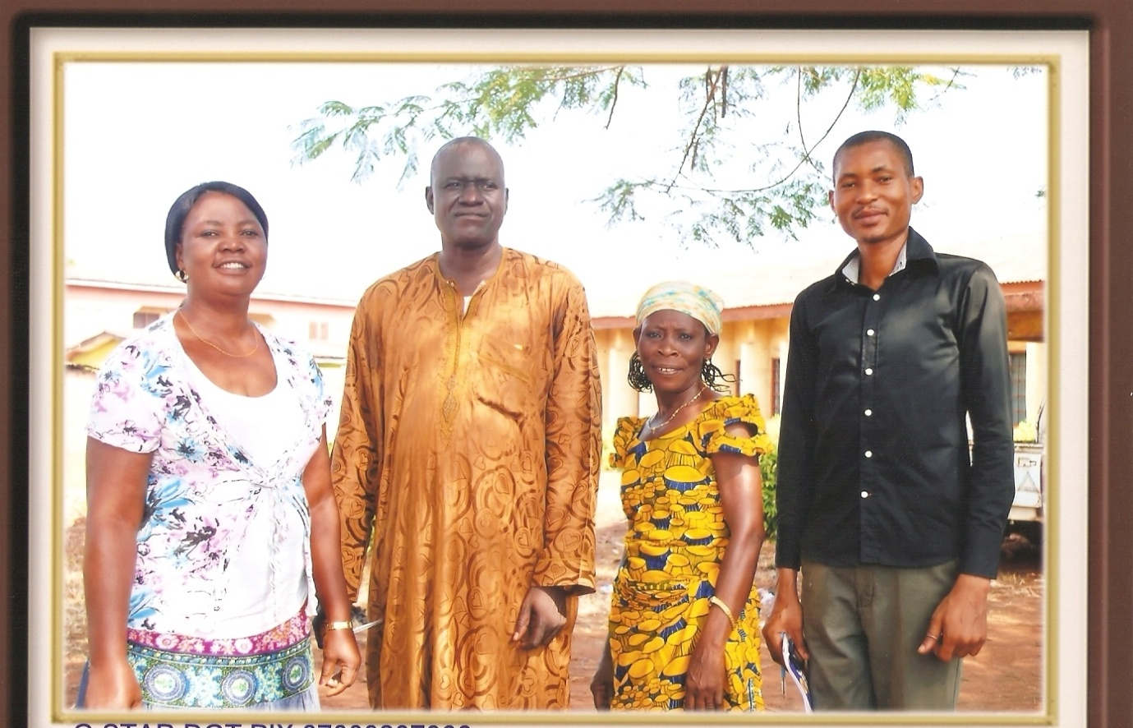
Image 4: Environmental Health Officers with iEARN Teacher (far right)
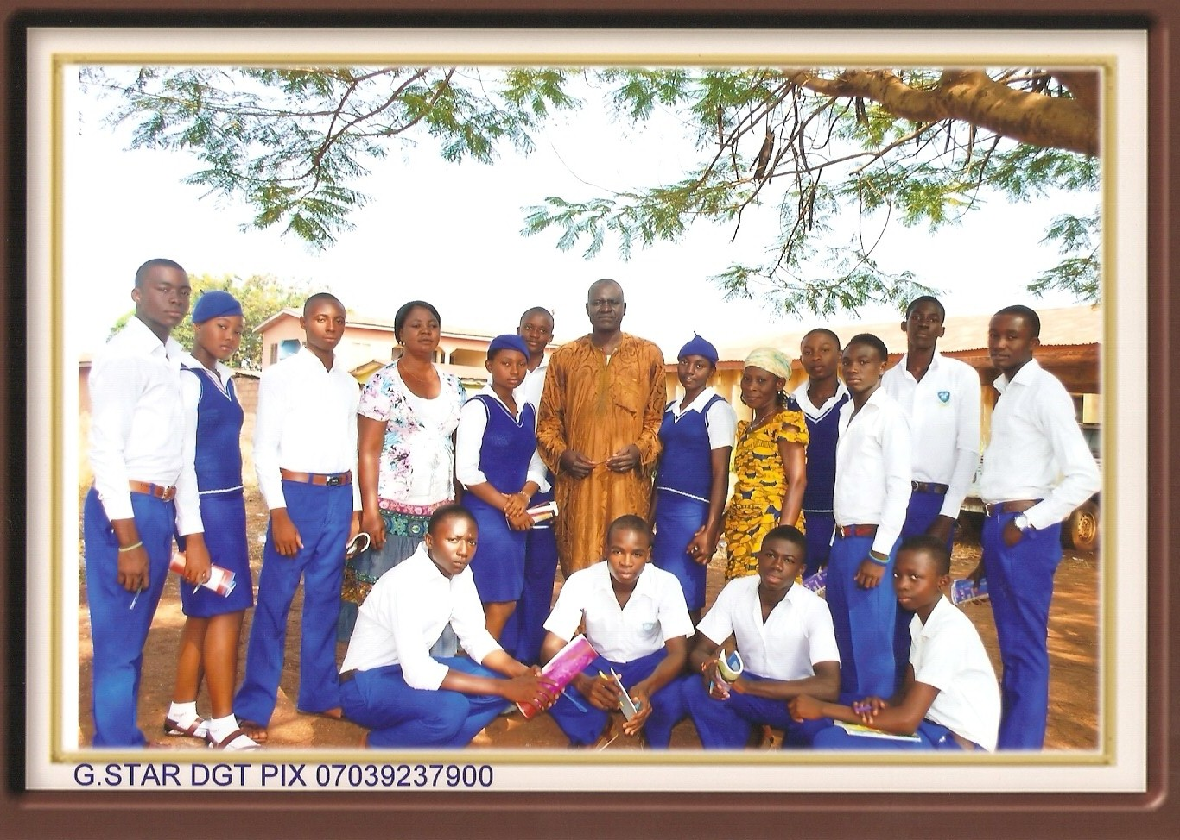Image 5: Environmental Health Officers with iEARN Health Team
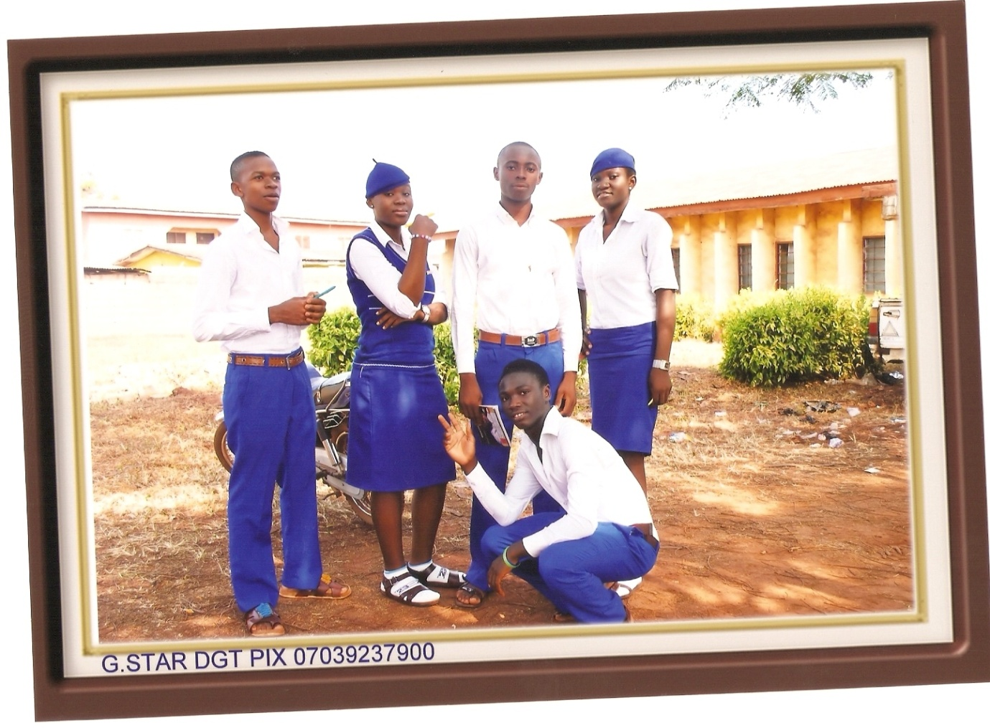Image 6: iEARN Health Team (above); iEARN Members dress in native attire (below)
Image 7: iEARN Health Team.
THE END

