PUBLICATION FROM KATSINA COLLEGE KATSINA
COMPUTER CHRONICLES HIGH SCHOOL
KATSINA STATE
NIGERIA

CONTENTS
- FRONT PAGE
- TO OUR READERS
- NAMES OF THE STUDENTS
- INTRODUCING THE CLASS
- INTRODUCING THE SCHOOL
- INTRODUCING THE COMMUNITY
- WEDDING CEREMONY
- BURIAL CEREMONY

TO OUR READERS

The teacher and students listed in this
Publication worked together in a Learning Circle called [COMPUTER CHRONICLES HIGH SCHOOL] , they worked cooperatively and shared together a new form of teamwork.
This teamwork was made possible by links between computers and the work of
the teacher who helped his students participate in this exciting new
form of learning.

Students typed their messages on their classroom computers and then, using
modems sent their messages to all of the other
classrooms in the Learning Circle by typing a single command on their
computer. Just as easily, they were able to receive messages that were sent
from these distant locations and different time zones.

Their first messages were class surveys in which they described themselves,
their schools and their communities. Once they learned a bit about one
another, they worked together to design Learning Circle Projects. The
results of these cooperative projects make up the content of this
publication. While this publication marks the end of their time together,
for many it also marks the beginning of a new pattern of teamwork over
distances. This cooperative work across geographic and cultural boundaries
is likely to play an increasingly vital role in all aspects of the future.

We hope you will enjoy reading the work of our students.

TEACHER

NASIR DANZARIA

CCH

KATSINA COLLEGE KATSINA

NIGERIA.

NAMES OF MY STUDENTS
1. NASIBA ISHAQ
2. RUFAIDA BISHIR
3. RUKAYYA MUKTAR
4. HAUWAU KHALIL
5. AMINA SHEHU
6. HALIMA AHMAD
7. AISHA GIDE MACHIKA
8. AMINA SA’IDU
9. FATIMA ISMAIL
10 .UMMA AHMAD IFO
11. FATIMA YUSUF RABE
12. SUMAYYA ALMUSTAPHA
13. AISHA USMAN
14 .HALIMATU SANI
15. USMAN HAMISU
16. USMAN ISHAQ
17. USMAN NASIR
18. USMAN SULAIMAN
19. MUHAMMAD TANIMU KAKA

The Classroom Survey

PART I. INTRODUCING THE CLASS
A. Name of teacher: Nasir Danzaria
B. Grade level:15-18 years
C. Class favorites (List your class top 5 favorites in each category):
1. Music groups : Traditional music such as Sa’adu Bori ,Dan Kwairo, Shata ,Dan Ibro and Michael Jackson.
2. Authors :Evans Nigeria L t d, Yusuf Ali ,Chinua Achebe ,Mahmud Gumi .
3. TV programs: Drama, News and comedies.
4. Foods: Tuwo (made from maize and corn),Fura ,rice, beans, yam, cassava e.t.c
5. School subjects: English language, Hausa, Math, Chemistry, Physics ,Islamic Studies, Economics ,History, Geography ,Biology, Agricultural Science, computer Sciences.
6. Sports: Football, basketball. Hockey, table tennis e.t.c
7. Video or computer games: Free cells ,Spider solitaire, Minesweeper, Sonic, Ultimate mortal combat .
8. Favorite Websites: 2go,games, education, Sefan.
9. Other Class Favorites of your choice: Going for excursions and attending traditional activities. Other student’s activities include impromptu speech as follows: 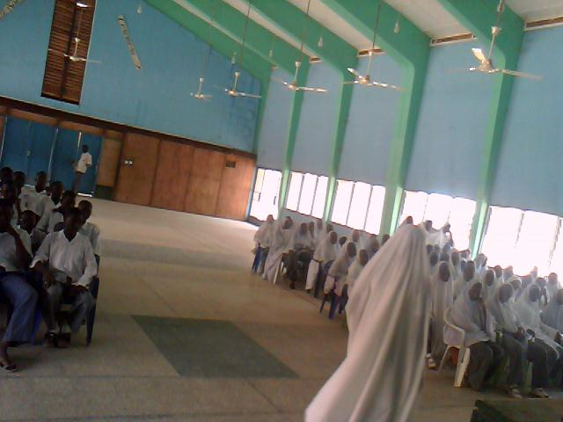
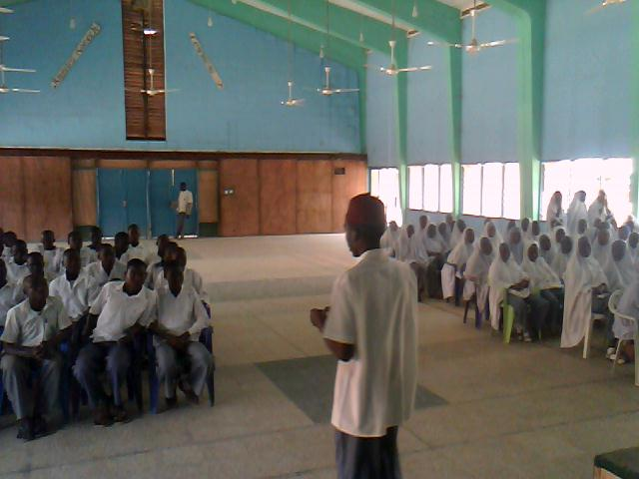

PART II. INTRODUCING THE SCHOOL
A. School information
1. Name and address of class and school : Katsina college katsina p.m.b 2008.
2. Number of students in class and school : Number in class = 50 – 60.Number in school about 2000.
3. Size of school : The size of the school is so big.
4. School emblem, colors or mascot: Our school emblem is :

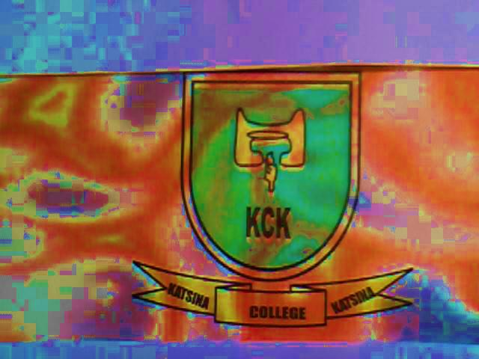

5. Type and number of computers: 25, Desk top speed star and 2 HP Lap top windows 7 for teacher use.
6. School history: Katsina college katsina was formerly known as katsina Teachers college. It was started as Elementary Training Centre in 1929 providing 3 years training to students leading to a Grade III Certificate. In 1949,Higher Elementary Training Centre was opened awarding Grade II Certificate very close to the college. In 1950 the two colleges were merged and were under the supervision of Mr. J. J Williams.
The name of the school was recently renamed by the state government as Katsina college katsina. It is a government owned school. The current Principal of the college is Isyaku J Bello.
B. School program
1.List 3 things about your school program that make it unique.
- Disciplinary subject taught in it
- Debates and quizzes conducted in the school
- Dedicated staff
2. List school calendar from the session dates (holidays and special events that may affect your participation).
None

PART III. INTRODUCING THE COMMUNITY
A. Your community
1. Name of your community: Hausa/Fulani
2. If not a city, name and size of nearest city : Katsina city
3. Location of your community: Northern part of Nigeria
4. The area of your community: The area is so big.
5. The population of your community: 2 million people.

B. Special characteristics
1.List 3 reasons why people come to visit your area.
- Traditional activities such as traditional boxing and traditional wrestling
- Traditional festival i.e Sallah festival and Hawan Daba
- Is an ancient city with historical places . This is our Emir’s Palace gate.
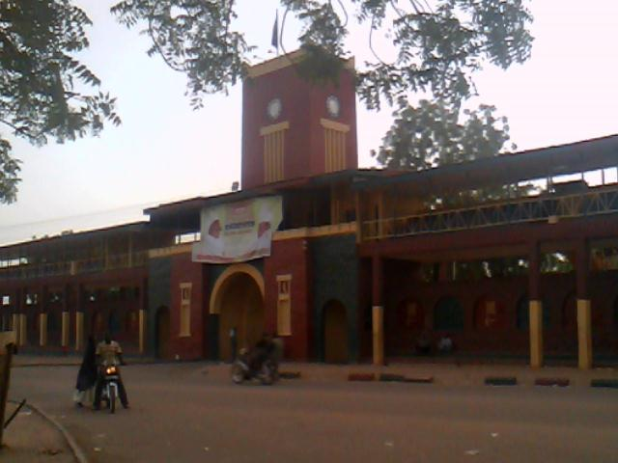
2. Describe any unusual land formation found in or near your community:
None
C. Industries
- Farming
- Pottery making
- Dying
- Craft works
- Cattle Rearing
- Poultry
This is a section of our local Market below:
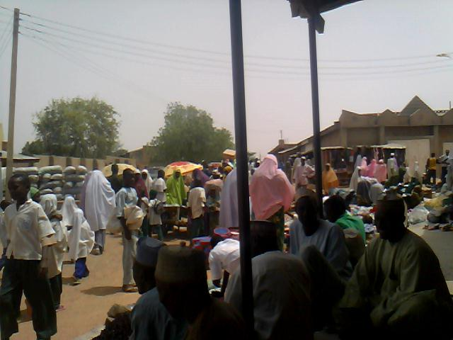

PART IV. OTHER INFORMATION
My community is a Muslim community comprising Muslims and Christians, we live, trade and learn together.

WEDDING CEREMONY
In our area wedding ceremony is an activity which took place when there is a mutual consent between a man and a woman who agreed to become husband and wife. The marriage contract must be witnessed by certain male witnesses in front of the guardian of the wife and that of the husband.
It is normally conducted in a Mosque or outside the house of the guardian of the bride.
People especially friends and relatives gathered in that place in order to witness the marriage contract. Cola notes were distributed during the wedding ceremony and then prayers were offered for the successful marriage life of the couple. Then people depart to their activities.

Women both young and old gathered in the bride ‘s parent house to celebrate the marriage ceremony, different types of food were brought by friends and relatives to the bride’s house.
Then in the night the bride would be escorted to the bridegroom’s house by her friends and relatives.
. 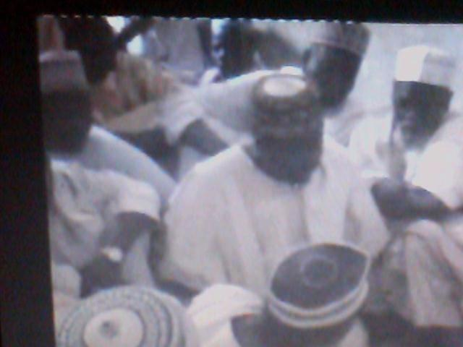WE

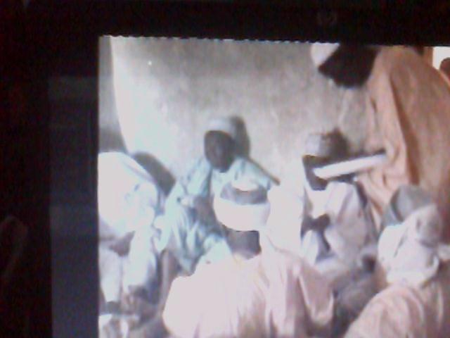
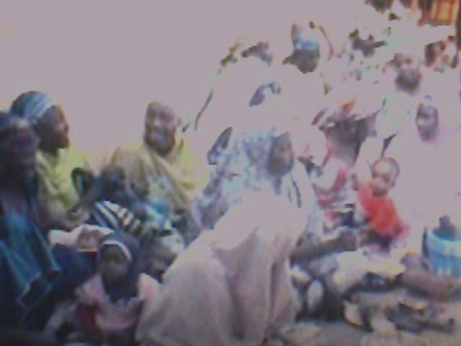
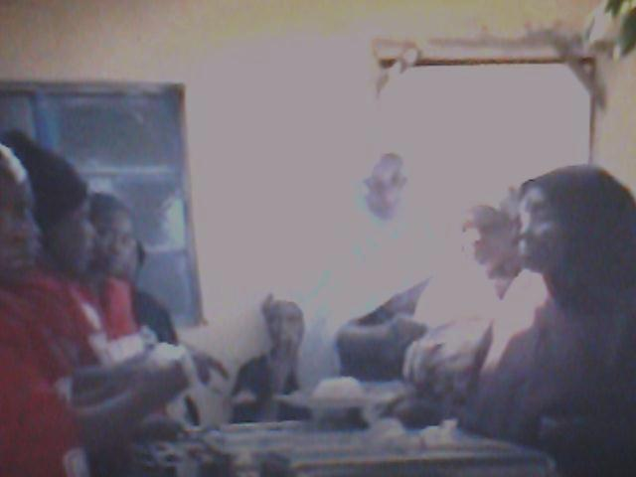

BURIAL CEREMONY
In our area when a person is dead , people will be shocked and with grief especially those that are close to the deceased i.e friends and relatives .Immediately the death is known/ascertained ,close relations ,friends, Muslim brothers and sisters will converge to the deceased ‘s house for preparations of his burial . No much time is wasted ,immediately the death has been confirmed the preparations begun.
The deceased body will be washed by his relations according to Islamic rites, then a white wrapper will be used to cover the whole of his body.
Then he/she will be put into a traditional stretcher and will be taken out from his/her home for the funeral prayer. The Imam and rest of the Muslims will put the dead body in front of them and start the prayer which is purposely for seeking forgiveness to the deceased.
After the prayer ,the corpse will be taken on shoulders and on feet to the grave yard where the dead body will be laid down in his/her grave. The grave will be covered with broken pots and wet sand and elevated up a little for identification. No cement is required and no any expenses is required in digging the grave but only volunteers who were given incentives if so wish as charity.
After the burial , prayers were again offered in the grave yard and in the deceased house after returning back. Friends and relatives will stay at the deceased house for at least three days receiving condolences from people.
The burial of a deceased took place on the day in which the person has passed away, unless it happened in the night.
NB: Friends and relations will be In grief and sorrow during a burial ,up to the end of the burial, so it is not easy to snap or record a video at that time, and our custom did not support that. We have tried much to do so but we are unable to do so .
With best Regards to all participants.
NASIR DANZARIA
COMPUTER CHRONICLES HIGH SCHOOL
KATSINA COLLEGE KATSINA
NIGERIA.

.

