IEARN LEARNING CIRCLE PROJECT JANUARY – MAY 2013
PUBLICATION FROM SCHOOL "GHEORGHE LAZAR" CORBU (ROMANIA).

CLASSROOM SURVEY
Circle name: Computer Chronicles
Grade: first grade ( 7-8 years)
Schools: Middle School "Gheorghe Lazar" Corbu
PART I. INTRODUCTION CLASS
A. Name of teacher: Luminita Agiurgioaiei
B. The class: primary
C. Preferences class (List 5 favorites in each category):
1.Grupuri music: Vank, Mandinga, LaLa Band, Voltage
2. Interpreters; Şachira, Puya, Smiley, Antonia, connect R
3. Authors: Ion Creanga, Elena Farago, Alecsandri, Hans Christian Andersen, Brothers Grimm
4. TV: Disney Channel, Disney Junior, Boomerang, Cartoon Network
5. Dishes: soup, pitzza, fries, rice, rotisserie chicken, pancakes, spaghetti, eggs, beans
6. School subjects: ed. Physics, ed. technological lb.română, mathematics, religion
7. Sports: football, volleyball, ballet, ballroom dance
8. Video or computer games: gta vice read, Madagascar, Zuma, counter strike,
9. Favorite websites: Y7 / 8, friv
10. Other preferences: hiking, cycling, care of animals / plants
PART II. ENTERING SCHOOL
A. Information about the school
1. Name and address classroom and school: Str. Main no. 27, Corbu Jud. Constanta
2. Number of students in class and in school: 18 students per class, 359 students in the school
3. Size of school: The school has 8 classrooms, library, physics, chemistry, biology laboratory, office of history and geography, computer room, gym, office managers, secretaries, file
4. School emblem, colors or mascot:
5. Type and number of computer: lenovo -21, but now not connected to internet
6. School History:
B. School program:
List 3 things about the school program that make it unique school program is conducted in two shifts: morning 7.50 - 11.30/12.20 - Classes I-IV, afternoon 12.30 - 17.00/17.55
List special dates on the calendar that are included in this session :holidays April 6 to April 14)
PART III. INTRODUCING COMMUNITY
A. Your Community
1. Community Name: Corbu
2. If it is not a big city, name and size of nearest city
3. Constanta-Is the county seat
4. The surface of your community: Corbu is 23 km north of Constanta and is bordered to the south by the administrative territory of Năvodari, west, north and east part of the administrative territory of the commune Săcele and east of the Black Sea. Corbu area is 11 804 ha and administrative area amounts to more than 20 000 ha.
5. Your community population: 5261 inhabitants, of which 2701 males
and 2560 girls and women
B. Special Features
1. List 3 reasons why people come to visit the area: Corbu is a border town "Delta Reserve", with numerous tourist attractions: the area can practice sport fishing, Corbu beach is close to town and offers peace and privacy no other beach in our country can not provide the Vadu find both peace and forest shade, coolness and sea murmur and thrill games green grass in a sunny day. Another place worth visiting is the micro zoo from Năvodari entrance.
2. Describe any existing party in or near your community
If you have not ever come Chituc is hard to imagine that in Romania there can be such a wonderful place like a loose piece of heaven, sand as the eye can see fine as there is no other on the Romanian seacoast , large, clean and incredibly blue, birds of different species (289 Grind identified protected species), quiet as there is in any other place on the Black Sea ...
Corbu beach is a place frequented by practitioners water sports, such as windsurfing, kitesurfing, sailing sports, diving, snorkeling, sport fishing. Corbu beach offers the opportunity to relax, rest beachfront or passive and active recreation - new entertainment places nearby. Pension in the village with boats water sports: kayaking, canoeing, wind surfing, sailing boats. Sports practiced with certified instructors and suitable for all water sports equipment. You have sports grounds with lawn specially designed for soccer, volleyball, field tennis, badminton, table tennis, archery, bike riding a bike, horse riding Pentre. Corbu Lake angling is practiced on the farm, the necessary being made dispoiţie away. Can be fished species like perch, carp and carp. Fishing is allowed on board as tourists stay and casual visitor fee and under certain conditions.
C. Industry: Petrolifera, tourism, ship building
List the main industries, corporations or occupations in your community
Corbu entered the map construction materials industry with the most modern lime plant in Romania. Investment worth 20 million euros, belongs to the company "Celco" SA Constanta first brick manufacturer in the country.
PART IV. OTHER INFORMATION
You are free to share any other information about yourself that you think would help us to know you better.
Our mission as educators is to help students personality development, form healthy young generation to occupy an important place in the cultural and social life of our community.
Disclaimer
- Enlist deeply into everything you do and realize your not half anything.
- Try to believe strongly in success.
- Make use of your talents, but to learn and grow.
- You have more confidence in yourself and be aware of what needs to be corrected or improved.
- The more you realize this inner strength that dwell in you the more you will succeed as you planned.
PROJECT IDEAS
Group Learning Circle: Computer Chronic primary school
Professor : Luminita Agiurgioaiei
School : "Gheorghe Lazar" Corbu
City: Corbu – Constanta
Country: Romania
Project Name: Leisure
The goal of our project: Sharing ideas about spending time after school
• The type of writing required: MS Word or Power Point
• Description of what we are looking at other schools: We want to hear from other schools, which takes place after-school activities.
• Questions:
1. What do students after school?
2. Who spend their free time after school?
3. Who would like to spend more tmip?
4. Have binding activities? (Sports, dance, music, etc.).
5. Why play games?
6. We can learn a game?
Preferred length of articles: Short and precise
We look forward answers.

CONTRIBUTION IN OUR PROJECT – “Leisure”
We live in the country.
After school we played outside, when the sun shining.
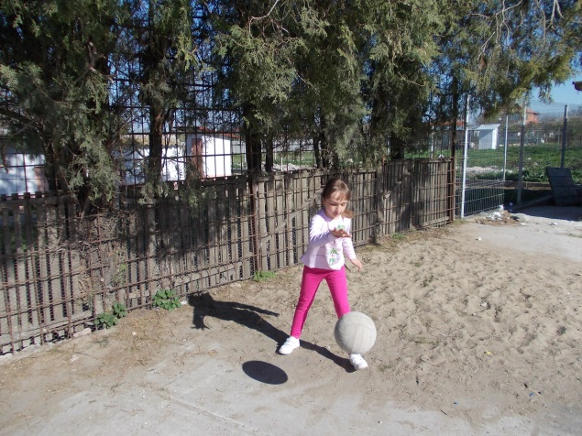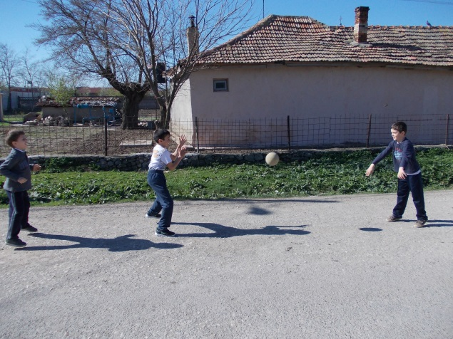
ball game ball game
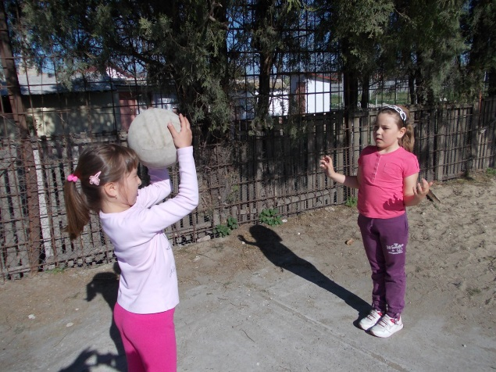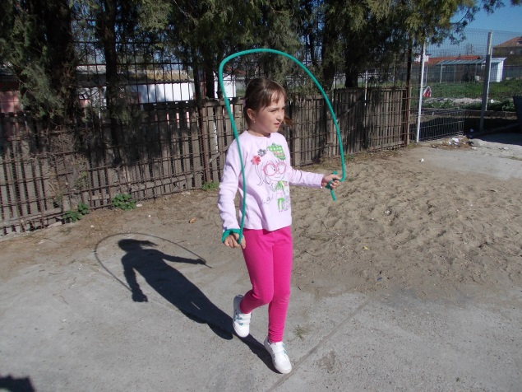
ball game jumping rope
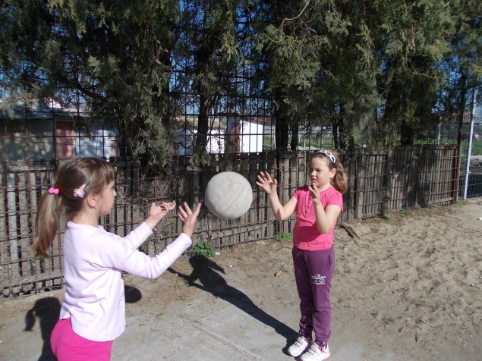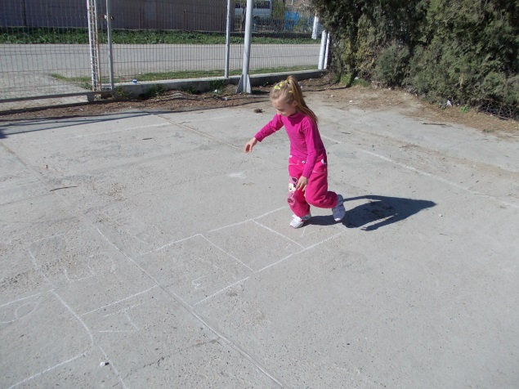
volley-ball drawing game – “Sotron”

CONTRIBUTION IN OTHER PROJECTS
1. CAPITAL CITIES (Anglia- Stephanie Ladbrooke)
- Bucharest is the capital of Romania. It is the largest city, industrial and commercial center of the country.
- Population of over two million residents is the capital Bucharest is the sixth largest in the European Union.
- The first mention of the town appears in 1459.
- In 1862 it became the capital of Romania.
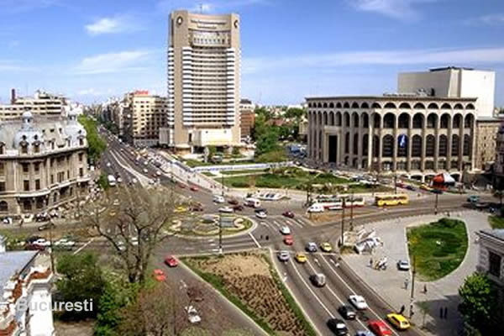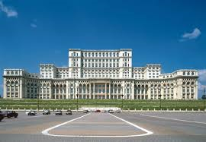
international hotel the houses of parliament

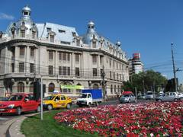
university of Bucharest

2. FEMALE STUDENTS PERFORMED BETTER THAN MEN (Nigeria-Nasir Danzaria)

In Romania, girls and boys have the same rights.
In our class we do everything together:

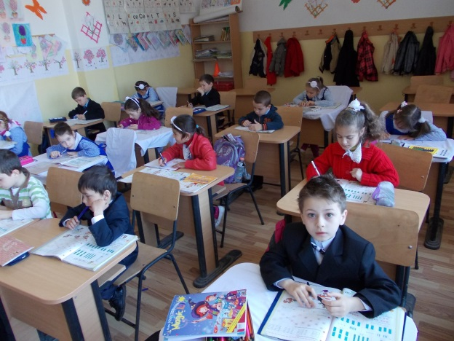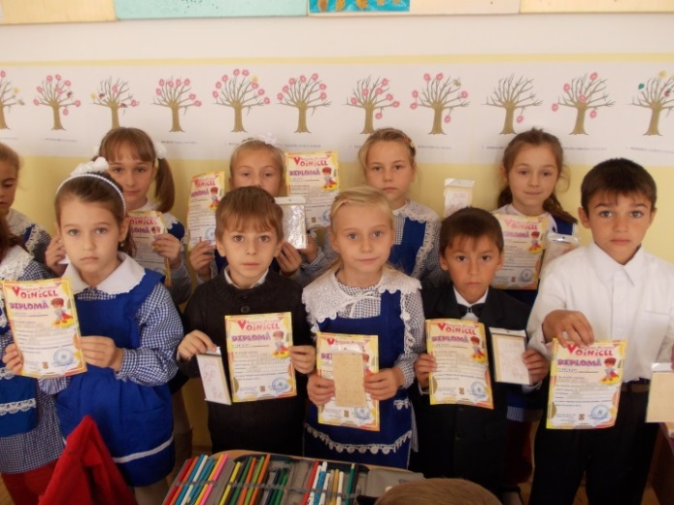
Studies Won awards in competitions
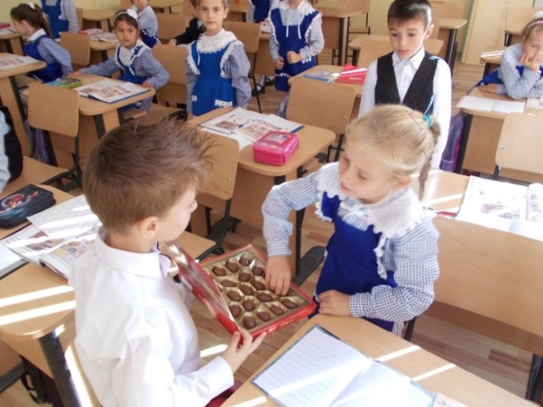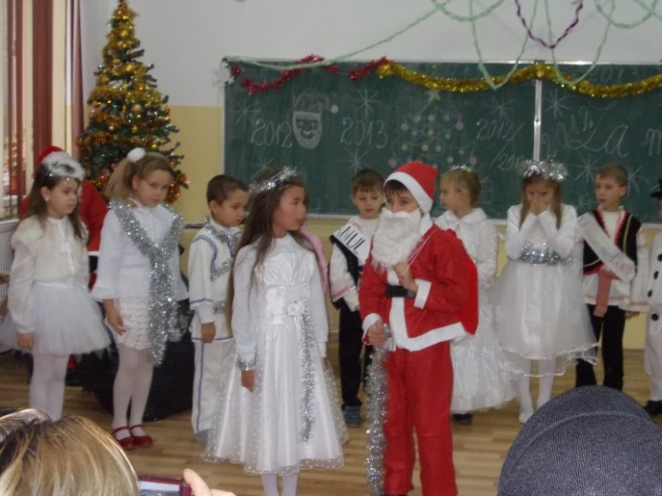
Birthdays We feast of Santa Claus

3. Historical and cultural heritage (Brest, Belarus- Yuliya Shileeva)
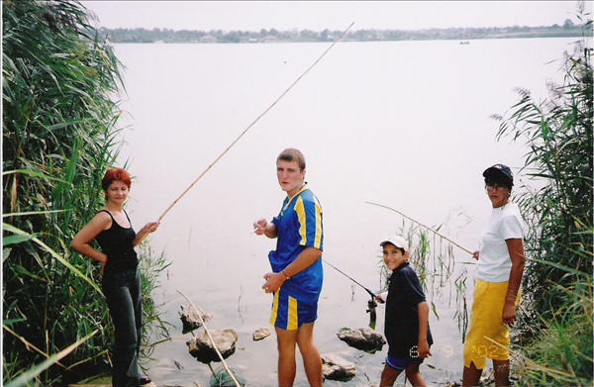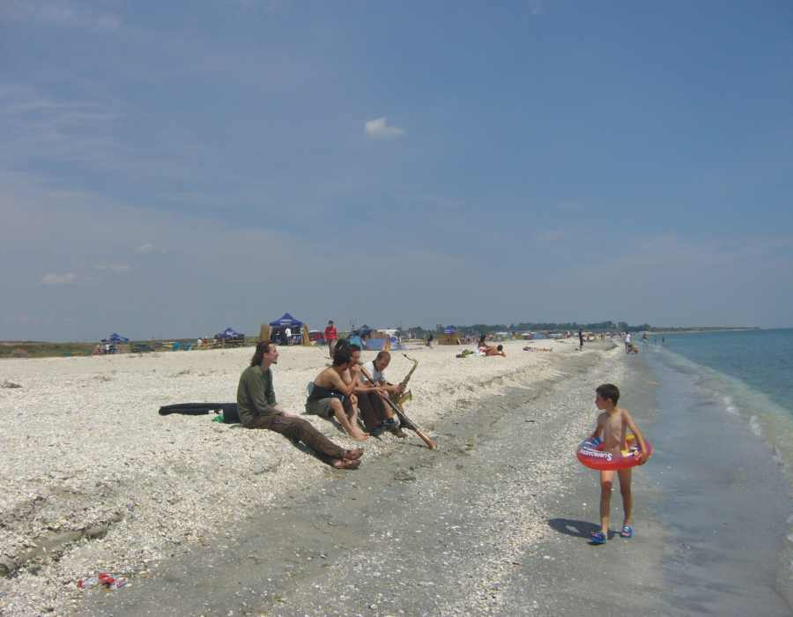
Corbu Lake angling is practiced in the loft, The beach at the Black Sea.
the necessary device of pension being made​​.
Different species can be caught.

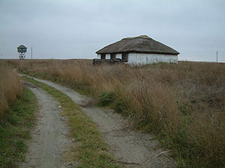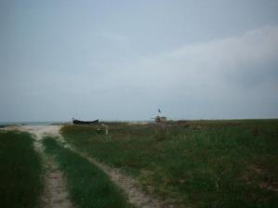
Chituc is a marine-type grind sandy lagoon, composed of Holocene-aged sedimentary formations, marine coastal belts (sandy deposits of mixed origin marina and lagoon). Which means it was formed by depositing silt brought by the Danube River on the way to the Black Sea.

4. SOCIAL PROBLEMS OF YOUTH
My kids worked on the project proposed by Nadejda Salikhova:
Large group had just finished and I was on summer vacation. Then I met a girl younger than me by two years who was abandoned by her mother since she was a year and a half. It was and is raised by her father as could be because not a place munca.Cu However it is registered and attending regular kindergarten.
I was surprised when some children are not raised by both parinti.Eu thought to all children is like my family, like all girls have what they want, are protected and feel real princesses. I thought when you can feel it when he sees around other children or their mothers hand when he takes in his arms and kisses her.
But when mom is sick and is not to hold her close to courageous? On celebration March 8 can not look into your eyes when my mother reciting poetry as well as her colleagues! . I was at home to know better and saw that has very few toys and clothes compared to mine.Este a very sociable girl, we played together and we hardly despartit.La next visit I provided toys, shoes, sweets and many of my lovely dresses that i could not wear them, but they made ​​them great joy. Now she feels a little princess.

Victoria

This year, a few weeks before spring break I met and visited with my parents two sisters who lived in my grandmother because their parents did not have a house of their own. Had eight and seven ani. When I saw how poor some people are. They had no heat, electricity, had their room and even TV. The clothes were very old and broken.
We found that never went to kindergarten or school. Did not even have a toy. Grandmother does not have a job. Working on the neighbors that you have to give them food. However, they were very happy with my grandmother were very smiling, and glad to have a house to live. Do not understand how they can be so happy with so little, and I often, though parents strive to have everything I need, I sometimes feel unhappy!
It was a real lesson for me happiness when I saw that you do not need the most expensive Barbie doll that you can be a happy child.

Miruna

5.LOCAL MYSTERIES OF NATURE
My kids worked on the project proposed by Linda Giesen.

Chituc has a rich flora and fauna.

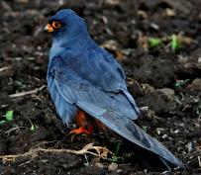
Red-footed Falcon, female
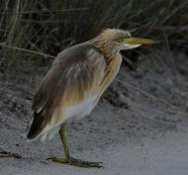
Heron Yellow
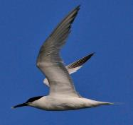
Tern

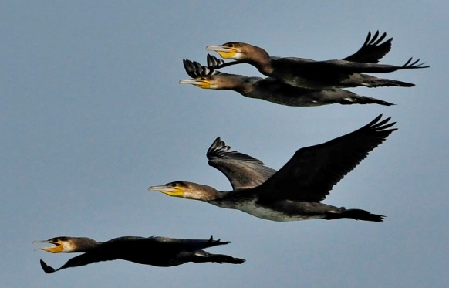
Great cormorants
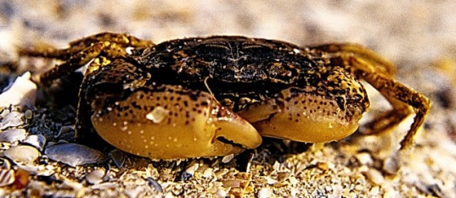
Crab
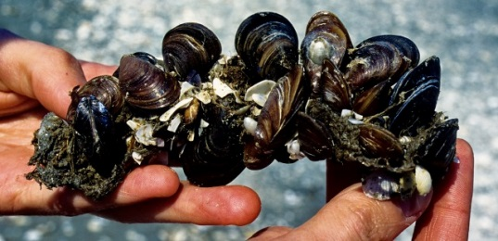
Mussels
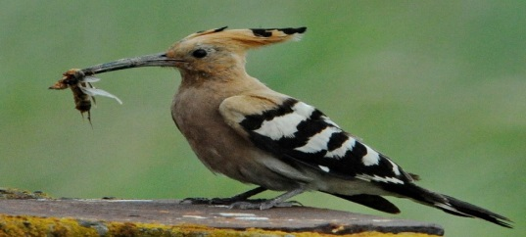
Pupaza

CONTRIBUTION OF OTHER SCHOOLS IN LEISURE PROJECT
1. After School Activity ( by Linda Giesen)
After school we play basketball, soccer, volleyball, tennis, piano. Also we practice martial arts, swimming, drumming, and Chinese. Lately we also hang out with our friends.
Who does it?
- We all do something with our free time.
- Some of us practice music, while some of us play sports.
- Most of us hang out with our friends
More time
- 12 out of our 22 students want more free time to do after school activities.
- 10 students don’t want extra free time, because they think they have enough time.
Our sports
- The binding activities we do include practices and games that are predetermined by coaches from the YMCA (young men Christian association), but they include girls, too. Basketball, martial arts, soccer, volleyball, football, and tennis are the sports we play.
- Some of us do drumming, dance, guitar, honor choir, and piano which are part of the visual arts.
Why do we play?
- We play games , because it is entertaining.
You can learn a game
- The game that probably would be easiest and most entertaining would be basketball.
- It is our classes favorite game.
- After School Activities
- After school I do my homework. As soon as I finish my homework either I go to a sport or play outside with my friends. On days that I don’t have anything to do I will invite a friend over to play. On Tuesday I have volleyball and my friend Madison comes over. We do homework, and then we make a video star. It is a video that you make, and then you put it with a song.
- - Ryan H.

After school I go to after school care. After school care is so fun. In after school care we get our homework done and then we can go outside and play. My opinion is that After School Care is awesome.
- After school Activities
- After school, I do a sport called cheerleading. It is a fun sport where you lift people in the air and they do tricks. I enjoy doing cheerleading because I have a great team and it is fun. I have a great team because they are always nice to me and help me when I need it. It is fun because I like to lift people in the air while they do tricks.

Basketball
I have been doing basketball since I was three. I play basketball in my backyard with my family a lot. It is my favorite sport especially when it is the season to play on a team. In my opinion basketball is the best sport ever and I am never changing that.
After school Activities
Ring! School is out! I’ve got to get ready for lacrosse and then basketball. I put on my lacrosse gear and head to practice. Practice is 90 minutes long. When it’s over my mom picks me up and we go to my basketball game. When the game is over I go home.
Hockey
After school I run to my parent’s car to go over to my hockey rink. That’s right. I play hockey, and I bet you thought that there was no hockey in ol’ hot Texas. Well there is! We’re pretty extraordinary too. We won the league last year and our higher level team won the National Championship for 18U. But I’m getting ahead of myself again. I mostly play hockey every day after school. On Monday and Wednesday I have practices and on Tuesdays my team and I go to a training facility and work out doing stretches. Though, on Thursdays and Fridays, I get the day off after school. I love playing Hockey!
After school I do my homework then I go straight to my Volleyball practice. Volleyball is my favorite sport, because it is fun and you don’t get hurt as often because the ball is soft. I have at least 10 people on my team. So far my Volleyball team is undefeated. I think I am a great server because almost every time I make it over the net. On my first game I made 9 points, and almost all of them were made by my serves. My coaches name is Coach McCray. He is a great coach.

2. “Leisure” Presentation from Katsina college Katsina .Nigeria (by Nasir Danzaria)

WHAT DO STUDENTS DO AFTER SCHOOL?
WE go to our various homes because we are day students and attend Islamic schools, and after the school we went to play.
HAVE BINDING ACTIVITIES? (SPORTS, DANCE, MUSIC, ETC.).
On Thursdays and Fridays and other free times of the day , we went to play football
WHY PLAY GAMES?
We play games to:
Enjoy ourselves
To get more hygiene
To be together with our peer group
Because is a physical exercise
Because all work and no play makes kid a doll boy.

