Earning Money
We(Kate, Kira) earned money . In our city teenagers earn money during the summer. They can go to gather mushrooms and berries. Also some may advertise or to distribute advertising. Last summer we didn't earn much money. 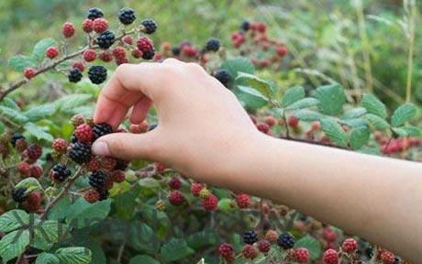
We went to the cinema when we earned our first money. 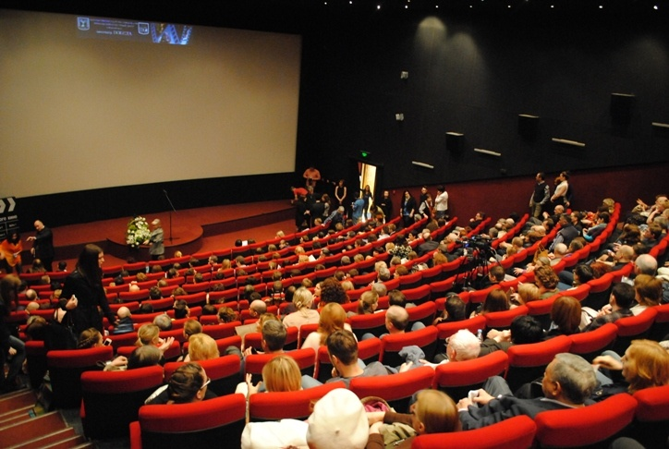
We work during vacations to earn some money. Some our classmates worked in summer to earn some money. We try to earn money because we want be independence. Once we participated in action to help people. We think actions is very important because we can help people and animals.

