The process of language learning
English has become a very important language all over the world and it also gained importance in our country. The official language in Slovenia is Slovene, but since our country is small and Slovene is spoken only by about 2.3 million people, English became a language in which we can communicate with people from other countries. We are also surrounded by English in everyday life. Most movies and TV-series are British and American and are not synchronised into our native language, as it happens in some other countries. We mostly listen to English songs, we read books in English (because the selection of books translatedinto Slovene isn’t that great), and we use websites in English, since few of them offer a Slovene language option.
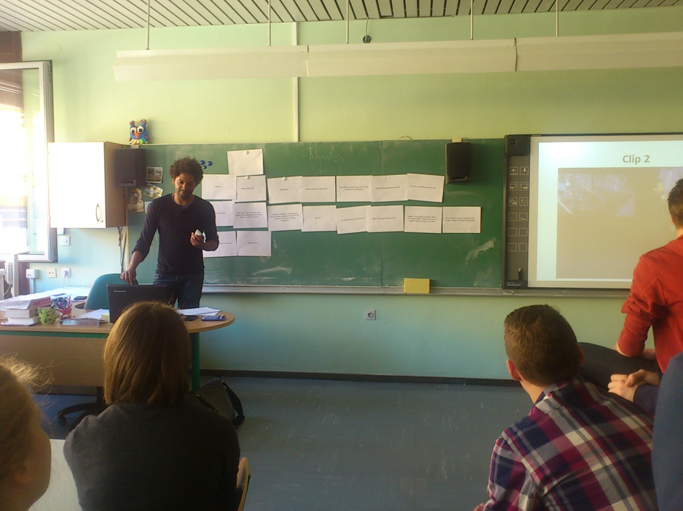
Slovenian children start learning English in the 4thgrade of primary school when they are 9 years old. Since last year English has gradually been introduced in the 2nd grade already (7 year-olds). Learning starts with simple forms and easy vocabulary and it intensifies throughout the years. Most schools also have programmes that include foreign teachers, native speakers usually from English-speaking countries.

Felipe, a foreign teacher from Namibia, during his English lesson in April 2015
In the third (last) triennium (the 7th, 8th and 9th grade)of primary school and in high school can students often choose the option of foreign exchange with a school in another country.
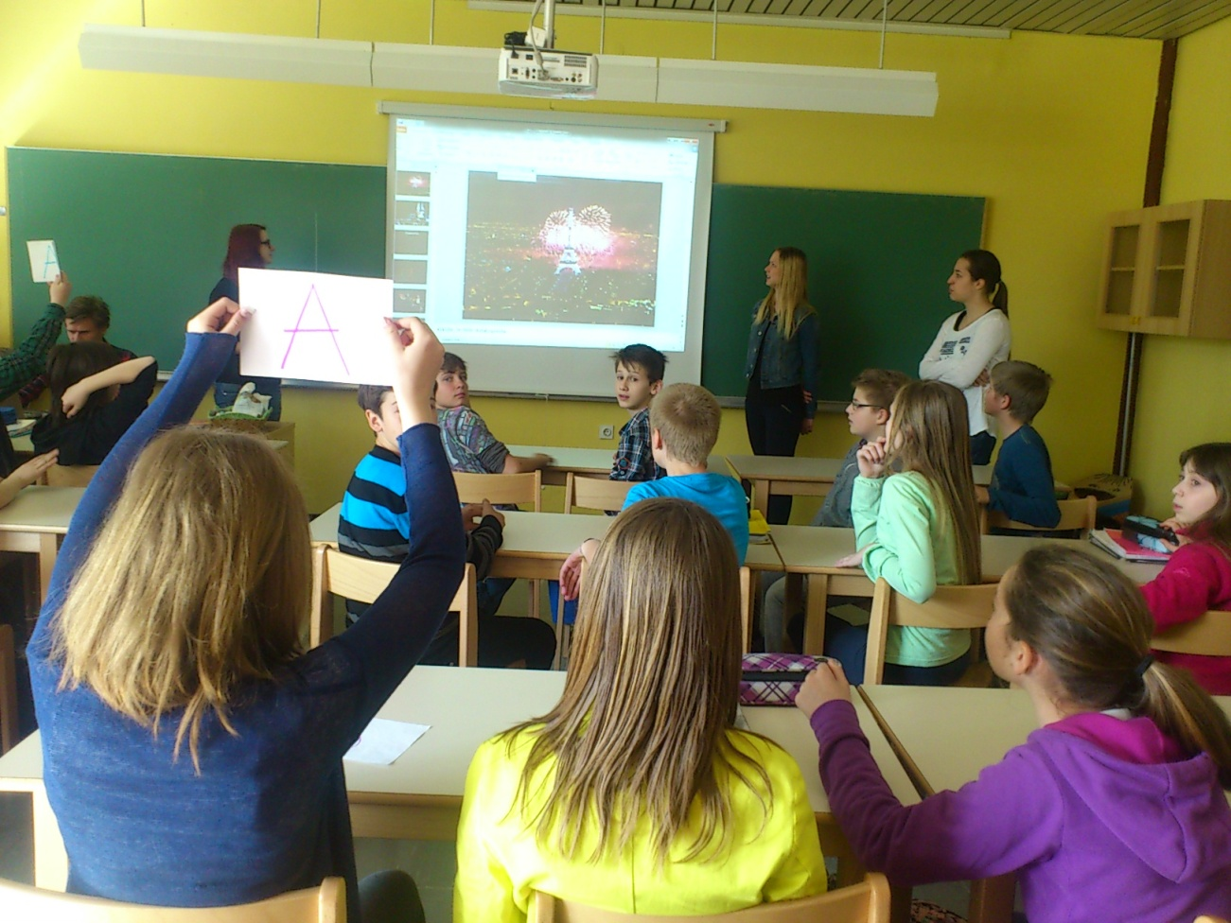
Senior students from our school during their activities with young learners in primary school
(presenting the French culture), April 2015

Our school is a secondary school and it’s called “gimnazija” in our language. Schooling in this type of high school lasts for 4 years and it ends with the matura exam (the equivalent of British GCSE). English is very important and is one of the 5 foundation subjects on the matura exam. We have English lessons three times a week, one hour less than lessons of Slovene, our mother tongue. Lessons are mostly given in English, with a few teacher’s translations into Slovene. English lessons are usually consist of learning grammar and vocabulary. For a few hours in a row we learn vocabulary on a certain theme (like food, clothes, superstitions, etc.) and how to talk about that theme in a more complex way. When we finish a theme, then we usually take some time for grammar. We learn new sentence structures, use of tenses and other specific structures. Our lessons are not focused on spelling and pronunciation, but those are learned along the way.
We asked our classmates what they thought of English lessons and asked them to compare it with the Slovene lessons and lessons of their second foreign language (which is required in all schools like ours), that is either German or Italian.
Most of them find English lessons harder in comparison to Slovene, as they don’t understand the words and tenses and it doesn’t come as natural to them as Slovene, their mother tongue, does. However, some of them find it easier, as the lessons don’t include as much literature study and they think that Slovene goes more into the details than English.
More than half of them answered that they find English lessons easier than lessons of the second foreign language. The reason is probably that we have been studying English for 9 years, but most of us only started learning our second foreign language in the 1st grade of high school when we were 15.
When asked what they find more complex; vocabulary, grammar or pronunciation, almost all of them answered grammar, while no one chose pronunciation. Most of them said that they learn enough in school from teacher’s explanation and they don’t have to study a lot at home. Some said that learning depends on their mood and their willingness to listen to the teacher and the teacher’s mood. While learning at home they use notes and their workbooks and textbooks. They learn by repeating and reading out loud, doing exercises and also by watching movies and listening to music.

Our school (“gimnazija”) is considered to be quite difficult since it provides mainly academic knowledge and it enables us to go to university. We are expected to have better knowledge of English in comparison to students from other schools that put more emphasis on other subjects. Therefore, the system of learning is designed for students who have fewer difficulties with understanding foreign languages, so students who are not fond of languages might have some problems. All in all, the process of learning the English language in our school may be slightly different compared to other schools in Slovenia and in the world, but the results are still very satisfying.

