Old and modern money
The history of the Belarusian bank notes ... The emergence of such banknotes Belarus began with the collapse of the Soviet Union. The National Bank of the Republic of Belarus May 25, 1992 has issued paper banknotes in rubles and kopecks. In the image of hare on the Belarusian ruble banknote money are called "bunnies". In addition to banknotes were depicted different animals: beaver, squirrel, wolf, bison, bear. What did bunnies start with? Soviet ruble! Belarus did not use coins, but paper money.
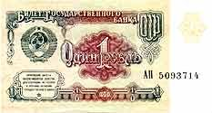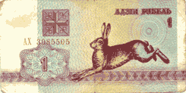
These bunnies looked as follows:
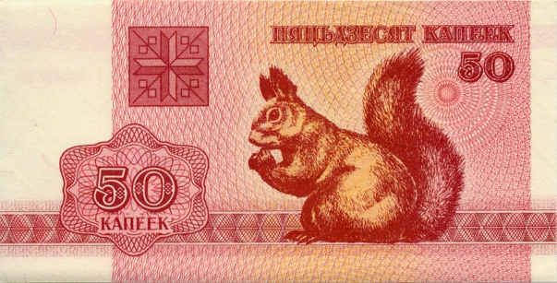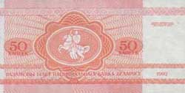
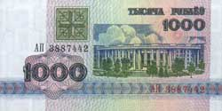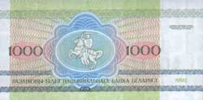

We asked classmates: they keep at home old money. Only 40% of the class have at home the old banknotes.
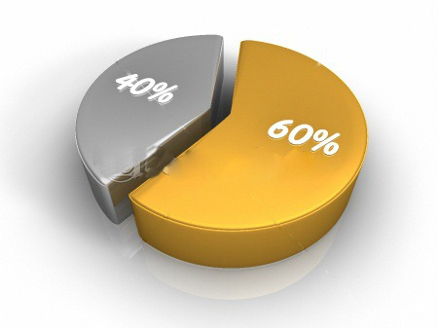
The smallest banknote at that time was 50 roubls, and the largest, 1,000 rubles. In our time, the smallest banknote is 50 rubles. And biggest is 20000rub. On the banknote attractions Belarus:
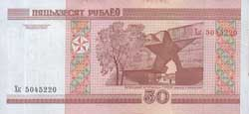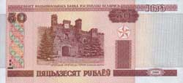
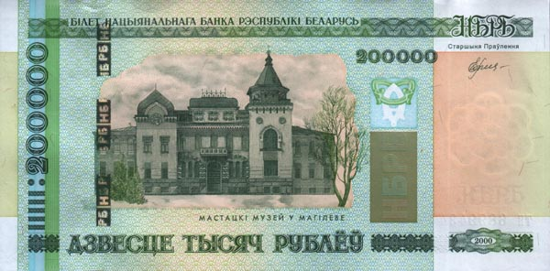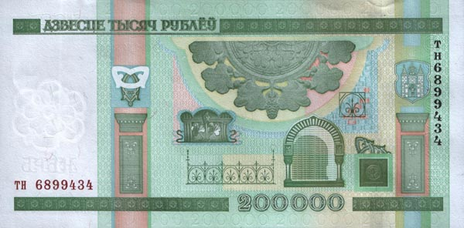
Money occupy a large part of our lives. But nowadays people no longer use them. There are credit cards, Internet shops and much more.

