Our Heroes

Our project’s purpose was to find out what kind of people elementary school students would choose as heroes, and whether there was any significant difference in what type of people were chosen, depending on the country. We were also interested in what criteria the students used to pick their heroes.
We received 52 submissions from schools in 3 countries – Canada, the United States and the United Kingdom. There were many different heroes identified, and after examining the submissions, we sorted them into 6 different categories, according to their characteristics.
Our categories:
Parents – This category included submissions about mothers, fathers, grandparents and family in general.
Friends – This category included submissions where the person chose someone they actually knew, personally, as their hero. (inspiring, uplifting painter, someone who stood up for a person being bullied)
Famous People – This category included submissions about people who were continually in the news, but not necessarily for helping others. (actors, video game creators)
Athletes – This category included submissions about professional athletes.( runners, hockey players)
Humanitarians – This category included submissions about people who performed selfless deeds to make the world a better place (Nelson Mandela, Terry Fox, Firefighters)
Other – This category included submissions that didn’t fit into any other category (God, Dog)

Our findings are presented in the following two graphs:
# 1. Our Heroes – which shows the percentage of people chosen in each category regardless of country, and
#2. Breakdown of the Type of Hero Chosen by Elementary Students, by Country – which is a comparison by country, of the people chosen in each category.
We have also included two “Word Clouds” made up of the character traits of heroes as identified in the various submissions.
Word Cloud # 1 – Character Traits of Heroes
Word Cloud # 2 – Things Heroes Do

Graph # 1

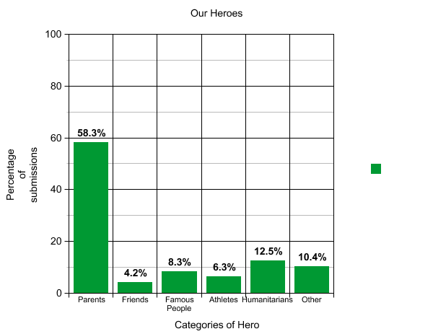
Observations:
The elementary students we received submissions from were much more likely to pick their parents as heroes than any other type of person.
Very few of the elementary students we surveyed consider their personal friends to be their heroes.
The students we surveyed consider people who give of themselves to make others’ lives better (humanitarians) heroes more than their friends, people who are famous, and athletes.

Graph # 2

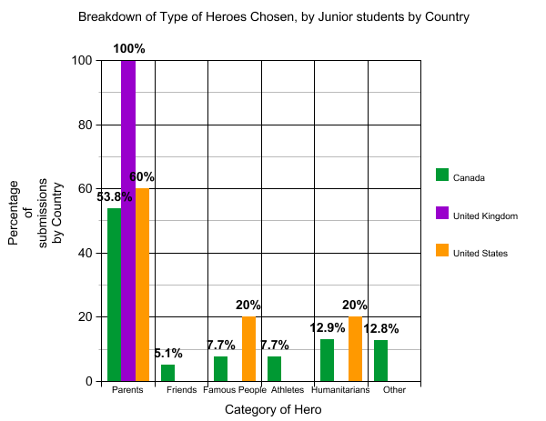
Observations:
U.K
In the United Kingdom, all of the students who replied chose their parents as their heroes.
United States
Elementary students in the United States picked famous people and humanitarians as their heroes the same amount of times.
The students chose parents as their heroes three times as often as they chose famous people and humanitarians.
American students chose parents as their heroes more than any other type of person, but only about half as often as students from the United Kingdom.
Students from the United States and Canada made very similar choices for heroes in all categories.
Canada
Canadian students chose famous people and athletes as their heroes the same number of times.
Canadian students showed the most variation in the type of person they chose as heroes, picking some from each categories.
Some Canadian students made unique choices for their heroes, thinking outside the box to choices other than real people.

Word Cloud #1 – Character Traits of Heroes

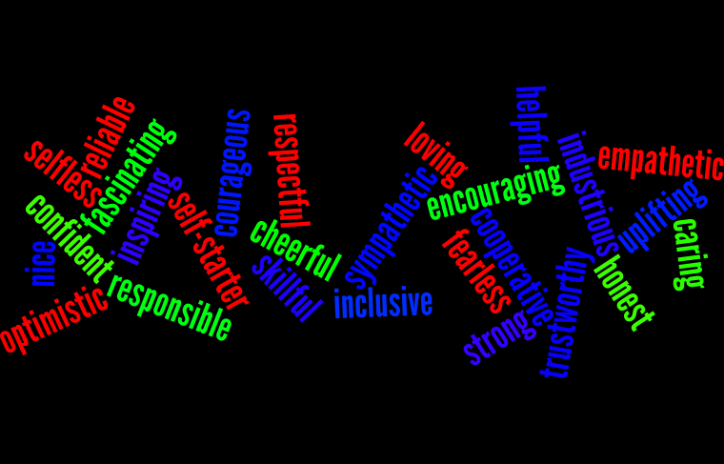

Word Cloud # 2 – Things Heroes Do