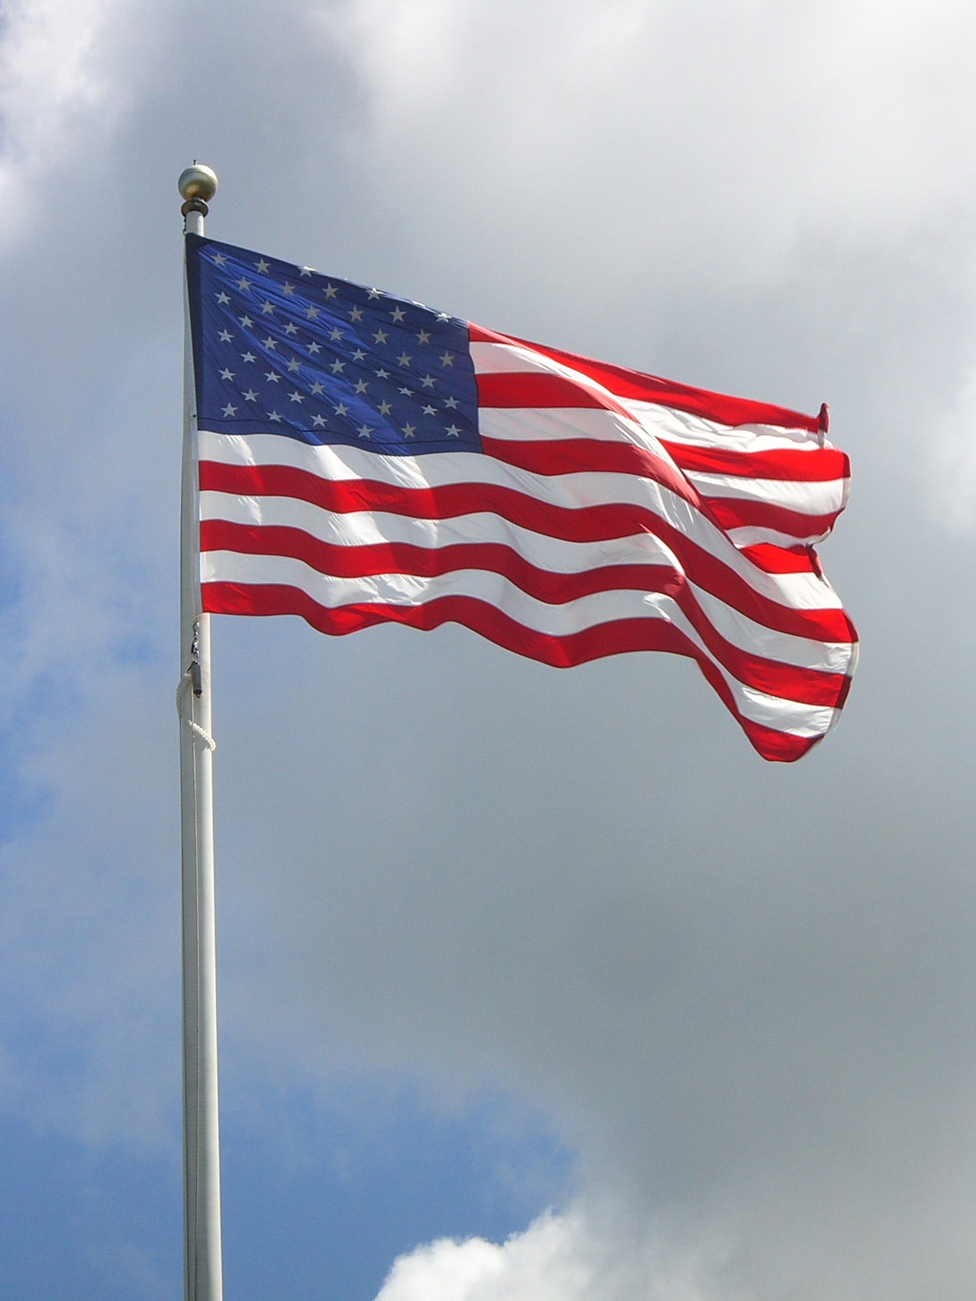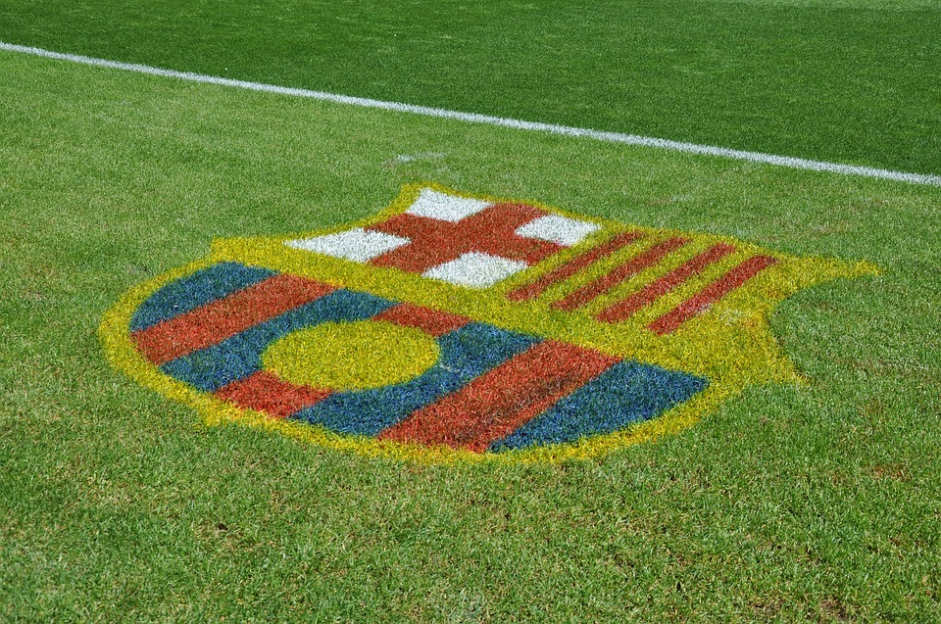

comostas amigos estes nuestros proyecto.

The general is located in the Usa. The capital is in Washington D.C High Rise Capital, our government is Greg Abbott, our flag is the United State,Texas, and Highland Park flag it’s our coat of arms are our ancestors, the currency is dollar bills and coins, and finally we greet each other by handshaking or saying hello and welcome.

Goethe dilate, Fort hill, Katy Trail, these are important buildings in our community.

Coffee Park ,dogs,U.P pool,squirrels,birds.

Fort Worth, Waco, Austin, Houston, these cities/town are near our citie.

State fair,cowboy stadium,Six Flags and Nasa museum even pecan tree lighting.

Hamburgers and pizza these are good dishes to eat.

One day at the state fair there is a statue called big tex and one day he burned down by one of the power lines but today they remodeled him and big tex is still standing big.

Hamburgers: 2 bread 1 patty some vegetables if you want and cheese if you want. Pizza: Dough shaped as circle tomato sauce any kind of cheese any toppings then oven. This is the recipe.

