Victoria Comerzan
A Trip in your Town”
The 5-6 forms
High School “Mihai Eminescu”
Country: Moldova
The goal of our project was to share information and ideas about many places of interest from different towns/cities.
We received some submissions:

Robin Sheridan- a project about Mendham, here you can see some pictures from a ppt projects.
A playground
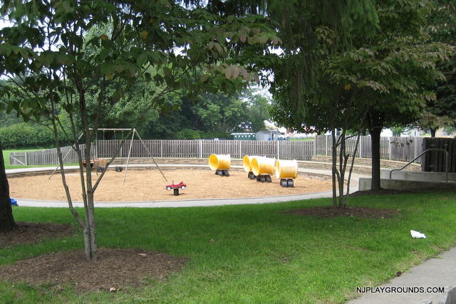
A pond to go fishing
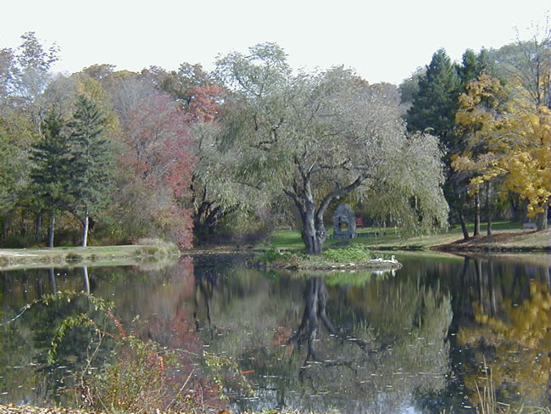

Matthew Ward send information about Concord
Some places of interest from Concord
Concord got its name from a soldier who fought in the revolutionary war. That war was between the east and the south.
Some natural attractions are all of the bike paths and woods trails. There is a lot of trail in the woods. Ryan sent some pictures with places of interest.

Sukmawati Salamah sent information about Jakarta

