My City (Village)
The history of Lipnishki
Your full name: Teresa Vyrostko
Name of the group: My City and Me Middle/High School Learning Circle.
Title of your project: The history of Lipnishki
Class that worked on the project: 10
Name of your school: Lipnishki School
City, state, and country your school is located: Lipnishki, Ivye District, Grodno Region, Belarus
Our village Lipnishki, Ivye district, Grodno region is one of the most ancient places in Belarus. It stands on the River Apita, a confluent of the River Gauya, the Neman watershed.
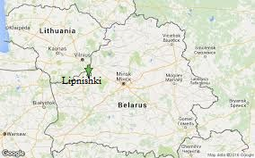
According to the Main Archive of ancient documents in Warsaw Lipnishki was first mentioned in XV century. The owner of the village was Zhygimont Keystutavich at that time. In 1411 he built St. Ann Catholic church. It was a wooden building. During Great Northern War in 1710 there was a fire in the village. The citizens tried to rescue the church, some of them even died. But the fire destroyed the church completely. To commemorate the victims of the fire a small chapel was built at the crossroads of three roads. It is often called “kaplitsa” in the Belarusian language.
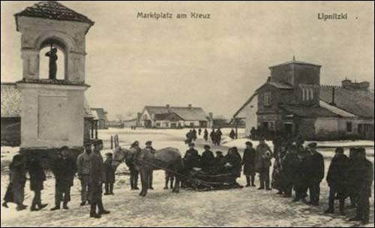

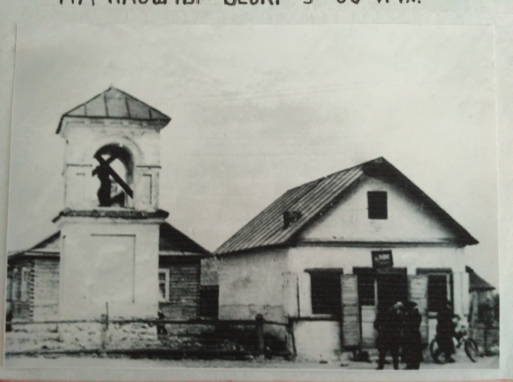
During the next 340 years Lipnishki changed a lot of owners. Among them were Zhygimont I Old, Albreht Gashtold, Zhygimont II August, Pavel Sapega, Albreht Radzivil, Aleksandr Bezbarodka, Voytsekh Puslousky.
On 30 May, 1610 Lipnishki was given Magdeburg rights by Zhygimont III Vaza. It was also given a coat of arms. Then an estate for owners was built on the bank of the River Apita.
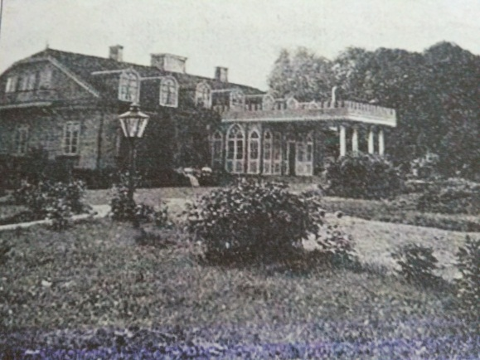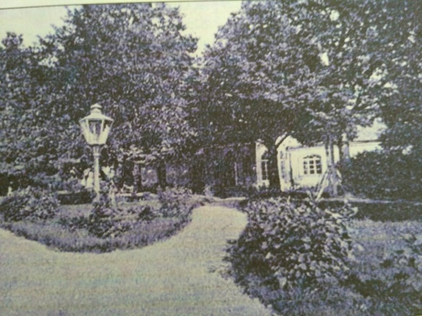
In 1792 Lipnishki was given a new coat of arms, so called “Pursuit”.
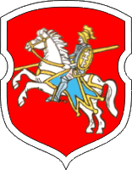
During the ruling of Mikalay Volsky (1854-1866) Lipnishki was developed a lot. 12 shops, various workshops, 3 taverns, chemist’s shops, a hotel, a water mill appeared. All the streets were paved with stones, a lot of trees and bushes were planted along the streets. A market was organized on the square once a week and during main holidays.
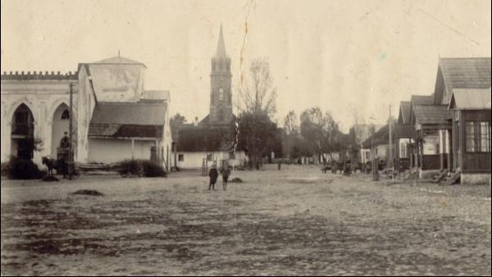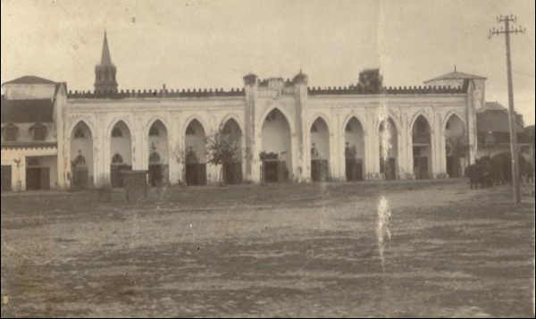
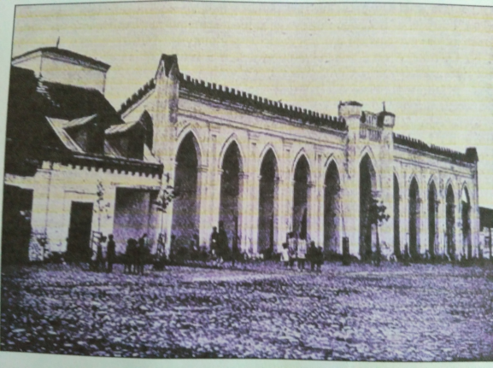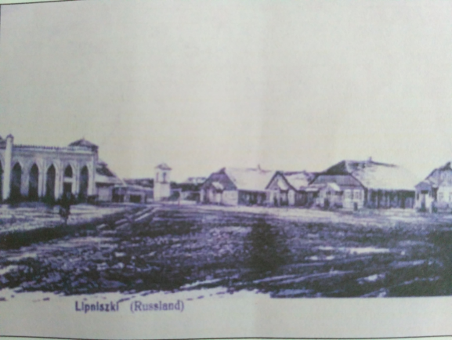
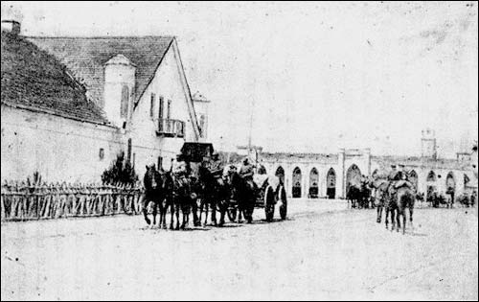

When Mikalay Volsky died in 1866, his son Aleksandr Volsky became the owner of the village. He started building a stone Catholic church in 1900. The project of the church was brought from France. German architects, Polish stonemasons built the church. The stones were gathered in the fields aroud the village and delivered with the help of horses.The construction of the church took more than 27 years. People said that citizens helped to build the church, brought eggs which were added to make cement stronger. The church is St. Kazimir Roman Catholic church.
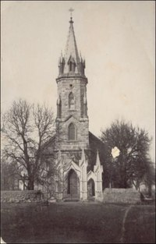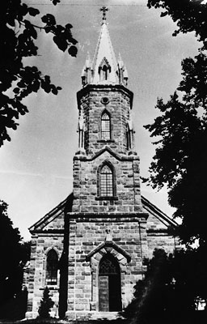
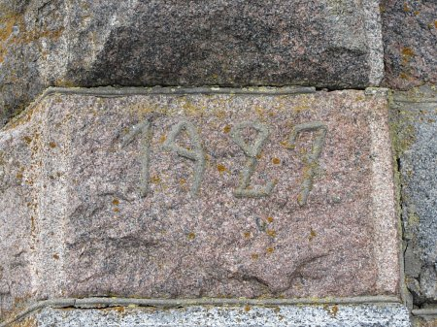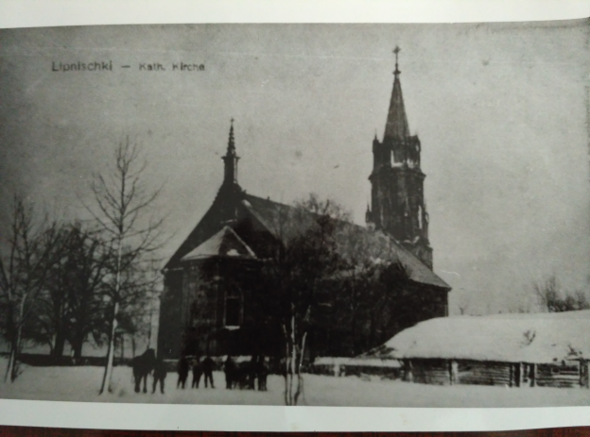
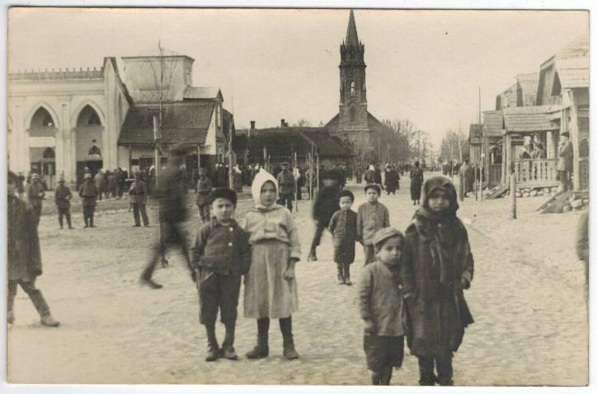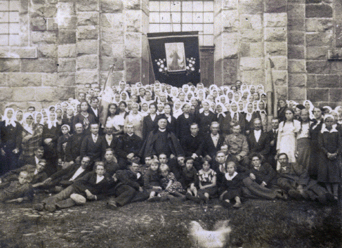
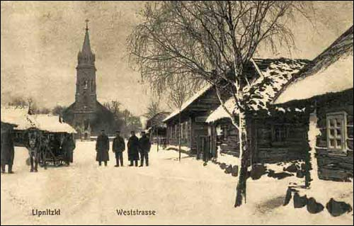
In 1897 there were 213 houses in Lipnishki and 1336 people lived there. There was an illegal printing-office of Polish Socialist party with Jozef Pilsudsky at the head. It was organized in the building of a chemist’s. In 1894 the first newspaper “Worker” was printed. There were 6 editions of the newspaper. The last one was printed on 24 December, 1894. But later the printing-office was closed and all the equipment was transported to Vilnius.
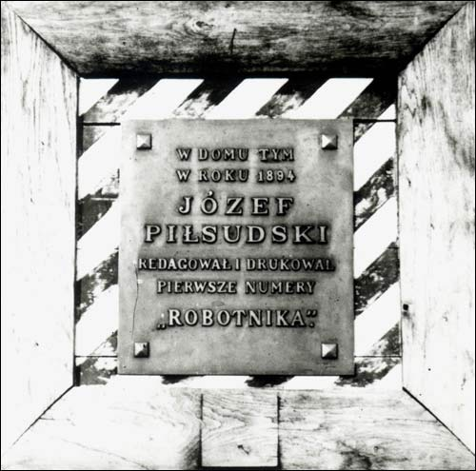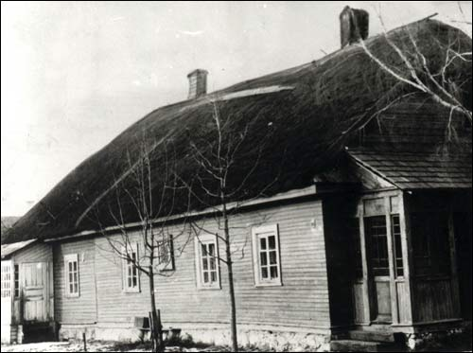
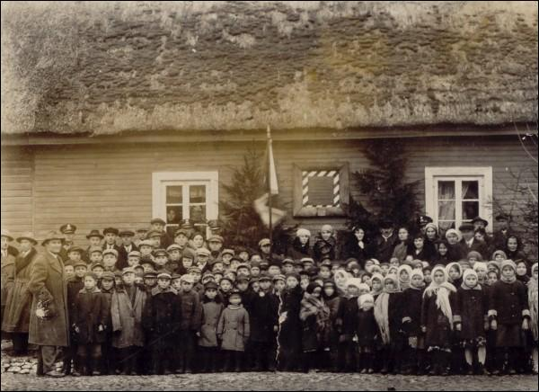
After the educational reform (1864) a people’s secondary school was opened in 1867. In 1937 the construction of a new school started. It was situated in Lidskaya Street.
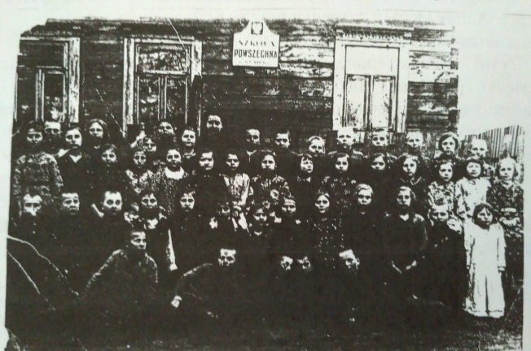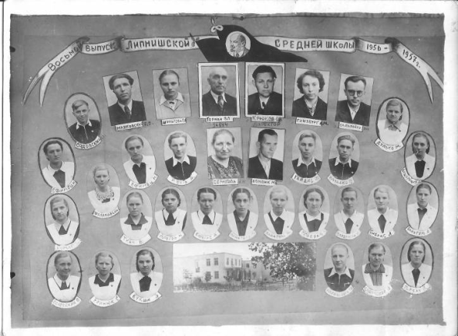
A lot of Jews lived in Lipnishki. They lived mostly in Lidskaya street, Sadovaya street, Melnichnaya street.
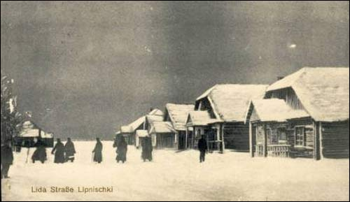
During Great Patriotic War more than 200 Jews who lived in Lipnishki were killed in May 1942. But some of them were hidden by local people and then moved to Israel. Their descendants sometimes come to Lipnishki.
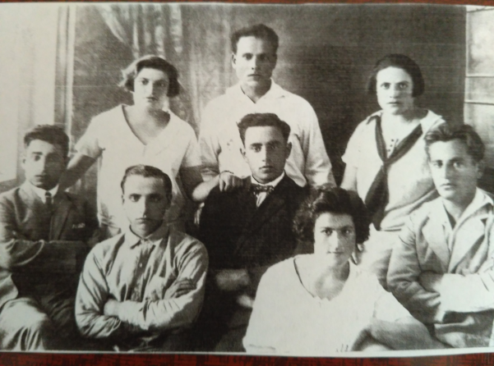
During Great Patriotic War a lot of local people and soldiers were killed. There is a monument to them in the centre of the village.
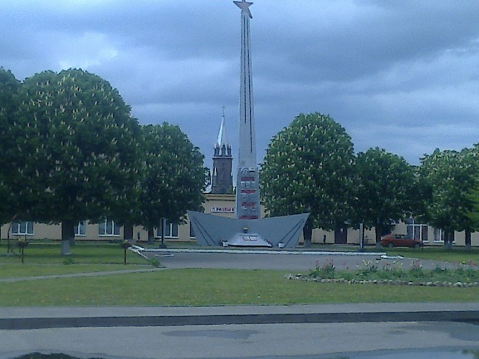
After the war people started to restore the village. A collective farm was organized. Many people worked there. A new hospital was built.
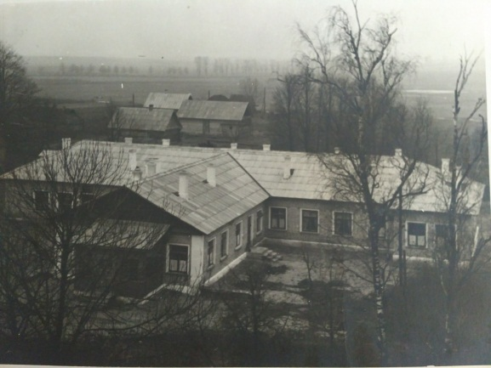
Nowadays Lipnishki is a well-developed village which is not far from the railway station in Gauya. People can easily get to Lida, Grodno or Minsk by bus or by train. There is a Roman Catholic church, a school, a post-office, a chemist’s, a hospital, a café, a club, a kindergarten, a lot of shops.

