PHARAONIC FISH

A fish is swimming in the sea,
Pharaonic fish.
Jesus comes after her
In the deep sea.
»Oh, wait fish, wait fish,
Pharaonic fish!
We would like to ask you
what is happening in the world.«

»If I flip over my tail,
the whole world will be submersed.
If I turn onto my back
The whole world will perish.«

»Oh, don't do it fish,
Pharaonic fish.
For the sake of innocent children,
For the sake of women in childbirth.«

ABOUT THE POEM

This folk poem is about the destruction of the world which will be submerged by the oceans.

Pharaonic fish is supposed to reign at the bottom of the sea. It appears in the form of a fish-woman or mermaid and has apocalyptic power. The fish is carrying the world on its tail and if it moves or shakes it, a disaster will hit the planet.

The poem Pharaonic fish (RIBA FARONIKA) has been preserved in the Tolmin region and even today people love to sing it.

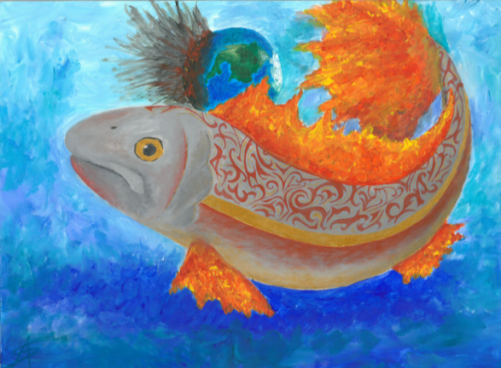

To listen to the song go to RIBA FARONICA: https://www.youtube.com/watch?v=jKmHN11pwgw

Poem translated by Zvonka Dalić Rink
Illustrated by Ana Svetičič

