Things I like to do and places I like to go in my free time
By Lynnwood Elementary students
My favorite place to go is Dragon Park just behind our school. In the summer, the dragon spits water and it is fun to run and get wet. You can also ride your bike, play ball or have a picnic. Sometimes our PE teacher takes us there. I also like to read, in the park when it is nice, or in my room when it is raining. Emma
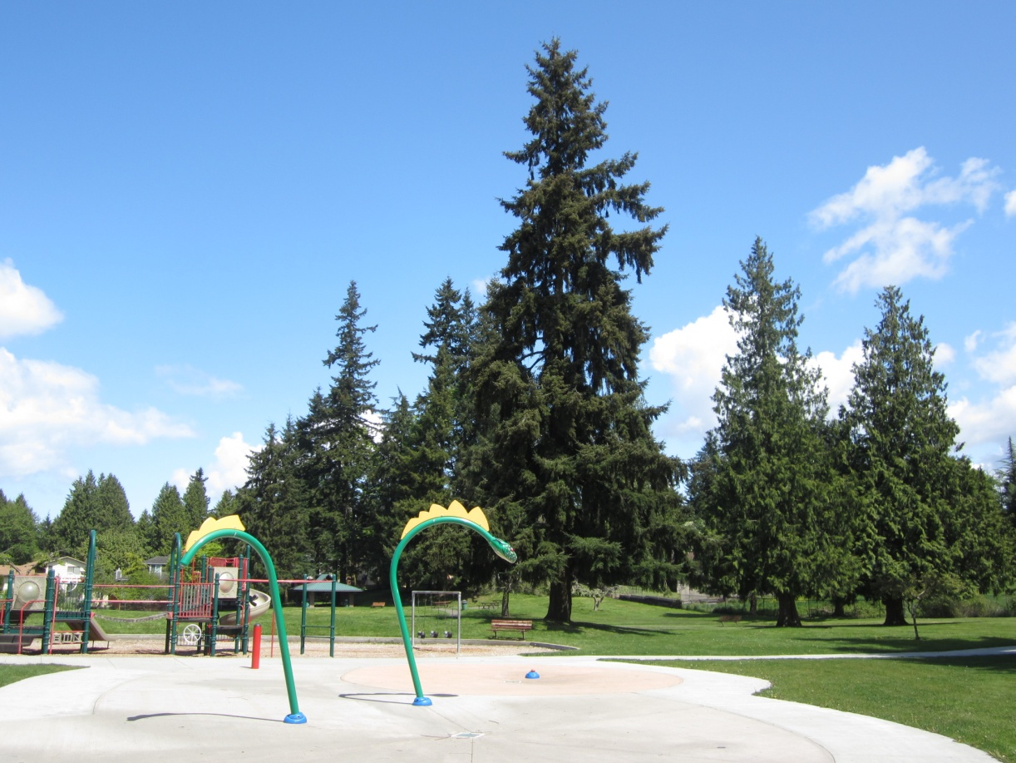
During my free time, I like to make videos
I also like to make cool toys with spare tools and other toys
Jo B
During my free time l like to go to Family Fun Center. It is a great place to have fun with your family. Well, that's only my opinion but you can also go with your friends like I do. From Lynnwood to Family Fun Center is 1.8 miles and it takes about 6 minutes to get there if there is not too much traffic.
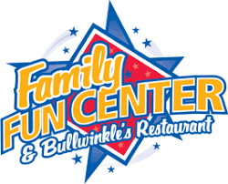
Stephanie R.

I like to go to the pool and relax at the Lynnwood Recreation center. We could have fun and swim but we could also play basketball at the pool. We could go to elevated sports so we could jump on the foam pit or we could play dodge ball and win the game.
Eddie

To relax I would go to Elevated Sportz. Elevated Sports is a trampoline park and event center. Elevated Sportz is a kid friendly trampoline place. With an area to do cartwheels and front/back flips, then fall into a foam pit. I would go there to relax because jumping on a trampoline will relax me, because I’m having fun.
Laprincia
