The names of  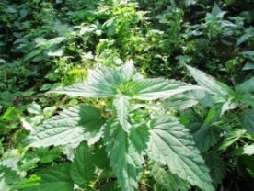  the flowers  in Russian, Belarusian, English and Spanish | The photos of  the flowers
Крапива;
крапiва;
nettle;
ortiga

Клевер, трилистник; канюшына;
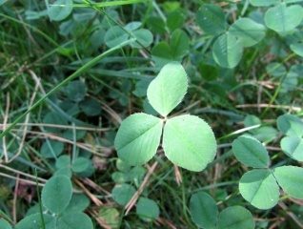
сlover, trefoil; tréboles
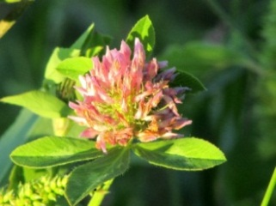

Папоротник; папараць;  fern;  helecho | 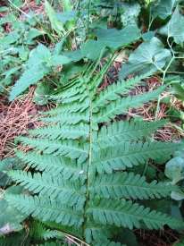
Щавель;  щаўе;  sorrel;  alazán | 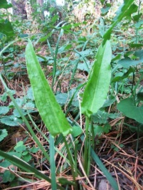
Земляника;  сунiца;  strawberry;  fresa, frutilla | 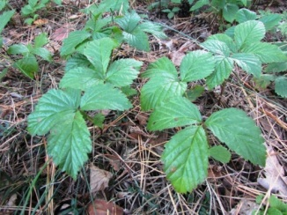
Пижма;  пiжма;  tansy;  tanaceto | 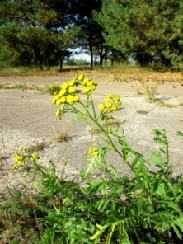
Зверобой;  святаяннiк;  tutsan,  St. John's wort;  corazoncillo,  hipérico,  hierba  de San Juan | 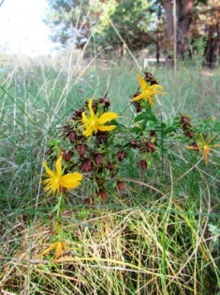
Гвоздика;
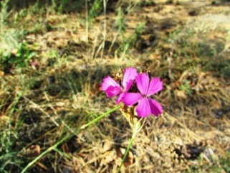
гваздзiк;
carnation; dianthus,
clavel,
clavelina

Цикорий;  цыкорыя;  chicory;  chicorium, achicoria | 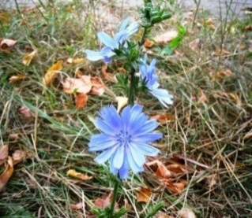
Молочай;  багаткi;  spurge;  euforbio | 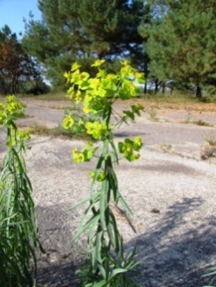
Василёк;
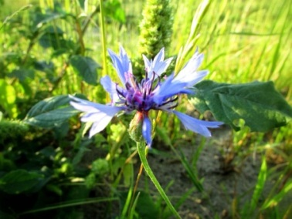
васiлёк, валошка;
cеntaury,
cornflower,
bluet,
knapweed;
scabiosa,
аciano,
azulejo

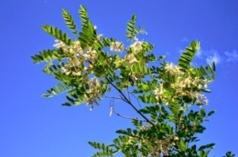
Акация;
акацыя;
thorn tree,
shittah tree;
madera
de acacia,
acacia

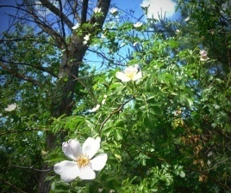

Шиповник;
шыпшыннік;
dog-rose, briar, eglantine;
rosal
silvestre,
rosa canina

Ландыш;  ландыш;  lily of the valley;  lirio de los valles  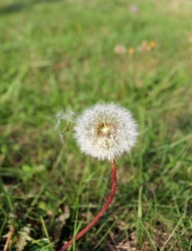 | 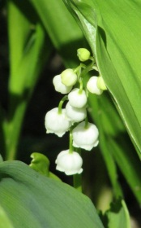
Одуванчик;
дзьмухавец;
dandelion;
diente de león, amargón

Чистотел;
падтыннiк, чыстацел;
celadine;
celidonia

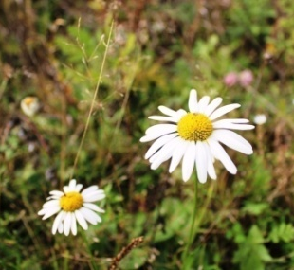
Ромашка;
рамонак;
chamomile;
manzanilla

Кипрей, иван-чай, «сорняк пожарищ»;  скрыпень;  willow herb, fireweed,  sally-bloom;  epilobio | 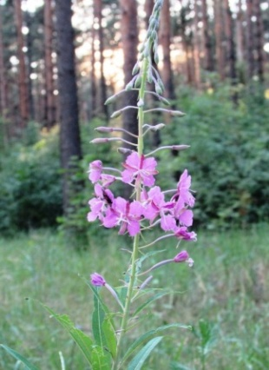
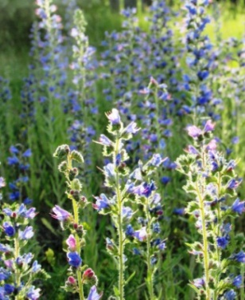
Синяк
обыкновенный;
сiняк звычайны;
echium vulgare,
viper's bugloss,
blueweed;
viborera,
buglosa,
hierba azul

Love and protect nature!

The state educational institution
“Lyceum under the University of Civil Protection of the Ministry for Emergency Situations
of the Republic of Belarus”

iEARN projects

Global Issues: Environment Learning Circle 1 (Middle/High School)

A FOUR-LANGUAGE MINI FLORAL
DICTIONARY

The names of the most widespread flowers that found in Iliych village, Gomel district,
Gomel region, Belarus in Russian,
Belarusian, English and Spanish

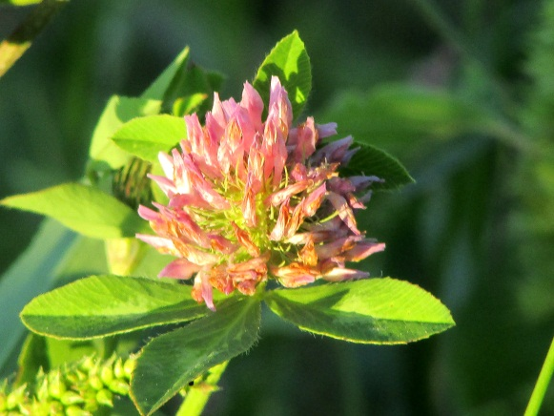
Gomel, 2017

