iEARN Learning Circle - CCM1 - 2004-2005

THE SCHOOLERS

Homeschooling Group outside of Toronto, Canada

Romanian Project - MUSIC and ART

The kids, age 9 - 13, listened to the "flower dance" music from Tchaikovsky's, The Nutcracker and created the following art and words.

Thank you Dorina for suggesting this project.

The kids really enjoyed the experience and each one told of the vivid images that came to their minds. This is what they saw.

- Watercolor on paper by Gaelan, age 9

- Illustrated Story by Maia, age 10

- Watercolor on paper and poem by Slater, age 12

- Illustration by Rachel, age 11

- Watercolor on paper by Sahara, age 9

- by Brann, age 10

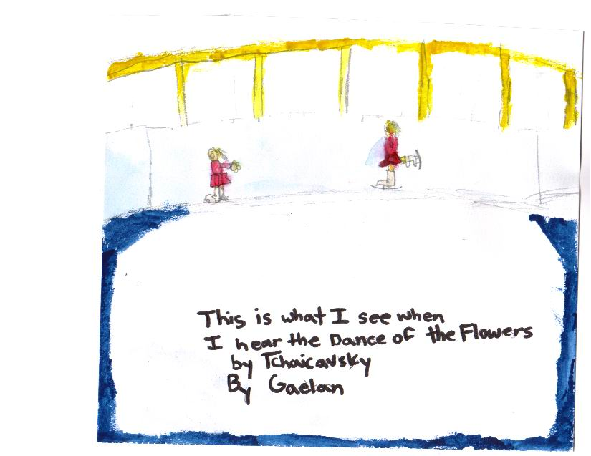
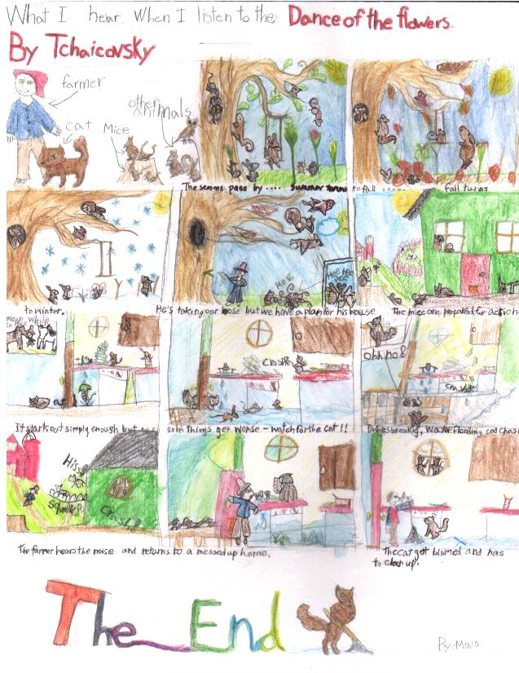
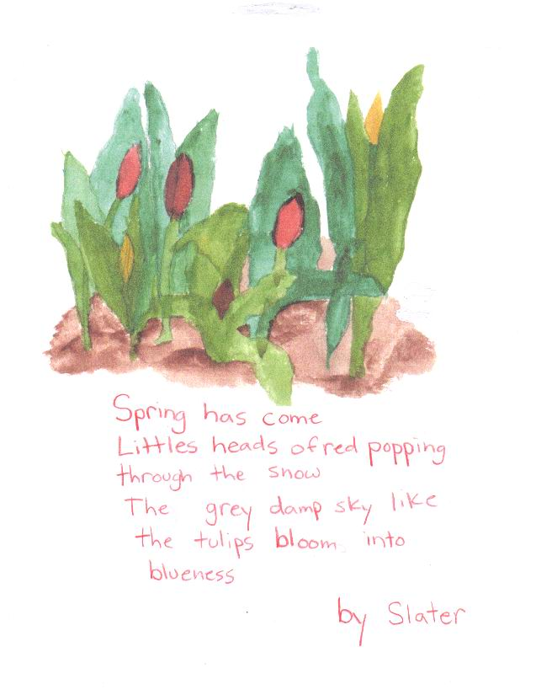
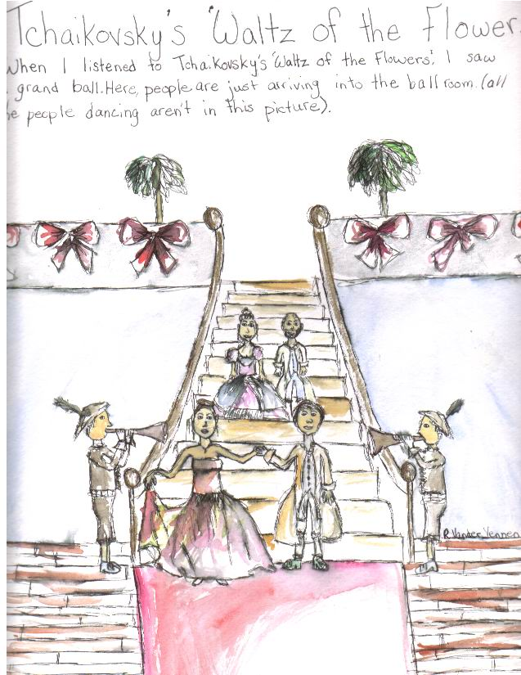
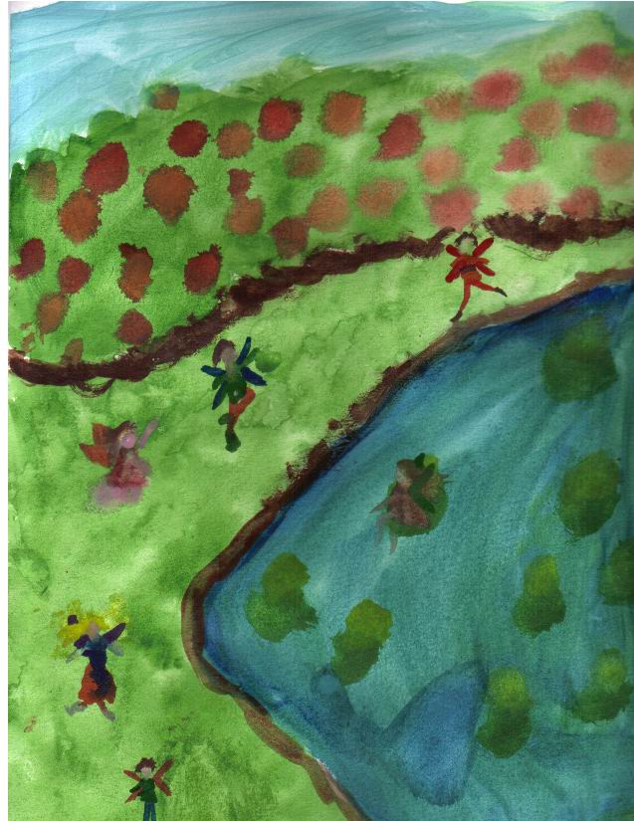 Watercolor on Paper By Sahara
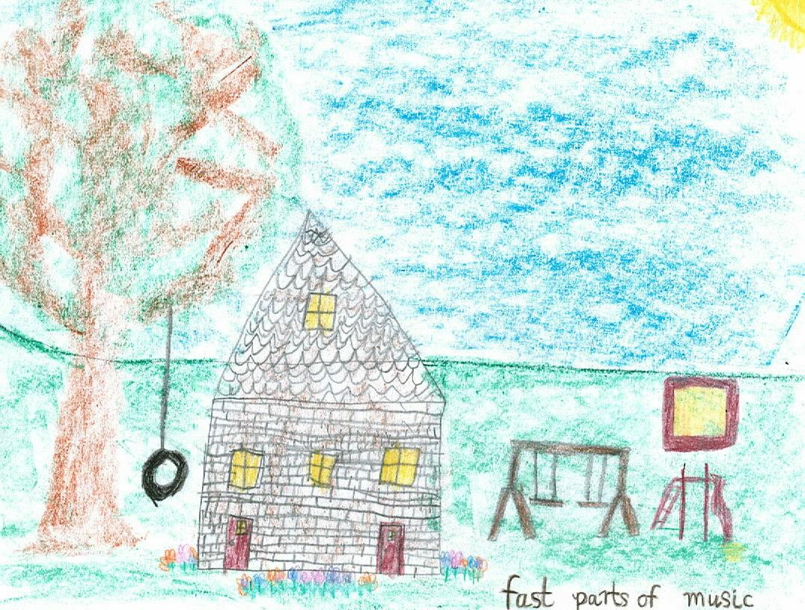By Brann (part one followed by part two on the next page)


