Here we are:
students from 2nd grade A
General School No.6
Arad, Romania
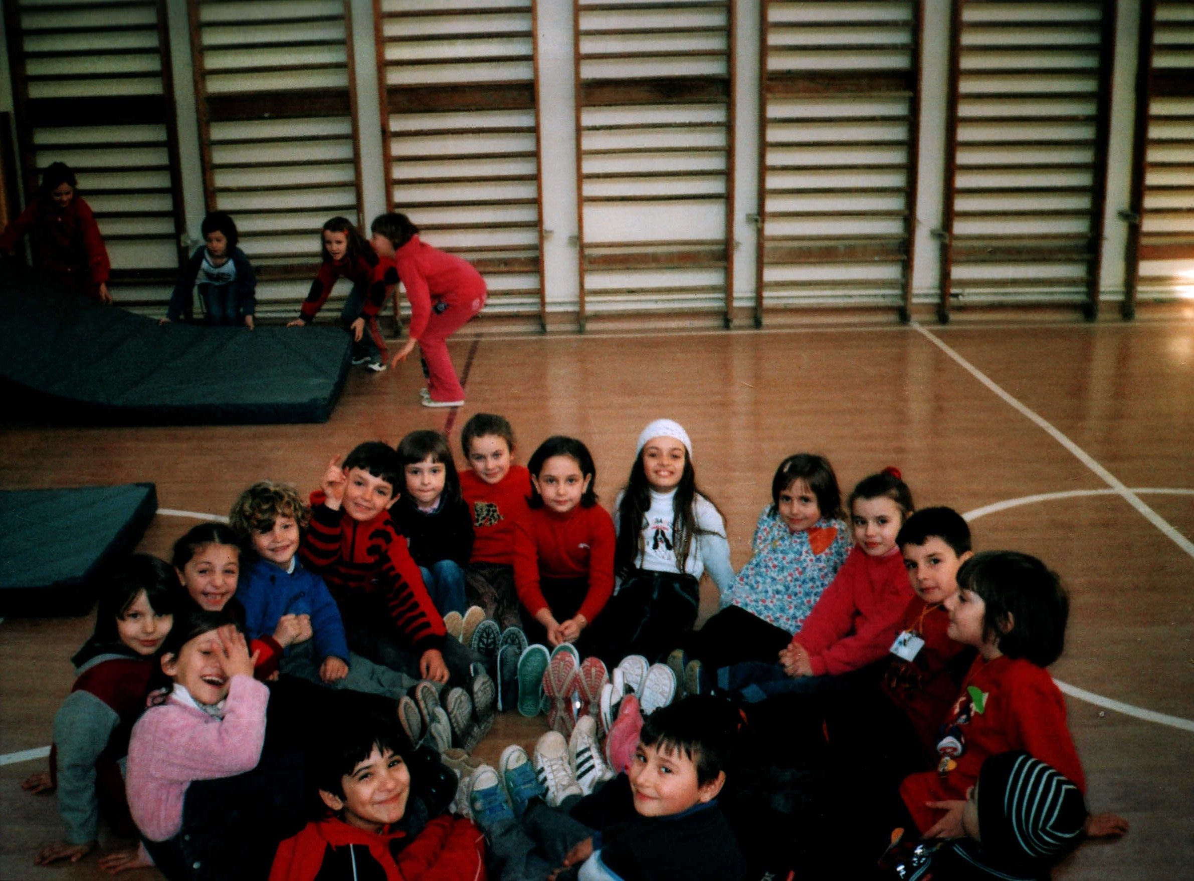

Talking about friendship, we all agree we have two kinds of friends: best friends and just friends. Best friends are very important because friendship relies on them. Friendship means firstly best friends.
We wanted to know better our best friend, so we took an investigation on their hobbies. We also thought about our own hobbies to check if they match. See what we found out!

Hobbies
Hobbies

My sister, Cristina, is my best friend. In order to select her hobbies, I took her an interview:
Diana: Which is your favorite cartoon?
Cristina: I like Tom&Jerry.
D: What story do you like most?
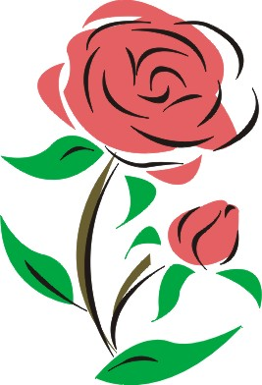
C: Snow White.
D: What is your favorite food?
C: Egg-fried meat with smashed potatoes.
D: What flower do you like most?
C: Rose.
D: Which is your favorite toy?
C: Barbie doll.
D: What is your favorite color?
C: Blue and pink.
My favorite toy is a Barbie doll. My favorite colors are red and violet. I like Cindarella story and The Spies cartoons. I adore drawing. My favorite food is noodle chicken soup. From all the flowers I like roses most.
Diana, 2nd grade A, General School No.6, Arad, Romania

My best friend is Roby. He likes to:
- play football
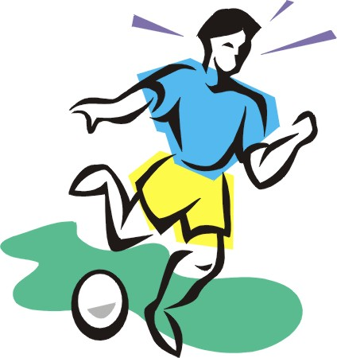
- travel
- play with toys
- play with me
- fight
I prefer to learn, to play on computer, to play football and to do my homework.
Daniel, 2nd grade A, General School No.6, Arad, Romania
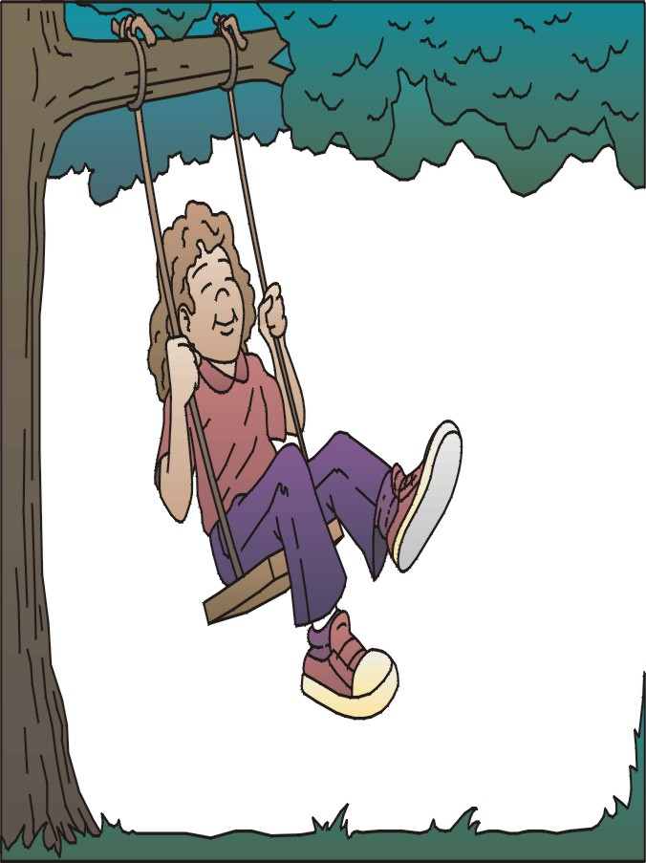

My best friend is my cousin, Adriana. She likes to balance in the swing. She loves to see the puppets show. She likes to travel by car and to play with her cousin. She also likes to play on computer.
My favorite activity is to travel in the country. I love rabbits. I like to go with my aunt on the fields. I like very much cartoons. In the winter I like to skate.
Andreea D, 2nd grade A, General School No.6, Arad, Romania
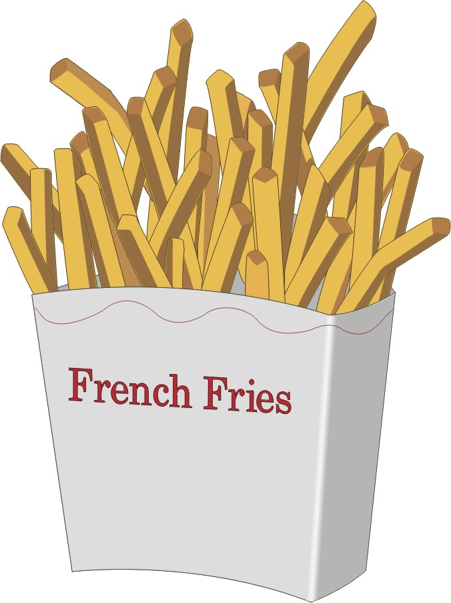

My name is Lorina. My favorite foods are fries and chicken. I like to ride my scooter. In my spare time I play on computer and I read. I listen to the music of Celine Dion and Thalia. I simply love little dogs.
My best friend is a boy who lives next door. He is my neighbor, Oni. I like being with him because we have so much in common. His favorite foods are fries, sarmale, pizza and chocolate cake. He is passionate for animals, especially rabbits and pigeons. His hobbies are sport and computers. He spends a lot of time in front of the computer. Oni likes music. He has two favorite bands: Holograf and Ozone. He also likes to ride his bike.

Lorina, 2nd grade A, General School No.6, Arad, Romania

My hobbies are: computers, music and playing with my Barbie dolls.
My best friend is Roby. His favorite things are: computers, bicycle, football, music and swim.
Brigitte, 2nd grade A, General School No.6, Arad, Romania

My best friend is Vlad M. His hobbies are:
- To watch TV
- To play
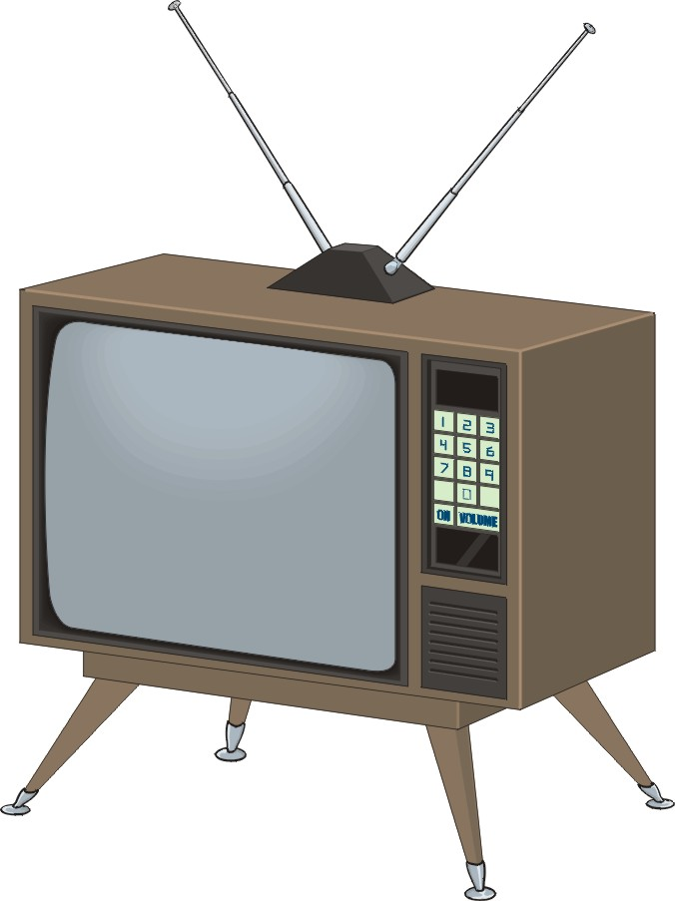
- Karate practice
- To spy
- To ride his bike.
My hobbies are:
- Listening to the music
- Playing basketball
- Building Lego towers
- Playing in the yard
- Going shopping.
Vlad R, 2nd grade A, General School No.6, Arad, Romania

My friend’s name is Natalia. She is 6 and she lives in the country. During the holidays I go to visit her and we play together. We like to eat a lot of sweets. Natalia likes to play with her pets. She is my best friend.
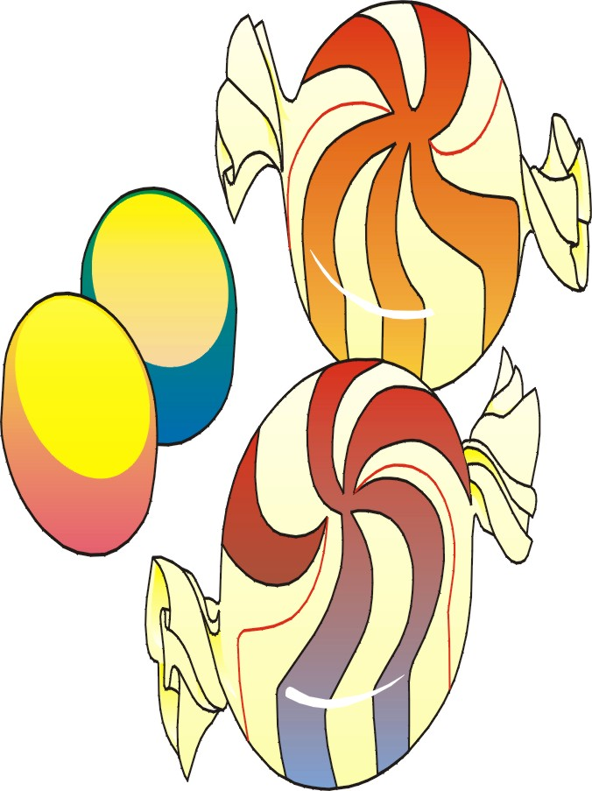
Daniela, 2nd grade A, General School No.6, Arad, Romania

My friend is Alina. Her favorite things are: bicycle, TV, dolls, computers and velvet toys.
I like computers, bicycle and toy cars.
Catalin, 2nd grade A, General School No.6, Arad, Romania

My best friend is Doru. He likes cartoons, computers, to play the trompe and to play football. He loves horses. My favorite activities are: going to the church, playing on computer, playing football. I also like cartoons and construction toys.
Andrei, 2nd grade A, General School No.6, Arad, Romania

My best friend is Flavius. His hobbies are: cartoons, playing the guitar, football, computer. He loves dogs. I like to play on computer and football, to go at the church, to watch cartoons and to play with construction toys.
Daniel, 2nd grade A, General School No.6, Arad, Romania
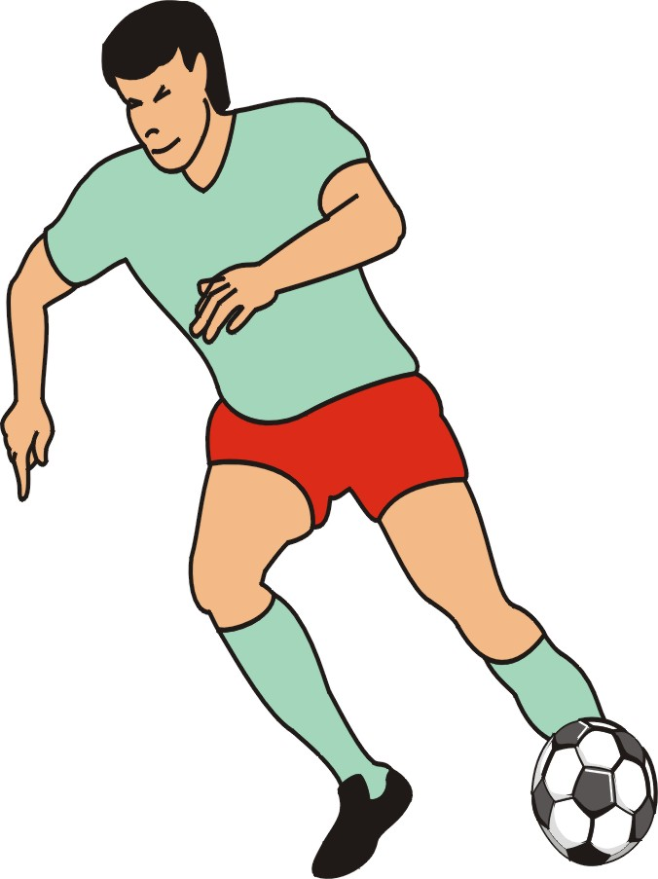
My best friend is Raul. His hobbies are:
- watching TV
- playing football
- playing with friends
- practicing sport
- playing cards
I like to play with my dolls, to walk, to play as if I was a teacher. I also enjoy shopping and listen to the music.
Romina, 2ndgrade A, General School No.6, Arad, Romania
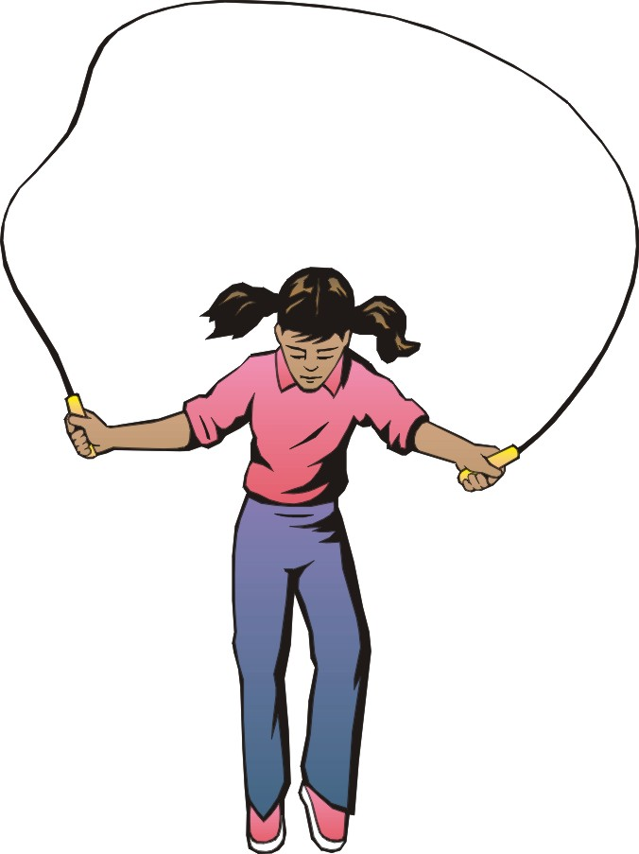

My best friend is Bianca. Her hobbies are: to play on computer, to dance, to walk in the park, to read and to ride her bike.
My favorite activities are: to read, to color, to write, to play on computer and to play with the skipping rope.
Diandra, 2nd grade A, General School No.6, Arad, Romania

My best friend is Diandra. She is my classmate. She likes to play with the skipping rope and with Barbie dolls, to ride her bike, to play on computer and to play cards. My favorite activities are: to play on computer, to watch cartoons, to visit friends, to play with Barbie dolls and to take trips.
Cosmina, 2nd grade A, General School No.6, Arad, Romania

My best friend is my mother. She likes to wash, to clean, to cook, to do shopping and she adores to travel. My favorite activities are: to play, to draw, to watch cartoons, to paint and to play with Barbie dolls.
Andreea B, 2nd grade A, General School No.6, Arad, Romania
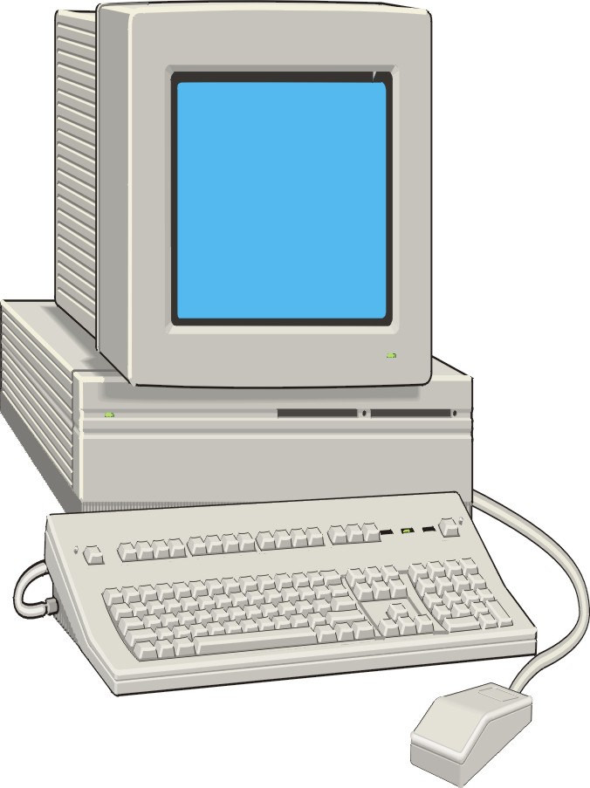
My best friend is Michele. His hobbies are: to write, to play on computer, to play with his younger brother, to travel by car and to ride his bicycle.
Rebeca, 2nd grade A, General School No.6, Arad, Romania

My best friend is Daniel. He is my classmate. My friend likes to draw, to play football, to balance in the swing, to play on computer, to ride his bicycle. I like to play with ball, to draw, to play on computer, to watch cartoons and to play with my younger brother and my younger sister who is a baby.
Alex, 2nd grade A, General School No.6, Arad, Romania
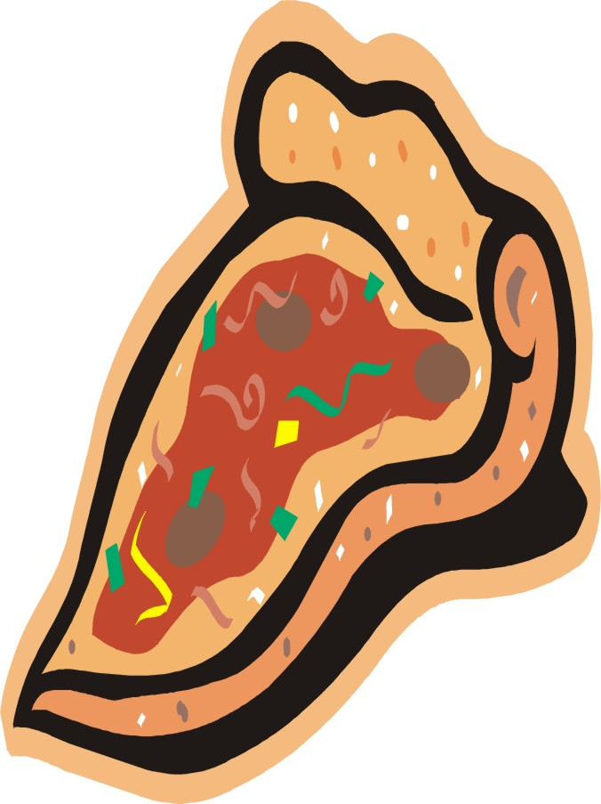
My best friend is Alex. His favorite things are: chocolate, pizza, candies, cartoons and music. Mine are: cartoons, pizza, computers, cars and music.
Dorin, 2nd grade A, General School No.6, Arad, Romania

Lorina is my best friend. She is my classmate. His hobbies are: to watch theatre plays, to play with Barbie doll, to visit her friends, to ride bicycle and sport. I like to watch theatre plays and sport too, to play on computer and with my friends.
Adina, 2nd grade A, General School No.6, Arad, Romania

My best friend is Raul. His favorite activities are: to play with ball, to ride horses, to write, to travel by car and by Santa’s Tram.
I like to eat hotdog, to play golf and Spider Man on my computer. My favorite subject is Math.
Emil, 2nd grade A, General School No.6, Arad, Romania
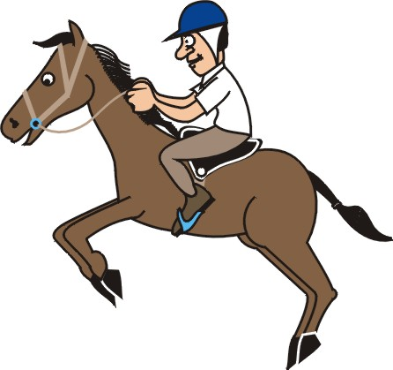

Arad, Romania, 2004
By Olivia Halic

