Transportation Project

Computer Chronicles (Elementary), Fall 2004
Anne Lambert, Lindsay McAuliffe, and students from San Diego, California, USA, suggested this project on Transportation
We would like to know what kind of transportation the other students use (foot, bike, car, plane, etc.) and where they have been.
Mostly people get around daily by foot, car, and bus. Children wanted to go all over the world, mostly by plane. A few had already traveled widely.
We also want to know if anybody is interested in traveling to another planet!
Pluto was the most popular planet choice overall. Many people thought it would be fun to go to space, but some said they would rather stay on earth.

City  Cars mentioned | How we get around mostly day to day | Where we have been | Where we want to go | Which planet we would like to visit
Arad  ROMANIA  Mercedes Opel, Dacia, Audi 6, BMW | In Arad: foot, tram, car, scooter, taxi, bicycle  To other places: Plane, car, bus, ship, minibus |  | To Europe and USA by plane | 
Chattanooga  USA |  |  | 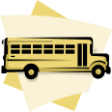 | 
Cordoba  ARGENTINA | Foot, bicycle, bus, taxi | 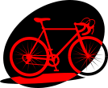 |  | 
Quakertown  USA  Denali,  Toyota, Tacoma,  Ford F-350 truck | Car, truck/ bus bus, motor home, bicycle, airplane, jet train, hover craft | Florida, Maine  Switzerland Spain Mexico Puerto Rico  Kansas, Kentucky,Texas Washington DC  Hawaii,Bahamas  New Mexico, Arizona, Outer Banks NC | Hawaii Australia, California,  New York Yankees game,  Germany,  Ireland  Australia | Pluto (3) Jupiter (2)-Europa/  Saturn (2)  Mercury  Saturn  Mars in a NASA robot
San Diego  USA  Nisson Skyline | Bus, car, foot | Tijuana, Mexico—car and foot | Theatre, park | None (3), Venus (2) , Neptune, Pluto (2)
Ust-Kamenogorsk  KAZAKHSTAN  Mazda | Foot, bus, car, taxi, tram, underground |  | Russia, Austria France
Kenya (guest) | Car, train, foot, bicycle (Bodaboda) |  | Plane to other countries | 
San Diego, California
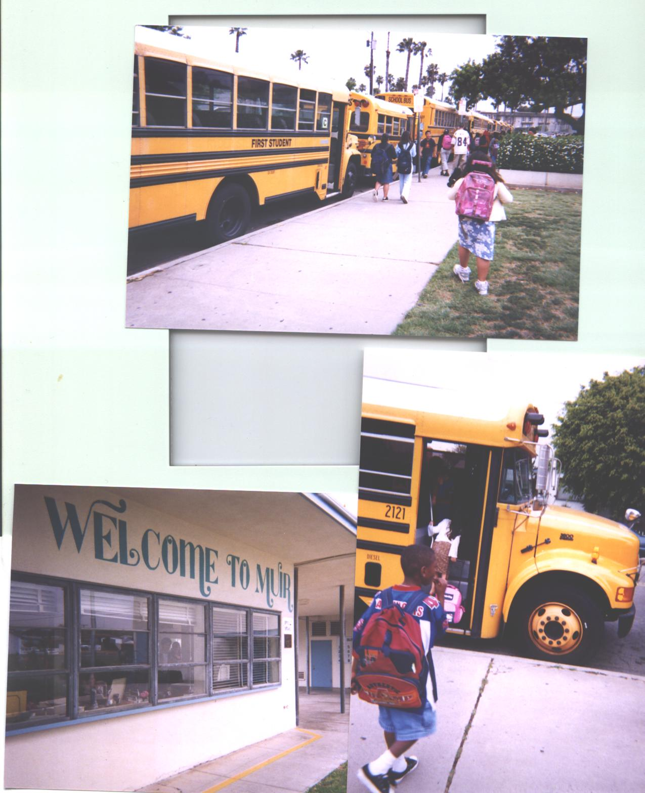 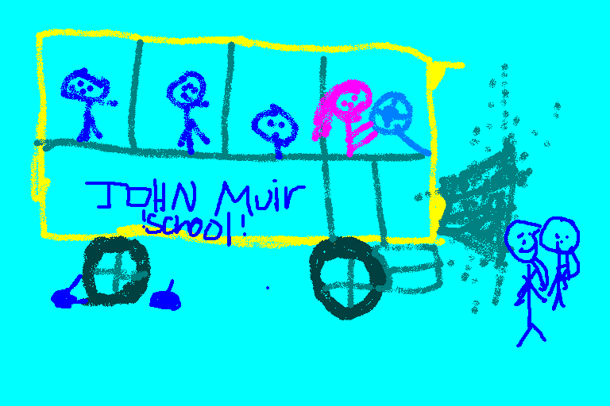 Bus by Jose, Grade 4, John Muir
Almost all Muir students come to school on busses. Our students choose to attend schools outside of their neighborhoods. This bussing started as a court order, so all kids could go to good schools. Anne Lambert - Nov 15, 2004 11:45 pm (1.)

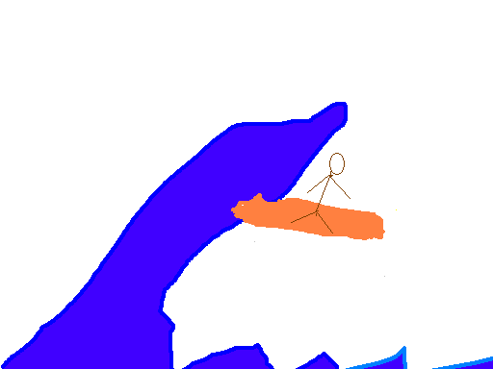 S Surfer by Ryan, Grade 4, John Muir School
Transportation
Nuria, Grade 4
John Muir School
San Diego, California
In the morning I go to my bus stop to wait for the bus. I like to ride
in my mother’s car. If I could go anywhere I would go to the park. I’m
not really interested in traveling to another planet.

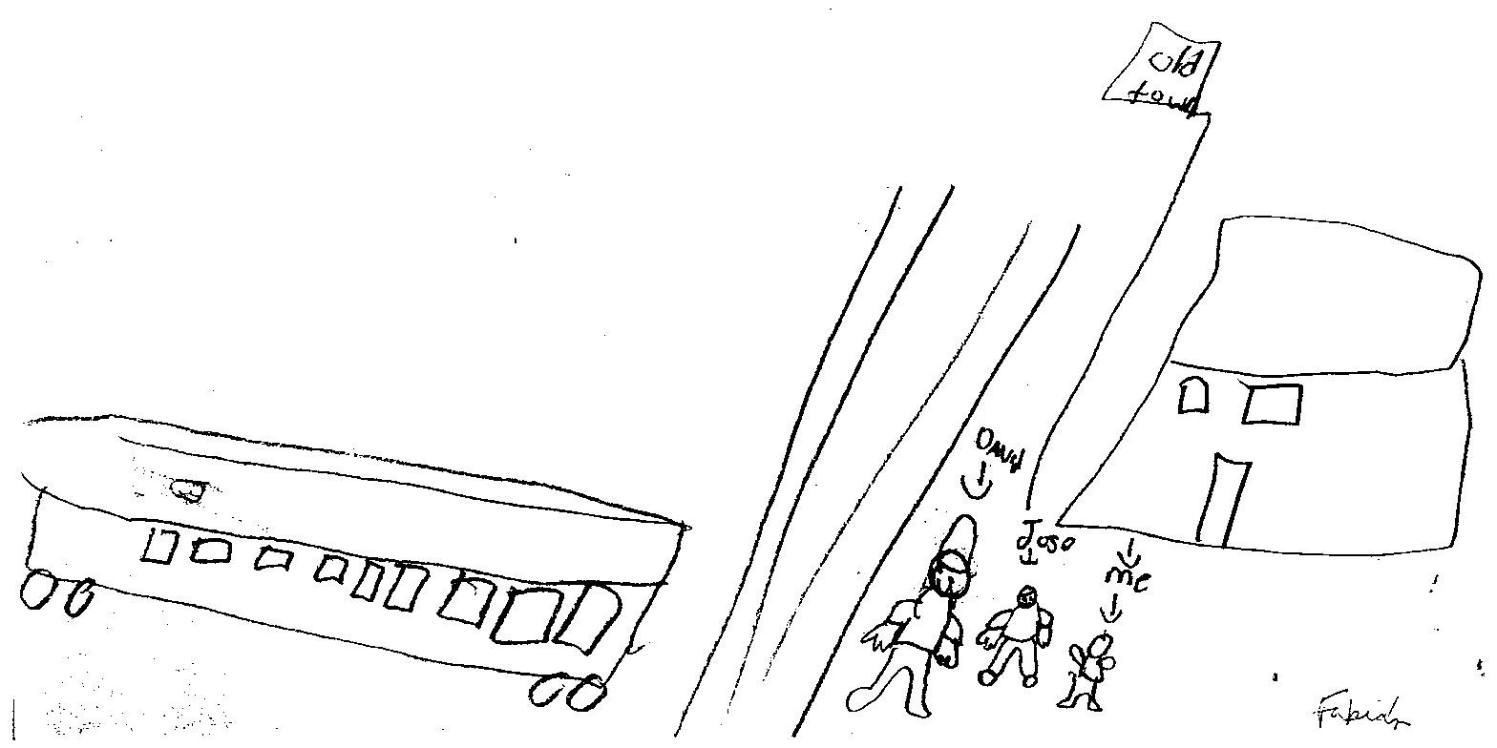Old Town Trolley by Grade Four

Transportation
Joshua, Grade 4
John Muir School
San Diego, California
When I go to Disneyland I go by car. I like the Nisson Skyline. If I
could go to another planet Id go to Venus.

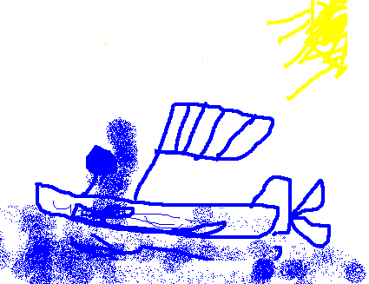
Boat by Mark, Grade 4, John Muir School
Transportation
David, Grade 4
John Muir School
San Diego, California
I go to John Muir School by car. If I could go anywhere I would go to
the theatre. I would like to go to Venus, Neptune or Pluto too.
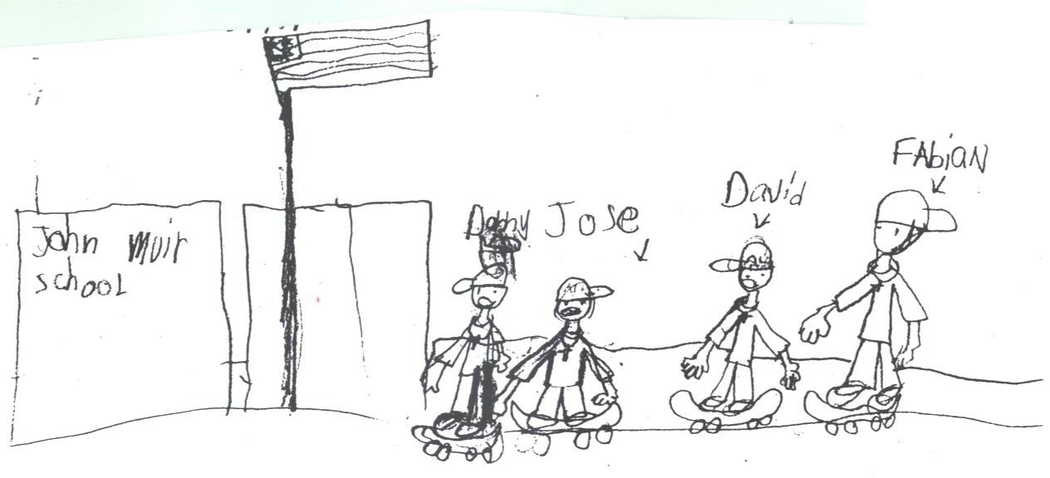
Transportation
Raquel, Grade 4
John Muir School
San Diego, California
I go to Tijuana, Mexico on the weekends. I travel by car and by foot. I
will go other places by bus. I would love to go to Pluto

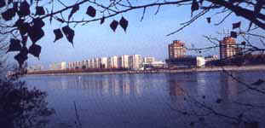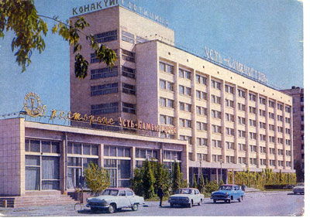

Ust-Kamenogorsk
We have beautiful mountains, rivers and forests. The most beautiful mountain to my mind is Belucha. Every year this mountain is visited by crowds of tourists. It's very dangerous but people like it. There are many types of transport in our town. We can see buses, trams, cars in the streets of our Town. We haven’t got an underground in it, because our Town is not very large. But we haven’t underground in cities of our country. We can go to school by bus, by car and by foot.

Student group work (Kazakhstan)

I go to school by foot because I live near the school. It takes me 5 minutes.Nikita
My name is Tanya. I am 9. I go my school by foot because I live near the school. It takes me 3 minutes.
My name is Egor. I go to school by foot because I live near the school. It takes me 5 minutes.
My name is Svetlana. I go to school by bus # 33, 23, 27 because I live far from school. It takes me 20 minutes. But my lovely transport is a car. My father has his own car.
My name is Artyom. My family has got a car. It is white. I usually go by car to guests. My lovely transport is car “Mazda”
My name is Aynur. I go to school by bus because I live far from school. But I go to training by tram. My lovely transport is different cars.

My name is Aslan. I go to school by bus because I live far from school. It takes me 15 minutes. But sometimes I go to school by tram and it takes me 30 minutes.
Some people are going somewhere by taxi because it more fast and comfortable then other types of transport and if no time.
My name is Aydar. I go to my grandmother and grandfather by bus. And to my training I go by tram. My family has a car so I don’t go by taxi any where.

My name is Radik. I go to school by bus and sometimes by tram. My mother goes to work by car but my grandmother goes to work by foot. I don’t go anywhere by underground. But my cousin lives in Moscow. It is our neighbor country – Russia. He goes by underground every day.

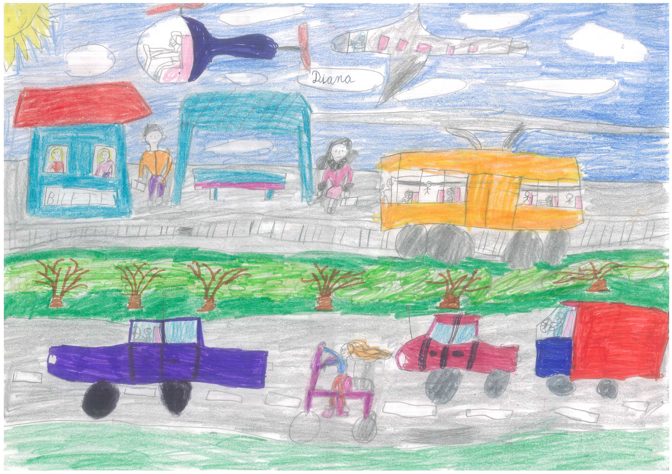
Romania

2th grade A, General School No.6, Arad, Romania
Top 5 of transportation in Arad:
- Tram
- Car
- Scooter
- Taxi/ cab
- Bicycle
Top 5 of transportation to another city or country:
- Plane
- Car
- Sightseeing bus
- Ship
- Minibus

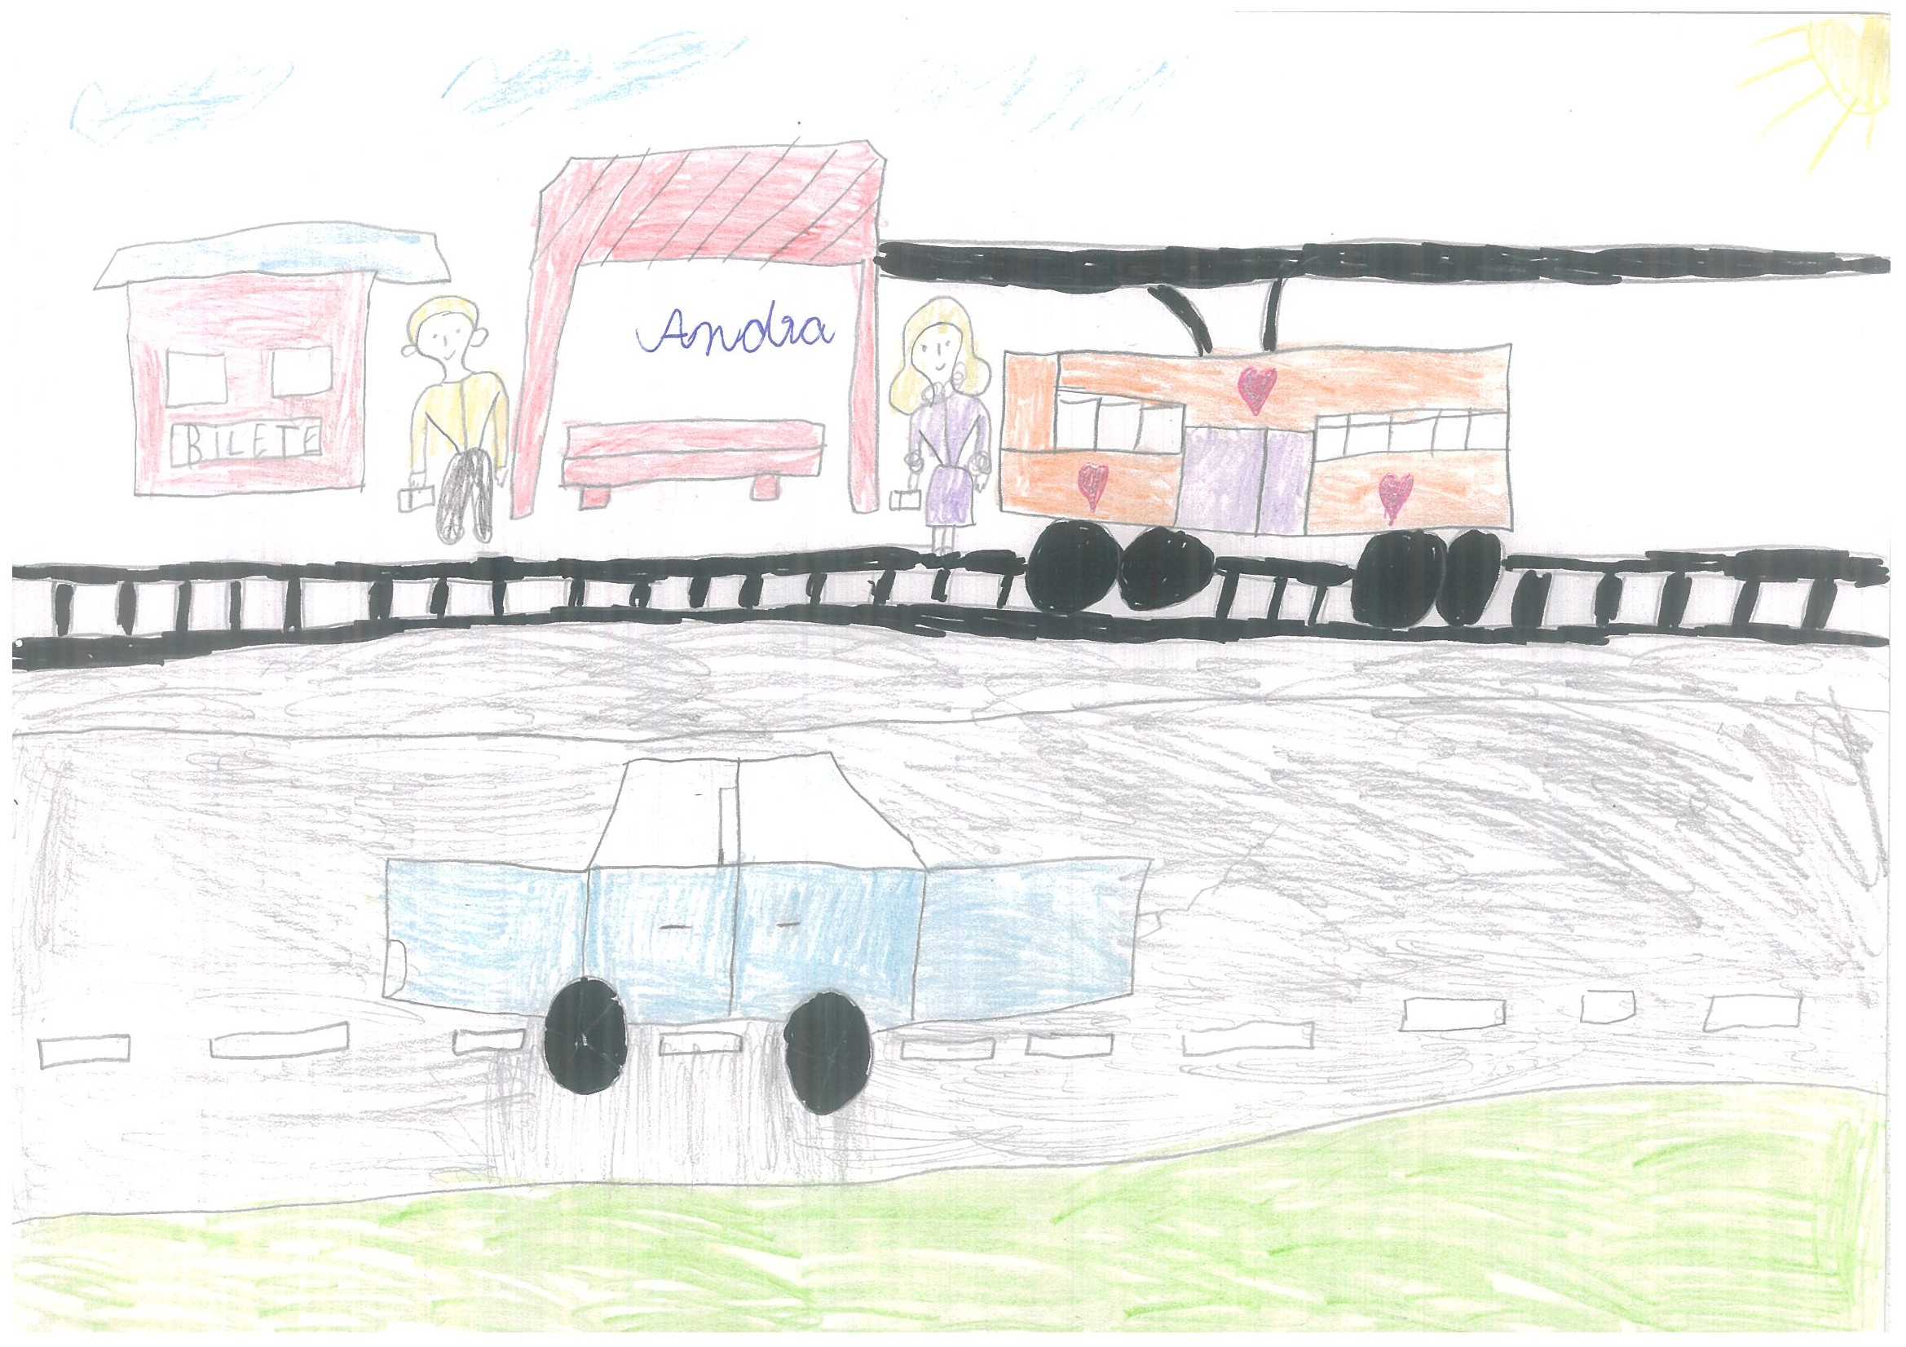

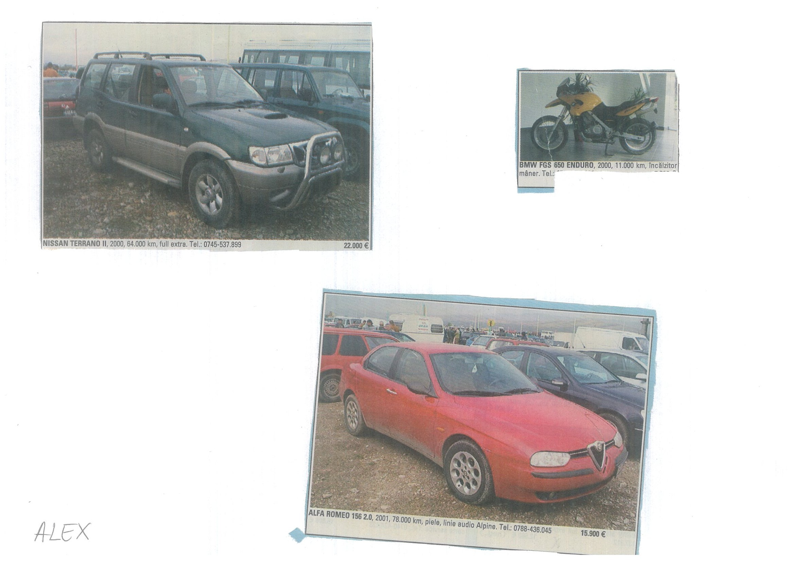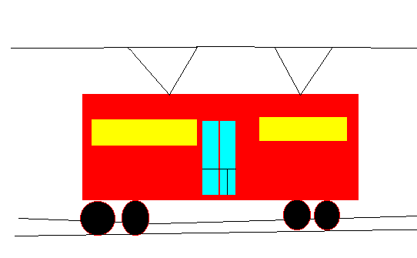
Transportation

I walk every day at school and back because the school is closed to my home. I meet my classmates on the road to school and we have fun talking and joking. I walk on the way to school and back with my best friend Catalin who lives next door. He is my classmate.
I go down town by tram. I also took the taxi to get in the center of Arad.
We go from school to the Puppets Theatre by bus.
I also traveled by train when I visited my grandparents.
I never traveled by plane. But I would like that very much.

Alina, 2th grade, General School No.6, Arad, Romania

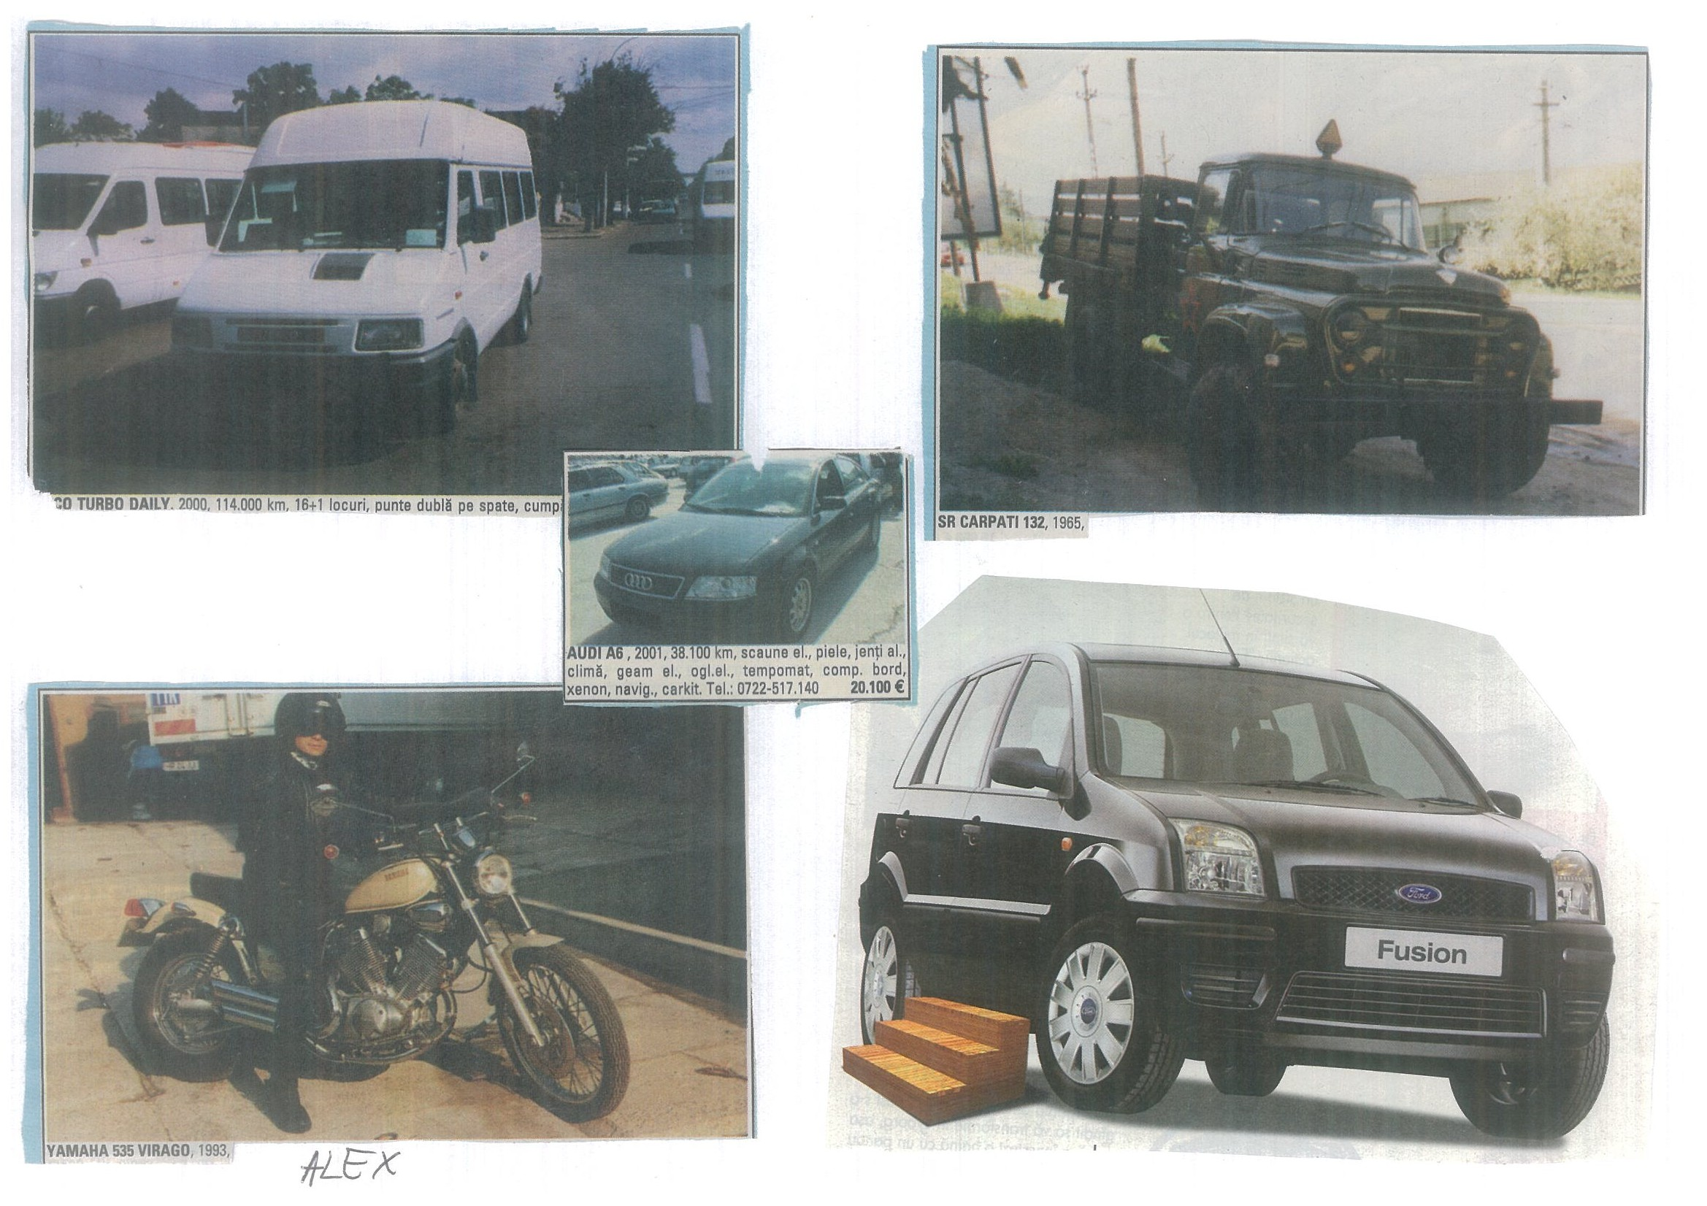

2th grade A, General School No.6, Arad, Romania

What is your favorite car? What car do you have or want to have?

Cosmina: I would like to have a silver Mercedes. I’d like to travel to France with my Mercedes.
Diandra: My family car is a grey Opel. I’d like to travel by it to Austria.

Andreea: I have a Romanian car, Dacia. I would like an Audi6. I would like to travel to Frnace by plane.

Vlad R: My favorite care is a BMW convertible. I want to travel to France by plane.

Emil: My family’s car is a Mercedes. I want to travel to United State of America by car, Dacia Logan.

Transportation
We live in a neighborhood. The school is near and some few boys and girls go to school by bicycle. As the neighborhood it's very dangerous, our parents go with us. They have time because they don't have work.
The teachers to arrive by bus (the service is very old and bad), by bicycle those that live near, and others in taxi. They spend some much of their money in arriving at to school, to give us class.
But our school is beautiful, we made him many paintings in the walls, it seems a great garden, so that they Know it we send them some pictures of its.
A small hug of Third C and D grade Alicia Gastellu - Oct 22, 2004 4:53 pm (2.)

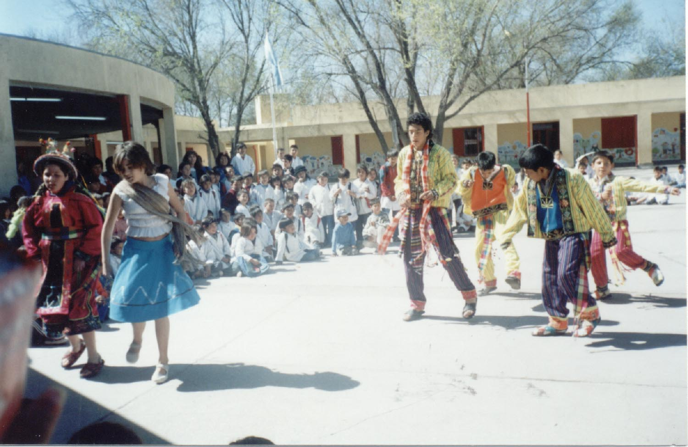

Alicia Gastellu - Nov 10, 2004 8:27 am (1.)
Transportes de mi barrio y mi ciudad
Un abrazo
En nuestro barrrio nos comunicamos con ómnibus, así llegamos al centro.
Córdoba se comunica con otras provincias especialmente por ómnibus, los hay muy bonitos, algunos son coches camas.
También nos comunicamos por avión; nuestro aeropuerto es internacional y desde aquí se puede viajar a Estados Unidos y a Europa directo
Un abrazo para los chicos de San Diego
Chicos de tercero

(Transportation project)
KENYA
Barry Kramer - 07:39am Oct 18, 2004 EDT
Guest User
Hi to all,
In our country, most primary and secondary schools especially in remote areas, there are slim chances of inaccessibility of various modes of transportation. Vehicles (to be) considered mostlikely are therefore not considered due to the transportation costs,
time inconvenience(s) as there are unnecessary stopovers delaying the students and other geographical climatic and natural factors that could hinder transportation such as ruggedness of the areas compared to the location of the school. They can prefer train here though this would be too slow. Therefore, foot-transportation is the BEST and SATISFYING, followed by bicycles commonly known as the (BODABODA) English term “border to border”. Unlikely where our schools are located in the town region, we use the vehicles as the most priority, followed by bikes and then footing with regard to the distance covered and the school destination. So far, our students could prefer vehicle transport as the BEST since they can g intercultural diversities.
Planes could take our highly interested students to other continents but chances of all of them affording to reach the (one close airstrip and international airport) around us are slim in terms of affording the airfare.

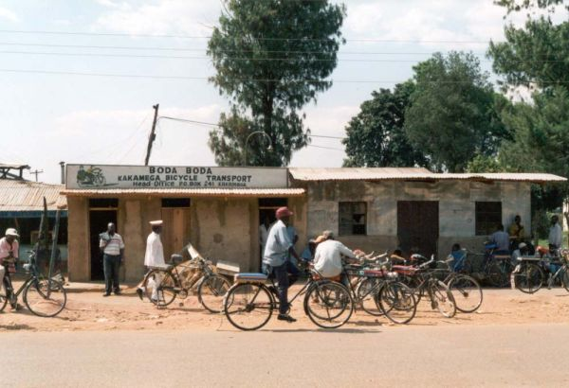

Transportation Stories for John Muir School
Barry Kramer - 12:44pm Nov 12, 2004 EDT
Guest User

Transportation Stories for:
John Muir School
San Diego, California, USA
From:The Fourth Grade
Franklin Township School
Quakertown, New Jersey
Our Transportation
My family uses many types of transportation. Our main transportation is acar. Our family car is a white Denali with two seats in the front, two seats in the middle, three seats in the back, and a trunk. The two front seats and the two middle seats have heat in them, which we love to use in the winter months. Our car also has a television set with a VCR and DVD player. This is a good thing, because our family is always up and going to sports and other activities. When we are not at sports, we are using
our car to drive to family celebrations many times a month. Our car also
takes us to various weekend trips. When we are not on the run my brother,
sister, and I use our bikes to ride up and down the street. When traveling to other states and islands, we use an airplane. Our family uses many types of transportation to go everywhere. The kind of transportation that we use depends on where we are going.
Gabrielle
Fourth Grade
Franklin Township School
Quakertown, New Jersey, USA
I would like to go to Pluto because it is a cool planet. It will take a long time to get there because it is the farthest planet in the solar system. Pluto is the smallest and coldest planet. If a person went to
Pluto it will take them along time to get there. I would like to go there because I would like to touch a planet.
CJ
Fourth Grade
Franklin Township School
Quakertown, New Jersey, USA
In New Jersey, we use cars because everything is so far away. My car is a
Toyota Tacoma truck. Our truck is a four-door truck and is silver. We
listen to music and talk in the car. Our truck has 4-wheel drive that is
great for snow. Every now and then we get gas so our truck doesn’t brake
down.
Brette, Fourth Grade
Franklin Township School
Quakertown, New Jersey, USA
Transportation
I use transportation all the time. I use my bike to ride to my neighbor’s
house and I use a car to get to many places like Florida and Maine. I like
transportation, because many people use it. Transportation also is a bad
thing because gas pollutes the air. If water came out of cars there would
be less pollution. I like transportation a lot.
BrittanyFourth Grade
Franklin Township School
Quakertown, New Jersey, USA
Traveling To a Different Planet
If I had the chance to travel to another plant, I would choose to travel
to Jupiter. I am not interested in the plant as in exploring its many
moons. The moon I am interested in is Europe, which may have an ocean
below its frozen surface. I am interested so much of this moon because if
it does have life on it I might get to explore it and see other life
forms. If this is true, then there might be life on it. This is why I find
Jupiter’s moon, Europe, the most interesting choice for such a long
journey.
Melissa
Fourth Grade
Franklin Township School
Quakertown, New Jersey, USA
We live in a small town right out of Flemington, New Jersey. The kind of
transportation we use is mostly automobiles. We go back and forth to school on a school bus. This bus holds about 50 children. The reason we don’t use city buses, trains, or subways is because we live in a rural area. Many people live on big plots of land. It is nice that we don’t have to ride buses and subways because you don’t have to worry about traffic jams or power outages. The reason I wanted to tell you about our
transportation is because yours is probably different in a big city. This is our transportation system.
Meghan
Fourth Grade
Franklin Township School
Quakertown, New Jersey, USA

Travel to Pluto
If I could travel a different planet I would travel to Pluto. I would travel there because it’s blue. I also would like to go there, because nobody has ever been there. I also wonder if there’s life on Pluto. I would be more popular then Hilary Duff if I went there. I wonder what the real size is. I will never have the guts to go to Pluto. I wonder if anyone will, but I can still dream!
Arlene. Fourth Grade
Franklin Township School
Quakertown, New Jersey, USA
I Want To Go to Hawaii
The place I would like to go to is Hawaii, in a Mustang. I would like to get on my own jet with my friends, (Melissa, Meghan, Paige, and Gabby) alone without my parents. When we got there we would get into our bathing suits and go to the beach. We would have an XL (extra large) suite in the hotel on the top floor. After we put the luggage down we would go into town and SHOP! When we were done for the 1st day of our one month vacation we would go and see everything in Hawaii, and another thing we would go to Honolulu Island. We would see everything on Honolulu Island too. When we got home we would plan another trip to California, Florida Keys, Australia
we would go everywhere tropical. That is why I would want to go to Hawaii with my friends!
Emily, Fourth Grade
Franklin Township School
Quakertown, New Jersey, USA
TRANSPORTATION
The kind of transportation vehicle I use the most is an airplane. I use an airplane because my parents are flight attendants and we can travel for free. We have to wait for all the paying passengers to get on and if
there is room left, we can go. I have been to France, Belgium, England, Sweden, Switzerland, Spain, St. Marten, Mexico, Puerto Rico, California, Florida, Kentucky, Texas, West Virginia, Virginia, Massachusetts, Washington, DC, and Hawaii. I feel very lucky that I get to do this and hope my parents will stay flight attendants.
Drew Fourth Grade
Franklin Township School
Quakertown, New Jersey, USA

Traveling To Another Planet
I wish I could travel to the planet of Mercury. Mercury is the closest
planet to the sun and I like the warm sun because I like warm
temperatures. I would also like to see the eclipse of this planet. I
would get there by using a space shuttle and by using a jet pack.
Gregory
Fourth Grade
Franklin Township School
Quakertown, New Jersey, USA
Transportation
The transportation I use to go to school is a school bus. A school bus is
a big yellow vehicle. It takes about 50 students to and from the school.
There are 12 rows of 3 seats and 2 seats on 1 bus. I go on it every school
day. That is how I am transported to school.
AJ
Fourth Grade
Franklin Township School
Quakertown, New Jersey, USA

I would go to Jupiter because it is a lot of room and you could fit a lot
more people on Jupiter than on earth. The only problem is you can’t live
on Jupiter without building a dome for the people
Jimmy
Fourth Grade
Franklin Township School
Quakertown, New Jersey, USA

Going To California
I would go in a car to California. In California I would go to
Disneyland. The reason why I would take a car is because I have a DVD
player in it. And I would watch the DVD is so I wouldn’t have to watch
the cars go by. I like watching Bring It On Again! I like a lot of movies
but in the car I can only watch one.
Shannan
Fourth Grade
Franklin Township School
Quakertown, New Jersey, USA
Transportation
When I use transportation I usually use a car. I’ve been to Kansas three
times. The boring thing about driving in a car is that you have to wait a
long time. If I could chose any vehicle I wanted to I would chose a
motorcycle. I would first go to a New York Yankees baseball game. Then I
would go to a Chicago Cubs baseball game.
I would go to baseball games because baseball is my favorite sport.
John
Fourth Grade
Franklin Township School
Quakertown, New Jersey, USA
Traveling to Another Planet
If I would travel to another planet I would travel to Saturn. There is a
big ring around it. I also like it because it is big so you can fit a lot
of people on it. Another planet I would like to travel to would be Pluto.
It is small so I would family and friends.
Stephanie
Fourth Grade
Franklin Township School
Quakertown, New Jersey, USA
I would like to take a plane too Germany Because I am German and there
is supposed to be a lot of neat stuff. Also we have relatives there.
Some of the neat stuff is pottery and neat little towns!
Mike
Fourth Grade
Franklin Township School
Quakertown, New Jersey, USA

Transportation.
I have been on a plane to the Bahamas. I have been on foot to Clinton.
My mom and my family have been driven in a car to a beach. My family and I have ridden our bikes on a path. I have been on a train to the strawberry
patch. As you can see, I have bin one car, train, foot, bike, and plane
but I really want to go is Florida. So now you no what Transportation I use, I hope you like it.
Paige
Fourth Grade
Franklin Township School
Quakertown, New Jersey, USA
Traveling To Another Planet
If I have the opportunity to travel to another planet I would choose Jupiter. I would choose to go to Jupiter because I studied that planet in 2nd grade. I studied Jupiter with my friend Andrew. We looked up
information on the Internet, wrote information down, made a project, and presented it in front of the class. That is why I would choose to go to Jupiter.
Jake P.
Fourth Grade
Franklin Township School
Quakertown, New Jersey, USA

What My Friends Use For Transportation
People at our school use their bikes or drive their cars to get to school.
I take the bus or I get dropped off at school. We have a room where we wait until the bell rings. At the end of school people usually take the bus but some people walk, ride their bike, or some get picked up. I
usually get picked up or take the bus.
Tyler, Fourth Grade
Franklin Township School
Quakertown, New Jersey, USA
A Motor Home Trip
The transportation I use is a motor home. My family and I go to all sorts of places like Florida, New Mexico, Maryland, Upstate New York,Connecticut, and Pennsylvania. On the way to New Mexico and Florida we
drove through Virginia, Washington, D.C., West Virginia, North Carolina, South Carolina, Georgia Tennessee, Arkansas, Texas, and Arizona. Also on
our way to these places, at night we went to state parks and rest stops nearby. If we couldn’t find a rest stop, we went to Wall Mart, because
Wall Mart let’s motor homes stay in their parking lots. In the morning my stepfather wakes us up bright and early. Other times he sleeps in. He makes really good breakfast. It’s fun riding in a motor home because you can eat, watch movies, play games and even go to the bathroom! You should try it sometime!
Lauren
Fourth Grade
Franklin Township School
Quakertown, New Jersey, USA

Ways of Transportation
There are many ways of transportation. You may use ways without evenknowing it. Some ways are by foot, bike, and even by bus and subway.
Some way you have to pay and some you don’t. Other ways are by taxi,boat, plane, car, and even balloon. That’s what I know about transportation!
Kacie
Fourth Grade
Franklin Township School
Quakertown, New Jersey, USA

Biking There are many ways of traveling. Biking is popular. There are trails
within the county. It is much safer to travel on the paths than the road. Many of the paths lead to the same places that the roads do.
Riding your bike to stores and shops is fun. Wearing a helmet and obeying the safety rules are important.
Jake P.
Fourth Grade
Franklin Township School
Quakertown, New Jersey, USA
North Carolina
If I could go anywhere, I would go to North Carolina. I would go to North Carolina because I love the beach. I like to collect seashells because they are beautiful. I also like to make huge sandcastles then smash them.
My favorite activities are body surfing, boggy boarding, and running into the waves because I love getting wet. I would take an airplane because it is much faster than a car. It takes twelve hours to get there by car!
Julie
Fourth Grade
Franklin Township School
Quakertown, New Jersey, USA

Outer Banks, North Carolina
I go to Outer Banks, North Carolina every summer. We’ve been going for 13years straight. We go with my Aunt Kerry, Uncle Mike, and my cousins Nicolina and A.J. We drive our car there. It takes 10 hours! Every year
I look forward to our trip to The Outer Banks.
Hannah
Fourth Grade
Franklin Township School
Quakertown, New Jersey, USA
How We Go Places
In our state we use cars, trains, airplanes, and, subways. I mostly use
cars then, I use airplanes. I love to use trans. my dad travels 1 hour to
work in a car.
Alexandra
Fourth Grade
Franklin Township School
Quakertown, New Jersey, USA

My Own Planet
If I were given the chance to go to a different planet I would go to Mars.
I would hitch a ride on a NASA robot. The best part would be I would be
the smallest in space. I’ve always wanted to launch off in a rocket to space. It would be cool to be in space!!!
Monique Fourth Grade
Franklin Township School
Quakertown, New Jersey, USA

Saturn
If were to go to another planet, I would go to Saturn. I would go to Saturn because I think it would be interesting. I would study how many rings are around Saturn and the atmosphere. I would also study how many
moons it has and the surface. I would also study the weather, the distance
between Saturn and Earth, and how big it is. I would observe the exact width and height of Saturn. I would bring my two best friends to come with me, Hannah and Lauren. I think it would be the greatest trip in the world to go to Saturn.
Stephen, Fourth Grade
Franklin Township School
Quakertown, New Jersey, USA
How I Travel
I like to travel by car and bike. I like those things because I’m afraid of boats sinking and planes crashing. On my bike I go on all the bike paths near my house. I also go on all the roads near my house. In my car I go all over New Jersey. I have also been to New York, Pennsylvania, Maryland, Delaware, and Florida. These are the places I’ve been in my car and on my bike.
Casey
Fourth Grade
Franklin Township School
Quakertown, New Jersey, USA
My Transportation
My transportation is a Ford F-350 truck. It is a big truck. My dad drives that. My family took it with us to summer vacation. It was
fun! We went to Lake George it was fun. It is a very nice truck. My dad takes it ever where with him. He is a homebuilder. So he goes to
meetings with it. He keeps it very neat inside.
Kevin, Fourth Grade
Franklin Township School
Quakertown, New Jersey, USA
Anywhere
If I could go anywhere I would go to Australia. I would take a hover
craft. I would go to Australia because of all the different animals like
the snakes. With a hover craft I could go nonstop over land and water.
Mitchell
Fourth Grade
Franklin Township School
Quakertown, New Jersey, USA

Where I Would Like To Go
Some day I would like to go to the country of Ireland. I have relatives in Ireland that I would like to see. I would like to travel there on an airplane because it would be the quickest way. Once I get there I would skateboard around. I bet I would really like the trip.
Kevin W.
Fourth Grade
Franklin Township School
Quakertown, New Jersey, USA

\

Chattanooga, Tennessee, USA
We liked the great Inspiration visual learning projects from Tennessee.


