TAKING CARE OF THE ENVIROMENT

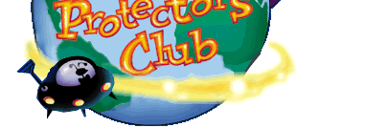
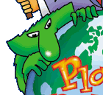
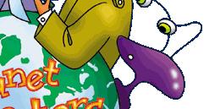



2006

What do people around the world do with trash?


Earth is getting fill up with the things we throw away. And it’s getting hard to handle all the waste we add each day.

We all have bins in our houses which we keep filling up with trash. Different sorts of trash get thrown away in different rooms of the house.
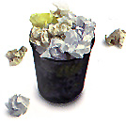
When our inside bins get full, we empty them into our big bins outside. Most people have got wheelie bins. These are much bigger than the dustbins we used to have, but some people still manage to fill them up very quickly.

Once or twice a week, the trash truck comes to collect our trash. The machine picks up the bins and empties them into the back of the truck. The trash is crushed so that it takes up less space.
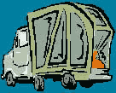
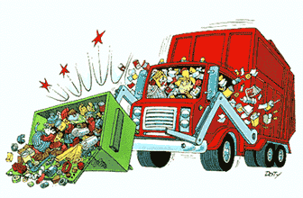

The trash is then taken to a landfill site. But, do you know what a Landfill site is? A landfill site is a huge hole in the ground which is being filled up with trash.
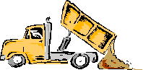

Almost all of our trash or waste ends up in a landfill site.

How can we help to solve this problem?

- RECYCLING
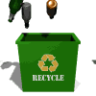
What is recycling? It is a way of separating some waste materials and making them into new products. For example, waste paper can be recycled into new paper and steel cans can be recycled into new cans, or paper clips or parts of bridges.

How does recycling help the environment?

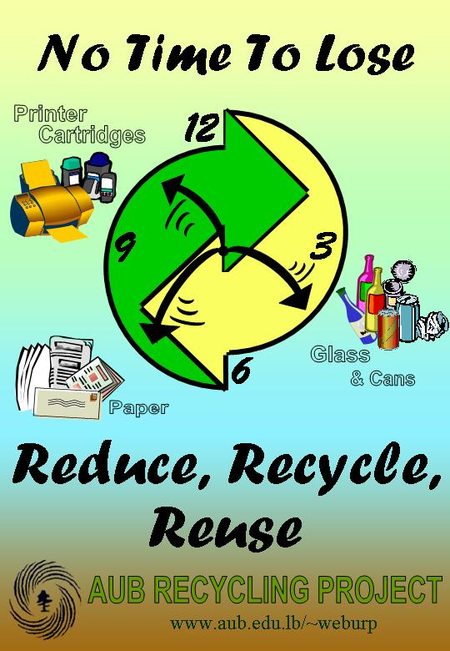
- Recycling helps the environment by slowing down the rate at which we have to burn garbage or put it in landfills.
- With fewer landfills we can have more space for people to farm, live, and work.
- Recycling also helps by reducing our need to consume fresh natural resources to make new products.
- As a result we can save these resources for use by future generations.
- Most importantly, recycling saves energy and reduces pollution.
- This could help slow down global climate change, another environmental problem caused by burning fossil fuels like oil and gas.

What materials can be recycled?

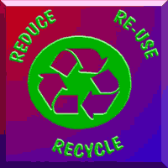

Technically, almost anything could be recycled. These include: aluminium, newspaper, plastic and glass.

ALUMINIUM

It is made from a natural resource called Bauxite Ore. making products from recycled aluminium saves energy and Bauxite Ore.

There is not limit of the number of times aluminium can be melted down and reused… that means aluminium can be recycled and reused over and over again!
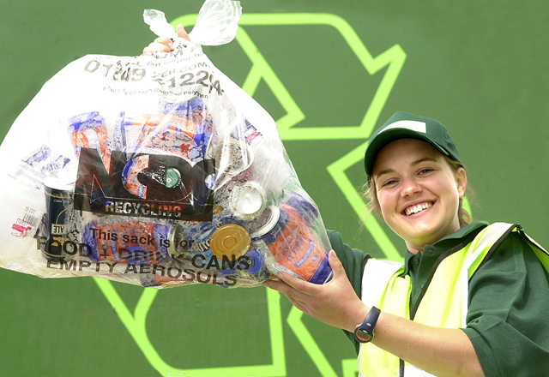
It takes 80- 100 years for aluminium can to decompose
(break down and disappear) in our landfills and dumps

GLASS

It is made of soda ash, limestone and lots of sand. The mixture is put into a very hot furnace and when it melts, it turns into glass. Heating the furnace takes a lot of energy!

Glass can be recycled and used over and over again! This saves energy and natural resources!
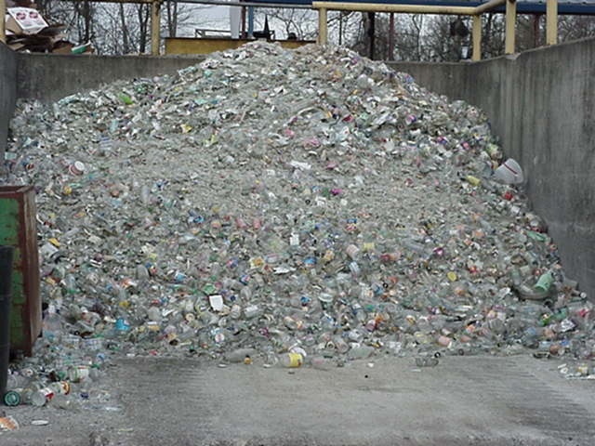
Recycled glass melts at a lower temperature than new materials, so it takes less energy to heat the furnace. In fact, most bottles and jars are made from recycled glass.

Glass takes over 1,000,000 (one million) years to decompose (breakdown and disappear) in our landfills or dumps.

Glass can be recycled into jars, bottles, jewellery, dishes, drinking glasses, coffee mugs and many other items!

Reuse your glass containers as a vase, pencil holder, or a container to hold a collection of things like buttons!
When you’re done reusing your glass container, recycle it!

PLASTIC

Plastic is made from oil, which is a non-renewable resource. This means that one day it will run out. Oil has taken millions of years to form. It is made from dead plants and animals and will probably run out in the next half century.
Plastic things, which are thrown away and get dumped in landfill sites, will never rot away.
It is more difficult to recycle plastics than other materials, because
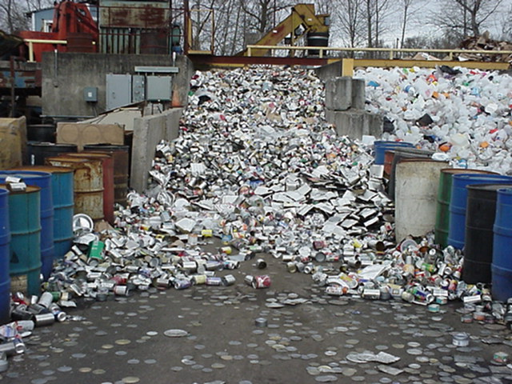
there are several different types. Each type needs to be recycled
separately.
Many items are made from recycled plastic, including bin liners,
garden furniture, video and CD cases and even fleece jackets!
Plastic cannot be recycled everywhere at the moment. In any case,
we should all try to reduce the amount of plastic we buy and re-use it
as much as possible.

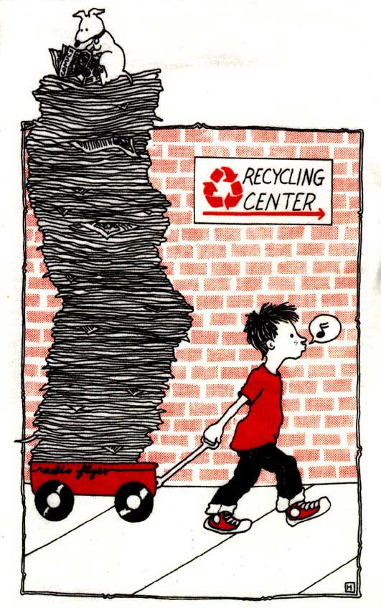
PAPER

About 25% of what we throw away is paper.
Recycling paper uses less energy and water than making paper from trees.
Waste paper which is dumped in landfill sites gradually rots down and produces methane, which is a dangerous greenhouse gas.


How can we reduce our waste?

We are now making more waste per person in our country than ever before. We are using up lots of resources and energy to make the things which soon afterwards, we throw away.
Waste causes many environmental problems and is also a big waste of money. If we reduce our waste, we make less waste.

How are students at fundación Santa Maria contributing to solve this problem?
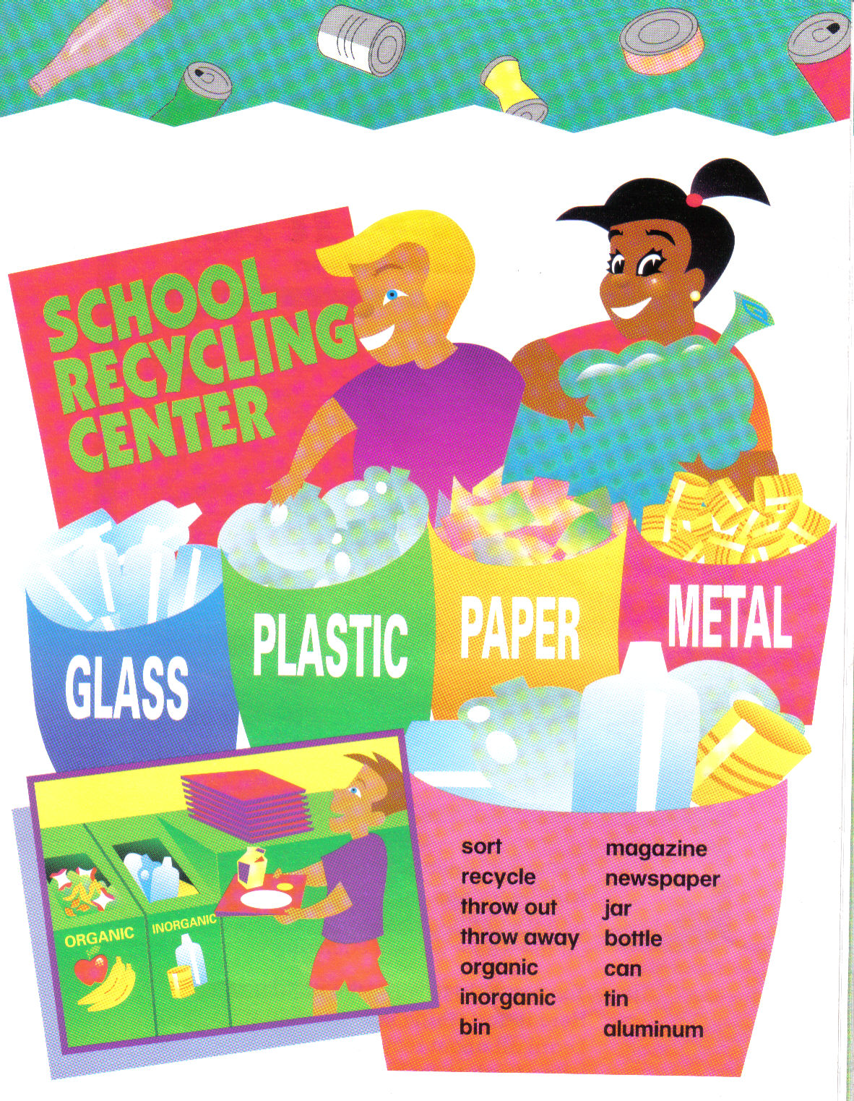
We are reducing waste at school, classifying trash in different cans.
  - Glass in blue cans
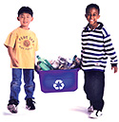
  - Plastic in green cans
  - Paper in yellow cans
  - Metal in red cans
Garbage is classified in different cans

Children at school are also reusing different kinds of materials during their arts and crafts class, in order to create:



- Recycled paper
- Puppets
- Cans
And they have decorated the school using the reused material.

Children are also reducing waste at home
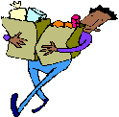
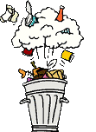
They are recommended their parents and families to think about waste reduction when they go shopping, so that they don’t buy the things which will have to be thrown away.
They recommend their parents to:
- Avoid buying things with lots of packaging, for example, fruit, which can either be bought in plastic trays or loose.
- Avoid buying things which are designed to be thrown away, like disposable cutlery and plates.
- Buy strong, hard-wearing items which last longer and create less waste, like ‘Bag for Life’ carrier bags.
Throng the experience children are having at school by means of this project, We hope to involve all the community here in Colombia and abroad.
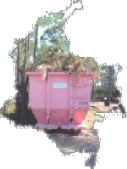

And that is why follow are presented the contributions made by students around the world.

SCHOOL NR.85 “PROF.V.BUNESCU”
BUCHAREST

ROMANIA

CLASS V A

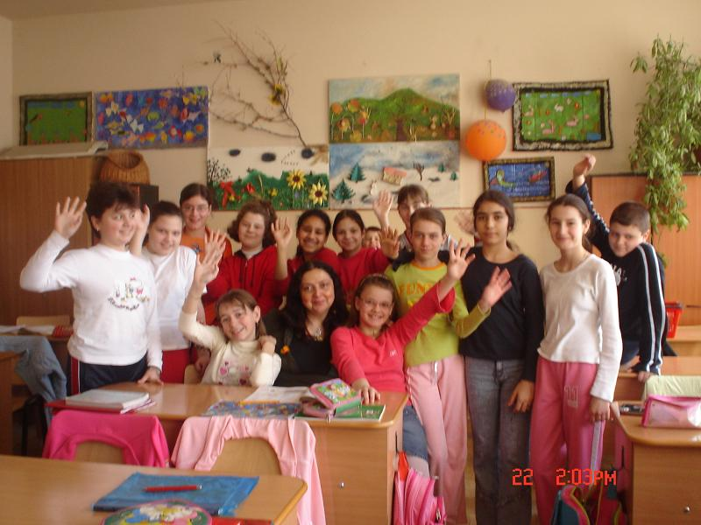

CARING FOR OUR ENVIRONMENT

Our city, Bucharest, is a big city with almost 2 million people. Generally it is a clean town but there are areas full of garbage, because some people – children or even older people – do not use the special bins for littering (the City Hall placed many garbage bins in the streets of Bucharest).
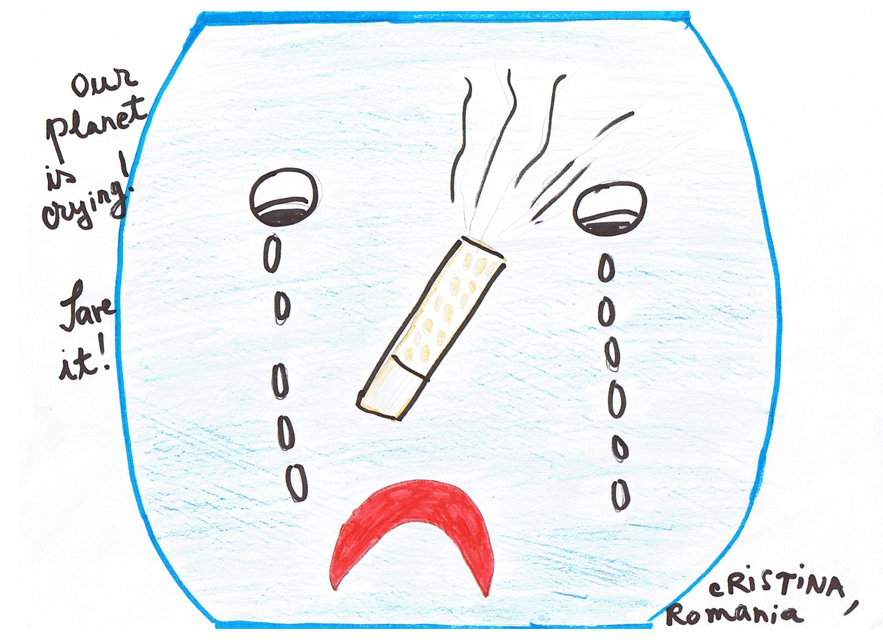

Garbage changes the “face” of a town, makes it more ugly. And some garbage, like chemicals or toxic substances can be very dangerous for the Earth! That is why, we think that there should be more specialized centers for recycling the garbage (we don’t know very many of them here) and the “bad” and dangerous garbage should be destroyed or buried in special places.

In our homes each of us has special bins for the litter (they are usually kept in the kitchens or in the yard, outside the house). WE do not have in our country special containers for different types of garbage (plastic, paper, etc) – so, everything goes in one big container near our homes and twice a week a garbage truck comes and collects all the garbage and takes it we don’t know where.

At school, there is a medium - sized bin in every classroom. We stay at school from 11 to 4 or 5 every day and at the end of the day the garbage bin is almost full. Mostly, it contains paper that we discard or play with during the breaks – it’s not nice, we know!, some boys tear paper from their notebooks and make planes that they fly in the classroom during the breaks - , wrapping paper or bags from the snacks we eat, fruit cores, empty bottles or cans.

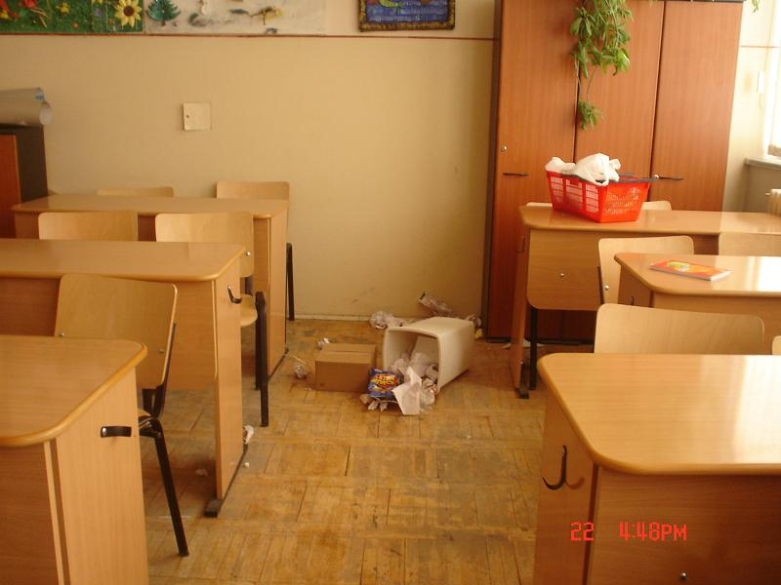
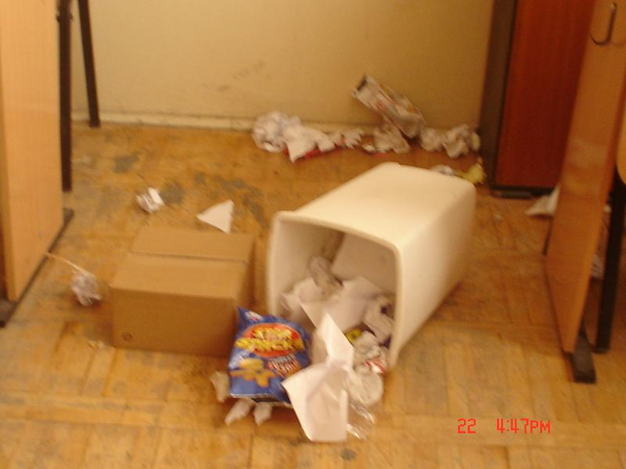

Every day, 2 of our colleagues are on duty and clean the classroom at the end of the day – we have cleaning ladies in school but we like to give them a helping hand!

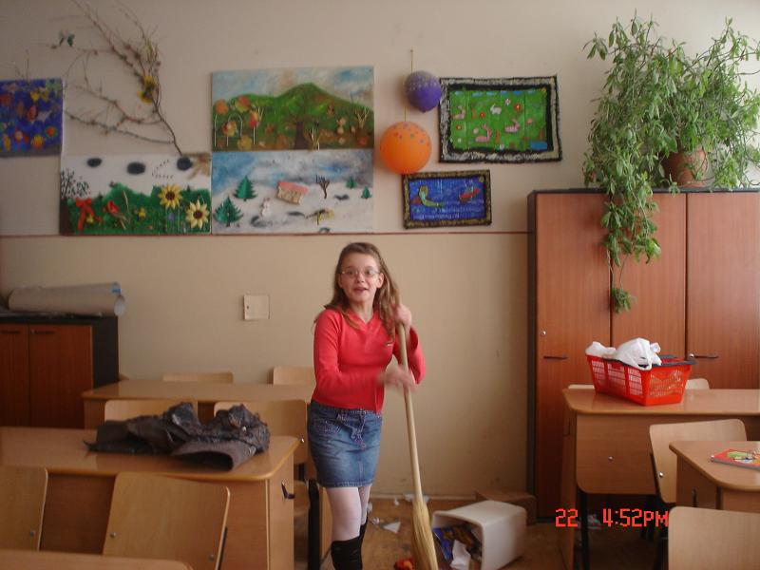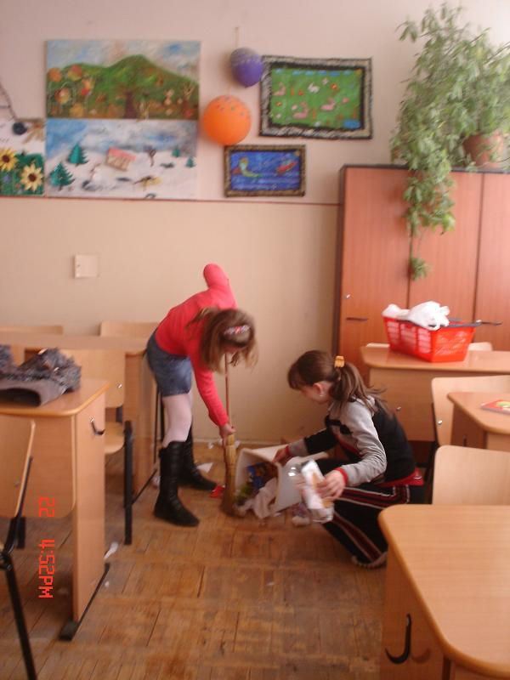
(Miriam and Iulia are on duty today and they have a lot of work to do!)

What can we do to reduce all this garbage? Ask our colleagues to stop destroying their notebooks and play other games, eat less junk food – this is difficult!, more fruits and ask our teacher to find a center which collects “good” garbage, the recycling one, and do collecting days with all the classrooms in our school. Here we need the help of our teachers to organize everything.

In order to change people’s garbage habits we all agreed that the best way is to start by giving very expensive fines to all those who drop garbage carelessly in public places.

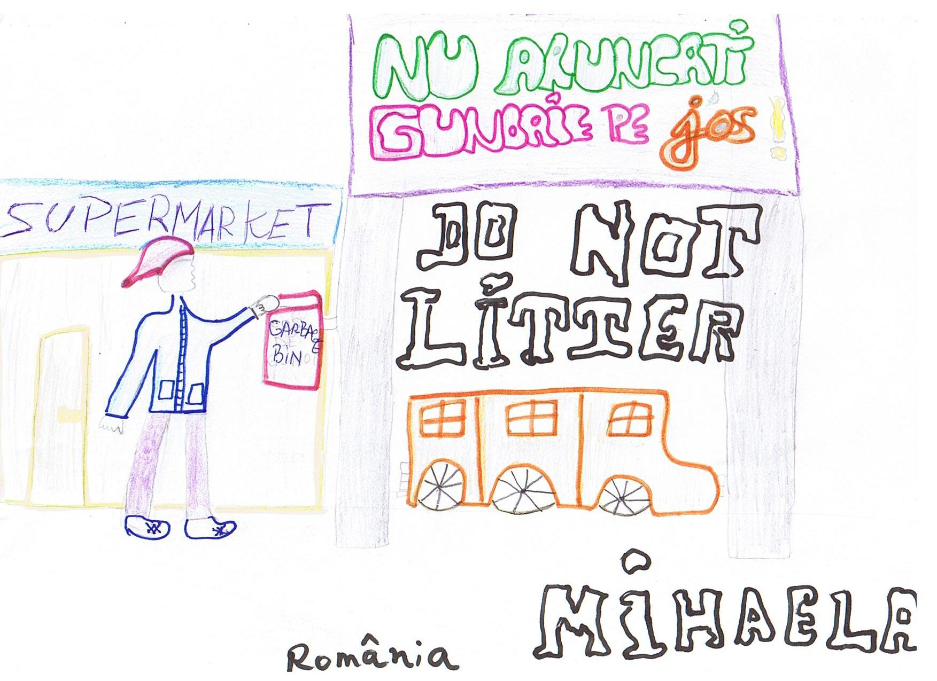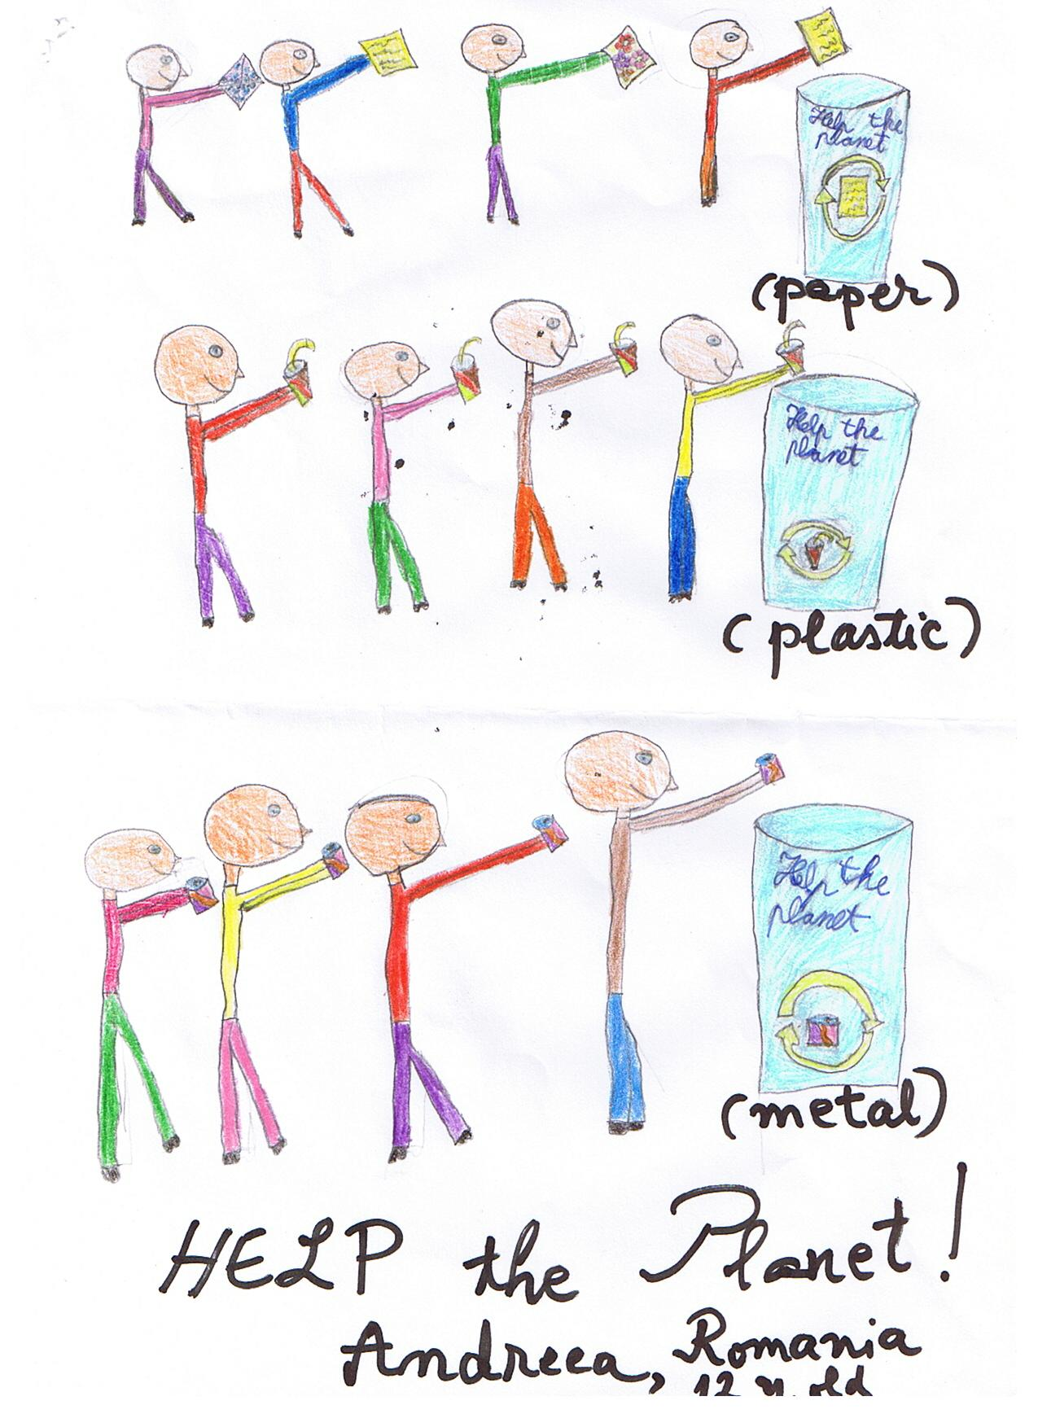

( Written by: Andreea, Cristina, Mihaela, Miriam, Andra, Iulia, Florin and corrected by our English teacher, Ms. Daniela St.Clair)

P.S. We decided (together with Ms. St.Clair) to organize such a “recycling day” with the whole school on the 22nd of April (on the Earth Day) and we started asking all our colleagues and teachers to collect plastic bottles and bring them to school to sell them to a special center.
Also, together with another 5th grade in our school, we decided to go to a park and clean it.

Follow the link to see Dallas’ student’s contribution

Eleonor Trush in Texas.pdf

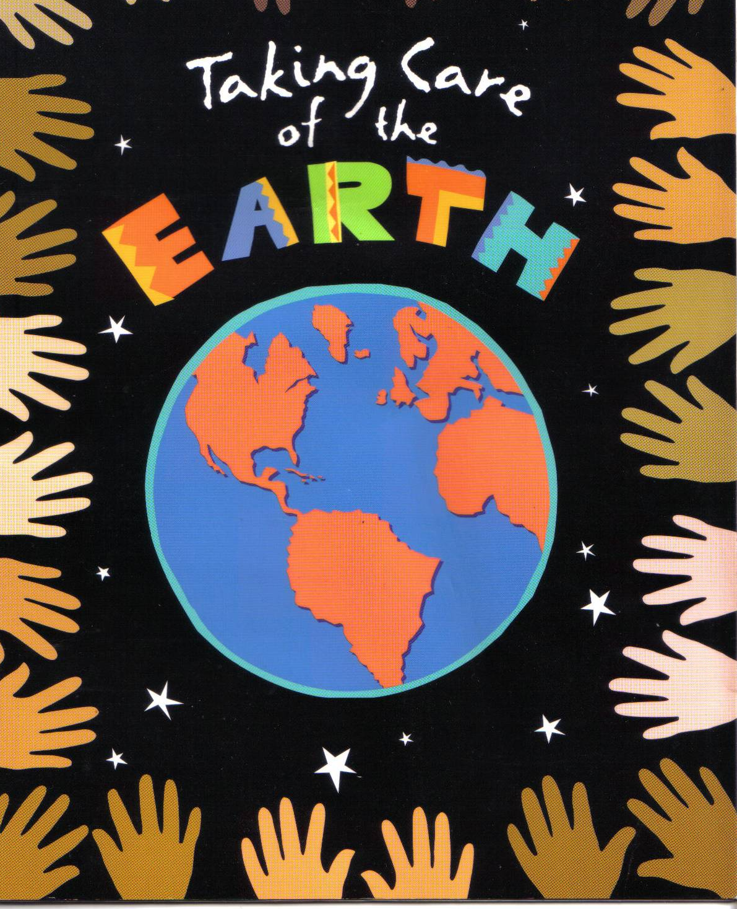

Dear pals don’t forget to practice the motto that says:

“Don’t throw it away it can be used another day”

Karen Ulloa
Fundación Santa María School
Bogotá, Colombia
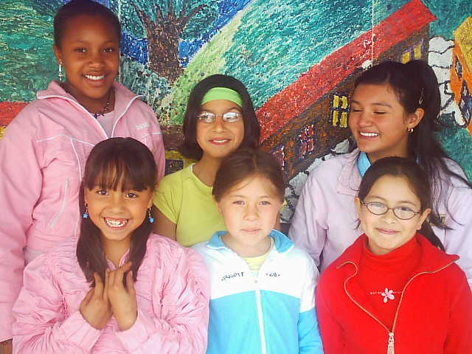
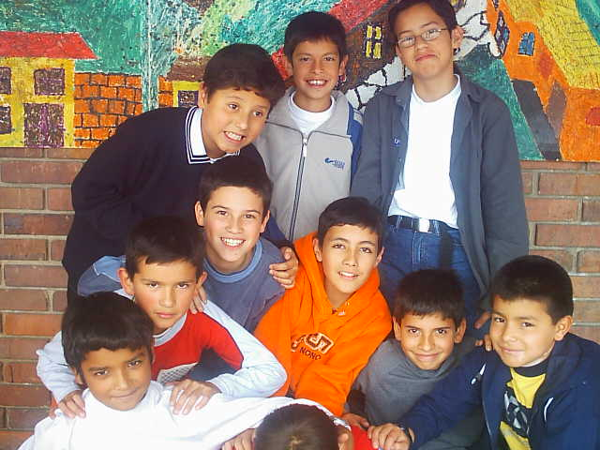

Good bye

