I * E A R N
International Education and Resource Network

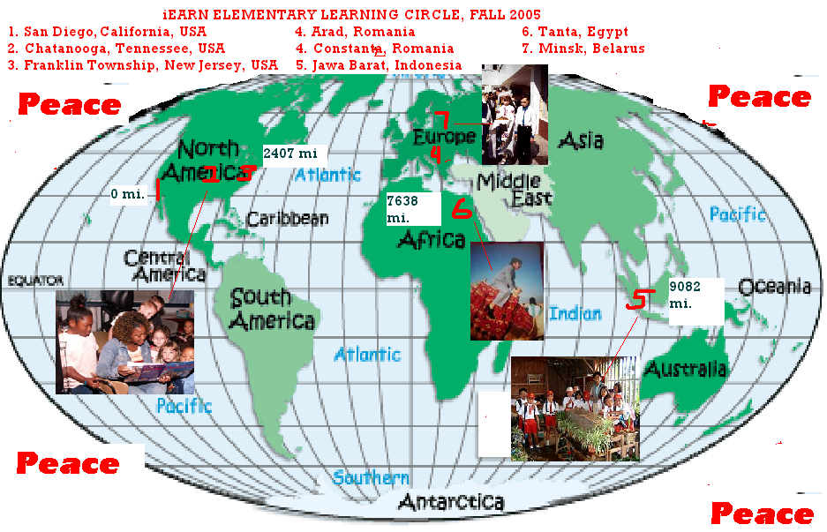

M Y T O W N

A LEARNING CIRCLE PROJECT

September 2005 through January 2006
Computer Chronicles: Elementary

Participating Teachers and Schools:

- BARRY KRAMER
Franklin Township School,
Quakertown, New Jersey, USA

- CHRISTINE HOCKERT
McConnell Elementary,
Hixson, Tennessee, USA

- ANNE S. LAMBERT
John Muir School,
San Diego, California, USA

- TATYANA STEFANYUK
Gymnasia no. 12,
Minsk,Belarus

- ECATERINA RUPESAC
“Dan Barbilian” School
Constantza, Romania

These are our country:

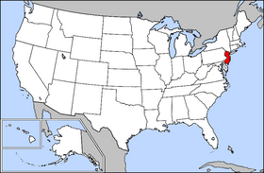

New Jersey

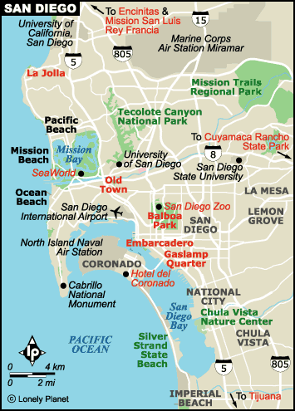

Tennesse

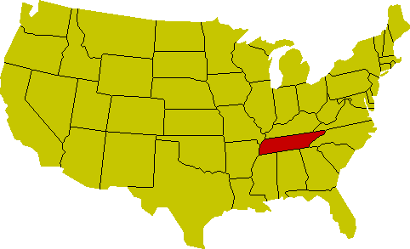

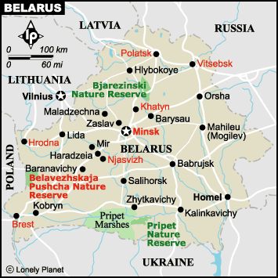

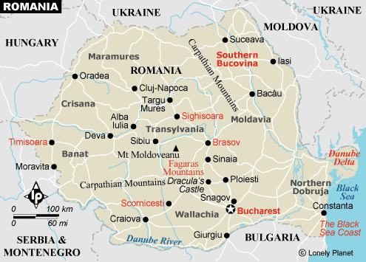

Class Survey

- Franklin Township School,
New Jersey, USA
PART I. INTRODUCING THE CLASS
A. Name of teacher: Barry S. Kramer and Tracy Strysky
B. Grade level: 4th Grade
C. Class favorites:
List your class top 5 favorites in each of these categories. It was difficult for us to choose our top 5 favorites so we compiled a list of some of our favorites.
1. Music Groups | 2. Authors
Greenday  Simple Plan  Linkoln Park  Black Eyed Peas  Bowling For Soup  Maroon 5 | Roald Dahl  R.L. Stine  J.K. Rowling  Astrid Lingren  Beverly Cleary  Judy Blume  Lemony Snickett

3. Television Shows | 7. Video Game
The Simpsons  That’s So Raven  The Family Guy  Drake and Josh  Lizzy MacGuire  SpongeBob Square Pants  MTV  Full House  The Sweet Life of Zach and Cody  All That!  (You can see that we watch a lot of TV) | Attack of the Zombi Squirrels  MVP Baseball 2004  Ice Age  Put-Put Golf  King of Hearts  Tony Hawke  The Sims  Halo  Star Wars  Mario Brothers
4. Foods | 8. Animals
Watermelon  Blueberries  Hot Dogs  Tacos  Pizza  French Fries  Macaroni and Cheese  Cheeseburgers  Oreos  (You can also see that we love to eat) | Monkey  Gazelle  Tiger  Python  Wolf  Cheetahs  Hamster
5. School Subjects | 9. Kind of Music
Art  Computers  Phys. Ed.  Science  Social Studies  Writing  English | R&B  Pop rock  Country and Western  Soft Rock  Theater Music  Disco
6. Sports | 10. Colors
Gymnastics  American Football  Basketball  Baseball  Cheerleading  Dance  Softball  Soccer  Tennis  Volleyball | Aqua  Indigo  Hot Pink  Hazel  Seagreen  Violet  Maroon  Dark Theater Red

11. Cars | 12. Pizza Topping
VW Beetle  Infiniti  Cadillac  Dodge Viper  Jaguar  SVT Cobra  Lambourgini  Hummer | Pepperoni  Mushrooms  Spinach  Bacon  Grated Cheese  Pineapple  Clams  Meatballs  Salad
PART II. INTRODUCING THE SCHOOL
A. School information
1. Name and address of class and school:
Franklin Township School
226 Quakertown Road
P.O. Box 368
Quakertown, NJ 08868
Phone: (908) 735-7929
FAX: (908) 735-0368
2. Number of students: 390 (Grades K through
There are 43 students in the 4th Grade
22 - Mr. Kramer's Class
21 - Mrs. Strysky's Class
3. Number of classrooms: About 25
4. Age of school: 68 Years Old
5. Building materials of your school: Brick.
The school facade is a very tradition Neo-classical New England style
school
6. School emblem, colors, or mascot: The school colors are
Blue and Gold;
Our school mascot is a Lion
7. School Web site: http://www.ftschool.org
Class Web site: http://www.ftschool.org/fourth/
8. Length of School Day: 8:35 am to 3:15 pm
B. School Program
1. List 3 things about your school program that make it unique.
1. Franklin Township has a computer lab equipped with 25 Macintosh iMac Computers. Each classroom also has about two new iMac Computers. All the teachers have wireless Apple ibooks. All the computers are networked and we have wireless access throughout the school building. Totally we have about 120 MAC computers.
2. Every Computer has full high speed Internet access.
3. Franklin offers a ski club for grades 5 through 8
4. An original Franklin Township one-room schoolhouse sits outside the main school building
5. We provide an after - school care program
2. List school year calendar (start and end of school, holidays, and special events).
School Calendar:
October 31 - Halloween Party
November 10, 11 - Teachers’ Convention in Atlantic City (School Closed)
November 16, 17 - Parent/Teacher Conferences
November 24, 25 - Thanksgiving Holiday
December 24 - January 2 - Winter Holiday
PART III. INTRODUCING THE COMMUNITY
A. Your Community
1. Name of your community: Franklin Township, Hunterdon County
There are 6 Franklin Townships in New Jersey
2. If not a city, name and size of nearest city:
The nearest cities are Clinton and Flemington, New Jersey
The nearest major cities are New York City and Trenton, New Jersey
3. Location of your community:
Franklin Township is due west of New York City. We are located off of Interstate 78. The small New Jersey cities of Pittstown and Quakertown are in Franklin Township.
4. The area of your community: Roughly 20 square miles

5. The population of your community: Slightly more than 3,000 residents. Also, many cows, chickens and horses.
B. Special Characteristics
1. List 3 reasons why people come to visit your area.
People come to Franklin Township because it is a rural area of New Jersey.
Nearby is picturesque Clinton with Old Mill and reservoir.
Many people come to Flemington to shop in the outlets.
2. Describe any unusual land formation found in or near your community.
The area that Franklin Township is in is known as the Highlands region of New Jersey. The area is characterized by low rolling hills and farmland. At one time there were many dairy, fruit and vegetable farms in our area, but the most profitable crops that are grown now are houses.
With Franklin Township being about 75 minutes commute to New York City; many people are selling their farms to housing projects. All homes in Franklin Township have to be on a minimum of five acres of land.
C. Industries
List major industries or occupations in your community.
Farming dominates in Franklin Township. Most farmers specialize in raising special products. The nursery and ornamental business has become a major farming trend.
Nearby: Exxon Oil has a major research facility.
Flemington is also known for outlet shopping
M & M Candies are made in Hackettstown, New Jersey
PART IV. OTHER INFORMATION
We will be sending some individual stories about us so that you can get to know us better.

- McConnell Elementary,
Hixson, Tennessee, USA

PART I. INTRODUCING THE CLASS

A. Name of teacher: Chris Hockert

B. Grade level: 2nd grade

C. Class favorites (List your class top 5 favorites in each category):

1. Our favorites:

2. Music groups
Usher, Rap Music Groups, Back Street Boys, Nellie, Dixie McCartney

3. Authors
Marc Brown, Mary Osborne, Barbara Park, Dr. Seuss, Jeff Brown, Tyler Bran ton

4. TV programs
Tom & Jerry, Jimmy Neutron, Courage, the Cowardly Dog, Sponge Bob, Fairly Odd Parents

5. Foods
Chicken fingers, pizza, apples, nachos, shrimp

6. School subjects
math, computer, P.E., science, social studies, reading

7. Sports
Soccer, tennis, football, baseball, softball

8. Video game
Star Wars, Tack- 2 Stack of Dreams, Midnight Club, Mario, Cras

PART II. INTRODUCING THE SCHOOL

A. School information
1. McConnell Elementary School

2. Name and address of class and school
8629 Columbus Rd., Hixson, TN 37343

3. Number of students in class and school
630 students in the school and 20 in the classroom

4. Size of school
There are 5 classrooms in each grade level from 2-5 and 4 classes each for first grades and kindergartens

5. School emblem, colors or mascot
The school mascot is the Mustang and the colors are blue and gold

6. Type and number of computers
Although there are 3 computers per classroom and 20 in the computer lab although they are ten years old and very slow

7. School history
The school was built in 1967 and it is a community school that receives a lot of support from the parents. We have a strong PTA
More information is available at www.hcde.org
Click on schools and find McConnell Elementary

B. School program
1. Each classroom has access to P.E., Library, Cultural Art, Music, and Computer lab each week for 50 minutes. Our curriculum focus is literacy and math. We also cover science and social studies content areas.

2. List 3 things about your school program that make it unique.
Great teachers
Super Parents
Wonderful playground

3. List school calendar from the session dates (holidays and special
events that may affect your participation).
Fall break: Oct 17-21,2005
Thanksgiving Holiday Nov. 23-Nov. 28, 2005
Christmas holiday break Dec. 20, 2005-Jan. 9, 2006

PART III. INTRODUCING THE COMMUNITY

A. Your community
1. Hixson, TN is a suburb of Chattanooga, TN

2. Name of your community

3. If not a city, name and size of nearest city
Chattanooga, TN and we are 2 hours away from Knoxville, TN, Atlanta, GA, and Nashville, TN

4. Location of your community
We are located on the southern border of TN with Georgia

5. The area of your community
Our area is surrounded by mountains, Lookout Mountain, Signal Mountain, Daisy Mountain, to name a few in addition, we also have the Tennessee River that snakes its way throughout the area and the city of Chattanooga. Hixson, TN is on a part of the Tennessee River called Lake Chicamauga

6. The population of your community
Hamilton County’s population is almost 500,000 people
More information about Chattanooga can be found at www.chattanooga.gov and www.50states.com

B. Special characteristics
1. Chattanooga is known for the “Scenic City of the South” It is beautiful here and there are a great many outdoor activities in addition to lovely museums for history and art

2. List 3 reasons why people come to visit your area. Lookout Mountain, Ruby Falls, Tennessee Aquarium and Coolidge Park plus many more great places including the Chattanooga Choo Choo

3. Describe any unusual land formation found in or near your community.
Lookout Mountain, Signal Mountain both of these were important in the time of the Civil War and the Tennessee River

C. Industries

List major industries or occupations in your community.
Many of the industries or occupations are based on tourism including services in the restaurants, retail operations, and museums. We also have a transportation base with the airport, electric buses, and trains. Another service industry is insurance companies in addition to several major hospitals in the area.

PART IV. INTRODUCING YOUR PROJECT IDEA

A. Your Learning Circle Project: Write or draw about What Peace Means to You and another project idea is Animals in our backyard.

B. Your information request:
Please send us poems, essays, pictures or Power Point presentations about What Peace Means to You. Also send poems, essays, pictures, or Power Point presentations about the Animals in your Backyard.

- John Muir School,
San Diego, California
PART I. INTRODUCING THE CLASS
A. Name of teachers: Susan and Rainee collaborate with Anne during library time
B. Grade level: K-1 and others
C. Class favorites
1. Music groups: Rock and Roll
2. Authors: Eric Carle, Denise Fleming, Jan Brett, Dav Pilkey
3. TV programs: Arthur, Animal Planet, Spongebob, Bugs Bunny
4. Foods: pizza, hot dogs, apples, spaghetti, noodles, broccoli
5. School subjects: PE, reading, art
6. Sports: running, basketball, bikes, football, soccer, tennis
PART II. INTRODUCING THE SCHOOL
A. School information:

1. Address
Anne Lambert--lkpals
Library, John Muir School
4431 Mt. Herbert Ave.
San Diego CA 92117
2. School
We have 29 students in the class and 300 students in the school.
We use 20 IBM computers at the library.
Our school started as a choice for students who did not want to attend large schools.
We have a special emphasis on nature, and we are making a garden this year.

B. School program
1. Uniqueness
We have many families with three or more children in the school.
All of our students are bussed in from other places in the city.
We are Kindergarten to Twelfth Grade.
2. Holidays
We have a whole week off of school at Thanksgiving, November 21-25.
PART III. INTRODUCING THE COMMUNITY
A. Your community
We are in the suburb of Claremont, but our children live in the center of the city. We are in San Diego, the sixth largest city in the USA.
B. Why visit?
We are the most southwestern county of the USA.
People come here to visit Sea World, the San Diego Zoo, and Tijuana, Mexico and to enjoy our year-round summer weather.
We are on the Pacific Ocean. There are islands off the coast of California.
C. Industries
The major industries are the military and technology. We have lots of naval ships in our harbor.
PART IV. OTHER INFORMATION
We would like to do a project about how to protect our environment--local animals and how to conserve their habitats.

- Gymnasia nr. 12,
Minsk,Belarus

PART I. INTRODUCING THE CLASS
A. Name of teacher: Tatyana Stefanyuk.
B. Grade level: Form 5"V" (10 years old).
C. Class favorites:
1. Music group: Korni, EMINEM, Crazy Frog, Shakira, Britney Spears.

2. Authors: Joanne Rowling.
3. TV programs: Cartoons, Jetix, Discovery.
4. Foods: potato, bacon, eggs, apples, jelly.
5. School subjects: Art, Nature, History, Maths, English.
6. Sports: football, roller-skating.
7. Video or computer games: Star Wars, Battlefront, Sims, War Craft 3, Underground, Renegade.
PART II. INTRODUCING THE SCHOOL
A. School information
1. Name and address of class and school: Gymnasia №12, Golubev Street, №10, Minsk, Belarus, 220116
2. Number of students in class and school : 10 students in our group, about 1200 students in our school.
3. Size of school: There are about 50 classrooms in our school including two computer classrooms. More than 150 teachers work here.

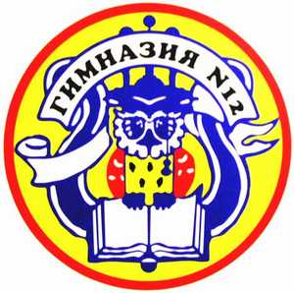
4. School emblem, colors or mascot: a wise owl with a book.

5. Type and number of computers: about 30 computers (Celeron 1200MHz).
6. School history: Our school building is 25years old, but School №12 existed from 1904 to the present. It just moved from one place to another. So it’s one hundred years old!
B. School program
1. List 3 things that make our school unique:
- We think our school is unique because of its students. Almost 98% of them enter universities after leaving school.
- There is a wide variety of extra classes to perfect knowledge of languages, Maths, Physics, Chemistry etc. Students can play music, dance, paint, do sports.
- There is a museum in our school where people can see documents and things connected with history of our school and history of education in Belarus.

2. School calendar: 31.10- 6.11 (autumn holidays)
24.12-8.01 (winter holidays)
PART III. INTRODUCING THE COMMUNITY
A. Your community
1. Name of your community: Minsk, the capital of Belarus.
2. If not a city, name and size of nearest city
3. Location of your community: Minsk is situated in the centre of Belarus.
4. The area of your community: about 200 sq miles.
5. The population of your community: about 2 million people.
B. Special characteristics
1. List 3 reasons why people come to visit your area:
- Our country is very beautiful: a lot of forests and lakes. There are forest reserves, ancient castles and churches.
- Minsk is a modern city. It was completely destroyed during the war 60 years ago. Now there are many museums, theatres and other places of culture in Minsk. We have memorial places as well.
- It’s a big industrial center. So optimistic people from different countries have their business here.

2. Describe any unusual land formation found in your community:
Our country has a picturesque landscape. There are lots of hills in Belarus. The same relief is in Minsk. There are many places to sledge in winter.
C. Industries: plants of trucks (MAZ), tractors (Belarus), fridges (Atlant), TVs (Horizon) etc. Our favourite factory is a chocolate factory “Communarka”.
PART IV. OTHER INFORMATION
Our dream is to have many friends all over the world and to visit them one day.

- School “Dan Barbilian”
Constantza, Romania

PART I. INTRODUCING THE CLASS
A. Name of teacher: Ecaterina Rupesac
B. Grade level: THE FOURTH GRADE (10-11 years old)
C. Class favorites (List your class top 5 favorites in each category):
1. Music groups: Akcent,Fifty Cent, Shakira, Backstreet Boys, Julio Iglesias
2. Authors: Mihai Eminescu, Ion Creanga, George Cosbuc, Andersen, Caragiale
3. TV programs: Cartoons ;Animal planet; Tv sport; Discovery, Fox Kids
4. Foods: pizza, fried potatoes, chicken, soup, hamburger,
5. School subjects: Mathemathics, Romanian Language, History, English Language, sports
6. Sports: tennis, volleyball, swimming, football, gymnastics
7. Video or computer games: Sims, Barbie, Underground, Fifa 2005, Harry Potter

PART II. INTRODUCING THE SCHOOL
A. School information
1. Name and address of class and school: The 4-th D class, School “Dan Barbilian” nr. 28, Street Decebal, nr. 15, Town Constantza, Romania
2. Number of students in class and school: In my sclass are 29 students, and in my school are cca 850 students
3. Size of school: My school is a big school with 20 classrooms, a labo for chemistry, a labo for physics, a labo for biology, a labo for computers, a sport indoor, a library. In school work 45 teachers.
4. School emblem, colors or mascot: The school has a emblem with the portret Dan Barbilian
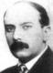
The students must to be: trustfull, respectful, responsible, fair, caring, a good and active citizen
The day of school is on 19-th March

5. Type and number of computers: 30 computers, PC, IBM

6. School history:
My school was born in 1966 year. It is in the center of Constantza. Is a big school and your students come in it from all of the districts of Constantza.
In 1998, the school was take a name “Dan Barbilian” because the school`s manager was a teacher of mathematics. Dan Barbilian is a big mathematician and a big poet, Ion Barbu (the pseudonym/ pen name).
B. School program
1. List 3 things about your school program that make it unique.
A curriculum is firmly grounded in the traditional disciplines. The programmes from the primary school give the possibility to the teachers to make another activities for education of the students. My class has the possibility to study English, computer and the economics.
Extracurricular activities: creative writing, math for the bettest students, reading club, tennis, sweeming, gymnastics, handball.
2. List school calendar from the session dates (holidays and special
events that may affect your participation).
The period from study: 12.09- 30.10
7.11- 22.12
9.01- 31.01
Holidays: 31.10- 6.11
24.12-8.01( Christmas holiday)
PART III. INTRODUCING THE COMMUNITY
A. Your community
1. Name of your community: Constantza- town and country
2. If not a city, name and size of nearest city
3. Location of your community: My town is situated in the south- east part of the Romania. It is on the Black Sea coast
4. The area of your community: The area of this country is as 7070 kmp. It has 11 cities, 52 communes and 186 villages. Is situated on the Plateau of the South of Dobrogea. In the west part of this country, is the Danubiu (Dunarea)river. In the middle of the country Constantza there is a Canal Dunare- Black Sea. In Constantza is a big sea- port.
5. The population of your community: In Constantza country live the various nationalities because Dobgrogea was ocupated many times by the Turkish occupation. But these nationalities live on good terms. There live Romanians, Turks, Macedonian, Greeks, Slavs.
B. Special characteristics
1. List 3 reasons why people come to visit your area.
The people can to visit the beach, the The Museum of National History and ASrcheology, The Art Museum, The Etnographical Museum, The Complex of Natural Sciences, The Military Museum and o lot of many.
2. Describe any unusual land formation found in or near your community.
Constantza is situated in the middle of the west coast of the Black Sea. Is the antic town, Tomis. Near there are many lakes with the sweets watter and the brine likes. From Constantza make part Mamaia village, too. Near Constantza there are the monuments of History, Adamclisi and Histria. On 130 km there is a Danube Delta.
C. Industries
List major industries or occupations in your community.
A big factory of oil
Factories of textile fabrics
Factories of furniture
In the villages people rise animals and cultivate the land.
PART IV. OTHER INFORMATION
Please feel free to share any other information about yourself that you
think would help us to know you better.
I work with my students with big pleasure. I like to teach to students and to another teachers. I am a methodist teacher in my country.
I organized the competitions on the computer with the students from seven country of Romania.
My students participate at the competition to math, computers, tennis, gymnastics.
I like to read and I want to make to my students the pleasure to read.
In this year, I learn to my students about economics, on optional.

O U R W O R K S

FRANKLIN TOWNSHIP SCHOOL,
NEW JERSEY, USA

The Red Mill

The Red Mill is located in Clinton, New Jersey. There is a mini village around it too. The mill is a good peace of history. At Halloween time the people who work there do something called The Hunted Mill. They also do something called The Hunted Hayride. Those are some facts about The Red Mill.

Zachary
Grade 4
Franklin Township School
Quakertown, New Jersey, USA

Pittstown

Pittstown is home to Sky Manor Airport. Sky Manor Airport has a restaurant with a buffet. Wires that run along the runway often distract pilots. Once a year they do free airplane rides for a day. The Pittstown Inn was originally called Hoff Farm.

Trevor , Grade 4
Franklin Township School
Quakertown, New Jersey, USA
My Town

My town is important because it tells it’s history. On one of the houses in Pittstown it says, “So this is Pittstown.” In Pittstown there are lots of air balloons. They are only in flat areas so they can land. There are lots of bare areas to play sports and to ride horses. There are many horseback-riding places you can go to.

Rachel
Grade 4
Franklin Township School
Quakertown, New Jersey, USA

Pittstown Inn

If you live in New Jersey come to the Pittstown Inn. The Pittstown Inn has had many fires. It has history in it right when you walk in. There are pictures of the fires hanging on the wall and its original land. The Pittstown Inn is a great place to visit. The Pittstown Inn also is a restaurant. Their food is the best you can get! The Pittstown Inn is known in my family for the best French fries. The Pittstown Inn is a great place to visit for dinner.

Michelle
Grade 4
Franklin Township School
Quakertown, New Jersey, USA

My Town

An important place in my town that helps people is the Hunterdon Medical Center. It helps people by making them feel better. If they are sick or not feeling well they can go to a regular doctor’s office or the Hunterdon Medical Center. They can get a shot to keep out or away germs or bacteria.
You can get better lots faster than a regular doctor’s office.

Megan
Grade 4
Franklin Township School
Quakertown, New Jersey, USA

My Town

The town I live in is Pittstown. Pittstown is a new town to me.
Because I just moved here 5 mouths ago. In Pittstown there is a tennis court. And next to my house is a nursery. My house is on 111 Locust Grove Road.
I think they call it that way because there are a lot of locusts. A locust is a type of bug. My house is the funniest house in the whole world. So Pittstown is were I live. And I like it.

Matthew, Grade 4
Franklin Township School
Quakertown, New Jersey, USA

My Town

An important place in my town is Peaceful Valley Orchard. It is an important place because it provides me with food and with a neighbor. The people that work there know me. Peaceful Valley Orchard is right across the street.

Hailey
Grade 4
Franklin Township School
Quakertown, New Jersey, USA

My Town

I think that the most important place in Pittstown is the firehouse. I think that the firehouse is important because it saves lives. If the firehouse wasn’t there then a lot of houses would be burnt down. I think that the firehouse is very important.

Emily
Grade 4
Franklin Township School
Quakertown New Jersey, USA

My Town

My town is Pittstown. I think the most important place in Pittstown is the Pittstown In. The Pittstown In welcomes people from outside of the
town. You can dine and get a lot of history. I love my town.

Brianna
Grade 4
Franklin Township School
Quakertown, New Jersey, USA

My School

An important place in my town is my school because kids can learn all different kinds of things there. The grades are Kindergarten to 8th grade. There are two of each grade. The teachers are nice and they make the lessons fun to learn. On the outside the school is small, but on the inside the school is full of learning.

Breanna
Grade 4
Franklin Township School
Quakertown, New Jersey, USA

The Clinton Mill

Something important about my town is the Clinton Mill it is important because lots of people can go fishing in the river. People can get food there and it is where the Haunted Mill is. It is also is important because people can take s across the bridge and take pictures.
It is a good place to go for the afternoon eat a lunch and go to a couple stores.

Blaise
Grade 4
Franklin Township School
Quakertown, New Jersey, USA

My Town

My town is important because there are a lot of people in Pittstown. There are a lot of beautiful places to see. There are a lot of animals.
There are a lot of fun things like playing with friends. This is why my town is important.

Andrew
Grade 4
Franklin Township School
Quakertown, New Jersey, USA

Why My Town is Special to Me

My town is special to me because everyone is important and everyone is special. Here people are always welcomed and really nice. If something happens we will be support them and tell them it will be ok. Here in Franklin Township we are like family, even if we don’t know each other. We have good trained officers and firemen so nothing could go wrong. We thank them a lot too. This is why I why I love my town.

Alicea
Grade 4
Franklin Township School
Quakertown, New Jersey, USA

MCCONNELL ELEMENTARY,
HIXSON, TENNESSEE, USA

Chattanooga, our unique and beautiful city http://www.chattanooga.gov/General_Government/62_305.htm
The Chattanooga Choo Choo is a place to visit with a friend. It is fun. It was a famous train station but it was turned into a hotel and restaurant. The song Chattanooga, Choo Choo was made when the train station was active. There are train cars at the hotel that you can spend the night and sleep in them instead of a regular hotel room. The trolley car that goes around the hotel is over 75 years old and is fun to ride in. This is a great place to visit and it has a lot of history. Mrs. Hockert knew the man who used to send messages on the telegraph at the station when he was young. The area used to send messages is now part of the restaurant lounge area.
Julie

My favorite place to visit in Chattanooga is Famous Dave’s because you can eat lots and lots of food! I know a lot of people so I could take visitors here and introduce them to everyone that I know. After that we will eat dinner and enjoy good Southern cooking.

Noah

My favorite place to go in Chattanooga is the Tennessee Aquarium because you can see swordfish, large mouth bass, small mouth bass, and all kinds of fish. There are also alligators, turtles, seahorses, jelly- fish, and sharks at the Tennessee Aquarium. This building has a unique glass ceiling that helps the indoor forest grow and lets in light for the butterflies.

Nathan

My famous place to go in Chattanooga is the Tennessee Aquarium because of the sharks, stingrays, alligators, turtles, jellyfish, and sea horses. This place is great!

Haylee

Friends that come to visit Chattanooga meet at McDonald’s. We can eat burgers and fries at McDonald’s. We can play on the playground. You can play with your toys on the playground at McDonald’s. This is the best place to meet a friend to play and eat.

Zachary

I love to go to the IMAX 3-D Theater with my mother. We take in the theater and the Tennessee Aquarium and make a great day. I like visiting the Chattanooga Choo Choo too. It is just down the street. Chattanooga is a great city to visit. Come and see us.

Destynee

Chattanooga is fun. Last night I went walking at the Riverpark and went downtown to visit the Chattanooga Choo Choo. It has beautiful flowers, an old train, and a very old trolley.

Veronica
I like visiting the museums in Chattanooga. You can find things that you never saw before. Many things are very old. The Chattanooga Regional History Museum is great. They have many things that you can look at and there are things in boxes that you can touch and feel. You can look at books and read books at the museum. You can read with a friend. Come and visit me in Chattanooga and we will go to the museum. There are also art museums and a glass museum. Chattanooga has a great African American History Museum too.

Lenzee

My favorite place to take a friend in Chattanooga is UTC (University of Tennessee) Moc’s football games. I like the Mocs. They play good. During the games, they shoot t-shirts out into the crowd. What a loud noise the cannon makes.

Rhonda

My favorite place to take a friend in my town, Chattanooga is the Tennessee Aquarium. It has sharks and stingrays. It is downtown. You can have parties there with the seahorses and jellyfish. You can go and watch the scuba divers feed the fish.

Michael

Chattanooga is the place to see! You should come here to visit us because you can learn about history. Many Civil War battles took place in Chattanooga. There is a rich history about the Cherokees. You can learn a lot at the local museums. You can learn a lot at these museums: Chattanooga Regional History Museum, African American History Museum, Hunter Art Museum, Houston Glass Museum and many others. Our Chattanooga Regional Bicentennial Library is located downtown too and it is simply wonderful. It has three floors of books, audio books, movies to rent and a great research department.

Alexis

JOHN MUIR SCHOOL,
SAN DIEGO, CALIFORNIA

OUR TOWN, San Diego, California USA

AMC Theater is near my house in National City. It is a corporation. It is big and crowded. It's about two stories on the inside. There is a box office in front and guest services inside along with a ticket drop and consessions.
All kinds of people work at AMC. They usher, sell tickets, do consessions, and clean up. The starting salary is $6.75, and there are medical benefits for workers. It is a corporation.
People like to go to AMC for popcorn, drinks, and movie tickets.

Sea World is a park with dolphins and seals and whales in San Diego.

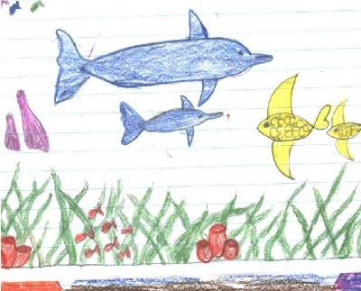

Petco Park is where San Diego people go to watch the Padres baseball team.
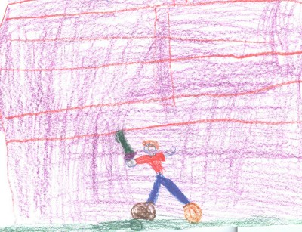

Family Health Services
I need Family Health Services to learn how to be healthy. I would like to work there because it is quiet and you learn lots of stuff.
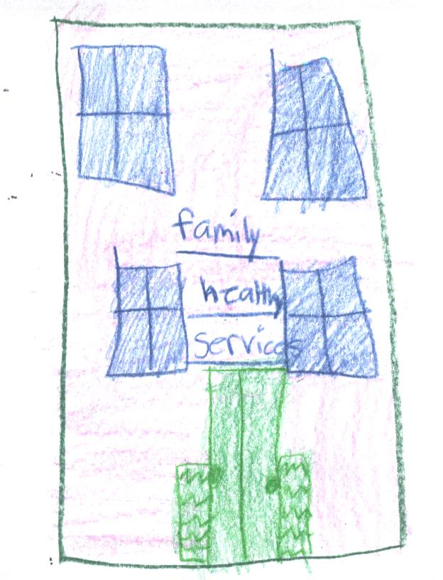

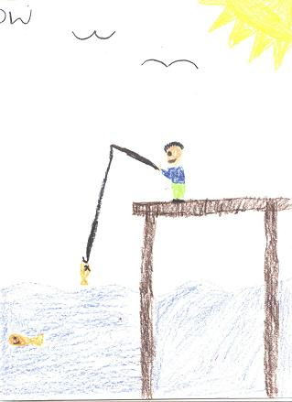

Fishing

Dave and Buster"s
I need to go there for food, and I want to go there to play games.

Qualcomm Stadium

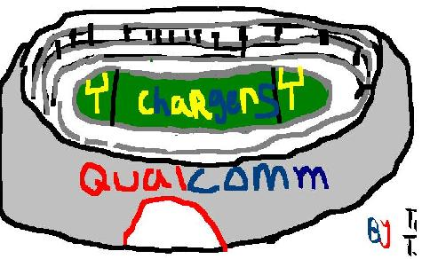

Qualcomm
Qualcomm is on Morehouse Drive. It is open 24 hours a day. It makes wireless communication, high quality products. It replaces products under warranty, and it has its own satellite to track customers.
It's a great work environment. Workers tend to make a lot of friends there. There are many good times and many laughs. This business is seventeen years old. Irwin Jacobs is the CEO of the company and the founder, but it is owned by stock holders.
Qualcomm will be here in the future because this company's main objective is to develop technology.

McDonald's
I need food and drinks and ice cream. I would love working there because they give us food.

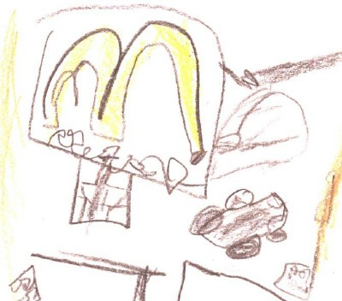

Gap clothing logo, by K

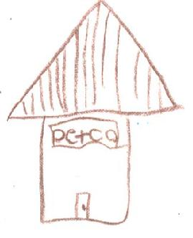

Social work is I would like to do. I knew a lot of good social workers when I was little. I was adopted at 8 years old. I think it is interesting about the background of people's lives. I would probably go to a four year college first to get the basic education I need. I would live by myself so I wouldn't have anyone to distract me.

Callaway Golf Company
This company is in Carlsbad. It sells custom fit golf clubs. Callaway is one of the largest club making companies in the world. The owner is Ely Calloway and the company was started in 1982. You would have to know a lot about golf to work there.

GYMNASIA NR. 12
MINSK,BELARUS

My town

My city is Minsk. Minsk is the capital of Belarus. Minsk is an ancient town. It was founded in 1067 between the Nemiga and the Svisloch rivers. Not far from our school there is a burial mound. This is a place where first people of Minsk were buried. During the Second World War Minsk was destroyed almost completely. And after the war it was rebuilt anew. Now Minsk is one of the most beautiful and clean cities of Europe. Minsk has a population of 2 million people. There are many theatres, historical monuments and churches in Minsk. In 1986 the first Metro line was extended. I like my city.

Antoniy Matrunchik, 10 years old,
Gymnasia â„–12, Minsk, Belarus,

My town

I live in Minsk. Minsk is a very big and beautiful city. There are many wide squares and fine streets in the town. I like to go to the circus. It is very interesting there. The circus building is very big and round.
There is very a beautiful place in Minsk – Isle of Tears. It is a sad place. Many people go there to remember soldiers who died in the war in Afghanistan. On the Island there is a beautiful fountain where you can see a crying angel. I like walking there.
My city is very beautiful! I like my city!

Valentina Zhukova, 10 years old,
Gymnasia №12, Minsk, Belarus

GORKY PARK

Minsk is not very big. I like Minsk! It is very clean and beautiful. In summer my city is green, because there are many parks. My favourite park is Gorky Park. There are many flowers and trees. It is autumn now and park is beautiful because all the leaves are red and yellow.
There are many ducks on the river. Children like feed ducks. They come to the park and bring some bread. Ducks like children.
Squirrels live in the park too. They jump in the trees. Children like squirrels too. They give them nuts.
All my friends like to spend their time in Gorky Park.

Nadya Popkova, 10 years old,
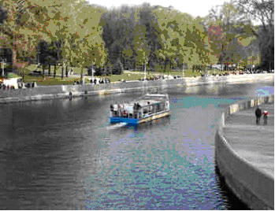
Gymnasia №12, Minsk, Belarus

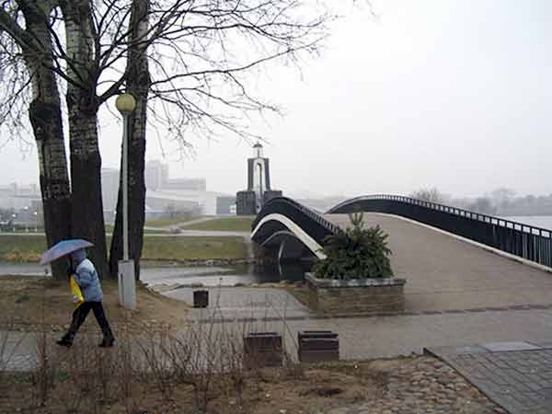

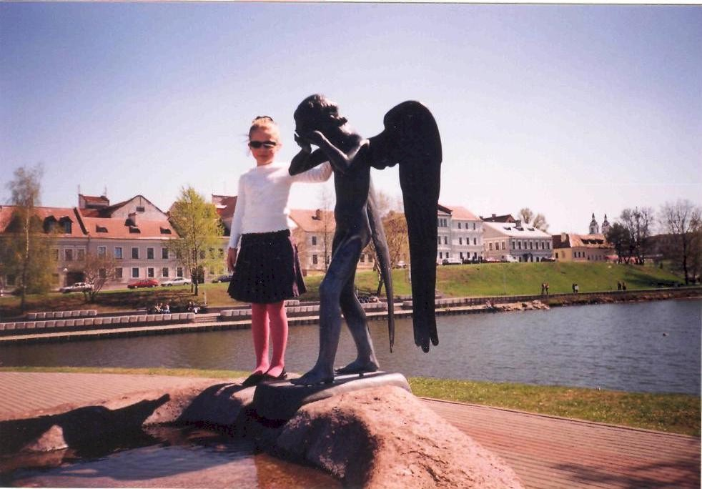

Belarus is а land of big forests, nice lakes and rivers.
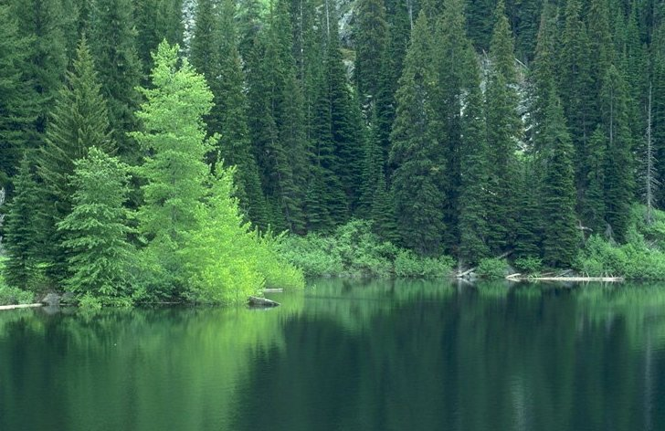
Minsk is the capital of Belarus. Minsk is an ancient city. The city really blossomed during the years after World war II. In the course of that war Minsk was destroyed 80%. We entered the 21st century having a new railway station building of a European level. The whole Railway Station Square is reflected in the mirror-like walls of a spacious foyer whereas inside a visitor seems to be entering the city through a gate-like main entrance. Authorities in many cities try to have a place in their cities where visitors could see what the city looked
like centuries ago. There is such a place in Minsk too. It is Troitskoye Predmestye. Walking there one would hardly be able to imagine how life went there, yet one would have an idea of what the old town was like . Today life in the settlement is in full swing. The renovated buildings are used as offices, shops, cafes, bars and restaurants.
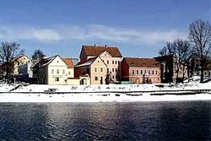
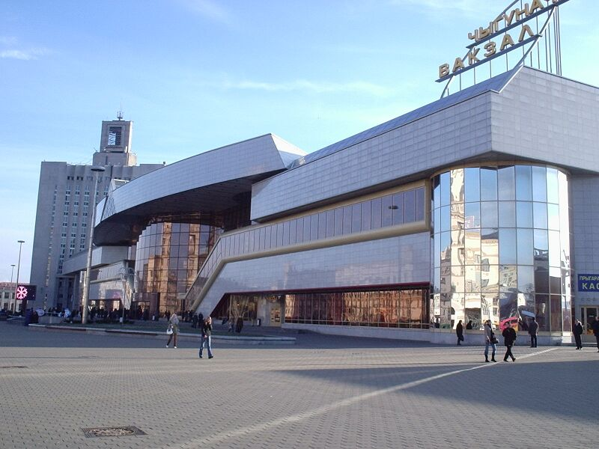

“DAN BARBILIAN” SCHOOL
CONSTANTZA, ROMANIA

CONSTANTZA TODAY…..

www.tourisme-patrimoine-antique.com
www.litoral.info.ro
www.romaniatravel.com

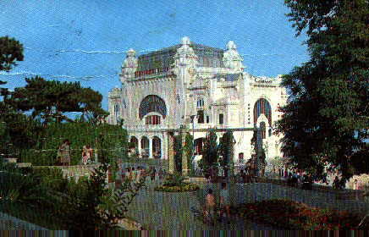

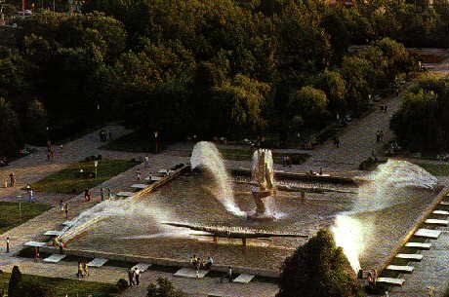

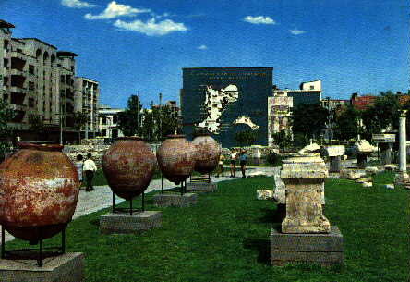

….. AND YESTERDAY
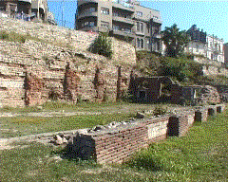

BRIEF HISTORY OF CONSTANTA

TOMIS – CONSTANTA

The origins of Tomis city – today Constanta interwove in the past, up to the legends mistery of the Greek antiquity. This mythical town took part into the phantastic life of heroes and Gods, in a time when the poetry embellished in wonders people deeds. If we leave the legends and enter the history, where people deeds mean traces and memories, we notice that Tomis birth was normal, similar to other Pontic cities of that time. The most hospitable Blak sea bays attrackted even from older times first the Phaenician sailors and than the Romans.

TOURISTICAL OBJECTIVES

The Roman Mosaic, situated in Ovidiu Square, discovered in 1959, is a vast complex built in three terraces, linking the antique town level and that of the port in the same period.
Museum of National History and Arhaeology building, situated in Ovidiu Square, was built between 1911-1921, being destined to the city Townhall.
The Orthodox Cathedral of the Saint Apostles Petru and Paul was built based on projects of the architect Ion Micu.
The Catholic Church Saint Anthony dated from 1937. The monument respects a basilica plan, specific to the Northern Italy.
The Mosque “Carol I”, monument of the city architecture, the main building of the Moslims in Constanta. It was built by the Romanian state in 1910.
The Casino. A monumental building, dominating the sea wall at portis end. The Casino housed in its performance hall numerous artistical companies, orchestras until Wold War II, later on, only the restaurant was open.
Adamclisi Triumphal Monument, visible from a great distance, was raised by the emperor Trajan, during 106-109 A. D. The monument is one of the greatest commemorative symbols of the antiquity built in an original architectural manner. It represents an important Latin civilization evidence at the Lower Danube, being considered together with Trajanis column from Rome a real birth document of the Romanian people.

Elena Vanghelici, The fourth grade
School “Dan Barbilian” Constantza, Romania

***
Kids, we knowsthe first time Constantza discover the greeks, named Tomis. Things evoluated they named Costanza, Constantia, Constantza, And finally Constantza. The same period discover settinc Calllatis, today Mangalia.
After the Independent War, ( 1877- 1878), Constantza, become the great port of the country.
In 1875 was createdthe railroad of Constantza- Cernavoda, one of the first in
Romania.

Zoe Caraiani
The fourth grade
School “Dan Barbilian” Constantza, Romania

The history of my localty

Citadel of Tomis, the future Constantza localty was grounded by greek colonists came from Milet.
In the second century, because of the roman troupes victory against local population, Traian Emperor rise a triumphal monument at Adamclisi to celebrate this event.
The invasion of the migration populations affected these places.
For a short while, in fourteenth century, Dobrogea was under medieval romanian countries influence.
In the fifteenth century the turks conquer Dobrogea and Ottoman Empire will master this region during four century.
After the Independence War Dobrogea came back under romanian administration.
Esential for the future economical development was the bridge built at Cernavoda,who links Dobrogea with the others region of the country.
We have great historical monuments as : the vestige of old greeks colony Histria and Tomis, the triumphal monument from Adamclisi, Dervent Monastery, Orthodox Cathedral, National Museum of History and Archeology.
In the present Constantza is the second city of Romania,as economic development, after Bucharest. Our harbour is the biggest harboure at the Black Sea and the main way for our trade.
Also, we have a lot of stations at the Black Sea shore.
For the future, Constantza has good opportunities to develope and become a modern city.

Bella Dumitru The fourth grade
School “Dan Barbilian” Constantza, Romania

Constantza’s history

Constantza it’s a port on the Black Sea coast . The city was built in the VIth century b.c. by the old greeks, with the name Tomis. Between 491 and 518 the old city of Tomis was restored.
At the start of the XXth century the old port has been enlarged and modernized and this way Constantza became the main romanian port and an important trading center.
The Old Far , built between 1859 and 1895 , and The Casino , built between 1904 and 1909 , are two of the most visited sites. We also have a lot of interesting museums.
I love living in this beautiful city! We will wait for you all to come and visit our city!

Ioana Pitu
The fourth grade
School “Dan Barbilian” Constantza, Romania

***
Tomis, the harbour city, was implemented by the greek colonistes, how were comming from Milet.
The existence of Axiopolis senttlement,Cernavoda today, was certifyed.
The latin poet,Ovidiu, the writer of „Tristelor” and „Poticelor, he was banisle in in the Tomis.

Stancu Sorina
The fourth grade
School “Dan Barbilian” Constantza, Romania

It was a beautyful summer day. The sun was shining on the sky. It was a perfect time for a fieldtrip. Our tacher took us for a walk and explained to us about Constanta’s history.
She explained that this city was called Tomis in the ancient times.
- Children, they say that, in time, Constanta will have the biggest sea harbour in Romania. The stores were replaced by supermarkets, old boildings were replaced by more beautyful and bigger ones, while turkish coffe was replaced by filter cofe. The intelectual capacity of the people has developed, so that the city has taken a new shape.
This is how we found out about Constanta’s history.

Bianca Tirlungeanu
The fourth grade
School “Dan Barbilian” Constantza, Romania

HISTORY OF CONSTANTA
In the today’s perimeter of Constanta, there were discovered proofs of human existence about 120.000 years old, from the Middle Paleolithic. The many archeological discoveries represent true revelations for the specialists and prove the human society evolution with changes and innovations from the old ages - Neolithic, Bronze, Iron - but, also local and original peculiarities of the native population, with Indo-European origin, the Traco-Geti, the oldest inhabitants of this region.
These were the historical premises, written in one sentence, which had driven to the settlement of the antiques fortress Tomis - Constanta today - during the Greek colonization of the Pontus Euxinus area (7th-5th century B.C.) The Greeks, arrived here, have found a Getic native settlement. They have, first, founded an "emporion" that evolved till the Hellenistic period till the level of "polis" with all its attributions (4th and 3rd centuries B.C.)
The importance of Tomis grew during 3rd and 1st centuries B.C. In this period huge wealth are accumulated due to the economical development, based on the harbor activity and enables the town-planning flourishing of the city, after the model of the Milet fortress.
In the 1st century B.C. on this territory, between the Lower Danube and the Black Sea, come the Romans. The Roman ruling (1st – 3rd centuries) modifies positively the geopolitical and economical status of the region, an economical and cultural growth is seen. Tomis is consolidated, the harbor become very active, the city knows a great town-planning activity. Here lived in exile, for 8 years, 8-17 A.C.) the poet Publius Ovidius Naso.
"Pax Romana" is followed by the barbarians invasions, the first wave was during 3rd and 4th centuries. The city survives and become the residence of the province Scythia Minor, in the context of the break up of the Roman Empire. There were difficult moments, with dramatic episodes and situation changes. Tomis from the Roman-Byzantine period was an important Christian religion center. The Christianity practices here were of apostolic origin due to the Saint Apostle Andrew. But the city has also a political and military role, 5th – 7th centuries, during the migratory waves – Huns, Slavs, Bulgarians, Petchengs, Cumanians and the last ones the Tartars and Turks.
The name of Constanta dates from the Byzantine ruling when Tomis appears in Byzantine and later Italian documents, as Constantia, after an important imperial Roman family. But the city images changes, become more rural after the devastating Barbarian migrations. In the 10th – 13th centuries the city will participate, as and urban center of some importance, at the period events and continue its harbor life. In this period the maritime trade was dominated by Italians, those from Genoa being the most important. Today, still exists a construction from that period, the "Genoese Light-house", reminding us the famous Genoese merchants.
In the 14th century another empire is in expansion in this region, the Turkish Empire. Dobrogea and is residence town, Constanta, are integrated in a Turkish province, being conquered by military force, starting with the 15th century till the end of the 19th century, when, after the independence War from 1877-1978, the province of Dobrogea is back in the Romanian state borders.
Only at this date begins the modern development of Dobrogea. Constanta, due to the harbor, was the "lung of the Romania" as the first Romanian king, Carol I, said. The most important development of Constanta, mostly of the harbor, was between 1878-1914. After the building of the bridge across the Danube, between 1890-1895, by the famous Romanian engineer Anghel Saligny, the longest bridge in Europe, and the 3rd in the world at that moment, the Romanian Maritime Service was founded, and the maritime line Constanta - Constantinopole was opened, the harbor was modernized but a great reconstruction plan (1985-1909), with installations, warehouses, silos; the harbor traffic grows constantly, hundred of ships under all flags boarding at its piers. Romanian Maritime Service had an important fleet, its ships navigating on the "Oriental line" (Constanta-Constantinopol-Alexandria), on the "Archipelago line" (Constanta-Pireu-Salonic) and on the "Occidental line" (Constanta-Rotterdam). The necessary infrastructure was built: railways and roads. Many beautiful buildings were built in this period that are still up and make the city image nicer.
During the First World War (1914-1918) the city had many losses, The Germans and mostly the Bulgarians made a lot of destructions, putting end to the most flourishing period of the town.
Between the two World Wars (1918-1940) the city economical and commercial development is resumed strictly to the harbor activity. Constanta made 70% from the total maritime traffic of the country. In this period the ship-building yard is developed, becoming, till the Second World War, the most powerful enterprise from the region, having the biggest work force concentrated here.
The Second World War meant again foreign occupation, destructions and material losses caused by the Soviet plunder after the war, under the for of "compensations", which practically destroyed the Romanian fleet and subordinated the Harbor to the interest of the occupants, our "friend" for 50 years. The communist regime maintained Constanta as the first maritime harbor of the country and accorded it the necessary importance from this point of view. In parallel, due to the Soviet type industrialization, the city knew a great development, mostly between 1960-1975. The ship yard was extended (for 150.000 tdw ships), the commercial fleet grew (around 250 ship in 1985), also grew the number of factories, the see side was developed for tourist purposes, realities that have to be mentioned for the correctness of the information. After December 1989, the city remains the second town after Bucharest and seeks new development directions.
Postoiu Ruxandra
The fourth grade
School “Dan Barbilian” Constantza, Romania

BRIEF HISTORY OF CONSTANTA
History
Incontestable archeological documentary proves show the existance – from the 6th century B.C (before Christ) - of the city Tomis, on the same place that represents Constanta city today.

Tomis was founded as a result of the Greek’s settlement on the “Pontus Euxin” land, starting to be a city from the 4th century B.C. The importance of Tomis raise during the regnal of Constantin The Great – from where the actual name of constantza is barrowed. Under the cavalcade of the migratory population, and under obedience of the ottoman Emperor, the city was destroyed many times . We can talk about a real upgrade of the city only after the independence war (1878), when the province was returned to the Mother-Country. A second step in enlargement of the city was in the interwar period, the next moment in it’s evolution being the 1989 revolution. The cultural life of the city is materialized by the activity of five theatres, five museums, and a scientific field research.

Constanta’s Geography
Constanta city is situated in Constanta county in the south east part of Romania, on the Black Sea coast. The administrative area is 1121.66 square kilometers. Northern part of the city is situated the spa Mamaia, beach being layed for 6 km orientated east. The port of Constantza is the main port of Romania at Black Sea and the 4th as importance in Europe, layed on a area of 3182 ha

Population
Constanta's population of 310,471 people is predominately Romanian however there are also other nationalities including Turks, Gypsies, Russians, Ukrainians, Bulgarians, Armenians, Tartars, Greeks, and Germans. Constanta also has a diverse religious community with Orthodox, Roman-Catholic, Greco-Catholic, Protestant, and Muslim.

Isabelle Balta
The fourth grade
School “Dan Barbilian” Constantza, Romania

The National History and Archaeology Museum

Fonded in 1879 it is placed in Ovidiu Square which represents the old zone of Constanta. It currently has a sigmficant patrimony of Greek, Byzantime and Middle Age Archeolagy, expvsing neolitical curios from Hamangia and Gumelnita Cultures, implements from the slave system, also sarcophagusfrom the third century, Graeco-Roman amphoras and statuettesrepresting Greek Goods and masterpieces.
The niost important art-curios are Glycon snake made by white mardle and the collection of old currency engraved with Scythian Kings. The attractions of this Museum is a special room from the first floor which is entirely dedicated to a mummy of our ancestors.
The purpose of the National Histori and ArcheologyMuseum is to keeps proves of Graeco-Roman Civilisation and to demonstrate it’s existence.

Craciun Cristina, the 4-th grade,
School “Dan Barbilian”, Constantza, Romania

A HERO OF CONSTANTZA

The name of Anghel Saligny is connected in one way or another to allmost all of the regions of my country, but especially to Constanta due to the Cernavoda bridge over the Danube and due to the harbour of Constanta.
The Cernavoda bridge, named the bridge “Carol I-st”, was inaugurated on the 14th of September 1895, in the presence of king Carol. Fifteen railway engines, dressed with flowers and waveing flags under clouds of steam, were rushing across the Danube with 70 km/hour.
The bridge had, at that time, the greatest bridge arch span from the Central Europe.
In August 1899, Anghel Saligny was incharged with leading the work for building of Constanta Harbour. The inauguration of the harbour took place after an intense 15 year work.
Through his work, Anghel Saligny succeeded to unite Dobrogea to Romania´s mainland
He builded a strong bridge that stands up even today and gifted our shores with a great harbour, where many of our parents and relatives are working nowadays.
He is a true hero for the city of Constanta and for Dobrogea county.

Daria Holostencu, the 4-th grade,
School “Dan Barbilian”, Constantza, Romania

The city of Constantza has heroes in all of the areas.In the football area, the hero was and is Gheorghe Hagi.The Constantza stadium named Gheorghe Hagi is a pride for the romanian football.
He has represented Romania in all of the football contest.
He is known in the world, at the world greatest football player.

Mangri Andrei, the 4-th grade,
School “Dan Barbilian”, Constantza, Romania

PUBLIUS OVIDIUS NASO
Publius Ovidius Naso (Sulmona, March 20, 43 BC – Tomis, now Constanta AD 17) Roman poet known to the English-speaking world as Ovid, wrote on topics of love, abandoned women, and mythological transformations. Ranked alongside Virgil and Horace as one of the three canonical poets of Latin literature, Ovid was generally considered the greatest master of the elegiac couplet. His poetry, largely imitated during Late Antiquity and the Middle Ages, had a decisive influence on European art and literature for centuries.
From his own time until the end of Antiquity Ovid was among the most widely read and imitated of Latin poets; his greatest work, the Metamorphoses, also seems to have enjoyed the largest popularity. What place Ovid may have had in the curriculum of ancient schools is hard to determine: no body of antique scholia survives for any of his works, but it seems likely that the elegance of his style and his command of rhetorical technique would have commended him as a school author, perhaps at the elementary level.
Ovid wrote in elegiac couplets, with two exceptions: his lost Medea, whose two fragments are in iambic trimeter and anapests, respectively, and his great Metamorphoses, which he wrote in dactylic hexameter, the meter of Virgil's Aeneid and Homer's epics. Ovid offers an epic unlike those of his predecessors, a chronological account of the cosmos from creation to his own day, incorporating many myths and legends about supernatural transformations from the Greek and Roman traditions.
Augustus banished Ovid in AD 8 to Tomis on the Black Sea for reasons that remain mysterious. Ovid himself wrote that it was because of an error and a carmen – a mistake and a poem (Tr. 2.207). The error itself is uncertain. Ovid may have had an affair with a female relative of Augustus, or withheld knowledge of such an affair. The carmen, however, is probably his Ars Amatoria, a didactic poem offering amatory advice to Roman men and women, which had been in circulation for several years.
It was during this period of exile -- more properly known as a relegation -- that Ovid wrote two more collections of poems, called Tristia and Epistulae ex Ponto, which illustrate his sadness and desolation away from Rome. Even though he was friendly with the natives of Tomis, he still pined for Rome and his beloved third wife. Many of the poems are addressed to her, but also to Augustus, whom he calls Caesar and sometimes God, to himself, and even sometimes to the poems themselves, which expresses his heart-felt solitude. The famous first two lines of the Tristia demonstrate the poet's misery from the start:
Bogdan Nicolae, the 4-th grade,
School “Dan Barbilian”, Constantza, Romania

THE BLACK SEA

The Black Sea (known as the Euxine Sea in antiquity) is an inland sea between southeastern Europe and Asia Minor. It is connected to the Mediterranean Sea by the Bosporus and the Sea of Marmara, and to the Sea of Azov by the Strait of Kerch.
There is a net inflow of seawater through the Bosporus, 200 km³ per year. There is an inflow of freshwater from the surrounding areas, especially central and middle-eastern Europe, totalling 320 km³ per year. The most important river entering the Black Sea is the Danube. The Black Sea has an area of 422,000 km² and a maximum depth of 2210 m.
Countries bordering on the Black Sea are Turkey, Bulgaria, Romania, Ukraine, Russia, Georgia. The Crimea is an Autonomous Republic of Ukraine.
Important cities along the coast include: Istanbul (formerly Constantinople and Byzantium), Burgas, Varna, Constanţa, Yalta, Odessa, Sevastopol, Kerch, Novorossiysk, Sochi, Sukhumi, Batumi, Trabzon, Samsun.

Bogdan Nicolae, the 4-th grade,
School “Dan Barbilian”, Constantza, Romania

THE BLACK SEA

Near the Constantza city there is a blue and boundless surface. This is the sea.
In the summer it has clear and warm water, and in autumn the water is cold or lukewarm, depending by the air temperature. In the frozen winters the sea freezes to the shore. In the spring the water starts to warm up.
This is our sea which we shell never be separated from.

Hada Madalina, the 4-th grade,
School “Dan Barbilian”, Constantza, Romania

The Sea

The sea represents the charm of Constanta. It is like a painting that is changing shapes continuously: one time roaring with foamy waves and other time silent and still as a mirror; one time dark as the night, another time with the color of turquoise.
Each wave carries on its comb a murmaid song which ends up when it meets the shore.

Daria Holostencu, the 4-th grade,
School “Dan Barbilian”, Constantza, Romania

Constantza is a harbour near the Black Sea.I love the sea,with her waves and her tremendously shore.In the summer I go with my family at the beach and I walk Through resorts.
In the sea ar alges,gelfish and fish.
For amusement,you can go with the boat and visit the ships.

Mangri Andrei, the 4-th grade,
School “Dan Barbilian”, Constantza, Romania

The Sea
The sea represents the charm of Constanta. It is like a painting that is changing shapes continuously: one time roaring with foamy waves and other time silent and still as a mirror; one time dark as the night, another time with the color of turquoise.
Each wave carries on its comb a murmaid song which ends up when it meets the shore.
Daria Holostencu, the 4-th grade,
School “Dan Barbilian”, Constantza, Romania

WHY TURISTS ARE VISITING CONSTANTZA?
After Danube Delta, Romanian Black Sea Coast is the second place to see in Romania. On the other hand, considering the large number of Romanian and foreign tourists, I could say it's the main place to visit. Romanian seashore extends on 245 km, having as limit points Vama Veche, to the South and Chilia branch of the Danube Delta to the North. The Romanian "Riviera" is made up of a continuous belt of seaside resorts: Navodari, Mamaia, Constanta, Eforie Nord, Eforie Sud, Techirghiol, Costinesti, Olimp, Neptun, Jupiter, Aurora, Venus, Saturn, Mangalia and 2 Mai. Wide and having soft sands, the beaches have mild slopes going into the sea, thus being accessible to children and to those who cannot swim. The transition climate, between the steppe and the marine ones, has Mediterranean influences in its Southern part. The marine breeze calms down the heat.
But Dobrudja and its access to the Black Sea may arouse visitors' interest and make them enjoy their stay there any other time of the year due to its unique mixture of natural sights and historic attractions.
For in the area a pleasant surprise is to discover traditional villages and rural civilization not far from modern seaports, vineyards, orchards, ancient monuments and remnants along with a whole network of modern holiday resorts situated along the Romanian shore of the Black Sea. Warmed up by the sun all summer long, that is from May until September, the sea which has been called for centuries Pontus Euxinus or the Hospitable Sea is still there, awaiting for visitors to come and have a good time.
The main urban settlement of the area is Constantza, a seaport to the Black Sea and one of the most important cities of Romania, situated in the south-east of the country. Constantza, with its charter flights during the summer, is also accessible by road, by railway or by water. It is a lively city where one will find it worthwhile to spend a few days and learn about a glorious ancient past, or simply about day-to-day life in a Romanian trade and tourism destination.
Some 10 main resorts of the Romanian Black Sea shore are stringing southwards along the coast, while Mamaia lies a few thousand metres north to Constanta. Romanian Sea resorts rank among the very few beaches in Europe which can offer all day long sunlight. Romanian beaches are sloping gently under the waters of the sea, thus allowing sea-bathing and walking on the sea. The sand beaches are generally natural ones, 400-500 m wide at Mangalia and Techirghiol, and 50-200 m wide on the rest of the littoral. But beaches are not the only assets of the Black Sea coast. By storing it, the Black Sea influences the thermal aspect of local seasons along the coast, resulting in comparatively longer summers and mild autumns. The healing mud used in treatments is of a high therapeutic value. Last but not least, this entire complex of water, sand, air and sun is a beneficial one, with significant results in thalassotherapy and psamotherapy, which most often would work miracles for those come to restore their health. But medical therapy is not the only reason one may find to visit Romanian seaside resorts: they also provide a wide range of possibilities for leisure tourism, including tennis and miniature golf, bowling, riding horses or scooters. Leisure facilities of the Romanian resorts are mainly attractive for family tourism though Neptun and Olimp for instance are much appreciated for their lively nightlife in clubs, bars, taverns and discos. Between these two "extremes", youngsters will always prefer Costinesti, a youth "planet" with its own games, shows, contests and ways of entertainment

Nicolae Bogdan, the 4-th grade,
School “Dan Barbilian”, Constantza, Romania

Constantza is the biggest harbour at the Black Sea.He is the second with a large surface and number of population.
The tourist are attracted to the romanian seacost and to the resorts of Mamaia,Eforie Nord.Eforie Sud,Neptun,Costinesti.
In Constantza,ar bounch of attractions: museums,resorts and nature monuments.

Mangri Andrei, the 4-th grade,
School “Dan Barbilian”, Constantza, Romania

MY CITY IN THE FUTURE

I imagine my city in the future having sky-scrapers one hundred ninety meters high, flaying machines, school-buses which take the children from home and drive them to school and back to home.
To be computers verbal commanded and to write from dictation. To be machines doing your homework and dream-machines to program a movie, choose the character you want to be, and after you asleep, dream you play in that movie.
To be big prices cut in stores.
This I would like to be my city in the future!

Hada Madalina, the 4-th grade,
School “Dan Barbilian”, Constantza, Romania
I wish to my town, Constantza, to be in future like the most beautifuls cities in the world and to have something special of everyone like: “ Le Tour Eiffel” of Paris, The Bolshoi Teathre of Moscow ,the opera house “ La Scala” of Milano, the Colosseum of Rome, the Blue Mosque of Istanbul, the Statue of Liberty of New York, and so many others…..
But, certainly, in the midle of the central square of my future town, will tower the same statue of Ovidius, looking with sadness to the sea and missing his home-land, Rome.

Caraiani Zoe, the 4-th grade,
School “Dan Barbilian”, Constantza, Romania

My city is beautiful,clean and interesting.In the future I want a modern city,with buildings and beautiful.The comercial places should have a playground for kids.The schools should have halls, gyms,cafeteria and a internet cafe.
The ways of travelling should be modern,everywhere in the town, like the subway,duble decker and cars for pupils.

Mangri Andrei, the 4-th grade,
School “Dan Barbilian”, Constantza, Romania

* * *
Constanta will be a clean and modern city where the sea wind will surround bothe the past and the future. There will be a city where you will never be bored, with plenty of parks and places to have fun.
In the summer the beach and water sports, and in the winter with the skating ring and artificial snow ski slopes.
The cinemas, libraries, sporting courts between the apartment buildings, the museums and the shopping malls will just wait for you to step into them.
The multistore boulevards and the cars with solar batteries will make the air clean and forever fresh.
The city of Constanta will become the most suitable city for work, relaxation and fun.
If you do not beleave me, take a closer look to the everyday changes.

Daria Holostencu, the 4-th grade,
School “Dan Barbilian”, Constantza, Romania

IF I WILL BE THE MAJOR OF CONSTANTZA

As the mayor of the town,I would handle with the playground arangements for kids,I would put train and bikes in the fun parks.The alimentation of the population is the problem of the town.
Cleaning,looking after the green spaces and planting new decorative plants,will change our towns look.The coast must be maintained and modernized.

Mangri Andrei, the 4-th grade,
School “Dan Barbilian”, Constantza, Romania

IF I’LL BE THE MAYOR

If I’ll be the mayor of my town, I would like to build one big fun park for children, well-dressed, with many coloured small flags, with clowns and fairy tales characters. I would like to arrange, also, the necessary special parking areas in order to relieve the streets and the side-walks. I’ll take care of better cleaning and public lighting and I will decorate the streets and the buildings for the special festivities.
I’ll will for bit the children walking alones on the streets in the night and I’ll will take care of them to have all necessaries at school.

Caraiani Zoe, the 4-th grade,
School “Dan Barbilian”, Constantza, Romania

If I were the Major of Constantza I would do many parks, I would give many Christmas and Easter presents and I would help the poor man. I clean up the city of garbage, infarctions and I would take care of the cats and dogs. I would fight for my city to have good people with good manner: to not throw the garbage on streets, to not fight and to not swear. I would clean up the garbage which pollutes the sea and the nature.
This I would do if I were Major.
Vote for me for a better life!!!!

Hada Madalina, the 4-th grade,
School “Dan Barbilian”, Constantza, Romania

If I would be The Mayor

If I would be the mayor of Constanta I would repair the schools, I would repair the streets pavement and I would try to solve, as many as possible, the problems of Constanta citizens.
I would create more parks and green spaces, I would put flowers along of all city streets and alleys and I would close down the Casinos and gambling games.
I would build houses and schools for the “Kids of the street” and I would repair the Historical area of the city.

Daria Holostencu, the 4-th grade,
School “Dan Barbilian”, Constantza, Romania

If I would be The Mayor
If I would be the mayor of Constanta I would repair the schools, I would repair the streets pavement and I would try to solve, as many as possible, the problems of Constanta citizens.
I would create more parks and green spaces, I would put flowers along of all city streets and alleys and I would close down the Casinos and gambling games.
I would build houses and schools for the “Kids of the street” and I would repair the Historical area of the city.
Daria Holostencu, the 4-th grade,
School “Dan Barbilian”, Constantza, Romania

My City in the future
Constanta will be a clean and modern city where the sea wind will surround bothe the past and the future. There will be a city where you will never be bored, with plenty of parks and places to have fun.
In the summer the beach and water sports, and in the winter with the skating ring and artificial snow ski slopes.
The cinemas, libraries, sporting courts between the apartment buildings, the museums and the shopping malls will just wait for you to step into them.
The multistore boulevards and the cars with solar batteries will make the air clean and forever fresh.
The city of Constanta will become the most suitable city for work, relaxation and fun.
If you do not beleave me, take a closer look to the everyday changes.
Daria Holostencu, the 4-th grade,
School “Dan Barbilian”, Constantza, Romania

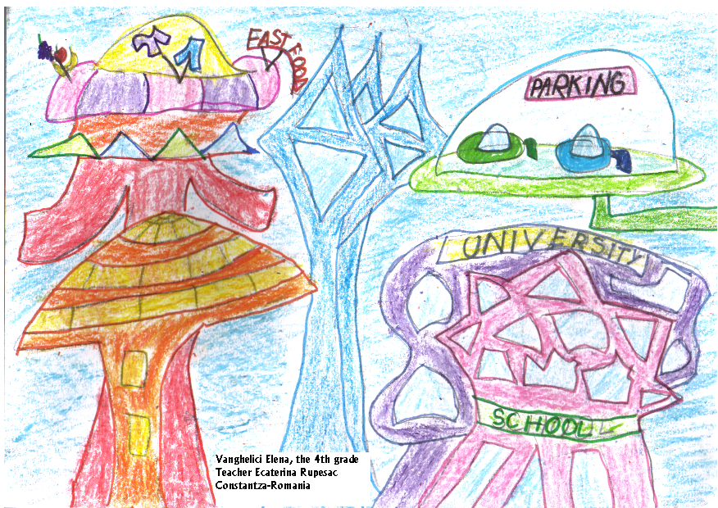

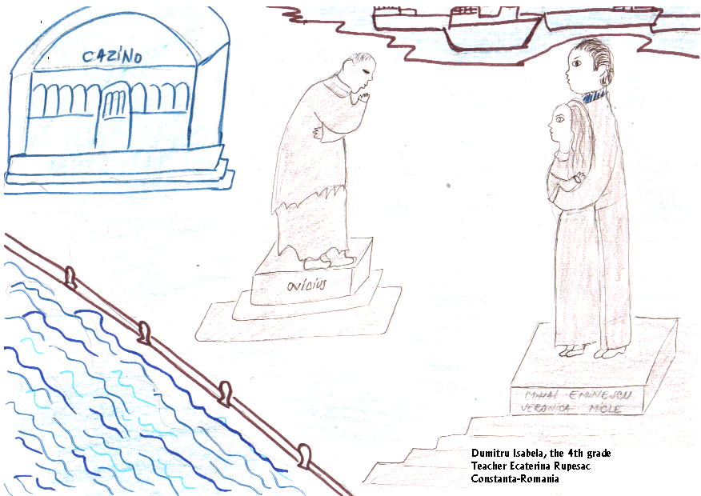

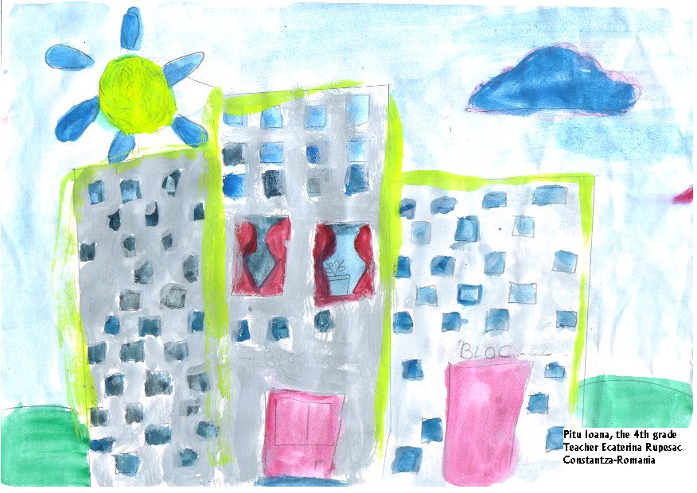

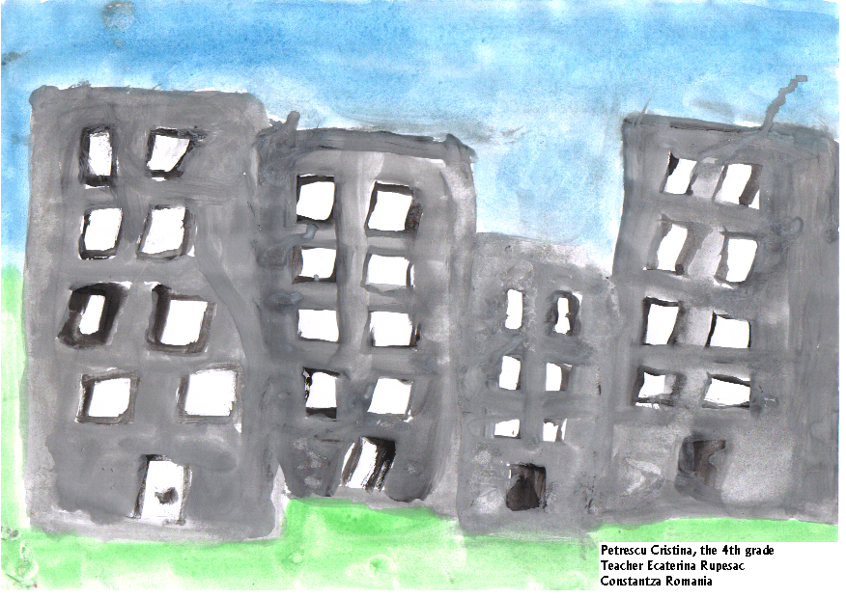

THE STUDENTS` IMPRESSIONS ABOUT YOUR PARTICIPATION AT THE PROJECT

Dear friends,
We want to be a surprise for you but we descript ower town. I hope ower town will be like you want to be and you’l like it.
With esteem,
Holostencu Daria.

Dear mates,

I liked the project „The history of the locality” because Constantza town has an beautiful history riched, with personalities in the van and his very interesting.

Caraiani Zoe

Dear contributors,

I liked the project „My town” because my town has many interesting things, builds and I do everithing to embellish it. The people want to look after it and want to have an beautiful look.

Zoe Caraiani

Dear friends,

Thank you that you have participated at this project .
We like very much to talk about the place where we were born.
Nothing isn’t more interesting than talking about our forefathers and about the won battles.
I hope that you enjoyed this project, too.

Best wishes,
Dumitru Isabela Bianca

Dear friends,

We tank you very much for proposing this subject and for partnership with other countries, especially Romania.

Yours truly,
Andreea Staetu
Dear penfriends,

Thank you because you accepted to take part in this project proposed by our class.I hope you liked its theme.
I like speaking about my town, about the town where I was born.My town has got museums, parks, beaches, everything that you can imagine.
Maybe you will visit this town one day and, if you come in the summer you will surely won’t regret.

Best wishes,
Dumitru Isabela Bianca

Dear friends,

I liked very much this subject and it was a pleasure for me to perform all the requests of my teacher regarding it. And if you will participate again to the similar projects, I would like to ask you to propose more subjects interesting like this one.
We will be happy to welcome you in our city and you’ll be convinced that my city is just like we described in the composition.

With friendship,
Andreea Staetu

Dear friends,
The title “History place” was great. Was amazing to impartition the data of our history place. Every need to learn the history place.
I happy to meet and ploughing the history place.

Of sweetheard,
Postoiu Ruxandra

I have been delighted to work on the project entitled ‘My city’, to describe an animal. To be an good alleger.
We love you!
Tirlungeanu Bianca

Dear friends,
Hopping that you liked the subject that we proposed to you and we are waiting impatiently to find out more about you and about your town.

With love,
Taune Alina- Gabriela
Dear friends,
Hopping that you liked the project about the town history of this place.Thinking that we will meet soon, we are waiting you.
Taune Alina- Gabriela

Dear friends,
For me, my city Constantza means home, the place where I feel best in. We don’t have skyscrapers, but we have the parks; we don’t have mountains, but we have sea. And we have something very special: friendly and hospitable people.
We’re wainting for you any time, here, in our home!
Best wishes,
Helen Vanghelici

Dear friends,
My city has existed since the 6th century B.C. At the beginning it was called TOMIS and it was funded by the greek colonists.
Today there are many vestiges of the past which I visit every year.
I like archeology and I’m fascinated by the pyramids and everything related to ancient history.
I’m waiting for messages on this topic!
Best wishes,
Helen Vanghelici

Dear friends,
The composition with title“The locality’s historian”it’s a grat, a beautiful idea.
Our teacher give we some suggestions and a home we create this composition with more enjoy.
Thanks youfor idea!!!
With esteem,
Pitu Ioana-Livia

Constantza city is a port a to the Black Sea.Greek, turkish, roman and local shopkeepers raised and developedthe City of Tomis. Due to its geographical position,Constantza town developed on the ruin of the City of Tomis.

Petrescu Cristina

The name of my town is ,,Constanta”. In the summer in Constantza is very warm. On the sea shore the sun is shining whith the power of 35 degrease.In the town the people understand ici oder.I’m proud the my thown!

Whith love,
Petrescu Cristina

