Tourism & Monuments

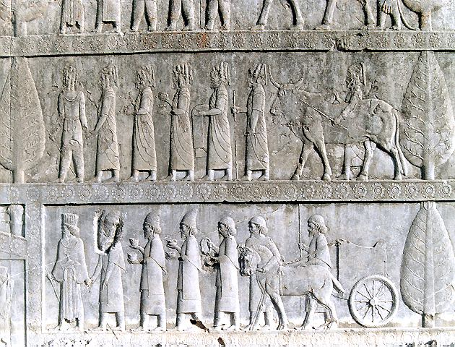

Our questions & Parteners

Our questions

Iran

Brazil

Ukraine

Bukhara

Ashley McDonald from USA

John Heater Washington USA

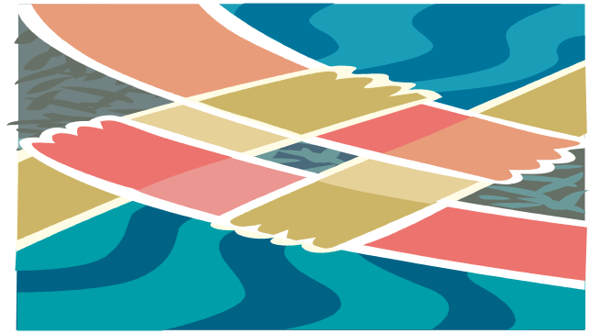

Our Questions

1- How many monuments are in your country?
2- Which monuments in your country are the oldest, most important and the most beautiful?
3- How old is the most ancient one?
4- Where is the oldest, most important and beautiful tourism place in your country?
5- Which characteristics of your country cause tourism attraction?
6- What kind of facilities does your government provide for tourism?
7- To what extent people in your country are interested in visiting historical places with tourism attraction?
8- Could you give an estimation of the number of foreign tourists visit your country every year?

9- From what countries do the tourists come?

10- Could you give us an estimation of the proportion of tourism in your country’s income?

Tourism and monuments in Iran

We have many monuments. Most of them are in Esfahan, Shiraz, Yazd and Hamedan.
Persopolis is the most important. It is located in Shiraz.

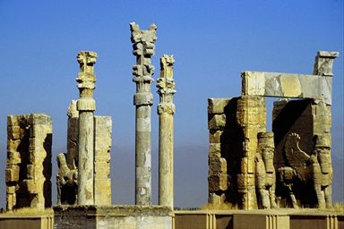
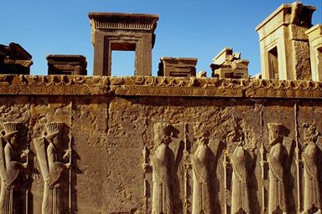
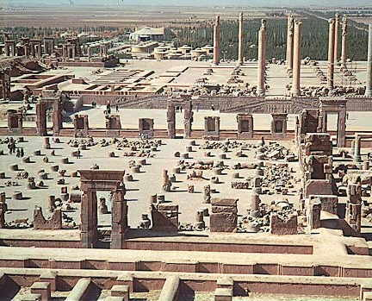

We have old ancients; Choghazanbil Zigurat (Khozestan Temple) is the oldest. It made before B.C (3000 years ago).
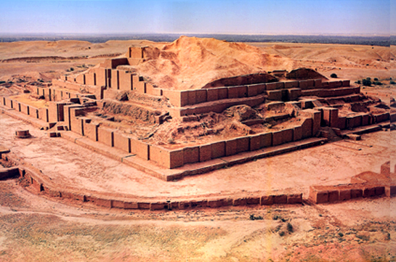

The below site is about Choghazanbil temple.
http://iranmiras.ir/arch_report/choghazanbil/home_e.htm
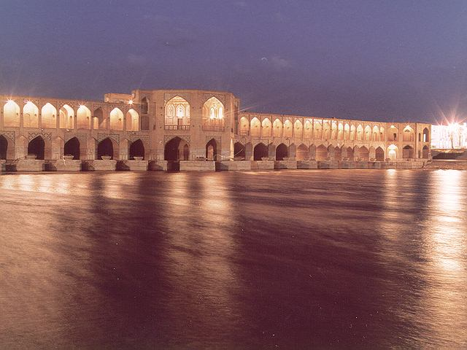
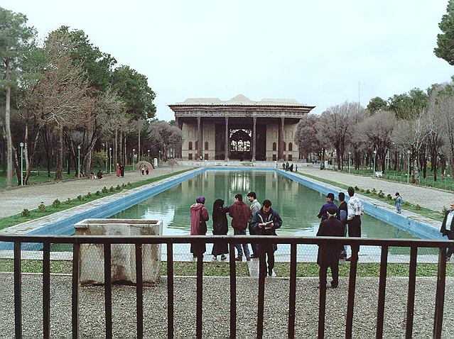
33 pol in Esfahan Chehel Soton in Esfahan
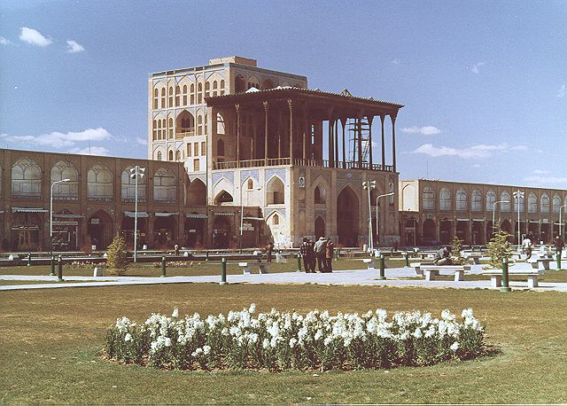

Naghshe Jahan Sq. in Esfahan

In the below sites you can find many beautiful picture from Iran.
http://www.chnphoto.ir
http://www.farhangsara.com
http://www.chn.ir/en/
/http://iranmiras.ir/
http://www.persepolis.ir
http://www.iran-india-scienceedu.com/iran_pics

People come to visit my area/country because:
1. Our country has old history and many beautiful historical places
2. Iran has places with very beautiful and natural views like the north part of Iran near Caspian Sea. This area has beautiful jungles and rivers and high mountains.
3. Iran has several religious monuments that attract pilgrims like Emam Reza Shrine in Mashhad.
4. We have 4 seasons at the same time in Iran.

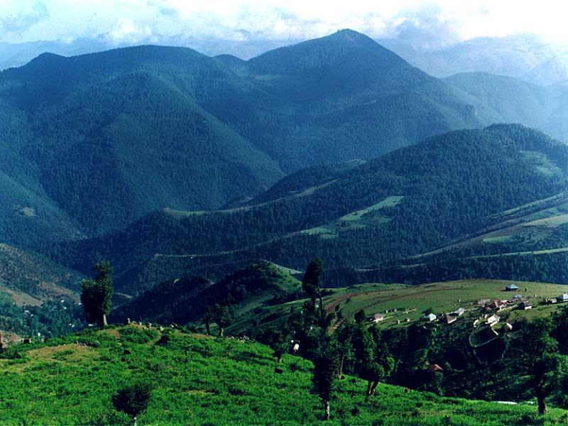
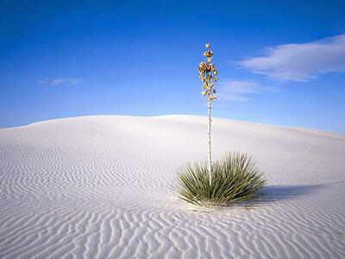

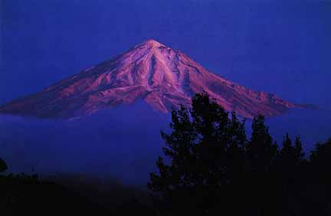
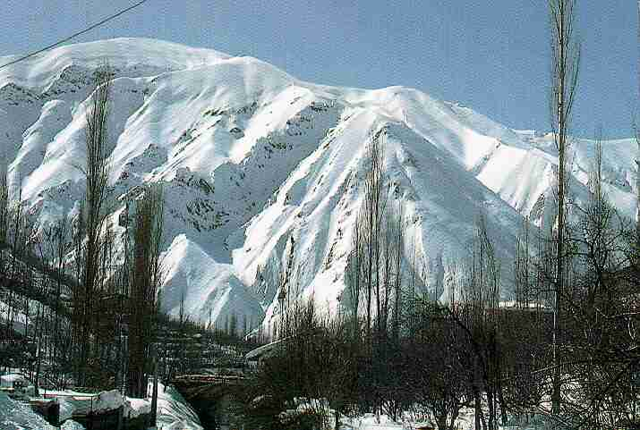

Tourism organization of Iran is responsible for giving all the information about places like hotels, museums, sightseeing, and monuments... to tourists who travel to Iran
The Iranian people go to historical places each year and these places are very crowded in all seasons especially in Norooz.Norooz is our New Year holidays and it is on March every year.
We think that our country has many tourists each year and this number increases. This can help our government's income. From every country we have many tourists.
Here a picture from tourism in Iran:

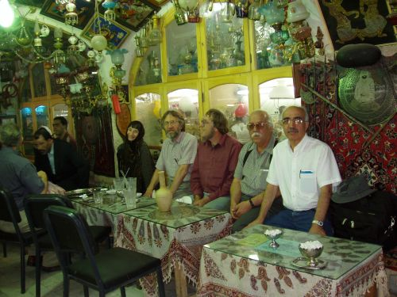

Traditional resturant in Esfahan

Tourism and monuments in Brazil

1- How many monuments are in your country?
Sorry, but it’s almost impossible to count how many monuments exist in Brazil. Everyday something deserves prominence.

2- Which monuments in your country are the oldest, most important and the most beautiful?

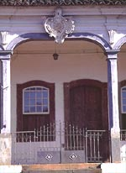
- Oldest:
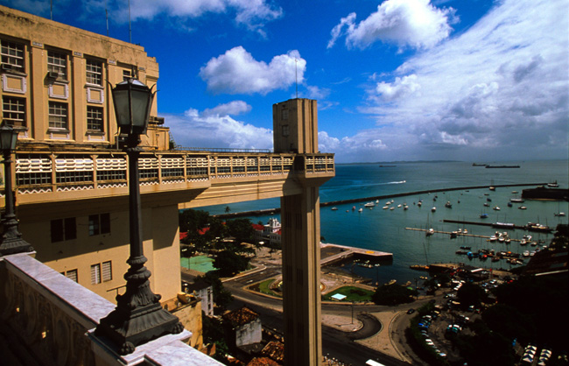
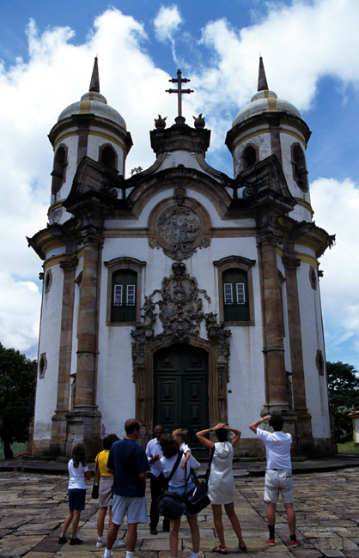

Chamber’s House Lacerda’s Elevator San Francisco’s Church
(Tiradentes) (Salvador) (Ouro Preto)

- Most importants:

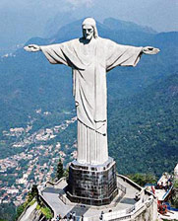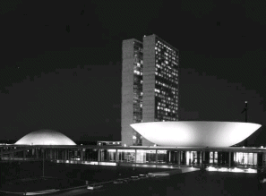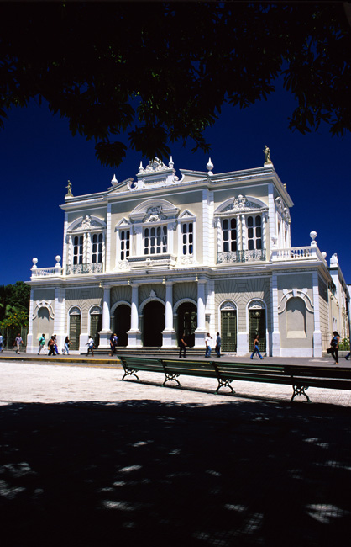
Corcovado National Congress José de Alencar Theater
(Rio de Janeiro) (Brasília) (Fortaleza)

- Most beautiful:

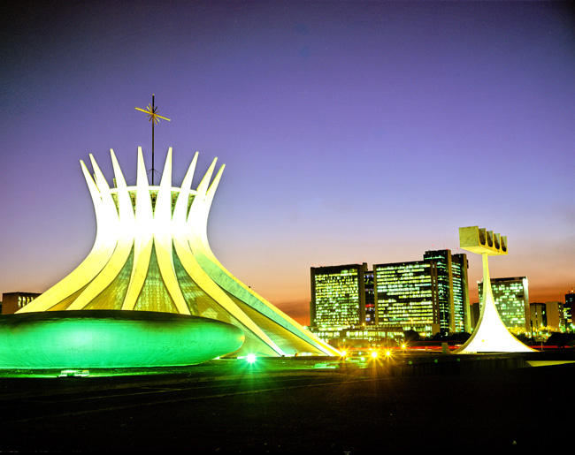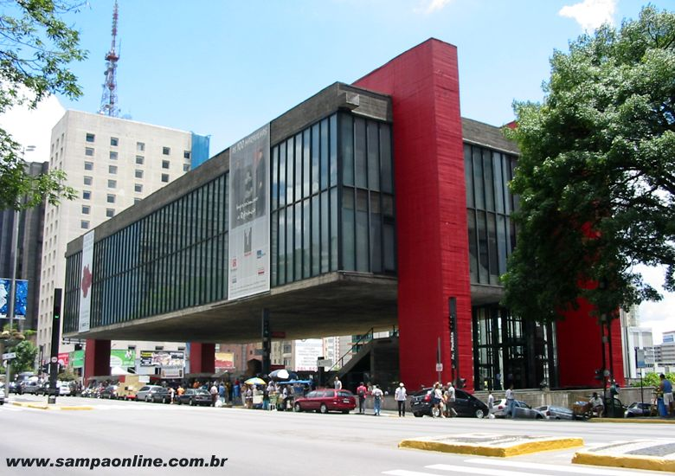
Cathedral Pampulha’s Church MASP
(Brasília) (Belo Horizonte) (São Paulo)
3- How old is the most ancient one?
Around 500 years
4- Where is the oldest, most important and beautiful tourism place in your country?
The oldest monuments are basically in the north and on the coast of the country, such as São Paulo, Rio de Janeiro, Bahia, Ceará and so on. But there are also some in the central area like Belo Horizonte, Tiradentes, Ouro Preto…
The most important ones are in the major cities, like Fortaleza, Brasília, Rio de Janeiro, São Paulo, Salvador…
All monuments are beautiful, the oldests ones reflect a European design due to the influence that we had from them. But nowadays there are a lot of modern monuments that were born from our colonial and pre-colonial past.
5- Which characteristics of your country cause tourism attraction?
Brazil is known internationally for the carnival, for the soccer and for tourist attractions as the Waterfalls of Iguaçu Falls. But, as well as it’s people and culture, the options of amusement of the country are diversified and exuberant.
In the Brazilian cosmopolitan metropolises, like Rio de Janeiro, São Paulo, Salvador and Brasília, there is a vast range of cultural options, as museums, gastronomical options of international quality, operas and symphony orchestras to the visitor's disposition.
But to know our culture, tourists can enjoy popular parties that reveal a lot of the history, art and wealth of the Brazilian people. There are options for all tastes: the Bumba-meu-boi in the North of the Country, the folk dances, the festivals with European influences in the South of the Country and, of course, the carnival of Rio de Janeiro - the largest party of the planet.
The nature in Brazil deserves special prominence, with several ecological parks and varied ecosystems: tropical forest in the Amazon, savanna in the Northeast, and Atlantic forest in the Southeast, swampland in the Center-west area and the pampas in the South area. Besides, in cities as Curitiba and Rio de Janeiro, it’s possible to visit botanical gardens that mix its historical value with the Brazilian biodiversity.
6- What kind of facilities does your government provide for tourism?
There are a lot of programs to incentives tourism in Brazil by NGO’s (Non-governmental organizations) and other programs by government. Like for example, the General Fund of Tourism (FUNGETUR). It is a mechanism of essential credit to the fomentation of the tourism as business and strategy for social and economical development-job generation and income, social inclusion and improvement of the life quality.
7- To what extent people in your country are interested in visiting historical places with tourism attraction?
Brazilians are interested in visiting historical places to know more about their origins. Like the influence that native Indians and European people had on our culture, reveled in the architecture.
8- Could you give an estimation of the number of foreign tourists visit your country every year?
There are 3.800.000 foreign tourists per year.
9- From what countries do the tourists come?
Tourists come from all over the world, but recently they’re coming more from developed countries. People who would like to enjoy beaches, sun, fresh air, fruits… nature in general.
10- Could you give us an estimation of the proportion of tourism in your country’s income?
According to the first volume of the Budget Law of 2005, Brazil invests around 6% of all investments in tourism.

Tourism and monuments in Ukraine

larysa-stepanenko
Ukraine has great potential for developing tourism: excellent geographic and climatic conditions, historical and cultural resources. Over 125 thousand archeological, architectural, and historical monuments, some dating from the 10-th – 11-thcenturies, and hundreds of museums reflect the history of the Ukrainian people, who have made the worthy contribution to world culture.
The most important and valuable historical, architectural and cultural monuments are concentrated in the regions around Kyiv, our capital, Chernihiv, Poltava, Cherkasy, Crimean peninsula and some other places.
In recent years tourism has undergone considerable changes. Excellent conditions have been created for good and safe vacations. At the request of different foreign companies, a great number of tourist itineraries are being explored.
Ukraine welcomes guests from all over the world to travel throughout its hospitable land.
If you happen to visit the southern part of our homeland, the Crimea, which is called the Pearl of Ukraine, the place where we are lucky to live, you would certainly have the opportunity to visit cave towns and ancient cities, memorial museums and palaces, enjoy the picturesque beaches and mountains, have a rest at our seaside resorts and get to know our culture and people better.
Balaclava
There are four districts in my native town, one of them is Balaclava. It is more than 2500 years old and, to my mind, is a unique place on the Earth where one can easily find traces of different peoples and nations.
Balaclava (Fish Nest) is situated in a small cozy bay. Its banks were inhabited from the ancient times. The ancient Greeks who settled here in 422 called it Syumbolon Limpe that is Harbor of Signs or Presage. The Tauri set fire on the coast to attract the ships sailing by. It is believed that it was the port of lestrigons Lamosa.
Homer described the bay in the tenth canto of “Odyssey”:
“For six days and nights they had been riding the waves, and on the seventh one
They entered a glorious harbor of lestrigons;
It was formed by the cliffs,
Steeply rising from the both sides, coming together at
The estuary so big, facing each other from the dark deep
On the sea sticking up rocks, blocking the entrance and exit…”
In 14-th century Syumbolon was conquered by the Genoese and called Chambalo. Balaclava became the west advanced post of the Genoese colonization. Many watching towers were built. The biggest and the best preserved is the Tower-Donjon- the last shelter of the beleaguered.
In 1357 the Genoese Simon del Orto built a temple which was turned into a Christian church under the name of the Twelve Apostles. It is the oldest building in Balaclava nowadays.
The local Tatars called the settlement Balyk-Kaya (Fish Cliff) as Afanasiy Nikitin (d. 1472) mentioned in his book” Traveling over the Three Seas”.
In 1475 the town fell to the Turks who gave it the name of Balyk Yuve that is the Fish Nest, which was transformed in Balaclava. Under the Turks Balaclava became a shipbuilding center. In 18-th century the town fell into neglect.
In 1820 A. Pushkin, a Great Russian poet, visited that place on his way from Gurzuf to Bakhchisarai.
During the Crimean war the battleships of the British Navy based in Balaclava bay. The English squadron came up to Balaclava on October 14, 1854. It was met by the gun fire from the fortress. The fortress stood firm till the last cartridge.
The English built an embankment, now it bears the name of Nazukin and the first Crimean railway in February 1855.
At night on November 24, 1854 during unusual hurricane and storm at Balaclava many of the British battleships which could not seek any shelter in the bay sank.
Not very far from Balaclava, at the village of Kadi-Koy, had the Battle of Balaclava fought by the British and the French against the Russians had taken place on October 25, 1854. There is a monument devoted to those hard days.
Balaclava was visited by the members of the British royal family. Its name entered the English history and language: there is Balaclava Street in London, a close-fitting woolen covering for the head and neck is called balaclava helmet.
If you have a chance, come to Balaclava. I am sure; you will definitely see all those historical places that are carefully preserved by my contemporaries.
Anna Shevchuk
The City of Chersoneses
I think we are lucky to live in the place like my native town Sevastopol. You are never bored there and always feel the atmosphere of the preserved history, your own connection with the past and are glad that can make your own contribution to the future.
My favorite place in Sevastopol is Chersoneses. It is a historical place where you can really understand the magnificent ties with other generations and nation’s.
.On the north coast of the Black Sea, where now the city of Sevastopol is situated, there are ruins of the ancient city-colony – Chersoneses. Ancient Chersoneses was the last Greek colony on the northern coast of the Black Sea: it was founded in 420 BC. In the words of Cicero it was like a border sewn on the barbarian lands. Chersoneses (Peninsula) were so named for its location on a peninsula between two bays. The city existed for 2000 years. Agriculture, construction, pottery-making, bone-carving and some other crafts flourished in Chersoneses.
Chersoneses were a slave-owning democratic republic. Medieval Chersoneses or Cherson was the chief Byzantine bastion in the Crimea until the 13-th century when Byzantium began to decline and the Golden Horde had established its rule. The city withstood numerous Tatar assaults and arose from the ashes many times. But at the end of the 14-th century Cherson was left in ruins.
Chersoneses were well-known in the ancient world. Chronicles record that Kyivan Prince Volodymyr made a long way to Korsun (the Russian name of the city) and took it by storm in 988. Here he accepted Christianity in 989 and established the Greek Orthodox faith in Kyiv. There is Volodymyrsky Cathedral in that place in honor of the Prince.
Now Chersoneses is an open air historical and archeological museum which is famous all over the world. A collection of exhibits was begun at the end of the 19-th century. Chersoneses have been explored for about 180 years. Today the visitors can stroll along the ancient streets and squares, admire the white marble columns on the seashore, mosaic panels, see with their own eyes the remnants of the amphitheatre and Monetary Mind, the tombstones and painted pottery of Chersoneses residents and examine the museum exhibits.
So ancient Chersoneses is not just the place that tells us about the culture, traditions and ways of life of the people who lived there hundreds centuries ago, but the one that attracts attention of representatives of different nationalities and thus promotes understanding between nations.
Olga Teslenko

Tourism and monuments in Bukhara

Venera Sharipova
Samarkand is the beauty of the earth, but Bukhara is
the beauty of the spirit.
In Sanskrit, the word Bukhara means a "monastery" and
this city was once a big commercial centre on the Great Silk Road.
Bukhara, with more than 140 architectural monuments, is a "town museum dating bask to the Middle Ages.2300 years later ensembles like Poi-Kalon,Qosh Madressah,Ismail Samani Mausoleum and the Kalon Minaret attract a lot of attention.
For instance, Ismail Samani mausoleum is the oldest monument. It was built by Ismail Samani, one of the rulers of the Samanid dynasty.
The 10th century saw Bukhara as a more of a scientific and cultural centre. Famous poets like Narshahi,Rudaki and Dakiki and scientists like Avicennawere well known in Bukhara as they played important role in the development of the country.
The end of the 10th century saw Bukhara under the Karahanids Reign. Monuments like Mogoki-Attari, Namoz-gokh Mosque and Chashma-Ayub were witnesses to this particular period. The Sitorai-Mokhi-Khosa Palace was the country residence of the last emir. It is one of the best examples of palatial architecture.So called "White Hall" with its Gunch carvings with mirror layer are of exceptional beauty. The 20th century saw a new modern city built close to the ancient one. There were many bazaars in ancient Bukhara, and one of the, Labi-Hauz bazaar (16-17century) has been preserved up to this day.
Labi Hauz,the most peaceful and interesting in the town, shaded by mulberry trees as old as the pool and people with street-sellers, old men hunched over chessboards or gossiping over tea, and everyone else with nowhere else to go. On the east side is statue of Hoja Nasriddin,a semi-mythical "wise fool"who appears in Sufi teaching tales around the world. Next
interesting place called the Nodir Divanbegi madresseh, which was originally built as a caravan saray, but the Khan later converted it into educational madresseh in 1630 AD.ON the west side of the square, is the Nadir Divanbegi Khanaka,which was built at the same time.
Samani Park is the town's oldest monument (complated about 905 AD.) and one of the most elegant structures in Central Asia.The mausoleum of Ismail Samani(the Samanid Dynasty's founder) apart from his own grave has the shrines of his father and grandson. You can see delicate baked terracotta which gradually changes "texture/shade" through the day as
the shadows shift. Bukhara is also famous for its astrakhan fur
enterprise; the only one in the republic. Bukhara astrakhan fur is always in great demand on the international fur auctions.
And so it is all about our perfect and ancient Bukhara. We are proud that we live in such paradise place

Tourism and monuments in USA

Ashley McDonald
Here in Connecticut, we really don't have a "National Monument". And there are too many monuments throughout the United States, but the most well known national monument in the United States that is closest to Connecticut is the Statue of Liberty in New York City. The statue of liberty is a colossal figure of a woman striding with an up-lifted flame across the entrance to the New World which is a symbol of America to most people. The Statue of Liberty was a gift to America from France back in the 1800's. You can visit the Statue of Liberty in New York, and it would usually include a 20 minute ride on a ferry-boat to Liberty Island, and then you would have to wait in a line for about 2 hours in order to climb 22-stories up the Statue to view a beautiful view across the New York Harbor over New York City. Also on the island, is museums where you can buy anything you want regarding the Statue of Liberty. Here are some pictures of the Statue of Liberty, and some souvenirs that you can buy at the museum. The Statue of Liberty is a National Monument, and is so well-known and highly visited by tourists, because it represents the United States and our freedom, and our "American Dream." Many immigrants who came to America in the early 1900's came to America, seeing the Statue of Liberty as their first sight of America. It says a lot, for such a simple statue of a woman holding a flame, and it means so much to people who need hope and something to look forward to.

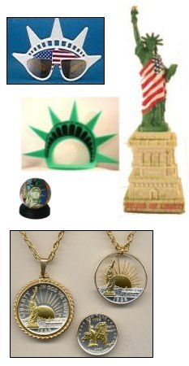
Mini-Statue

Snow globe

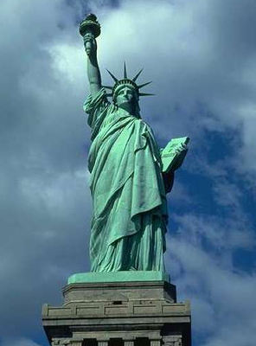
Necklace Pendants

Mini-Statue

Statue of Liberty NecklacePendants

Tourism and monuments from Washington

John Heater
Here are our Monuments and Tourism answers. Students do know the
answers to some of the questions.
1- How many monuments are in your country?
In Taiwan we have lots of monuments but the most famous monument is castle that called Hongmauchun. Hongmauchun's beauty is good because their atmosphere is red color. Spanish made this castle.
In Korea also we have castle but Korean style. That castle called GwangHwaMoon. 300~400 years ago Korean king and high level people lived there. Only 300poeple can live there. Gwanghwamoon was broke because of Japanese they attacked Korea and then Gwanghwammon was broke but we
remade it so it is okay now.
4- Where is the oldest, most important and beautiful tourism place in your country?
In Korea we have four gates that we called North gate, East gate, West gate, South gate.
It is not the oldest but theses gates are steel old. Those gates are for the Gyungbokgoong that is also castle for the king. The four gates protected Gyungbokgoong so that Japanese can not attacked Gyungbokgoong but Japanese broke North gate and West gate. So we only have two gates now. In Taiwan, the oldest building is Chin Kan Lou. It's also famous place. The first people went to Taiwan is Holland' people. They made the building in Taiwan. The building is for the people who work for
government.
8- Could you give an estimation of the number of foreign tourists visit your country every year?
120,000tourists come to Taiwan. It's not many people come to Taiwan, because we don't have perfect facilities.
100,000 tourists come to Korea.
The Northwest School, Seattle, Washington, USA

