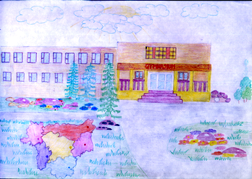

Everyday Cultural Experiences

- Of course, clothes vary for different activities.
We wear a school uniform at school. It may be a dark skirt or dark trousers for girls, a jacket and a light blouse or shirt. Boys usually wear dark suits and light shirts.
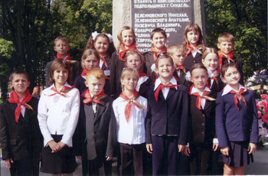

At home we wear different clothes: jeans, shorts, T – shirts or sweaters, it depends on weather.

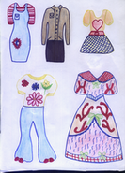
by Natasha Perevalova

- My parents usually buy clothes for me at the supermarket or at our local market. Our clothes are made at the factories, but sometimes my granny knits something especially for me: socks, gloves, scarves, caps, sweaters.

- It’s my mother who washes my clothes. She usually does it once a week in the washing machine.

- Of course our chores depend on whether we are made or female. Women usually cook for the family they wash the clothes. Men try to help the women. Sometimes they clean the room wash up. And while repairing the flat men do a lot of work.

- It doesn’t take my parents much time to do their chores, as the shops are not far from my house. But sometimes they take a car to do some shopping in the nearest town.

- My parents give me some money (not so much as I want) ≈ 5 dollars a week. They want me to learn how to spend money on different things, how to do shopping.

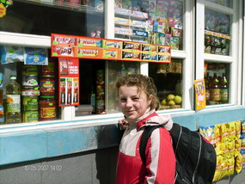

- I usually invite my friends to my birthday party. My mother lays the so-called “sweet table”, when we have only sweet things on it. My mother cooks a tasty cake for me on this day. My parents used to make a surprise for me on this day. It may be a bike, skates, a ticket to the theatre or a trip to an interesting place.

- I usually have different kinds of presents. They may be: books, albums, cassettes, toys, clothes, pictures and different games or sports items and so on.

But the best gifts for me are soft toys: big monkeys, lions, cats, and dogs.
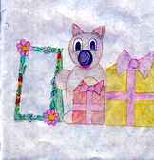
by Ksyusha Shotskaya

- Of course, at my birthday party we treat our guests with special dishes. My mother makes different kinds of cookies, cakes and salads.

- I think we have some differences while eating and preparing food from those in other countries. The main food in my country is potatoes. We eat different dishes from potatoes almost every day: it may be potato soup, boiled or fried potatoes, mashed potatoes, potato pancakes, potato babka and many others.
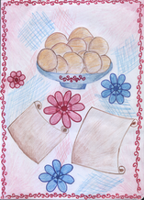
by Dasha Perevalova

- People in my place have their small kitchen gardens, where they grow some
vegetables: carrots, beets, onion, cucumbers, tomatoes, potatoes, etc. But we have to go to the shop to buy some foods there. We go to the shop almost every day to buy milk products, sausages, bread, meat and so on.

- My favourite food is potato pancakes. To cook them is not difficult. You should take a kilo of potatoes and peel them, then grate potatoes, add 3 spoonful of flour, one egg, some salt and fry pancakes on the pan using oil.

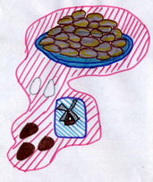
by Sveta Biritskaya
- My house is made of bricks. But in our town there are houses made of wood.

- We’ve got many appliances in our houses: cold and hot running water, vacuum cleaners, washing machines, different electric items for cooking.

- Some people in our town live in their private houses. The houses can be of one or two stores. Some families live in big block of flats. There are about 60 flats in these houses.

- As we study at our gymnasia six days a week, we have only one day off. It is Sunday. On Saturday we have 3 or 4 classes and they are over at 12 o’clock.
On weekends I like to visit my grandparents. They live in the village and they have a small farm. I like to look after different animals, to feed them, to play with cats and a dog. Sometimes I go fishing or I go to the forest to gather mushrooms or berries. Sometimes I go to the club to the discotheque for children. They organize school parties as well, where we dance and enjoy ourselves.

- I like to spend my weekends with my friends. But my parents want me to spend the weekends with them.

- I have some limits in my life. I must not stay out of my house later than 10 o’clock in the evening during the school time and not later than 11 o’clock during my holidays.

