GOAL OF THE PROJECT: to show the country’s natural attractions and to find out more about the natural attractions of other countries.

TYPE OF WRITING A Word document
REQUESTED:

THE NAME OF THE GROUP: pph1
THE NAME OF THE SCHOOL: Srednja elektro-računalniška šola, Maribor (Secondary School of Electronics and Computing)
THE CLASS WHICH WORKED ON THE PROJECT: 4. b High School
THE CITY, STATE, AND COUNTRY OF THE SCHOOL: Maribor, Slovenia

The place described in this project is only one of our natural beauties in our country.
Enjoy the reading.

If you want to find out more about us, search on http://www.sigov.si/
for more information.

ABOUT NATURE
An old wisdom says that mother nature is like a cloud, it is always the same but never the same. The nature is always changing. Unspoiled nature is shrinking, but the needs of it are increasing. In nature there is everything very important, each detail includes itself in the entire system of the universe.

NATIONAL PARK
It is one of many possibilities of protecting nature. It’s a land that is specially protected, usually owned by the country. We let the nature go its own way, we don’t use its fortune and sources, and especially we don’t build houses there.

TRIGLAV NATIONAL PARK - LOCATION

MAP POSITION

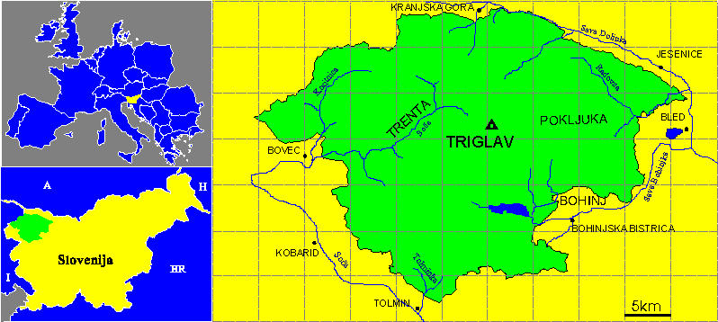

INFORMATION ABOUT THE PARK

The name comes from Triglav, a mountain in the center of the park and it’s also the highest Slovenian mountain (2864 meters)
It is located in the north-western part of Slovenia, near the border of Italy and Austria.
There are about 2200 inhabitants in 25 villages in this area.

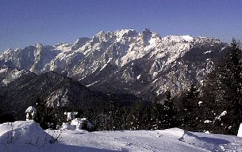
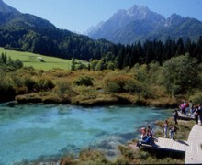

http://www.sigov.si/tnp/
http://www.tnp.si/national_park/

CLIMATE

It is mostly alpine with cold, long winters and short summers. The higher we go the more decreasing is the temperature.
The highest temperatures in July are between 5°C and 20°C, it gets very cold in January, there are temperatures around 9°C.

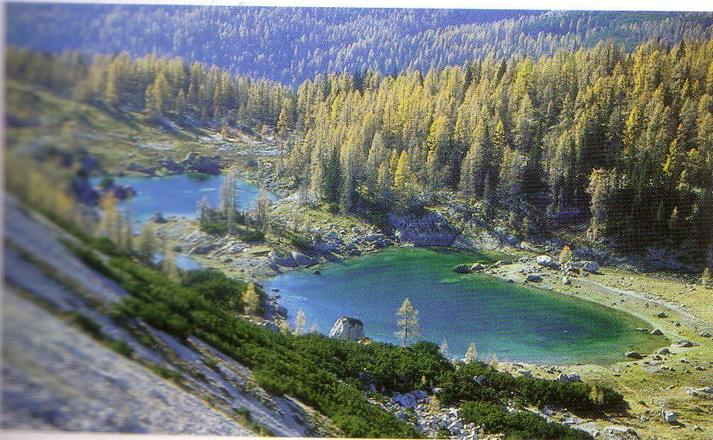

3.1.4.TOURISM
Visitors in the park can do different sport activities. And if you decide to spend your time during holidays here, you can go cycling, parachute-diving, you can visit some underground caves, you can sky or also walk the mountains.
But you can also get a guided tour through the park and discover the beauty of Triglav National Park.

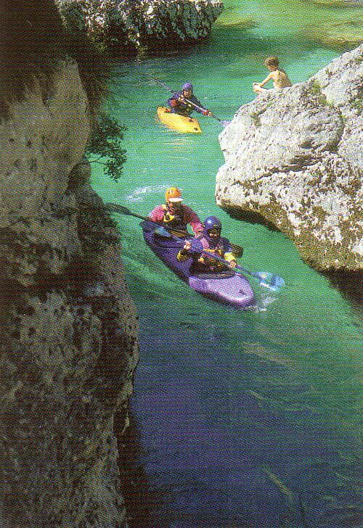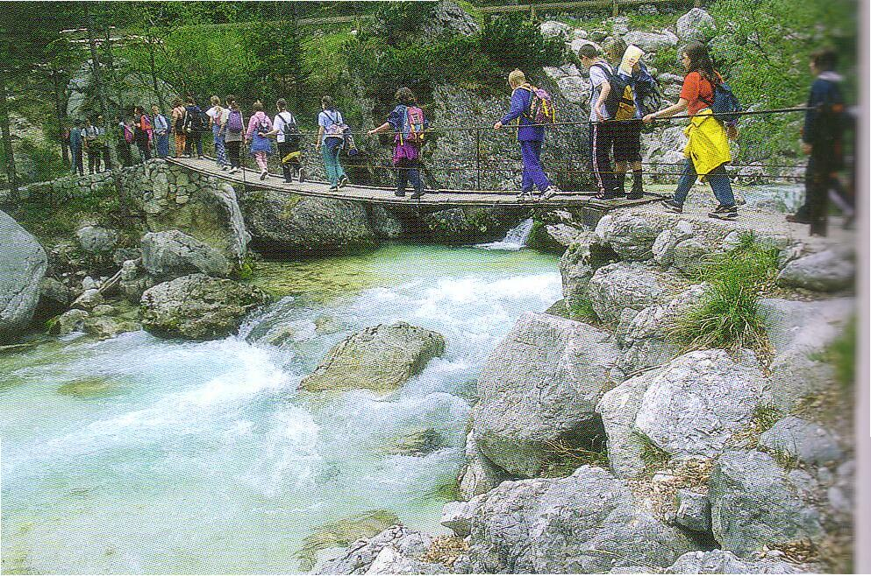

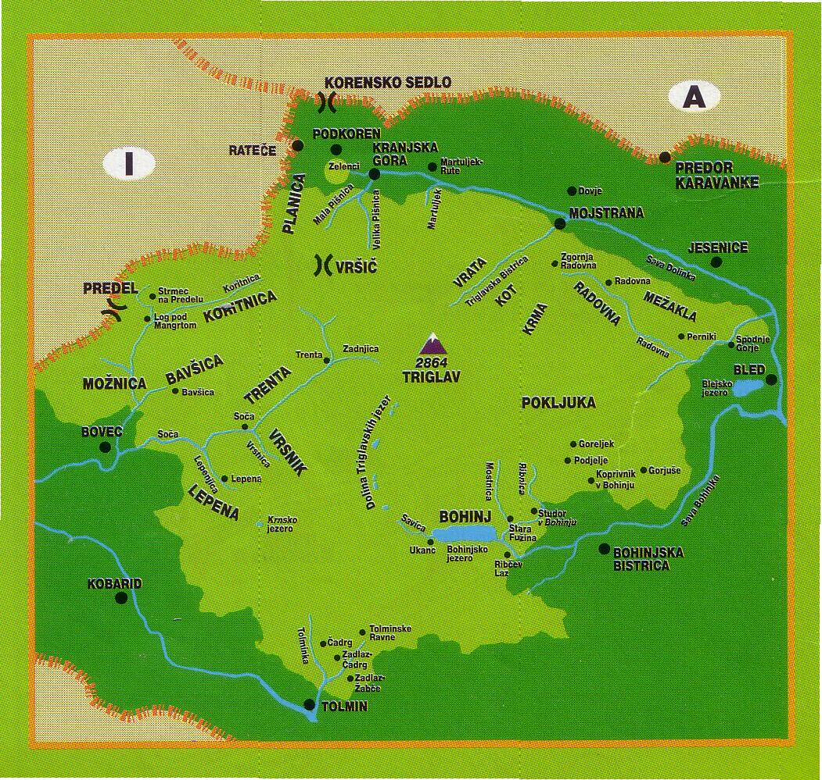

4. CONCLUSION
With our Triglav national park, we have protected one of the last oases of the true nature in Europe.
The importance of such kind of parks is not only the protection of nature but also the attraction to the visitors. It allows us to relax and to become one with nature.

prepared by Aleš Rola, 4bg, Slovenia

