iEARN

LEARNING CIRCLES

CREATIVE WRITING

IOAN BOB SCHOOL, CLUJ-NAPOCA, ROMANIA

CLEVELAND SCHOOL, NEWARK, USA

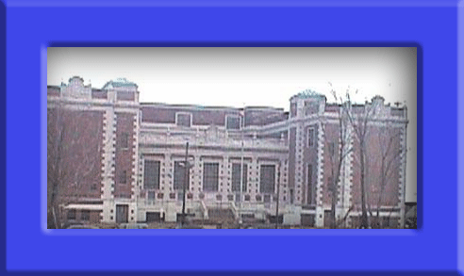

The Classroom Survey --Getting to Know You!
Circle Name: Mind Works
Class Name
A. Name of teacher: Mrs. Mitchell, and Ms. Hendricks
B. Grade level: Five
C. Class favorites (List your class top 5 favorites in each category):
Music
Lil Wayne | Beyonce | The Cheetah Girls | Hannah Montana | 50 Cents
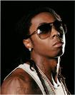 |  |  |  | 

2. Authors
Dr. Seuss | Beverly Cleary | Louis Sachar | Barbara Park
 | 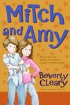 |  | 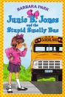

3. TV programs
Hannah Montana | Drake and Josh | That So Raven | NCIS
 | 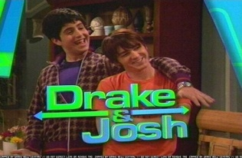 | 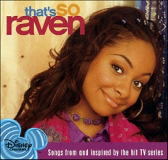 | 

4. Foods
Fried Chicken | Pizza | Steak | Chinese Food
 |  |  | 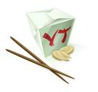

5. School subjects
Math
Science
Literature
6. Sports
Basketball | Track | Soccer | Football
 |  | 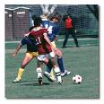 | 

PART II. INTRODUCING THE SCHOOL
A. School information
Name and address of class and school
Cleveland School, 388 Bergen Street Newark, New Jersey 07103 USA
Classroom 304
- Number of students in class and school
Our school enrollment is currently 300.
3. School emblem, colors or mascot
Our colors are Blue and Gold, and our mascot is a ram.
4. Type and number of computers
We are a PC school with over 80 networked computers.
B. School program
1. List 3 things about your school program that make it unique.
The field trips, clubs, and activities makes Cleveland a great school to attend.

PART III. INTRODUCING THE COMMUNITY

A. Your community Newark New Jersey USA
1. Name of your community Newark
2. Location of your community Essex County (Central Ward)
3. The area of your community Northern New Jersey
4. The population of your community Newark is the largest city in Northern New Jersey, and the county seat of Essex County. In present day Newark has a total population of 275,000, making it the largest municipality in New Jersey and the 64th largest city in the U.S. According to the US Census Bureau, the city's 2006 population estimate is 281,402, an increase of 2.9% from 2000^{2]}

B. Special characteristics
- List 3 reasons why people come to visit your area.
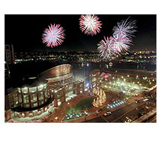
NJPAC
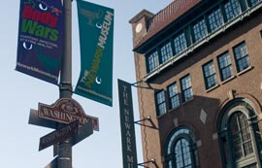
The New Jersey Performing Arts Center has garnered national attention in its first nine seasons, serving as a model for programming, audience diversity, education initiatives, and the catalytic role it has played in returning nightlife and economic activity to NJ's largest urban community. On its Opening Night in 1997, NJPAC became the sixth largest performing arts center in the U.S. (based on annual operating budget).
Newark Museum
The Newark Museum, New Jersey's largest museum, features 80 galleries of world-class collections showcasing the arts and natural sciences. Exhibits of American, Asian, African, and classical art complement the museum’s mini zoo, planetarium, sculpture garden, and Victorian Ballantine House, a National Historic Landmark that lets visitors experience another era. Museum shops and a café complete the visit.
Check out this link to learn more.
http://www.ci.newark.nj.us/visitors/

PART IV. OTHER INFORMATION

Please feel free to share any other information about yourself that you think would help us to know you better.

The financial, commercial, and transportation nucleus of the Garden State, Newark also is a thriving cultural hub, filled with events and attractions for visitors from near and far. From festivals and parades to museums and musical venues, there something for everyone to explore and enjoy in Newark.
To say nothing of the diverse culinary adventures awaiting inquisitive palates. Portuguese, Spanish, Brazilian, Greek, and soul food are but a few of the many cuisines to be found in Newark’s restaurants. Home to the Weequahic Golf Course, the Newark Bears baseball team, and numerous parks and recreation centers, Newark also is a destination for sports enthusiasts. And with the new Train-to-Plane direct link from Newark International Airport and more than a few hotels, Newark is both easy to get to and a great place to stay.C. Industries

http://en.wikipedia.org/wiki/Newark,_New_Jersey

The Classroom Survey --Getting to Know You!

Circle Name: Mind Works
Class Name: mixed classes

PART I. INTRODUCING THE CLASS

A. Name of teacher: Otilia Moldovan

B. Grade level: teams of students from grades 5-6-7-8

C. Class favorites (List your class top 5 favorites in each category):

1. Music groups: Metallica, Pussycat Dolls, Scorpions, Linkin Park, Tokio Hotel

2. Authors: Jules Verne, Roald Dahl, Mark Twain, Ion Creanga ( Romanian classic), Mihai Eminescu ( Romanian classic poet-the World Record for the longest poem, “The Morning Star”)

3. TV programs: Documentaries, Music, Films, Sports, Cartoons

4. Foods: pizza, French fries, chicken, sushi, stuffed cabbage ( traditional Romanian – cabbage leaves stuffed with minced meat, rice, spices)

5. School subjects: Physical Education, English, Maths, Biology, History

6. Sports: football, handball, skiing, swimming, tennis

7. Video or computer games: The Sims 2, Conquiztador, GTA 4, FIFA 09, World of Warcraft.

8. Other Class Favorites of your choice: school trips/traveling, youth camps, school championships, international exchanges, fashion

PART II. INTRODUCING THE SCHOOL

A. School information

1. Name and address of class and school: Ioan Bob School
Nr. 10 Episcop Ioan Bob Street
Postal Code 400014
Cluj-Napoca
Romania

2. Number of students in class and school: 25-28 students in class
595 in school

3. Size of school: 27 classrooms, 1 gym, staff’s rooms

4. School emblem, colors or mascot: 

5. Type and number of computers: about 40 Pentium computers

6. School history: The beginnings of our school go back to the last century when, 156 years ago, its spiritual mentor, the Greek-Catholic bishop Ioan Bob, inaugurated the first Romanian school. Year after year, school children and teachers contributed in promoting the renown of the oldest "intra muros" school (inside the walls of the Cluj principality during the Austro-Hungarian Empire, when Transylvania became a province under Hungarian control).

B. School program

1. List 3 things about your school program that make it unique:

- semi-boarding school at primary level. i.e. the class teacher accompanies the children to have lunch, then they come back to school to do their homework for the next day, so that at about 16.00 their parents may come to take them home;
- temporary two-shift-program (7-12.10 / 12.15-17.15) , until building of the top floor is ended;
- collaboration with Music School for individual violin and piano lessons.

2. List school calendar from the session dates (holidays and special
events that may affect your participation).

- 2-8 February – between semesters holiday
- 9 February - 12 April courses
- 13-20 April – Easter holiday
- 21 May – 12 June courses
- 15 June – 15 September students’ summer holidays

PART III. INTRODUCING THE COMMUNITY

A. Your community

1. Name of your community: Cluj-Napoca

2. If not a city, name and size of nearest city: N/A

3. Location of your community: North-West of Romania, central Transylvania

4. The area of your community: 179 sq km

5. The population of your community: 317,000 inhabitants

B. Special characteristics

1. List 3 reasons why people come to visit your area.
- Cluj-Napoca is the most important cultural and university centre in Transylvania. People come to see concerts, museums, churches of different religions, medieval buildings and about 100,000 students from lots of countries around the world come to study in the biggest university in Transylvania.

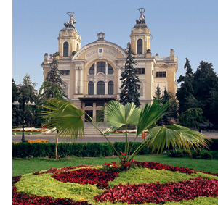
The National Theatre

- The Botanical Garden - one of the most beautiful and most complex botanical gardens in South-Eastern Europe. It was founded in 1920. Trees and plants from all over the world enjoy here optimum conditions for growth, so that the garden becomes a real museum of the environment.

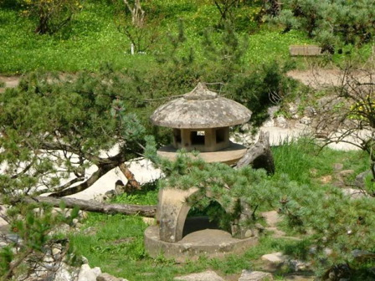 | 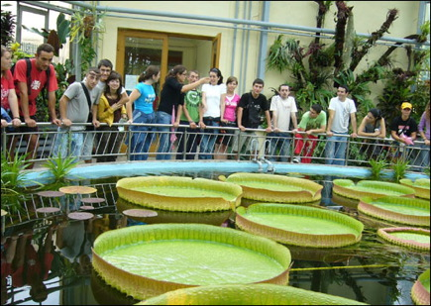

- The open-air Village Museum

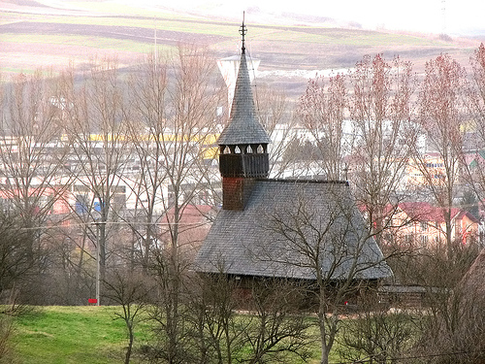 | 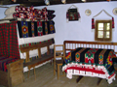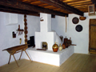  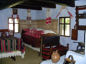

2. Describe any unusual land formation found in or near your community.

- The Apuseni Mountains
They are the western range of the Romanian Carpathians. They are low mountains, the highest altitude can be reached on the Curcubata Mare peak (1849 m). Nevertheless this mountain area is one of the most visited in the entire country, due to the spectacular karst landscape to be admired here. You will find all kind of karst landforms: gorges, sinkholes, intermittent springs, and more than 400 caves, many of them ranking among the most valuable natural monuments in Romania.
The main destinations in the Apuseni Mountains are Stana de Vale, the Padis area, Vladeasa and the Cheile Turzii Gorges.

The Cheile Turzii Gorges  The gorges spread over 2 km along a river which cut its way through the limy rocks . The site had been appreciated ever since the Romans' times, due to the majestic landscape and to the complex diversity of the flora and fauna. The relief of the gorges is impressive by the vertical mountain sides, the array of rocks and the numerous caves. | 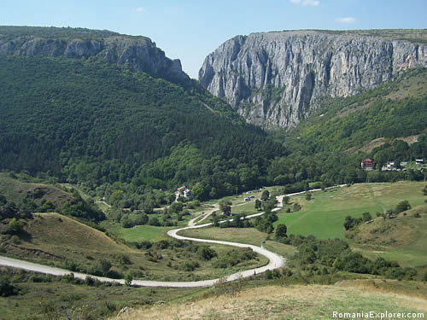

- The Scarisoara Cave

It’s the biggest ice-cave in Romania. It is at 1165 meter height and it is more that 3000 years old. It has a length of 720 meter and a depth of 105 meter. The volume of the ice we find in the cave is of 75 000 m3 and its width of 15 metres.

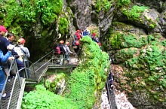  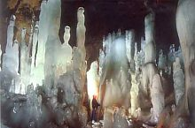 | 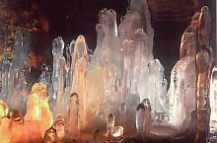  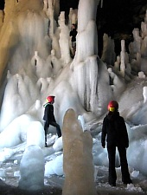

- The Bears’cave

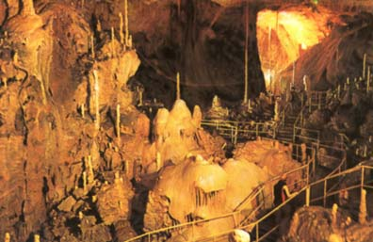

C. Industries
List major industries or occupations in your community.

- NOKIA plant: cell phones
- Chemical/Pharmacy industry: TERAPIA
- Textile industry: JOLIDON, ARGOS
- Cosmetics: FARMEC
- Dairy products: NAPOLACT
- Shoes: CLUJANA
- Furniture

PART IV. OTHER INFORMATION

Please feel free to share any other information about yourself that you think would help us to know you better.

You may also visit my school online magazine:

http://magazinefactory.edu.fi/magazines/kidschronicle/

Words of Wisdom

Ways to reflect

Intelligent Conservation

Someone care enough to share

Do as I say not as I do

Our ancestors taught us lessons

Many generations heard their words

Wisdom it’s a powerful thing!

Renee Daniels-Mitchell

Buddy is my pal; we play in the park every Saturday in the summer. He makes me laugh at his many funny faces. We shared so many secrets. Buddy is my pal.

Buddy loves ice cream; vanilla is his favorite ice cream flavor. One day I caught Buddy licking my ice cream cone, he had ice cream all over his face. It was so funny I screamed. We both started rolling on the floor. Yes, Buddy is my pal.

Makulah Sheriff
Grade 3
Room 204
Mrs. Green



“Doctor Doctor”

Doctor is it the swine flu or do I have a cold. My mom says no school today. I can’t miss another day. Please tell me what to do? Do I need a needle or a pill? Oh no, I don’t want the bill. I need to get fast! Can you tell but I need to do?

Angel Mercado
Grade 3
Room 203
Mrs. Green



“Talking Back”

Control yourself is what I say daily. There are some things I can not control, but I am learning how to take charge of my life. I will not follow the crowd, because I am a leader not a follower. I know that people are watching me to see how I am going to react, or to see if I will fall flat on my face. I can make choices, some good and some bad.
My choices cause me to get into trouble. Well on the flip side some of my choices help me have great success. I have learned that I must be focused in everything I do. My teacher says that we should live life out loud. We should enjoy all the things and opportunities we have. I plan to live life out too.

Hassan Trazie
Grade 6
Room 310
Mrs. Oyawusi

A Smooth Problem


DJ Smooth rapped long and hard on the stage. The crowd looked bored. Only a few people were dancing. When the music stopped, Smooth had tears in his eyes. Roberto ran up to him and say man you gave it your best shot. Smooth laughed, and said that was a rough crowd. I did not feel any love on the stage.

Roberto smiled and said it is time for you to rethink about your career choice. Yes, I love the stage, but I need the energy from the crowd. Well if you can’t take the heat get out of the kitchen, Roberto said with a smile.

Remember Smooth you have some many gifts, and talents. You make the best curry chicken in New Jersey. You have cooked for some many years at your parents’ restaurant. You should open a restaurant or a night club; I know that with your skills you would make lots of money. Roberto, I know just the right spot for a restaurant, but I needed a partner. We both started to laugh, as we walked out the stage.

Roberto Irizarry
Grade 8
Room 308
Mr. Ward
Cleveland School
Newark, New Jersey

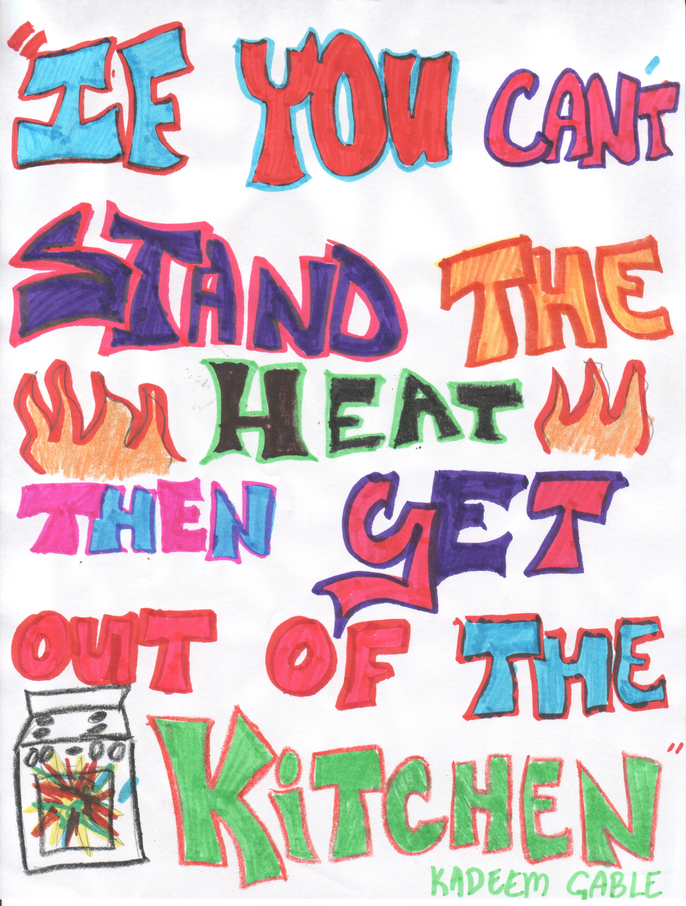

This proverb means that you should never tell a lie. When you tell a lie to someone and two days later you respond with a different answer. They will know that you told them a lie. That person may think you are lying and you have to think of what you said from the previous day. So that’s why someone should never tell a lie, because you may forget the original lie that you told.

By, Imani Smith
Grade 5
Cleveland School
Teacher: Ms. Hendricks

Always Be Yourself

I think this proverb means to always be yourself around people. You can’t just be one way around your friends then act different around another set of friends. You should act one way and stay that way. For instance, if you’re always nice to your friend, but when certain people come around you, you start to act differently as though you don’t like or know that person. Some people try to act differently when others come around because they want to fit in or make friends, but it’s not worth it. You should always be yourself and its better to be you because you will probably make more friends that way. When people see the real side of you, they will like it because all people have a human quality. It is always important to be yourself and not be fake.


By, Safiyyah Williams
Grade 5
Cleveland School
Teacher: Ms. Hendricks



John Doe
Slamming the phone book on the ground was a man name John. He was looking for another job to pay to pay bills. As John was sitting there he started to get frustrated and his legs started to shake like jelly in a bowl. As John was sitting there reading the news paper he started to search for jobs in the back of the news paper.
Wow he wondered as he sat there in the dim light. Recession, and a poor economy to boot, keeps me out of the loop. My pockets are empty, I am just another John Doe, he thought to himself how it would be if he had a new life. John Doe is a man without a name. I have no claim to fame.

Shawn Hall
Grade5
Room 304
Ms. Hendricks
Cleveland School

Football

Walking to the store in the blazing heat Amarie, Shawn, and Abdul are talking
about their favorite sport, which is football? Amarie began to reach in his pocket and he grabbed his football cards of the Colts, Cowboys, and Giants.
“I know Shawn and Abdul will love the new football cards I got them” Amarie thought to himself.
Suddenly Abdul and Shawn began to reach for their favorite teams.

Behind them is their friend Xaqaui running with his blue and white basketball.
“What’s up you guys” he exclaimed while running out of breathe.”Do you guy’s
want to play a little b-ball” he exclaimed while constantly dribbling the ball.
“Alright!” they replied while walking to the basketball court. Man what happened
to it, it’s destroyed!” Amarie exclaimed while running to the gate. Now what
are we going to do, Shawn said to his friends. Suddenly the four friends decided
to go the other way.

“At least we have our football cards so we can still talk about our favorite teams, right guys? Then everyone replied okay.

Amarie Sears
Cleveland School
Grade 5
Ms. Hendricks

This English Proverb means to me that when someone doesn’t like you and pretend that you are the best friend in the world to them and your really not. Your so call friend is getting your hopes up high and making you think you’re something to them that’s so close. They are just using you like you’re her/his back up plan because you’re nothing to them but a GOOD ENEMY. If you have any concerns please talk to a real friend and see what evidence you receive…

By,Ciara Pugsley
Grade 5
Cleveland School
Teacher: Ms.Hendricks

Can you tell?
♥♥♥♥♥♥♥♥♥♥♥♥♥♥♥♥♥♥♥♥♥♥♥♥♥♥♥♥♥♥♥


Did you ever see the look of a lost child? Well I have, it broke my heart into pieces. While I helped him look for his mommy, I cried. One moment she was there and now she gone. She stood by the window and watched me love him. She is the one crying now. I wonder does she feel regret or joy. I love him now, he is my son.

BY: Shania Tate and Yvonnie Holley
Cleveland School
Grade 5
Room 304
Ms. Hendricks

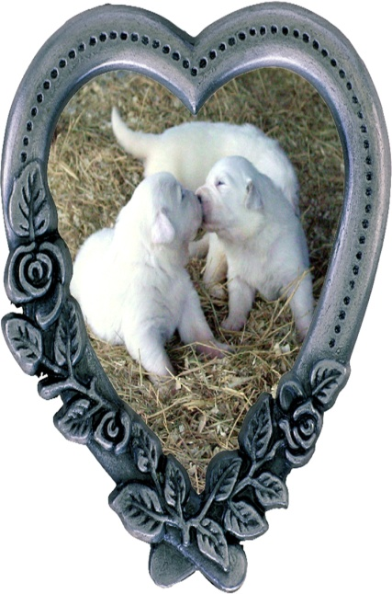

Crazy
Yelling and screaming Mary bangs on the science table, stomping her feet on the smooth floor. She started to get aggravated and shake like a rattle snake. Mary thought to herself, she is getting on my last nerve!
Nearby the table was Ms. Perry telling Mary something. Then Ms. Perry says “why are you acting smart Mary” then Mary replies “I’m not acting smart!” Instead of Mary saying I’m not acting smart, she should have said I am smart but I’m not acting bad. She should have thought about what she really wanted to say.
By, Abdul Brown
Grade 5
Cleveland School
Teacher: Ms. Hendricks


Profound Conservation
Resourceful
Opportunities to learn
Victory
Education
Redefined
Benefits

Mrs. Mitchell
Cleveland School
Newark , New Jersey

