MY HERO:
Alexander Matrosov
by Ponomaryov Alexander from Kurgan

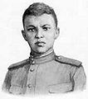

Alexander Matveyevich Matrosov (February 05, 1924 - February 22 or 27, 1943), born in Yekaterinoslav (now Dnipropetrovsk) was a famous Soviet infantry soldier during World War II.
On February 22, 1943 in the battle for the village of Chernushki near Pskov, Matrosov threw himself onto a German pill-box, blocking the machine-gun with his own chest, to allow his unit to advance. For his self-sacrifice in battle, Matrosov was posthumously awarded the distinction Hero of the Soviet Union.

Alexander Matrosov was born in Dnepropetrovsk. Having spent his early youth in orphanages and correctional camps, he was drafted in September 1942 and started training in a military academy near Orenburg. In January 1943 he was sent to the front as a private with the 91st Pacific Naval Volunteers Brigade.

In 1942 the men of the brigade were attacking a Nazi strong-point near the Russian
village of Chernushki. The Nazi were defending it with all their strength, and their machine-guns were firing hard. The Soviet men could not move forward. They were firing and throwing hand-grenades at the German machine-guns. Bullets were flying all round them.

Soon only one Nazi machine-gun continued to fire. Then Alexander Matrosov moved forward and threw a hand-grenade at the embrasure through which it was firing. There was a loud explosion and then a sudden silence. With a shout the Soviet men rose to their feet and ran forward. But the enemy machine-gun came to life again! The men, who were already quite near the strong-point, fell to the ground once more – a lot of them were killed and wounded.

Suddenly Alexander Matrosov rose to his feet and ran towards the enemy strong-point. The whole regiment could see everything he did. He turned, fell on his left side and with all his strength threw his whole body against the embrasure. The machine-gun stopped. In a second the Soviet men were on their feet. "For our Motherland! For Comrade Stalin! For Sasha Matrosov!" they shouted.

The Nazis could do nothing to keep the attack back. In a minute the enemy strong-point was in the hands of the regiment. Ten minutes later, a fierce fighting was going on in the village, and soon the victorious regiment raised over Chernushki the red flag of the country for whose freedom the Young Communist Alexander Matrosov gave his life. His name is on the roll of his regiment for ever -- Guards Private Alexander Matrosov, Hero of the Soviet Union.

Over 300 Soviet soldiers are said to have thrown themselves on Nazi machine-guns during the War. Alexander Matrosov was the first among them.

There were Soviet soldiers who survived after repeating Alezander Matrosov’s feat of valour. One of them was Vladimir Maiborsky, a Ukrainian lad. On July 13, 1944, when his unit was driving the Nazis out of the village of Cheremkhuv, Ivano – Franko region, he closed the embrasure of an enemy weapon emplacement with his body. Though heavily wounded, he remained alive. After recovering he returned to the front and reached the lair of the Nazi beast.

Alexander Matrosov’s heroic deed continues to be a well-known and powerful symbol of self-sacrifice for the younger generation of Russian boys, for me and my classmates.
http://en.wikipedia.org/wiki/Alexander_Matrosov
World War II 1941-1945: Events. People. Documents. M., 1990
Heroes of the Soviet Union. Brief biographical dictionary. M., 1988
Young heroes. M, 1970

MY HERO:
Ernst Thälmann
byYemelyanov Sergey from Kurgan

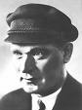

Ernst Thälmann (16 April 1886 – 18 August 1944) was the leader of the Communist Party of Germany (KPD) during the Weimar Republic. He was arrested by the Gestapo in 1933 and held in solitary confinement for eleven years, before being shot in Buchenwald on Adolf Hitler's order in 1944. In 1936, the Thälmann Battalion of the International Brigades during the Spanish Civil War was named in his honour.
Born in Hamburg, Thälmann was a Social Democratic Party member from 1903. Between 1904 and 1913 he worked as a stoker on a freighter. He was discharged early from his military service as he was already seen as a political agitator.
Towards the end of 1917 he became a member of the Independent Socialist Party of Germany (USPD).
When the USPD split over the question of whether to join the Comintern, Thälmann sided with the pro-Communist group which in November 1920 merged with the KPD. In December Thälmann was elected to the Central Committee of the KPD. In March 1921 he was fired from his job at the job centre due to his political activities. That summer Thälmann went as a representative of the KPD to the 3rd Congress of the Comintern in Moscow and met Lenin. In June 1922 Thälmann survived an assassination attempt at his flat. Members of the right-wing nationalist organisation Consul threw a hand grenade into his ground floor flat. His wife and daughter were unhurt; Thälmann himself came home only later.
Thälmann participated in and helped organise the Hamburg Uprising of October 1923. The uprising failed, and Thälmann went underground for a time. After the death of Lenin in January 1924, Thälmann visited Moscow and for some time maintained a guard of honour at his bier. From February 1924 he was deputy chairman of the KPD and, from May, a Reichstag member. At the 5th Congress of the Comintern that summer he was elected to the Comintern Executive Committee and a short time later to its Steering Committee. In February 1925 he became chairman of the Rote Frontkämpferbund (RFB), the defence organisation of the KPD.
In October 1925 Thälmann became Chairman of the KPD and that year was a candidate for the German Presidency. Thälmann's candidacy in the second round of the presidential election split the centre-left vote and ensured that the conservative Paul von Hindenburg defeated the Centre Party's Wilhelm Marx. In 1933 Hindenburg would appoint Adolf Hitler as German Chancellor.
In March 1932, Thälmann was once again a candidate for the German Presidency, against Paul von Hindenburg and Adolf Hitler. The KPD's slogan was "A vote for Hindenburg is a vote for Hitler; a vote for Hitler is a vote for war." Thälmann returned as a candidate in the second round of the election, as it was permitted by the German electoral law, but his vote count lessened from 4,983,000 (13.2%), in the first round, to 3,707,000 (10.2%), which seems to indicate that, despite his fierce opposition, Hindenburg received more than a million votes.
After the Nazis came to power in January 1933, Thälmann proposed that SPD and KPD should organise a general strike to topple Hitler, but this was not achieved. In February 1933, a Central Committee meeting of the already banned KPD took place in Königs Wusterhausen at the "Sporthaus Ziegenhals", near Berlin, where Thälmann called for the violent overthrow of Hitler's government. On 3 March he was arrested in Berlin by the Gestapo.
Thälmann's trial – which he said he looked forward to – never took place. Thälmann's interpretation was that his two defense lawyers, both Nazi Party members (whom he nonetheless trusted to a certain extent) at some point gathered that he planned to use the trial as a platform to appeal to world public opinion and denounce Hitler, and had told the court. Furthermore, Thälmann assumed that after the failure of the trial of Georgi Dimitrov for complicity in the Reichstag fire, the Nazi regime did not want to allow the possibility of further embarrassment in the court room.
For his 50th birthday in April 1936 Thälmann received greetings from around the world, including from Maxim Gorky and Heinrich Mann. That same year the Spanish Civil War broke out, and two units of the International Brigades named themselves after him.
Thälmann spent over eleven years in solitary confinement. In August 1944 he was transferred from Bautzen prison to Buchenwald concentration camp, where on 18 August, on Hitler's orders, he was shot and his body immediately burned. Shortly after, the Nazis announced that together with Rudolf Breitscheid, Thälmann had died in an Allied bombing attack on 23 August.
After 1945, Ernst Thälmann, and other leading communists who had died violently, such as Rosa Luxemburg and Karl Liebknecht, were widely honored in East Germany, with many schools, streets, factories, named after them. Most of these names were abolished after German reunification though it is still possible to find places named after Thälmann in cities like Berlin, Hamburg, and Frankfurt an der Oder.
The East German pioneer organisation was named the Ernst Thälmann Pioneer Organisation in his memory. In 1972, Cuba named a small island, Cayo Ernesto Thaelmann, after him. The British Communist composer and activist Cornelius Cardew named his Thälman Variations for piano in Thälmann's memory.
My classmates and I admire Ernst Thälmann a fearless fighter against fascism. I think one should have great courage to oppose fascism in its citadel.

http://en.wikipedia.org/wiki/Ernst_Thälmann
Sosnovsky A. A. Everything Even one’s Life. M, 1983
MY HERO:
Leningrad – Hero-city
by Klimov Vlad from Kurgan

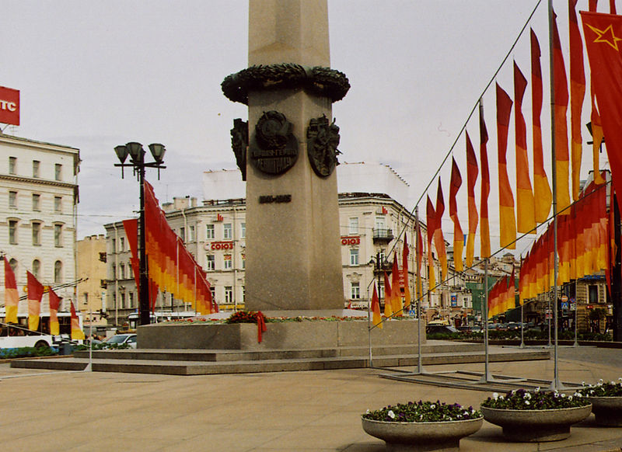
Leningrad Monument
During World War II, Leningrad was besieged by Nazi Germany and co-belligerent Finland. The siege lasted 872 days from September 1941 to January 1944. The Siege of Leningrad was one of the longest, most destructive and most lethal sieges of major cities in modern history. It isolated the city from most supplies except those provided through the Road of Life across Lake Ladoga, and more than a million civilians died, mainly from starvation.
For the heroic resistance of the city and tenacity of the survivors of the Siege, in 1945 Leningrad became the first city in the Soviet Union awarded the title Hero City.
Saint Petersburg (with 18 August 1914 until January 26, 1924 - Petrograd; from January 26, 1924 to September 6, 1991 - Leningrad) - the city of federal value in the northwest of the Russian Federation, the most important after Moscow economic, industrial, scientific and cultural center, large transport unit
The city was founded in 1703 by Peter of the First. From 1712 through 1918 the city was the capital of the Russian Empire and the residence of Russian emperors.
The history of the city is more than three hundred years old. During these years foreign invaders tried to capture the city several times, but all their attempts failed.

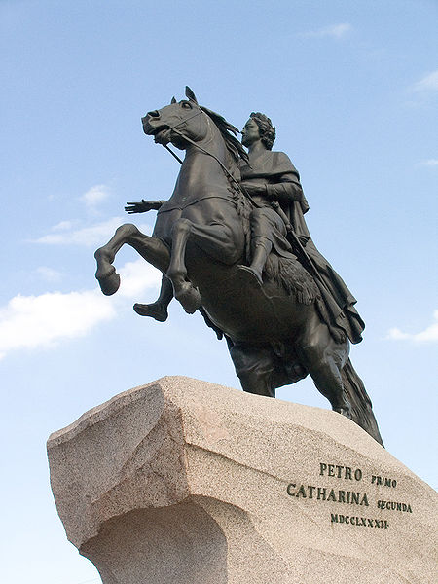
Bronze Horseman – Monument to Peter the First
Especially hard times for the Leningraders were the years of the Great Patriotic War of 1941 -1945 when for 29 long months the city was blockaded by the enemy.
The Nazi plan “Barbarossa” considered Leningrad one of the most important strategic objectives. The German secret directive No 1-a 1601/41 said quite definitely: “The Fuhrer has decided to wipe the city of Petrograd off the face of the earth…”In those days the people of Leningrad did not know about this inhuman directive but all of them understood that the life of the Soviet state was at stake.
On June 30, 1941 the people’s volunteer corps began to form in Leningrad. Over 300,000 applications to enlist in this corps were made. Ten divisions and 14 separate artillery machine-gun battalions were formed. In addition, 9,786 Leningraders were sent to carry out guerilla warfare.
Despite hunger, bombings and bombardments the people of Leningrad dug 626 km of antitank ditches, built 35 km of barricades, 635 km of wire entanglements, 15,000 pill-boxes, 22,000 weapon emplacements and many command and observation posts. The city was turned into a fortress which the enemy could not capture.
The General Committee of the Communist Party and the Soviet Government did their best to help the besieged city. Ammunition, arms fuel and food stuffs were brought to Leningrad along the famous Road of Life built on the ice of the Lake Ladoga.
Unprecedented sufferings were the lot of the besieged Leningraders. Since November the workers began to get 250 grams of bread on their food cards for a day, other people - 125 grams Starvation and cold were the order of the day. Almost 800,000 people died during those 900 days. The hardships of the blockade did not break the spirit of the Leningraders. They continued to defend the city. The workers of city repaired 2 thousand tanks, one-and-a-half thousand aircraft, thousands of sea and field guns, produced 225 thousand automatic weapons, 12 thousand mortars, more than 10 million projectiles and mines.
On January 12, 1943 the troops of the Leningrad and Volkhov Fronts broke through the ring of the blockade. A year later the blockade of the city was completely raised. Up to 50 Nazi divisions were destroyed in the battle around Leningrad.
For the mass heroism, courage and staunchness the City of Leningrad was awarded the title of Hero-City. All the defenders of the city, including the inhabitants, were decorated with the medal “For the defense of Leningrad.”
Today Leningrad – St Petersburg is one of the largest political, industrial, scientific and cultural centers of our country.
I’ve been to Leningrad twice. I think it is the most beautiful city in the world. I’ll always remember the exploit of its defenders.
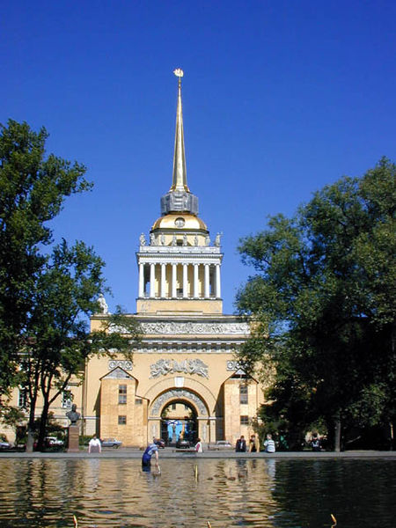
Admiralty – the symbol the city
http://en.wikipedia.org/wiki/Saint_Petersburg
Vakhmistrov V. V. English Textbook for Military Colleges. M., 1979
Belozyorova F. M. English Textbook “The Heroic Past of Our Country.” Kurgan, 1985.

MY HERO:
Musa Dzhalil
by Dorodnov Maxim from Kurgan

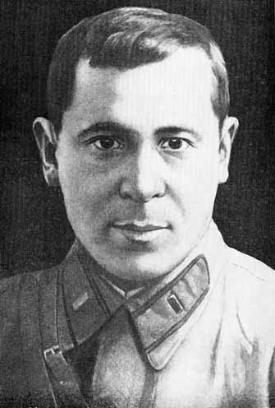

Musa Dzhalil, Musa Mustafovich Zalyalov, ( February 15, 1906 – August 25, 1944) was a Soviet Tatar poet and resistance fighter. He is the only poet of the Soviet Union who was simultaneously awarded two of the highest government decorations: Hero of the Soviet Union for personal courage and meritorious performance of duty, and the Lenin Prize for his cycle The Moabit Notebooks (both awarded posthumously).
Musa Dzhalil was born in Mustafino, a village in the Orenburg region in the family of a junkman. He graduated Xösäyeniä madrassah in Orenburg. His first publishing were revolutionary verses. In 1919 he entered underground Komsomol cell of Orenburg. Then Musa participated in the Russian Civil War. In 1920 Dzhalil returned to the native village, establishing pro-communist youth organization The Red Flower there. He also became an Komsomol activist in Mustafino.
In 1925-26 Dzhalil became an instructor of Orsk uyezd Komsomol cell, where he visited Tatar and Kazakh auls, agitating for Komsomol there. In 1926 he became the member of Orenburg Komsomol committee. In 1927 Musa moved to Moscow, where he combined his study in the Moscow State University and job in Tatar-Bashkir section of the Central Committee of Komsomol.
In 1929 Dzhalil joined Communist Party of the Soviet Union. The same year his second collection, “To the Comrade” was published. There were verses, full of optimism and admiration with the future trends. Living in Moscow, Dzhalil met Russian poets Zharov, Bezymensky, Svetlov, attended Vladimir Mayakovsky's performances.
In 1931 Dzhalil graduated Literature Faculty of Moscow University. Until 1932 he was a chief editor of the Tatar magazine for children. Then he headed the section of literature and art in the central Tatar newspaper Kommunist. In 1934 Musa Gälil published two collections. The first of them, The Millions, decorated with Orders was devoted mostly to youth and Komsomol, The mainstream lyric was full of optimism and spirits.
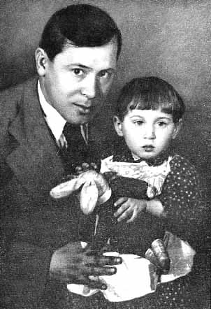
Musa Dzhalil with his daughter Chulpan
In 1935, the first Russian translations of his poems were published. His verses, set to music, became popular Tatar songs. In 1930s Dzhalil also translated to the Tatar language writings of poets of the USSR peoples, such as Shota Rustaveli, Taras Shevchenko, Pushkin, Nekrasov, Mayakovsky and Lebedev-Kumach. To this day Musa Cälil is regarded as one of the most significant authors in the Tatar language.

After Nazi Germany's invasion of the Soviet Union in June 1941, Dzhalil volunteered to the Red Army. Briefly graduating political officer courses, he arrived to the Volkhov Front and became a war correspondent in Otvaga newspaper.
In June 1942, Dzhalil's unit was encircled, when they tried to run a blockade he was seriously wounded, shell-shocked and captured. After months in concentration camps for Soviet prisoners-of-war, including Stalag-340 in Latvia and Shpandau, was Dzhalil transferred to Dęblin, a fortified stronghold in Poland. There Musa met his fellow countrymen, for the Nazis were assembling prisoners of Idel-Ural and Eastern nationalities in the camp. He sought out people he could trust in and together they subsequently formed a resistance group.
In late 1942, the Nazis started forming what they called national legions. Among others, the Idel-Ural legion was formed in Jedlina, Poland, of prisoners-of-war belonging to the nations of the Volga basin. Since the majority were Volga Tatars, the Germans usually called it the Volga-Tatar legion. The Nazis brainwashed the prisoners in a rabidly chauvinistic and anti-Soviet spirit, to prepare the legionnaires for action against the Soviet Army. He joined the Wehrmacht propaganda unit for the legion under the false name Gumeroff.
Dzhalil’s group set out to wreck the Nazi plans, to convince the men to use the weapons they would be supplied with against the Nazis themselves. The very first battalion of the Volga-Tatar legion that was sent to the Eastern front mutinied, shot all the German officers, and defected to the Soviet partisans in Belarus.

In August 1943, Nazi spies managed to track down the resistance group. Musa Dzhalil and most of his militant comrades were seized. There followed nightmare days and nights of interrogations, torture, and more torture. The Gestapo broke his left arm and injured his kidneys. His body was covered with welts from the beatings he got with an electric cord and rubber hose. His crushed fingers were swollen and would not bend. But the poet did not give up. Behind bars he continued his fight against Nazism. He had only his poetry for a weapon.
On August 10, 1943, he was arrested with his comrades and sent to Moabit Prison in Berlin. He sat in a cell with Belgian patriot and resistance fighter André Timmermans, and also with one Polish prisoner. Dzhalil studied German in prison to communicate with the cellmates. As the regime was not so harsh, he managed to compile at least hundred of all his verses, composed in the prison, to the small self-made notebooks. He and his group of 12 were sentenced to death on February 12, 1944 and guillotined at Plötzensee Prison, Berlin, on August 25. His body was never recovered, possibly buried in mass grave.
On April 23, 1945, the 79th Infantry Corps of the Soviet Army that was advancing on the Reichstag took up positions along the Berlin streers of Ratenowerstraße and Turnstraße. A soldier who paused there before the next attack noticed several lines in Russian on one of the clean pages of a book that was lying about: "I am the Tatar poet Musa Dzhalil, held in Moabit prison as a prisoner-of-war against whom political charges have been preferred, and will most likely be shot soon. If some Russian finds this note, convey my regards to my writer-friends in Moscow and break the news to my family". The soldiers sent the page to Moscow, to the Union of Writers. That was the first his country heard of the heroic fate of Musa Dzhalil.
Dzhalil’s first notebook was preserved by the Tatars Ğabbas Şäripov and then Niğmät Teregulov . Şäripov also was imprisoned in Moabit and received Dzhalil's and Abdulla Aliş's writings when the prison guards hide of bombing. To preserve the writings, Dzhalil's group fenced him off. The second one was preserved by the Belgian cellmate André Timmermans. Those notebooks were passed to the Tatar ASSR Union of Writers in 1946 and 1947 correspondingly. They were published as two books under the title Moabit Däftäre (The Moabit Notebook). Dzhalil’s widow Äminä Zalyalova gave the originals to the National Museum of Tatarstan for safekeeping.
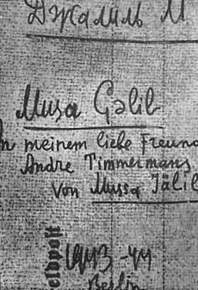
Moabite Notebook 1
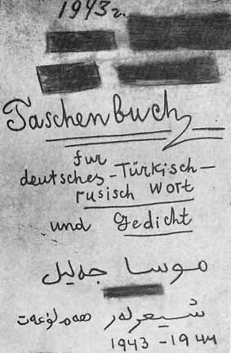
Moabite Notebook 2
Tatar writers and Tatarstan department of state security managed to prove Dzhalil’s underground work against the Nazis and his death. In 1953 The Moabit Notebooks were published in Kazan and the Russian translation also was published in Literaturnaya Gazeta owing to its editor Konstantin Simonov. Musa Dzhalil was awarded to the star of the Hero of the Soviet Union in 1956 and Literature Lenin Prize in 1957 for The Moabit Notebooks.
After that Musa Dzhalil gained recognition as the most heroic Tatar participant of the World War II, despite of being in Nazi prison and his formal participating in the collaborationist legion. The monument to Musa Dzhalil is placed near the Kazan Kremlin, the museum in his flat was opened in Kazan in 1983. His poetry was popularized all over the Soviet Union and the Warsaw Pact countries.
I love Dzhalil’s poetry. My favourite poem is “Barbarians.” I share the opionion of Azerbaijani poet Səməd Vurğun “The world and its literature know many poets who have made their names immortal, but there are few poets who have won immortality both by their unfading works and by the gallant sacrifice of their lives. They are: the great Byron, the renowned poet of the Hungarian people Sándor Petőfi, the heroic Julius Fučík and, finally, Musa Dzhalil.”
A minor planet 3082 Dzhalil discovered by Soviet astronomer Tamara Mikhailovna Smirnova in 1972 is named after him.

http://en.wikipedia.org/wiki/Musa_Galil

MY HERO:
Nikolai Gastello
by Dmitriev Alexander from Kurgan

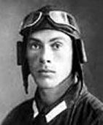

Nikolai Frantsevich Gastello (May 06, 1908 - June 26, 1941), Russian aviator, Hero of the Soviet Union. He is one of the best known Soviet war heroes, being the first Soviet pilot to conduct a "fire taran" - a suicide attack by an aircraft on a ground target.
Nikolay Gastello was born in Moscow on May 6, 1908. Some sources mistakenly claim that his father was German; however Franz Gastello was a Belarusian. He had recently moved to Moscow and changed his Belarusian last name Gastylo to an exotic-sounding Gastello.
Nikolay Gastello graduated from a Sokolniki high school in Moscow in 1918, and his family then moved to Bashkiria, escaping the horrors of the Russian Civil War. By 1923 Gastello was back in Moscow, where he worked at a factory as a fitter. In 1928 he became a member of the Сommunist party, and in 1932 by special decree he was sent to the Lugansk Pilot's School. Graduating in 1933 as a bomber pilot, Gastello initially flew the Tupolev TB-3 heavy bomber. Gastello fought against the Japanese in Battle of Halhin Gol in 1939, where he was awarded the Order of Lenin; then he saw the actions in the Winter War with Finland.
During the early days of the Great Patriotic War, the commander of a bomber squadron, Captain Nikolai Frantsevich Gastello, began to carry out combat missions. The aircraft of his squadron, under the 207th long-range bombardment regiment of the 3rd bomber air corps of long-range bombardment aviation, accomplished several combat missions
By the fifth day of the Great Patriotic War almost all Soviet aviation from the boundary to Smolensk had ceased to exist. To cover the Western Front, commanders threw everything which could contribute to stopping the Germans into battle. As a result, long-range aviation was directed to bomb tank column. This was not their usual mission, and they had not trained for it, hence there were heavy losses
By the 25th the 207th BAP (Bomber Aviation Regiment) of the 3rd DBAK (Long-Range Bomber Corps) was forced to launch small flights of unescorted DB-3s on low-level ground attack missions that these large lumbering aircraft were hardly suitable for. Having flown three conventional night-time bombing missions, Gastello was facing increasingly unfavorable odds. The day before his final sortie he returned to base with heavy battle damage, and his regular navigator heavily wounded.
The next day, the 26th of June, Gastello's regiment, the 207th flew multiple sorties targeting enemy transport columns along the Molodechno - Radoshkovichi highway. Bombers were launched in single pairs, without fighter escort, with about two hour intervals between pairs. The day's first sortie took off at 0830, led by Captain Maslov. Senior Lt Viskovsky's pair took off at 1000. Captain Gastello's zveno (flight) of DB-3F's took off at 1200. Gastello's wingman was Lt Vorobiev.

A total of four people were in Gastello's aircraft: Gastello himself, his navigator lieutenant Anatoly Burdenyuk, sergeant Aleksy Kalinin in the dorsal gunner turret, and lieutenant Grigory Skorobogaty in the ventral gunner position. Skorobogatov was the squadron adjutant, a staff officer, and gunner stations were usually manned by NCOs; however Skorobogatov decided to jump into Gastello's bomber at the last minute, for uncertain reasons.
The only surviving aircraft of Gastello's flight, Lt Vorobiev's bomber, returned to base sometime after 2 pm. The only known crewmen of the second bomber are lieutenant Vorobiev and his navigator lieutenant Rybas. They reported that after about an hour in the air, they located a large armored column on the highway near the village of Dekshany, and conducted a bombing run from 400 meters of altitude.

Having expended his bomb load, Gastello then flew a low-level pass, with his defensive gunners firing their 12.7mm (.50 cal) machine-guns at enemy vehicles. Gastello's plane received a direct hit in the fuel tank and caught fire. Initially set on a return course, his burning bomber then turned around, headed back to the transport column, and dove straight in, causing a "powerful explosion that shook the gaggle of enemy armored vehicles, and caused a burning storm that engulfed other enemy tanks"
To leave the falling machine from the low altitude is practically impossible. Parachutes also will not help. Even if by some means it will be possible to leave the burning machine and to satisfactorily go down by the parachute, then they will be immediately gripped by Germans. The pilot deliberately directed the doomed aircraft into a German Panzer column, performing the first "fire taran" of the Great Patriotic War.
The report of a large number of German tanks destroyed in the suicide attack apparently was deemed important enough to require independent proof. The next day regiment HQ ordered a reconnaissance flight to photograph the strike area. The photos it brought back reportedly showed a typical large crater, with multiple burned-out of German tanks surrounding it.
On July 25th, Gastello was posthumously awarded the Hero of the Soviet Union, one of the first Soviet soldiers to receive the title in World War II. The crew members of the plane -- Lieutenants A.A. Burdenyuk, G.N. Skorobogatyy and Senior Sergeant A.A. Kalinin -- were awarded with the Order of The Great Patriotic War 1st class. The crew of Lt. Vorobiev, were killed in action just a few days after Gastello.
For Russia, Gastello is a legendary name. The heroic deed of Gastello became well-known, commemorated in a song by Aram Ilyich Khachaturian "Captain Gastello", as well as the strategic bomber base named after Gastello. By the order of the Minister of Defense of the USSR the captain of N.F. Gastello is forever enrolled in the lists of one of the aviation regiments.
Monuments to him were established in Moscow, Minsk, into the Radoshkovichi Molodechnenskeyeo region of Minsk region, and in the territory of the Voroshilovgrad highest military air school of navigators. On the building of the Moscow school № 270, there was established memorial board. His name was applied to collective and state farms, factories, plants, streets, pioneer groups, mine № 30 in Kizel city the Perm region, and motor ships.
Nikolai Gastello was a true son of his country. The feat of his crew will never be forgotten.
http://en.wikipedia.org/wiki/Hero_of_the_Soviet_Union
http://en.wikipedia.org/wiki/Nikolai_Gastello
Nikolai Gastello from the Legends and Facts (in Russian)
Legends of WWII (in Russian)

MY HERO
Richard Sorge
by Makarov Alexander

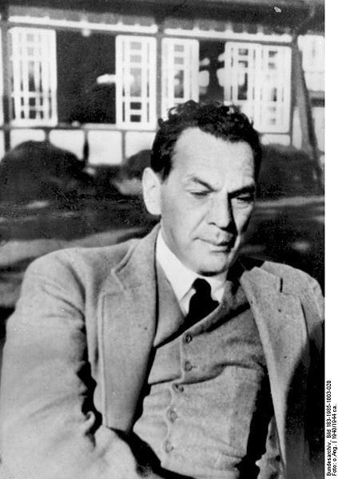

Richard Sorge (October 04, 1895 - November 07, 1944) was a spy who worked for the Soviet Union. He has gained great fame among espionage enthusiasts for his intelligence gathering during World War II. He worked as a journalist in both Germany and Japan, where he was imprisoned for spying and eventually hanged. His codename was "Ramsay". He is widely regarded as one of the best-known Soviet intelligence officers of the Second World War, according to Phillip Knightley, the author of The Second Oldest Profession (1986).
Sorge was born in the settlement of Sabunchi, suburb of Baku, Azerbaijan, which was part of Imperial Russia at the time. He was the youngest of the nine children of Wilhelm Richard Sorge a German mining engineer and his Russian wife Nina Semionovna Kobieleva. His father's lucrative contract with the Caucasian Oil Company having expired, Richard Sorge's family moved back to Germany.
In October 1914 Sorge volunteered to serve during World War I. He joined a student battalion of the 3rd Guards, Field Artillery. During his service in the Western Front he was severely wounded in March 1916 when shrapnel cut off three of his fingers and broke both his legs, causing a lifelong limp. He was promoted to corporal, received an Iron Cross and later medically discharged.
During his convalescence he read Marx and adopted communist ideology, mainly due to the influence of the father of a nurse with whom he had developed a relationship. He spent the rest of the war studying economics at the universities of Berlin, Kiel and Hamburg. Sorge received a Ph.D. in political science at the University of Hamburg in August 1919. He also joined the German Communist Party. His political views, however, got him fired from both a teaching job and coal mining work. He fled to Moscow where he became a junior agent for Comintern.
Sorge was recruited as a spy for the Soviet Union and using the cover of being a journalist he was sent to various European countries to assess the possibility of communist uprisings taking place.
In 1924, he moved to Moscow where he officially joined the International Liaison Department of the Comintern, also an OGPU intelligence gathering body. In 1929, Sorge became part of the Red Army's Fourth Department (the GRU, or military intelligence). He remained with the Department for the rest of his life.
In 1929 Sorge arrived in England in order to study the labor movements then prevalent in the region, the status of the Communist Party in England, and the country's political and economic conditions. He was instructed to remain undercover and not to become involved in politics while living in England.
In November 1929 Sorge returned to Germany where he was instructed to join the Nazi Party and not to associate with left-wing activists. To help develop a cover for his spying activities he obtained a post working for the agricultural newspaper, Deutsche Getreide-Zeitung.
In 1930, Sorge moved to Shanghai (China), to gather intelligence. Officially, he worked as the editor of a German news service and for the Frankfurter Zeitung. As a journalist, Sorge established himself as an expert on Chinese agriculture. This gave him the freedom to travel around the country making contacts with members of the Chinese Communist Party. In January 1932, Sorge reported on fighting between Chinese and Japanese troops in the streets of Shanghai. In December he was recalled to Moscow.
In May 1933, the Soviet Union decided to have Sorge organize a spy network in Japan. At the time, collecting intelligence from inside Germany was more dangerous and difficult.
As a cover, he was sent to Berlin with the code name "Ramsay", to renew contacts in Germany so he could pass as a German journalist in Japan. In Berlin, he insinuated himself into Nazi ranks, read a great deal of Nazi propaganda, devoted particular attention to Hitler's Mein Kampf. While in Germany, he was able to get commissions from two newspapers, the Borsen Zeitung and the Tagliche Rundschau. He also got support from the Nazi theoretical journal, Geopolitik. Later he was to get work from the Frankfurter Zeitung.
Sorge arrived in Yokohama on September 6, 1933. He was warned by his spymaster not to have contact with the underground Japanese Communist Party or with the Soviet Embassy in Tokyo. In 1933-1934 Sorge built a network to collect intelligence for the GRU in Japan. His agents had contacts with senior politicians and through that, to information of Japan's foreign policy.
Officially, Sorge joined the Nazi party and became a German journalist in Tokyo. In Tokyo, he came to work closely with the German embassy and Ambassador Eugen Ott. He used the embassy for double-checking his information, having access to telegrams in Ott's office.
Sorge supplied the Soviet Red Army with information about the Anti-Comintern Pact, the German-Japanese Pact and warned of the Pearl Harbor attack. In 1941, Sorge is said to have informed them of the exact launch date of Operation Barbarossa. Moscow answered with thanks but Stalin largely ignored it.
Toward the end of September 1941, Sorge transmitted information that Japan was not going to attack the Soviet Union in the East. This information made possible the transfer of Soviet divisions from the Far East, although the presence of the Kwantung Army in Manchuria necessitated the Soviet Union's keeping a large number of troops on the eastern borders.
This information allowed the release of Siberian divisions for the Battle of Moscow, where the German army suffered its first strategic defeat in the war. Sorge's information might have been the most important spy work in World War Two.
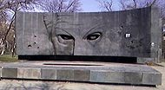
The monument to Richard Sorge
The second most important piece of information he allegedly passed along concerned the Battle of Stalingrad - the turning point in the war which is considered one of the bloodiest and largest battles in history. Richard Sorge alerted Moscow that Japan would attack the Soviet Union from the East as soon as the German army captured any city on the Volga, thus effectively disrupting oil supplies from Baku and also ammunition and food supplies sent by the allies from the Persian Gulf through Iran, Soviet Azerbaijan and up the Volga River.
As the war progressed, it was becoming increasingly dangerous for Sorge to continue his spying work. Nevertheless, in view of the critical juncture of the war, he continued spying. However, due to the increasing volume of radio traffic from one-time pads (used by the Soviets), the Japanese began to suspect a spy ring operating. The Japanese secret service had already intercepted many of his messages and begun to close in.
Sorge was arrested on October 18, 1941 in Tokyo. German ambassador Eugen Ott heard of Sorge's arrest on 19 October, the next day, a brief memo notifying him that Sorge had been arrested "on suspicion of espionage" together with another German, Max Clausen. Ott was both surprised and outraged, and assumed it was a case of "Japanese espionage hysteria". He thought that Sorge had been discovered passing secret information on the Japan-US negotiations to the German embassy, and also that the arrest could be due to anti-German elements in the Japanese government. It was not until a few months later that Japanese authorities announced that Sorge had in fact been indicted as a Soviet spy.
Initially, the Japanese believed that, due to his Nazi party membership and German ties, Sorge was an Abwehr agent. However, the Abwehr denied that he was one of their agents. Even under torture, he denied all ties with the Soviets. The Japanese made three overtures to the Soviets, offering to trade Sorge for one of their own spies. However, the Soviets declined all the offers, maintaining that Sorge was unknown to them. He was incarcerated in Sugamo Prison.
Richard Sorge was hanged on November 7, 1944, 10:20 a.m. Tokyo time in Sugamo Prison. The Soviet Union did not officially acknowledge Sorge until 1964.
Sorge was survived by his mother, then living in Germany. He was buried in the Sugamo Prison (Zhogaya) graveyard, but his remains were later relocated to Tama Cemetery in Fuchū, Tokyo. His lover Hanako Ishii continued to visit his grave until her death in 2000.
In 1961 a movie called Who Are You, Mr. Sorge? was produced in France in collaboration with West Germany, Italy and Japan. This movie was very popular in the Soviet Union as well. In the movie, Sorge was played by Thomas Holtzmann. In 1964 Soviet premier Nikita Khrushchev saw the film and asked the KGB whether the story was true. When it was confirmed that it was indeed true, Khrushchev posthumously awarded Sorge with the title of Hero of the Soviet Union on 5 November 1964.
A Moscow street was named after him, and his face was even put on postage stamps. Books and articles were published about his career. Two decades after his death, he was finally recognized as the brilliant spy he undoubtedly was.
In addition his widow Hanako Ishii received a Soviet pension. She eventually died in July 2000 in Tokyo.

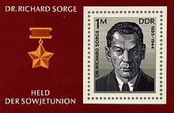

I think Richard Sorge was a true son of two countries Russia and Germany, an exceptionally gifted professional, a staunch fighter against fascism.

http://en.wikipedia.org/wiki/Richard_Sorge
Paul Dowswell and Fergus Fleming. True Spy Stories. M.,2006

MY HERO:
Victor Talalikhin
by Titov Maxim from Kurgan

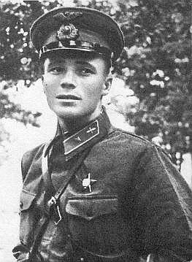

Viktor Vasilievich Talalikhin (1918-1941) was a Soviet lieutenant during World War II and a Hero of the Soviet Union.
Viktor Talalikhin was commissioned as a 2nd Lieutenant in 1938, became a fighter pilot. He participated in Soviet-Finnish War (1939-1940) .

During the Great Patriotic War (WWII), he was first a wing commander, then a deputy squadron commander. On August 7, 1941 he was the first pilot who used a night-time aerial ram against a Nazi bomber. In subsequent battles, he shot down 5 enemy planes. He was killed in an aerial dog-fight.
August 1941. Victor Talalikhin, the pilot of a combat plane, looked at the sky and said: “ What a wonderful moon there is over Moscow tonight! Just the night for a walk with a girl…”
Suddenly alarm was given. In a minute Victor Talalikhin was in his plane ready to carry out his combat mission.The next minute he was in the air. Victor’s orders were to destroy enemy bombers flying to Moscow. Now the only thought in his mind was to find the enemy planes in the air and prevent them from reaching Moscow.
Talalikhin noticed Nazi plane at a great distance. It was a very big bomber and it flew heavily through the air. The distance between the two planes became shorter and shorter with every minute. Now Talalikhin saw clearly the black swastika on the Nazi bomber.
Realizing the danger, the Nazi pilot tried to hide in the clouds.
“No, you won’t get away and you will not get to Moscow this time!” Talalikhin shouted and opened fire.
The bullets hit the bomber and smoke appeared from the right motor of the Nazi plane. The bomber did not answer Victor’ fire but increased his speed trying to get away. The air combat continued. Victor changed the position of the plane many times in order to attack the bomber from a short distance. But the bomber pilot sent his plane from side to side trying to escape from bullets and changed his course and altitude.
Talalikhin attacked the bomber six times. And every time the pilot of the bomber skillfully changed the position of his plane. It was clear that he was very experienced.
Talalikhin attacked the bomber for the seventh time. The distance between the planes was not more than ten meters. He pressed the trigger but no fire followed - the plane had no ammunition.
This was too bad. To let the enemy get away when he was at the distance of only ten meters… No, that must not happen! Victor was thinking of what to do. Suddenly the bomber opened fire again and Victor was wounded in the right arm.
Paying no attention to the pain in his right arm victor directed his plane straight to the enemy bomber.
There was a terrible crash, and the Nazi bomber went down to the ground leaving a cloud of smoke.
Talalikhin’s plane was also badly damaged and Victor had to leave it and jump with a parachute. He landed successfully on field. His combat friend arrived later and took him home.
It turned down later that he had destroyed a very skilful and experienced Nazi pilot, a lieutenant-colonel. The enemy pilot had many decorations which he had received for bombing Poland in 1939 and Paris and Norway in 1940. And it was not his first mission against the Soviet Union.
Victor Talalikhin was posthumously awarded the honorary title of Hero of the Soviet Union in 1941.

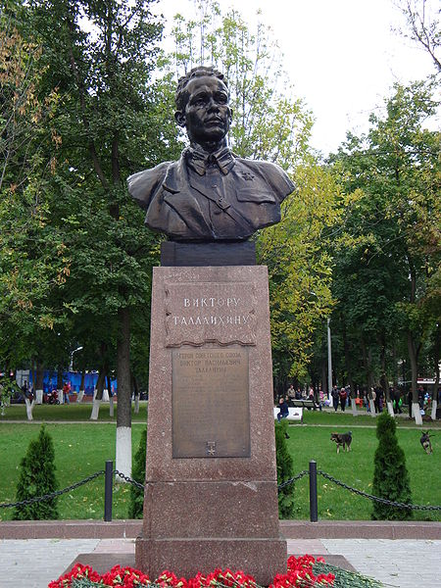

Victor Talalikhin will always be in our hearts, in the annals of the Russian combat glory. He deliberately sacrificed his life for the lofty aim of routing the enemy.

http://en.wikipedia.org/wiki/Viktor_Talalikhin
Heroes of the Soviet Union. Brief biographical dictionary. M., 1988
Rumyantsev N. M. People of legendary exploit. Saratov, 1968
Kononenko E. Ram Them. Tales about Daring Soviet Airmen

MY HERO:
Young Guard - a World War II resistance organization
by Kulshmanov Kairbek from Kurgan

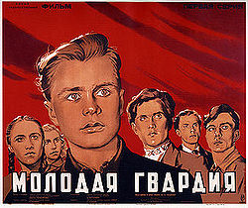

The Young Guard was an underground anti-fascist Komsomol (Young Communist League) organization, in the Nazi-occupied Soviet city of Krasnodon (Ukrainian SSR, now Luhansk Oblast of Ukraine). They were active during the Great Patriotic War until January 1943. They carried out several acts of sabotage and protest before being betrayed to the Nazis. Most members of the Young Guard, about 80 people, were tortured and then executed by the Germans.
The Young Guard was established soon after Krasnodon was occupied by Nazi Germany on July 20, 1942. Several youth groups amalgamated, calling themselves the Young Guard. One of the first meetings of the organization was held on October 2 of the same year. The first leaflet issued by the Young Guard members read: “Fellow- citizens! Don’t believe the Nazi propaganda. They’ve brought misfortune to our town. They wish to intimidate us and to bring us to our knees. But we shall prefer death to slavery. Truth will win. Destroy the invaders!”
The organization was led by the local Communist Party underground of Krasnodon, headed by Philipp Lyutikov. Lyutikov was the former head of the parents' committee of the 4th secondary school of Krasnodon, where many members of the organization had studied.
There were about 100 members of the Young Guard, all young boys and girls - workers, 8th-10th form schoolboys and schoolgirls from Krasnodon and surrounding villages and settlements. Due to the secret nature of the Young Guard, only people well-known to other organization members, and who took the special oath of faithfulness, could become members. The most active members and founders of the organization made up the Staff of the Young Guard: Ulyana Gromova, Oleg Koshevoy, Vasily Levashov, Lyubov Shevtsova, Viktor Tretyakevich, Ivan Turkenich, Sergei Tyulenin, and Ivan Zemnukhov.

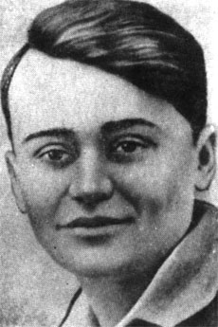
Oleg Koshevoy
Among the main activities of the organization were:
the release of 70 prisoners from the Nazi concentration camp on November 15, 1942 (20 more people were released from the hospital of the camp);
the burning of the Nazi Labour Exchange of Krasnodon on December 6, 1942. A list of about 2,000 citizens of Krasnodon, who were intended for the deportation into the Nazi Germany, was burnt, thus saving them from deportation;
eight Flags of the Soviet Union were hung out on highest buildings of Krasnodon on November 6 and November 7, 1942 to commemorate the 25th anniversary of the Great October Socialist Revolution;
about 5,000 anti-fascist leaflets were issued and spread in Krasnodon during the existence of the organization.
Members of the organization also destroyed motor vehicles, ammunition and enemy fuel supplies. Jointly with the Communist Party underground of Krasnodon the Young Guard prepared for an anti-fascist armed rebellion, but a treachery within the organization and the betrayal of the organization to the Nazis stopped these preparations.
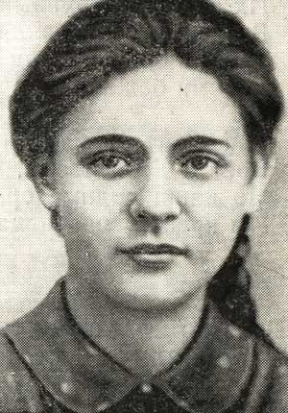
Ulyana Gromova
The Nazis knew about the existence of the underground and tried to discover its membership. Finally they succeeded in this, helped by treachery within the organization. Massive arrests began on January 5 and lasted until January 11, 1943. Just 11 members managed to evade their pursuers. All the arrested people were tortured. None of them was subdued. This infuriated the Nazis. They took 71 prisoners out of town and threw them down into the pit of Coal Mine Number 5 (53 meters in depth). Then they pushed two mine cars after them. The sound of the victims’ moans reched the inhabitants for some days. Such was the end of Ulyana Grromova, Ivan Zemnukhov, Liza Androsova and other boys and girls. Among them were Communists Lutikov, N. Barakov, G. Vinokurov and D. Vystavkin. Oleg Koshevoy, Lyubov Shevtsova, Viktor Subbotin, Dmitry Ogurtsov, Sergei Ostapenkov were shot on February 9, 1943 in the town park of the town Rovenki. Just five days later, on February 14, 1943 Krasnodon was liberated by the Red Army.
On September 13, 1943 five members of the Young Guard: Ulyana Gromova, Oleg Koshevoy, Lyubov Shevtsova, Sergei Tyulenin and Ivan Zemnukhov were awarded the title Hero of the Soviet Union posthumously; many other members were awarded various orders and medals.
Soviet writer Alexander Fadeyev wrote the book Molodaya Gvardiya (The Young Guard), in which he depicted the activities of the Young Guard.
In Krasnodon the Monument to the Members of the Young Guard was erected in 1951-1954, the memorial complex Young Guard with the museum was built in 1970 and the monument Nepokoryonnye (Unsubdued in English) was erected near the Coal Mine Number 5 in 1982. The new town Molodogvardeysk in Luhansk Oblast of the Ukrainian SSR was named after the Young Guard in 1961. Many towns, settlements, streets of Soviet cities were also named after the organization and its members.
The Krasnodon boys and girls were under twenty. They were bubbling with life, were fond of poetry and thirsty for knowledge. They were full of romanticism and dreamed of performing great deeds for the sake of their Motherland. They were imbued with patriotic feelings and at the moment of mortal danger to their country they unhesitatingly joined the ranks of the defenders.
The boys and girls of the Young Guard lived a short life. But they became immortal after their death.

http://en.wikipedia.org/wiki/Young_Guard_(Soviet_Resistance)
Silina O. Young Guard’s immortal feat. Soviet Military Review, 1983
Fadeev A. Young Guard. M,1965
MY HERO
Zoya Kosmodemyanskaya
by Lukyanov Artyom from Kurgan

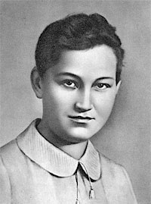

Zoya Anatolyevna Kosmodemyanskaya (September 13, 1923 – November 29, 1941) was a Soviet guerilla and a Hero of the Soviet Union (awarded posthumously) She is one of the most revered martyrs of the Soviet Union.
Zoya (her name is a Russian form of the Greek name Zoe, which means "life") was born in 1923 in the village of Osino-Guy (meaning Aspen Woods), not far from the city of Tambov. Her father, Anatoly Kosmodemyansky, studied in a theological seminary, but did not graduate. He later worked as a librarian. Her mother, Lyubov Kosmodemyanskaya, was a school teacher.
In 1925 Zoya's brother Alexander was born. Like his sister, he was destined to become a Hero of the Soviet Union, and, like Zoya, posthumously. In 1930 the family moved to Moscow.
Zoya's favorite subject in school was literature. Her teachers noted her essays for deep understanding of the subject and for imagery. She read far beyond the curriculum. The list of authors she read includes Tolstoy, Pushkin, Lermontov, Karamzin, Zhukovsky, Byron, Molière, Cervantes, Dickens, Goethe, and Shakespeare.
Zoya kept a notebook where she recorded her thoughts about the books she read. Such as this "In Shakespeare's tragedies the death of a hero is always accompanied by a triumph of a high moral cause." She liked Beethoven's Egmont and often sang Klärchen's song "Die Trommel gerühret." Her favorite music was Tchaikovsky's Symphony No. 5.
Her striving for high ideals led to misunderstandings with her classmates. On the eve of 1939 the girls wrote each other notes with New Year wishes. Zoya received the following note "Zoya, don't judge people so strict. Don't take everything so close to heart. Know that most people are egoist, flatterers, are insincere and you can't depend on them. You should leave their words without attention. Such is my New Year wish." After reading the note Zoya said "If one thinks of people like that, then what has one to live for?"
Kosmodemyanskaya joined the Komsomol in 1938. In October 1941, still a high school student in Moscow, she volunteered for a guerilla unit. To her mother, who tried to talk her from doing this, she answered "What can I do when the enemy is so close? If they came here I would not be able to continue living."
Zoya was assigned to the guerilla unit 9903 (Staff of the Western Front). Of the one thousand people who joined the unit in October 1941 only half survived the war. At the village of Obukhovo near Naro-Fominsk, Kosmodemyanskaya and other guerillas crossed the front line and entered the territory occupied by the Germans. They mined roads and cut communication lines. The guerilla detachment was very fond of Zoya. She endured bravely all the hardships adversities of this dangerous life. She was given the pseudonym “Tanya.”
On November 27, 1941 Zoya received an assignment to burn the village of Petrischevo, where a German cavalry regiment was stationed.
In Petrischevo Zoya managed to set fire to horse stables and a couple of houses in which the Nazis were quartered. However, one Russian collaborationist had noticed her and informed his masters The Germans caught Zoya as she started to torch another house. She was tortured and interrogated throughout the night but refused to give any information.
In the morning Zoya was led out to be executed. She was brought to the square in the centre of the village and the local people were forced to watch the execution. Her final words were "Comrades! Why are you so gloomy? I am not afraid to die! I am happy to die for my people!" and to her tormentors, "You'll hang me now, but I am not alone. There are two hundred million of us. You can't hang us all. No matter will you do victory will be ours."
The Germans left Zoya's body hanging on the gallows for several weeks and mutilated her body several times with bayonets and by cutting off her left breast. Eventually she was buried just before the Soviet liberation in January 1942. In February, she was identified and was immediately awarded the order of Hero of the Soviet Union.
Many streets, collective farms and Pioneer organizations in the Soviet Union bore the name of Zoya Kosmodemyanskaya. Soviet poets, writers, artists and sculptors dedicated their works to Kosmodemyanskaya. In 1944, the film Zoya was made about her.
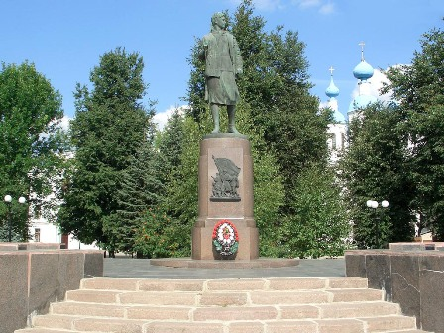
The Soviet sculptors O.A.Ikonnikov and V.A.Feodorov erected a monument in her honour.

Another statue is located at the Partizanskaya Moscow Underground station.

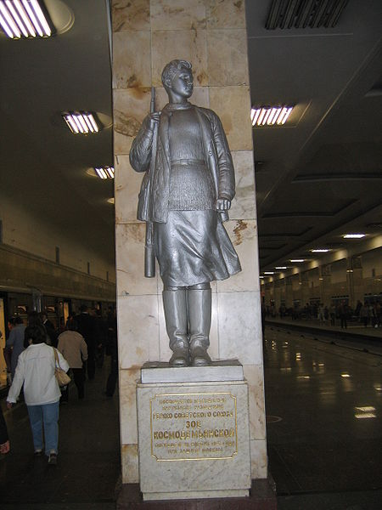
A 4108-meter (13,478 feet) mountain peak in Trans-Ili Alatau is named after her. A minor planet 1793 Zoya discovered in 1968 by Soviet astronomer Tamara Mikhailovna Smirnova is named after her. Zoya Kosmodemyanskaya is buried at Novodevichy Cemetery in Moscow.
Zoya Kosmodemyanskaya's brother Alexander (1925 - April 13, 1945), a Senior Lieutenant, died in combat in Germany and was posthumously awarded Hero of the Soviet Union in 1945.
We should never forget Zoya and Alexander Kosmodemyansky who gave their lives for our Motherland.
http://en.wikipedia.org/wiki/Zoya_Kosmodemyanskaya
Golubeva T., Gellerstein L. Early Russia – the USSR. M., 1976
Alexeyev S. Russian History in Tales. M., 1982
MY HERO:
Dmitry Karbyshev
by Derzhavin Roman from Kurgan
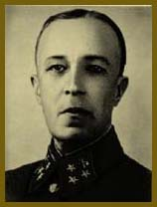
Dmitry Mikhaylovich Karbyshev ( October 26, 1880, Omsk — February 18, 1945, Mauthausen, Austria) was a Red Army general and Hero of the Soviet Union (posthumously).
Karbyshev was taken prisoner in the Second World War. He was tortured by the Nazis, who poured cold water on him and left him to expire in the frost. He died on February 17, 1945 in the concentration camp at Mauthausen.
Before the war, in November 1940, the Gestapo entered the name of General Dmitry Karbyshev into its secret files. A prominent designer, Karbyshev took part in the reconstruction of many fortifications on Russia’s western border. According to German intelligence, he was an authority in building all Soviet strongholds.
Dmitry Karbyshev was born in the Siberian city of Omsk into the family of a serviceman. He graduated with honors from the cadet school and the military engineering college. For his combat achievements in the Russian – Japanese War the young lieutenant was awarded five orders and two combat medals. In 1906 he was suspected of antigovernment agitation and was put in the reserves.
A year later he returned to active military service to a sapper regiment, and he continued his education. Thirst for knowledge brought the young officer to the Military Engineering Academy. After graduation of it he took part in building the Brest Fortress fortifications.
When the First World War (1914 -1918) began, Captain Karbyshev was sent to the front. There he proved a talented and daring engineer. He was decorated for service in battle and promoted to the rank of lieutenant – colonel.
Lieutenant – Colonel Dmitry Karbyshev accepted the October Socialist Revolution. He was placed at the head of fortification work and the technical equipment of positions of different fronts. For special services he was awarded a gold watch with the inscription “To a Red Fighter of the Socialist Revolution, from the All – Russia Central Executive Committee.”
e Civil War ended and peaceful years set in. Karbyshev, already at that time a well - known theoretician and practician in the field of military engineering, held responsible posts in the central apparatus of the country’s Armed Forces.
He also gave much of his time to inventing. In the thirties the Red Army was armed with the “Karbyshev snares,” a name given to the hardly visible obstacles (HVO). They were made of thin steel wire and were light in weight and compact. The HVO were used against infantry, baby tanks and light tanks of the period.
From September 1923 Karbyshev taught at the Military Academic Courses, the Military Academy of the Red Army, the Military Air Force Academy and the Frunze Military Academy.
The students were very fond of Karbyshev. He used to express his thoughts clearly and effectively held the attention of the audience. In January Karbyshev was awarded a gold watch for his fruitful scientific and pedagogical work. In July 1936 he was appointed assistant head of the Academy of the General Staff’s department of tactics of the higher engineer troops formation.
In the twenties and thirties Karbyshev engaged a great deal in scientific work. He wrote more than a hundred books, text-books, articles. He was the first scientist to study and fully develops problems in the use of demolition and artificial obstacles in modern warfare. . He gave a deep analysis of the interrelation of fortification with armaments in the armed forces.
For enormous fruitful scientific work Karbishev was awarded the title of professor and the degree of Doctor of Military Science. He was also awarded the Order of the Red Banner and promoted to the rank of lieutenant – general of the engineer troops.
Although Karbyshev was very busy he was a wonderful family man. According to his daughter Elena there was none of the pedantry of a scientist about Karbyshev’ s behavior at home. You could burst at his study at any time of the day to tell him your troubles or joys.
He was an unusually modest and cheerful man. He loved people very much, could see well in them and there was hardly a person about whom he said an unfriendly word.
Right before the war, in June 1941, Lieutenant General with the Army Engineers, Dmitry Karbyshev went on a business trip to the western border to inspect fortifications and determine the extent to which they could be used in wartime. He was in Grodno, Byelorussia, when the war broke out. In the morning on June 23rd the command insisted that Karbyshev should come back immediately.
He arrived at the headquarters the next day saying that the route for an organized retreat of Russian troops had been cut off by the enemy. Karbyshev and a small group of officers had to break out of the encirclement.
A month later during the withdrawal Karbishev was wounded and shell-shocked. He was unconscious when the Nazis took him prisoner as he was crossing the Berezina River. He was put in one concentration camp after another – Hammelburg, Flossenburg, Oswencim, Sachenhausen…Three and a half years of torture, hunger, forced labor, illness.
The Germans spared no effort to force Dmitry Karbyshev to betray his country and cooperate. For the Nazis Karbyshev was a gifted engineer who knew the secrets of Soviet strongholds. He was brought to Berlin and offered freedom, prosperity and the opportunity to do scientific research, naturally, for the good of Germany. They spent a lot of time trying to win him over, but in vain. His refusal was point-blank. “My convictions do not fall out with my teeth,” he would say.
For a person like Dmitry Karbyshev treason was worse than death. His determination and courage served an example to other prisoners strengthening their morale. Karbyshev’s motto – “not to lose honor even in the sorriest of plights” became the rule for many people.
Becoming convinced that Karbyshev could not be subdued the SS men reported to Berlin: “This prominent fortifications expert, regular officer of the old Russian army and man of over sixty, proves infected through and through with the Bolshevik spirit and fanatically devoted to the idea of loyalty to his military duty and patriotism…Karbyshev may be considered hopeless in the sense of use as a military engineering specialist.”
Seeing the unyielding determination of the general, the Nazis dropped their courteous attitude, deprived him of the status of a prisoner of war and sent him to the Flossenburg hard labor camp. The general worked in the quarries 14 hours a day subjected to humiliations by the overseers. Worn out by the camp regime, Karbishev often fell ill, but was firm and inflexible in spirit.
An uncompromising patriot of his country, General Karbyshev boosted the spirits of his fellow prisoners informing them about the situation on the fronts, helping them to understand the developments and inspiring in them belief in the victory of the Red Army.
D.M. Karbishev was in Nazi captivity for three and a half years.He did not bow his head to the enemy. In the Mauthausen concentration camp the Nazi tortured him to death, as they did many other prisoners, by pouring water on him in the frost.
Valentin Sakharov, head of the anti-Nazi underground movement of Soviet prisoners at Mauthausen, related: “One night, after being given a hot shower, General Karbyshev was taken outside. The temperature was - 12 C. He was sprayed with icy water. Karbyshev slowly become covered with ice.”
The Canadian officer Sedon de Saint-Clair, one of the few eyewitnesses of Dmitry Karbyshev’s death, related: “General Karbishev’s patriotism was not a passive one. He not only knew how to die courageously, he knew how to live courageously. And this was much more difficult considering the situation we were in. An elderly man he did more agitation work among the prisoners than ten young men could hardly have handed.
We went by Karbyshev’s not by Nazis’ reports on the situation on the fronts. We viewed at the military events through the eyes of your general, and these were fine, very truthful eyes. They helped us look to the future and to get a clear picture of the events. And what was very important for me and many people like me, they helped me understand your great country and its magnificent people.
The Soviet Union can be proud of such people, all the more so since, by all indications, there are many Karbyshevs in this amazing country.”
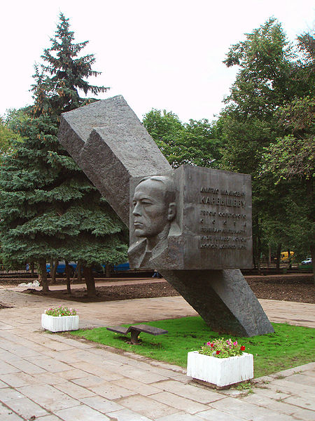
For the extraordinary staunchness and courage he showed in the fight against the Nazi invaders during the Great Patriotic War, Dmitry Karbyshev was posthumously awarded the title of Hero of the Soviet Union.
A minor planet 1959 Karbyshev discovered in 1972 by Soviet astronomer Lyudmila Zhuravlyova is named after him.
There are streets in the former Soviet Union named after Karbyshev. In Omsk, Tallin, Brest and other cities people place flowers at the foot of the monuments to General Karbyshev.
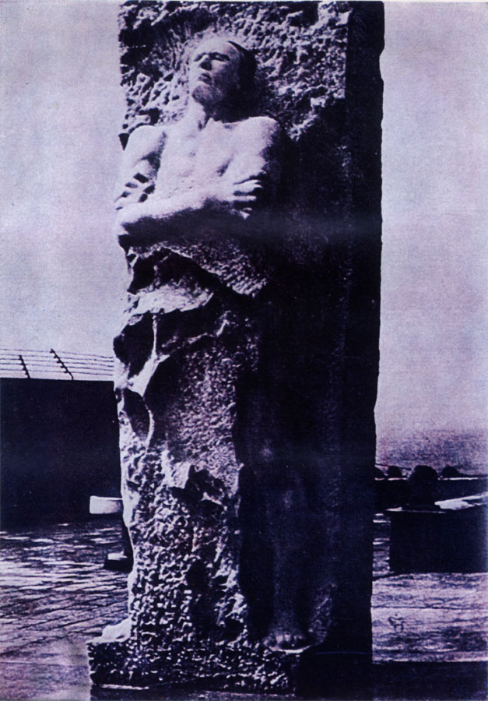
In the Alps, in the small town of Mauthausen, there stands before the iron gates of a former Nazi concentration camp – now a museum – a monument of snow white, almost transparent, marble. The figure of a man seems to grow out of a block of ice. Hewn on a granite slab in two languages, German and Russian are the words: “Dmitry Karbishev. Scientist. Soldier. Communist. His life and death were feats for the sake of life.”
http://en.wikipedia.org/wiki/Hero_of_the_Soviet_Union
http://www.smi.ru/05/03/22/3400292.h+html
Mikhailov V. A True Son of His People. Soviet Military Review. M, 1980
MY HERO:
Georgy Zhukov
by Kozlov Yevgeny from Kurgan

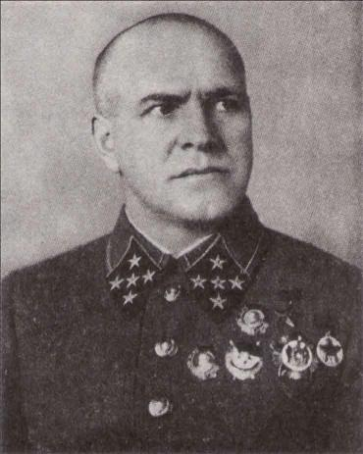

Marshal of the Soviet Union Georgy Konstantinovich Zhukov (December 1, 1896 – June 18, 1974) was a Russian career officer in the Red Army who, in the course of World War II, played a pivotal role in leading the Red Army through much of Eastern Europe to liberate the Soviet Union and other nations from the Axis Powers' occupation and conquer Germany's capital, Berlin. He is the most decorated general in the history of both Russia and the Soviet Union.

Georgy Zhukov was born to the family of a poor peasant in the Kaluga region. He set out his military career in1915. 1915 was conscripted into the army of the Russian Empire. During World War I, Zhukov was awarded the Cross of St. George twice and promoted to the rank of non-commissioned officer for his bravery in battle. He was much respected by his fellows for his gallantry, integrity and sense of justice.

Zhukov joined the Bolshevik Party after the October Revolution. In August 1918 he joined the Red Army’s 4th Cavalry Regiment. By 1923 Zhukov was commander of a regiment, and in 1930 of a brigade. He was a keen proponent of the new theory of armored warfare and was noted for his detailed planning, tough discipline and strictness, and a "never give up" attitude.

In the summer of 1939 the Japanese provoked a conflict on the border of Mongolia, a USSR ally, and invaded that country by the Khalkin Gol River. Zhukov was sent there in charge of the 1st Soviet Army Group which with the Mongolian People’s Revolutionary Army fought the Japanese 6th Army.

Zhukov’s command qualities shone through. He was the first in the world to use his tanks to hit at the enemy flanks, surround and destroy them. This brought him his first Gold Star as a Hero of the Soviet Union from the Government. In June 1940 he was made a General of the Army.

Zhukov’s military talent was displayed to the full during the Great Patriotic War. He was sent to the most important sectors of the front. In September 1941 Zhukov was appointed Commander of the Leningrad Front. In a short time he managed to organize precise troop control and stable defenses which frustrated all the enemy attempts to capture Leningrad.

In the course of the battle of Moscow, when the Nazi troops approached the capital, Zhukov was appointed Commander of the Western Front. At this post he also showed a firm will and high skill in controlling large masses of forces.
In 1942 and 1943 Zhukov coordinated the actions of the fronts at Stalingrad and Leningrad, and during the battles of Kursk and for the Dnieper. He was made Marshal of the Soviet Union for the victory at Stalingrad and blockade-break at Leningrad.

Before the battle of Kursk, Zhukov spent days and nights reconnoitering. Hr examined the terrain and enemy behavior down to the last detail. He interrogated dozens of prisoners, and analyzed the intelligence reports and captured documents. The conclusion he made was that the Germans had chosen precisely the Kursk Bulge for the decisive offensive of 1943. The next conclusion was that the Soviet forces should not launch into an offensive, but dig in and wait for the enemy, knock out his tanks, and throw everything on him.
The battle of Kursk was a brilliant victory. The enemy was utterly defeated.

From November 1944 to the end of the War Zhukov was in charge of the1st Byelorussian Front. Together with the 1st Ukrainian Front it undertook the crucial Oder-Vistula Operation. That operation saw Zhukov mass his forces in the main directions. He resolved to deliver three main blows – two from a beachhead on the west bank of the Vistula, the third north of Warsaw. This concentration of forces assured a quick breakthrough, a maximum of damage to the enemy, and a good momentum to the Soviet advance.

April – May 1945 Zhukov’s 1st Byelorussian Front alongside with the 1st Ukrainian 2nd Byelorussian under Marshal Ivan Konev and Konstantin Rokossovsky, undertook the culminating Berlin Operation. In just about three weeks, a million Germans massed in a multi-stage defense were torn asunder.

On May 8, 1945 Marshal of the Soviet Union Zhukov on behalf of the Soviet Supreme Command accepted with the representatives of the Allied Commands the capitulation of the armed forces of the Nazi Germany.
I think Marshal Zhukov as an exceptional military leader. He had been described by Marshal Rokossovsky as a man in whom “everything was truly extraordinary – his talent, energy and confidence in his strengths”.

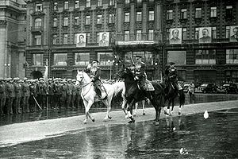
Marshal Zhukov commands Victory Parade in 1945

http://en.wikipedia.org/wiki/Georgy_Zhukov
Vakhmistrov V. V. English Textbook for Military Colleges. M.,1979

MY HERO:
Matvey Kuzmin
by Ivanov Roman from Kurgan

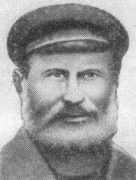

Matvey Kuzmich Kuzmin (03 August 1858–14 February 1942) was a Russian peasant-patriot who was killed in World War II. He was posthumously named a Hero of the Soviet Union on May 8, 1965, becoming the oldest person named a Hero of the Soviet Union.

Kuzmin was born in 1858 in the village of Kurakino, in the Velikoluksky District (then Uezd) of Pskov Oblast. He was a self-employed farmer who refused to join a collective farm, while continuing to hunt and fish on the territory of the collective farm "Rassvet" ('Dawn'). He was considered a "counter-revolutionary" and was nicknamed "Biriuk" (lone wolf).

Kuzmin's home region was occupied by the forces of Nazi Germany in World War II. In February 1942, he helped house a battalion of the 1st Mountain Division ("Edelweiss") in the village of Kurakino. The German battalion was ordered to pierce the Soviet defense in the area of Velikiye Luki by advancing into the rear of the Soviet troops dug in at Malkino Heights.

On February 13, 1942, the Nazi commander asked the 83-year-old Kuzmin to guide his men and offered Kuzmin money, flour, kerosene, and a "Three Rings" hunting rifle. Kuzmin agreed, but on learning of the proposed route, sent his son Vasilij to Pershino (6 km. from Kurakino) to warn the Soviet troops and to propose an ambush near the village of Malkino.

During the night, Kuzmin guided the German units through meandering paths, leading them to the outskirts of Malkino at dawn. There the village defenders and the 2nd battalion of 31st Cadet Rifle Brigade of the Kalinin Front attacked. The Nazi battalion came under heavy machine-gun fire and suffered losses of about 50 killed and 20 captured. Kuzmin was shot and killed by a Nazi officer during the skirmish. His last words were: “You wanted to buy old Matvey, didn’t you? You offered me thousands …A Soviet man doesn’t sell his soul! You bought your death with your money! Sons, don’t spare old Matvei. Fire at these rascals so that no one gets away alive!”

Three days later Kuzmin was buried with military honors. Subsequently he was reburied at the military cemetery of Velikiye Luki. This is how Matvei Kuzmin, the old hunter, met his death. He died the death of a hero for his country.

Kuzmin's death became known through an article in Pravda, by Boris Polevoy. Polevoy was a military correspondent in that area and attended Kuzmin's funeral. In 1948 Polevoy wrote the children's story The Last Day of Matvey Kuzmin, which is still included in Russian school readings for third grade.

Kuzmin's self-sacrifice, which was compared with that of Ivan Susanin a Russian Hero of the 17th century, earned him the posthumous honor of being named a Hero of the Soviet Union. Throughout the USSR streets were named in his honor. A Soviet naval trawler was also named for him.

A statue to him was raised in the Moscow underground station Partizanskaya.

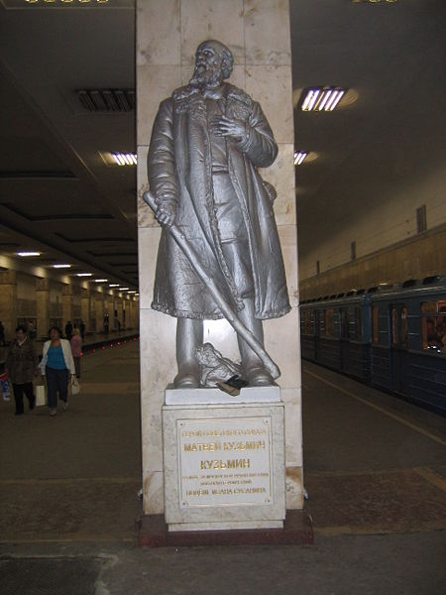

http://en.wikipedia.org/wiki/Matvey_Kuzmin
Heroes of the Soviet Union. Brief biographical dictionary. M, 1987.
Polevoy Boris. The most memorable stories. M, 1980.
Kainov Mikhail. Stories about the Great Patriotic War. M, 1970

MY HERO:
Nikolai Kuznetsov
by Katirkin Denis from Kurgan

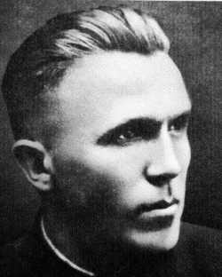

Nikolai Ivanovich Kuznetsov (July 27, 1911–March 9, 1944) was a Soviet intelligence agent and guerilla who operated in the occupied Ukraine during World War II. He used several pseudonyms: e.g. Rudolf Schmidt, Nikolai Vasilevitch Grachev, Paul Wilhelm Siebert.
He was born into a peasant family in the Yekaterinburg region. He studied forestry in a technical school and, after discovering his linguistic talents, learned German, Esperanto, Polish and Ukrainian. In 1932 he enrolled into Sverdlovsk Industrial Institute and continued to study German and other foreign languages.
In 1938, Kuznetsov moved to Moscow and joined the NKVD (Department of Home Affairs).
When the Great Patriotic War started, Kuznetsov, at his own request, was sent to join guerilla units in the Nazi-occupied Ukraine. In 1942, he fought as a member of guerrilla group "Victors", led by Dmitry Medvedev, in central and western Ukraine.
He was in charge of several complex operations involving assassinations and kidnappings of high-ranking Nazi officials in the Rovno and Lvov regions, such as successful operations against the Nazi-appointed chief judge of Ukraine, the vice-governor of Galicia, the imperial adviser to the Reichskommissar of Ukraine, three German generals and others.
Kuznetsov was also the first intelligence agent to uncover Nazi plans to launch a massive tank attack in the Kursk region, information about Nazi V-2 rockets, as well as about Operation Long Jump, Hitler's plan to assassinate the heads of the USSR, USA and Great Britain during the Tehran Conference.
Kuznetsov was acting in Rovno (the capital of fascist state in Ukraine) under the name of Nazi ober-lieutenant Paul Siebert. It was Kuznetsov, who obtained information about the location of Hitler's bomb-proof shelter - "Werwolf" near the city of Vinnitsya.
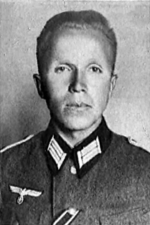

On the night of March 9, 1944, when he was returning from a mission, he was surrounded West Ukrainian nationalist fighters, the notorious Bandera gang, near the village of Goratyn. When they approach him he blew himself up with a hand grenade.
On November 5, 1944 Nikolai Ivanovich Kuznetsov awarded the title of Hero of the Soviet Union posthumously. A minor planet 2233 Kuznetsov discovered in 1972 by Soviet astronomer Lyudmila Zhuravlyova is named after him.
Kuznetsov is no unsung hero. His feats have been described by books and films. I highly appreciate his valour, intelligence and love for his Motherland. He provided the Soviet Command with a mass of valuable information on the enemy army. He sacrificed his life for the sake of his people.

http://en.wikipedia.org/wiki/Nikolai_Ivanovich_Kuznetsov
Heroes of the Soviet Union. Brief biographical dictionary. M, 1987
Medvedev Dmitri. Strong by spirit, M., 1968
MY HERO:
The Brest – Hero Fortress
by Demidenko Alexander from Kurgan
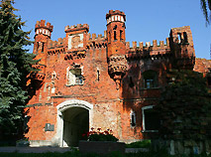
The Kholmsk Gates
Fighting hard, the Soviet Army had to retreat to the east in the summer of 1941. But from the very first days of the war the enemy encountered the staunch, truly heroic resistance of the Soviet troops and the population in the frontier areas.
General Franz Halder, Chief of the German Land Forces General Staff, wrote in his diary on June 24: “There were cases when pillbox crews blew themselves up together with the pillboxes rather than surrender.” Five days later he noted: “Reports from the battlefront confirm that everywhere the Russians fight to the last man.”
Initially, the brunt of the fighting was borne by the Soviet frontier guards. They were the first to meet the Nazi onslaught. Greatly outnumbered by the attacking enemy forces, the soldiers, commanders and political instructors of the frontier posts and detachments everywhere stood to the last man – in Karelia, the Baltic region, Belorussia, the Ukraine and Moldavia. A never-to-forgotten exploit was performed by the defenders of the Brest Fortress.
The Germans planned to seize Brest and the Brest Fortress which was located in the path of Army Group Centre during the first hours of Operation Barbarossa. The fortress and the city controlled the crossings over the Bug River, as well as the Warsaw–Moscow railway and highway.
The word “fortress sounds very impressive,” but it is necessary to say that this fortress was already more than 100 years old and by 1941 it had almost lost its defensive importance.
The 3,500-strong defending force comprised regular soldiers, border guards and NKVD men. Soviet soldiers belonged to the elements of the 6th (under Colonel Mikhail Popsuy-Shapko) and 42nd Rifle Divisions (under General Ivan Lazarenko), the 17th Frontier Guards Detachment of the NKVD Border Troops and various smaller units inside the fortress (up to a total of 7 to 8 thousand people.) were also 300 families of servicemen inside as well.
The initial defense plan allowed for 12 hours to secure the area in face of the 45th Infantry Division (about 17,000 strong) as well as elements of the 31st, 34th Infantry Divisions and 2nd Panzer Group under Heinz Guderian (in total, about 20,000 people).
The fortress had no warning when the Axis invaded on 22 June 1941, and became the site of the first major fighting between Soviet forces and the Wehrmacht which surrounded the fortress. From the first minutes of the invasion, Brest and Brest Fortress were bombed and shelled by the German Wehrmacht.
The initial bombardment took the unprepared fortress by surprise, inflicting heavy material and personnel casualties. Fierce battles were fought at the border, in the town of Brest and in the fortress itself. The first German assault on the fortress took place half an hour after the bombardment started.
The surprised Soviet defenders were unable to form a solid front and instead defended isolated strong points–the most important of which was the fortress itself. Some managed to escape the fortress; most were trapped inside by the encircling German forces. Despite their surprise, the subsequent attempt by the Germans to take quickly the fortress with infantry stalled, and the Germans started a lengthy siege.
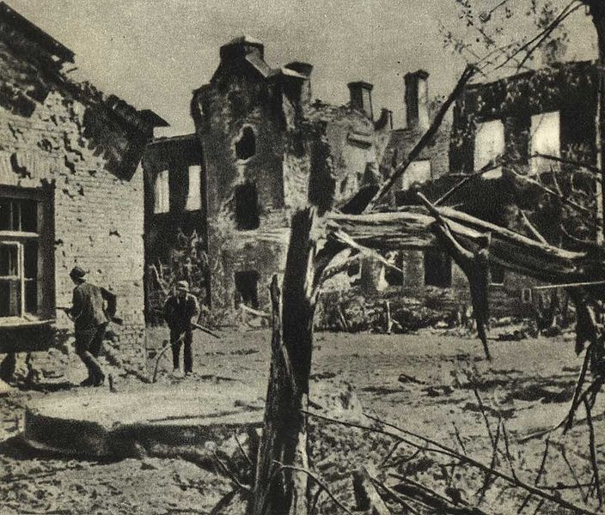
The commander of the 45th Infantry Division General Fritz Schlieper wrote to the High Command in his detailed report: "It was impossible to advance here with only infantry at our disposal because the highly-organized rifle and machine-gun fire from the deep gun emplacements and horse-shoe-shaped yard cut down anyone who approached. There was only one solution - to force the Soviets to capitulate through hunger and thirst. We were ready to use any means available to exhaust them... Our offers to give up were unsuccessful..."
Although the Soviet soldiers in the opening hours of the battle were stunned by the surprise attack of the heavily outnumbering enemy, being short of supplies and cut off from the outside world, they fought and counter-attacked much harder and longer than the Germans expected. The Germans deployed powerful guns, rocket mortars, resorted to tear gas and flame throwers but could not break Soviet resistance.
The civilians inside the fortress looked after the wounded, reloaded the machine-gun discs and belts with cartridges and even took up rifles to help defend the fortress. Children brought ammunition and food supplies from half destroyed supply depots, searched for and brought weapons and watched enemy movements.
Schlieper wrote in his detailed report that "the 81st Combat Engineer Battalion was given the task of blowing up a building on the Central Island ... in order to put an end to the Russian flanking fire on the North Island. Explosives were lowered from the roof of the building towards the windows, and then the fuses were lit. When they exploded, we could hear the Soviet soldiers screaming and groaning, but they continued to fight."
Chaplain Rudolf Gschöpf wrote: "We only gradually managed to take one defensive position after another as a result of stubborn fighting. The garrison of the so-called "Officers' House" on the Central Island only ceased to exist with the building itself ... The resistance continued until the walls of the building were destroyed and razed to the ground by more powerful explosions".
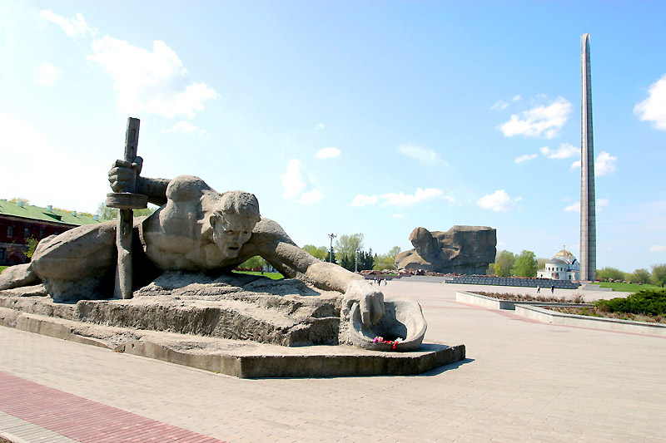
The monuments “Thirst”
On 24 June, with Germans having taken parts of the fortress, the remaining Soviet troops were able to link up and coordinate their actions under the command of Major Ivan Zubachov; his second in command was political commissar Yefim Fomin. On June 26, the Soviet forces tried to break out from the siege but were unsuccessful and sustained heavy casualties.
On June 27, after a week of assault, the Germans began to use 540 millimeter artillery which fired 1.25 ton shells and two 600-millimeter guns Karl-Gerät which fired concrete-piercing shells weighing over 2 tons. Shells from the 600-millimeter guns formed craters 30 meters wide and inflicted gruesome injuries on the defenders, including ruptured lungs of defenders hidden deep within the fortress from the concussive force of the explosions.
On June 29 -30, June Germans launched a major assault, which penetrated deep into the fortress and resulted in the capture of both Zubachov and Fomin. Zubachov was sent to a concentration camp in line with the Nazi policy of extermination of Soviet prisoners of war and would die there; Yefim Fomin was executed on spot for being a commissar and a Jew.
R.Gschöpf wrote: “Late on the 30th of June the division received the order to abandon Brest.” The main units of the Division abandoned Brest on the 2nd of July 1941.
The 45th divisional after-action report of June 30, 1941 related:"The division took 7000 prisoners, including 100 officers. German losses were 482 killed, including 32 officers, and over 1000 wounded". The magnitude of these losses can be judged by the fact that the total German losses on the Eastern front up to 30 June 1941 amounted to 8886 killed. The citadel of Brest therefore accounted for over 5 percent of all fatal casualties.
After nine days of fierce fighting the Germans had captured most of the fortress. It meant that the strategic objective was accomplished with a considerable delay and losses. Regarding the fights around Eastern Fort, that was taken only on June 30, 1941.
To be fair, the date June 30, 1941 as the end of the battle for the Brest Fortress is not quite correct. Even after the fortress was officially taken, a few surviving defenders continued to hide in the basements and harassed the Germans for several weeks. The resistance still continued in isolated pockets, primarily underground in the old dungeons, in the Citadel and the Kobrin Fortification.
From late June until the very end of July rifle fire and short bursts of machine-gun fire continued to ring out from basements and half-destroyed dungeons with small groups and individual soldiers inside. The actual front had by then already moved about 300 miles (480 km) east.
During the last days, the remaining defenders made inscriptions on the walls. They said: "We'll die but we'll not leave the fortress". "I'm dying but I won't surrender. Farewell, Motherland. 20. VII. 41." Major Pyotr Gavrilov, one of the best known defenders of Brest (later decorated for it as Hero of the Soviet Union) was captured only on 23 July.
There were reports that isolated defenders were weeded out by Germans as late as in August when Hitler and Mussolini visited the fortress with heavy security to protect them from remaining defenders. To eliminate last pockets of resistance German High Command had given orders that the fortress cellars be flooded with water from the Bug River.
The resilience of the fortress defenders did not significantly affect the German early successes as the Wehrmacht fast advance into the Soviet territory proceeded largely according to the German plan leaving the fighting fortress well behind the front line. The Soviet General Staff, however, realized the importance of fiercely defending towns and villages on the way of the enemies advance as evidenced in its November note.[4]
The Museum of the Defense of the Brest Fortress was opened in 1956, while the Memorial Heroic Brest Fortress Complex was opened in 1971. The fortress was awarded the title Hero Fortress on 8 May 1965 (the twentieth anniversary of the German surrender).
The legendary citadel, one of the sacred places for the Soviet people, is still serving its Motherland. It is not only a symbol of courage. It has also become a school of patriotism and devotion to Motherland for younger generation of Russia.
I have never been to the Brest Fortress. I saw the film and read the book by S. Smirnov about the immortal garrison. One day I’d like to visit this glorious place.

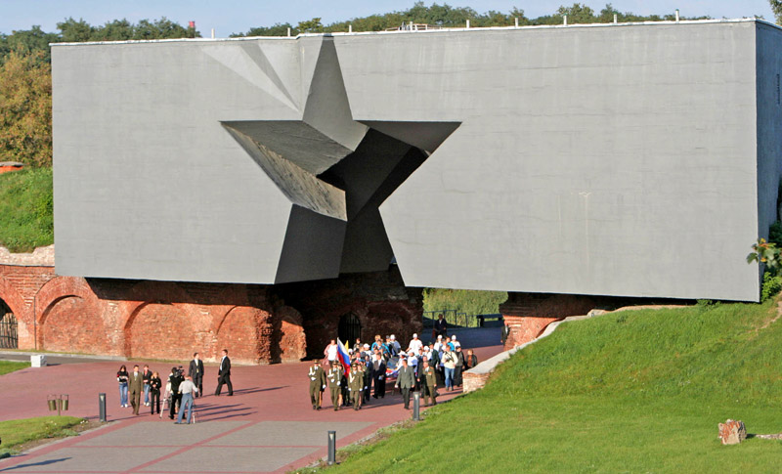
The main entrance to the War Memorial

http://en.wikipedia.org/wiki/Brest_Fortress
Vakhmistrov V. V. English Textbook for Military Colleges. M, 1979

MY HERO:
Janusz Korczak
by Khodko Svetlana from Kurgan

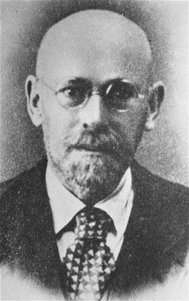

Janusz Korczak, the pen name of Henryk Goldszmit (July 22, 1878 – August 1942) was a Polish-Jewish children's author, pediatrician, and child pedagogue.
Korczak was born in Warsaw to an assimilated Jewish family. His mother Cecylia Głębicka was the daughter of prominent Kalisz Jews and his father Józef Goldszmit was from a family of proponents of the haskalah. Korczak's father died in 1896, leaving the family without a source of income. Over the next few years, the family was forced to abandon their spacious apartment and, during his teens, Korczak was the sole breadwinner for his mother, sister, and grandmother.
In 1898 he used Janusz Korczak as a writing pseudonym in Ignacy Paderewski's literary contest. In 1890s he studied in the University. In the years 1898–1904 Korczak studied medicine at the University of Warsaw and also wrote for several Polish language newspapers.
After his graduation he became a pediatrician. During the Russo-Japanese War in 1905–1906 he served as a military doctor. Meanwhile his book Child of the Drawing Room gained him some literary recognition. After the war he continued his practice in Warsaw.
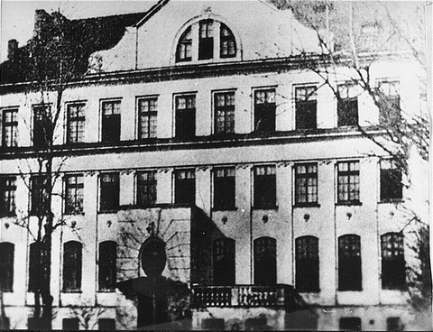
The Krochmalna Street orphanage where Korczak worked. He lived in a room at the attic
In 1907–1908 Korczak continued his studies in Berlin. When he was working for the Orphan's Society in 1909 he met Stefania Wilczyńska. In 1911–1912 he became a director of Dom Sierot, the orphanage of his own design for Jewish children in Warsaw. He took Wilczyńska as his closest associate. There he formed a kind-of-a-republic for children with its own small parliament, court and newspaper. He reduced his other duties as a doctor.
In 1914 Korczak again became a military doctor with the rank of Lieutenant during World War I. During the Polish-Soviet War he served again as a military doctor with the rank of major but was assigned to Warsaw after a brief stint in Łódź
In 1926 Korczak let the children begin their own newspaper, the Mały Przegląd (Little Review), as a weekly attachment to the daily Polish-Jewish Newspaper Nasz Przegląd (Our Review). In these years his secretary was the noted Polish novelist Igor Newerly.
Korczak was one of the first pedagogues who changed the general attitudes of teachers and parents towards students and children. His general concept was that any child has his own way, his own path, on which he embarks immediately following birth. The role of a parent or a teacher is not to impose other goals on a child, but to help children achieve their own goals.
In 1939, when World War II erupted, Korczak volunteered for duty in the Polish Army but was refused due to his age. He witnessed the Wehrmacht taking over Warsaw. When the Germans created the Warsaw Ghetto in 1940, his orphanage was forced to move to the ghetto. Korczak moved in with them. In July, Janusz Korczak decided that the children in the orphanage should put on Rabindranath Tagore’s play, the Post Office.

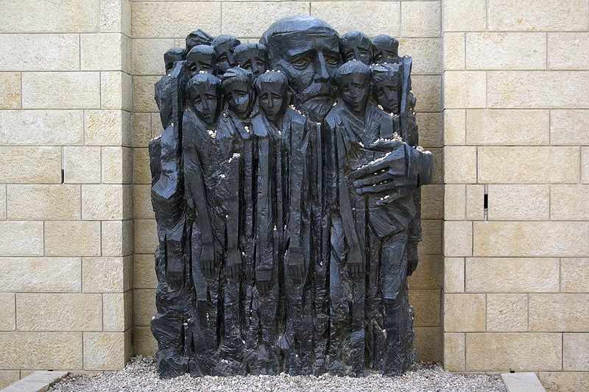
Janusz Korczak and the children, memorial at Yad Vashem

On August 5 (some say August 6), 1942, German soldiers came to collect the 192 (there is some debate about the actual number and it may have been 196) orphans and about one dozen staff members to take them to Treblinka extermination camp. Korczak had been offered sanctuary on the “Aryan side” by Zegota but turned it down repeatedly, saying that he could not abandon his children. Now too, he refused offers of sanctuary, insisting that he would go with the children. The children were dressed in their best clothes, and each carried a blue knapsack and a favorite book or toy. Joshua Perle, an eyewitness, described the procession of Korczak and the children through the ghetto to the Umschlagplatz (deportation point to the death camps):
... A miracle occurred. Two hundred children did not cry out. Two hundred pure souls, condemned to death, did not weep. Not one of them ran away. None tried to hide. Like stricken swallows they clung to their teacher and mentor, to their father and brother, Janusz Korczak, so that he might protect and preserve them. Janusz Korczak was marching, his head bent forward, holding the hand of a child, without a hat, a leather belt around his waist, and wearing high boots. A few nurses were followed by two hundred children, dressed in clean and meticulously cared for clothes, as they were being carried to the altar. On all sides the children were surrounded by Germans, Ukrainians, and this time also Jewish policemen. They whipped and fired shots at them. The very stones of the street wept at the sight of the procession.
According to a popular legend, when the group of orphans finally reached the Umschlagplatz, an SS officer recognized Korczak as the author of one of his favorite children's books and offered to help him escape. By another version, the officer was acting officially, as the Nazi authorities had in mind some kind of "special treatment" for Korczak (some prominent Jews with international reputations got sent to Theresienstadt). Whatever the offer, Korczak once again refused. He boarded the trains with the children and was never heard from again.

Korczak's evacuation from the Ghetto is also mentioned in Władysław Szpilman's book The Pianist:
One day, around 5th August, when I had taken a brief rest from work and was walking down Gęsia Street, I happened to see Janusz Korczak and his orphans leaving the ghetto. The evacuation of the Jewish orphanage run by Janusz Korczak had been ordered for that morning. The children were to have been taken away alone. He had the chance to save himself, and it was only with difficulty that he persuaded the Germans to take him too. He had spent long years of his life with children and now, on this last journey, he could not leave them alone. He wanted to ease things for them.
He told the orphans they were going out in to the country, so they ought to be cheerful. At last they would be able to exchange the horrible suffocating city walls for meadows of flowers, streams where they could bathe, woods full of berries and mushrooms. He told them to wear their best clothes, and so they came out into the yard, two by two, nicely dressed and in a happy mood.
The little column was led by an SS man who loved children, as Germans do, even those he was about to see on their way into the next world. He took a special liking to a boy of twelve, a violinist who had his instrument under his arm. The SS man told him to go to the head of the procession of children and play – and so they set off.
When I met them in Gęsia Street, the smiling children were singing in chorus, the little violinist was playing for them and Korczak was carrying two of the smallest infants, who were beaming too, and telling them some amusing story. I am sure that even in the gas chamber, as the Zyklon B gas was stifling childish throats and striking terror instead of hope into the orphans' hearts, the Old Doctor must have whispered with one last effort, ‘it's all right, children, it will be all right’. So that at least he could spare his little charges the fear of passing from life to death."
Some time after, there were rumors that the trains had been diverted and that Korczak and the children had survived. There was, however, no basis to these stories. Most likely, Korczak was killed with most of his children in a gas chamber upon their arrival at Treblinka. There is a cenotaph for him at the Powązki Cemetery in Warsaw.
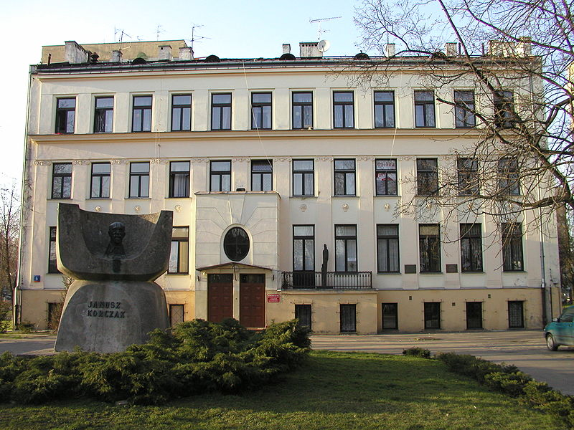
Korczak's orphanage is still in operation today

Korczak's ideas were further developed by many other pedagogues such as Simon Soloveychik and Erich Dauzenroth.
The year of 2010 is proclaimed as the year of a teacher. The same year all progressive people celebrate the 65th anniversary of the Great Victory over fascism. Korczak’s life is inevitably linked with these events. In severe times of the Nazi occupation of Poland he did not abandon his beloved pupils but shared their tragic fate. He has always been for me a HERO the best TEACHER I ever heard about.

http://en.wikipedia.org/wiki/Janusz_Korczak

MY HERO:
Smirnov Yuri
by Fadeev Maxim from Kurgan

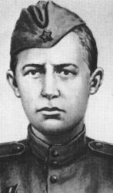

Smirnov Yuri Vasilyevich (02.0 9. 1925 - 25. 06. 1944 ) a private, an infantry man
Hero of the Soviet Union (posthumously ).

On the third day of the Byelorussian Operation the Nazi were already rolling back under the crushing blows of the Soviet forces. On June 25, 1944 the 26th Guards Infantry Division approached the village of Shalashino. The ground was badly scarred by the battle. The night before Soviet tanks with troops on their armor had broken through the Nazi defenses here to thrust forward to straddle the Moscow – Minsk highway.
The infantry was advancing quickly. Suddenly they heard a cry; “Boys! Come here!”When they arrived they saw that their comrade was at the entrance of a Nazi staff dugout.
Inside it was dark and damp. When their eyes got accustomed to the darkness they could hardly believe what they saw. A man, a Soviet soldier, had been crucified on the wall of the dugout. His head, hands and feet were nailed to it. There were several knife wounds in the chest. His face was smashed. They stood here in a state of shock. for some time.
The man nearest to the table exclaimed: “Look, there are papers here.”On the table there were a few leafs of paper and a Young Communist League membership card. One of the men picked it up and read: “Smirnov Yuri Vasilyevich, born in 1925.”
Indeed, only a few hours before Private Yuri Smirnov and his mates – tank-borne infantrymen – had been forcing their way through the night cut by heavy tracer fire. Seriously wounded, he fell down from the tank and was captured by the enemy.
The Nazi were seized with fear they were eager to know the number of tanks that had effecte3d the breakthrough and their destination. Yuri had the information.
The Nazi couldn’t afford to wait; every minute was precious. The boy remained silent. A Nazi officer cried out: “We’ll make you talk!” Yuri was knocked down by a terrible blow. The enemies started to beat him savagely. And stabbed him several times. “How many tanks were there? Where were they going? What was the mission?”
But Yuri wouldn’t speak. He didn’t say a word. The record of the interrogation showed that he had not said a single word.
The events cut side were developing at a rapid rate. A telephone message informed them that the Russian tanks were approaching the Moscow-Minsk highway. The tanks were already there. The orders were to prepare for withdrawal. The Nazis burnt some of the papers. They were now ready to leave at any moment.
What should they do with this captured Russian soldier? Maddened by his staunchness they decided to put him to death in a most savage way.
How come did this 19-yearold boy show such pluck? When did he have the time to steel his character and where?
Yuri’s childhood was not much different from that of most of his friends. First he went to a general education school and then to a vocational school in his native Makaryev.
When the war broke out Yuri’s father went off to fight at the front. Yuri was working at a factory in Gorky at the time. He was eager to join his dad, but his time had not yet come.
One rainy day in September 1942 the Smirnovs received the news about Smirnov Vasily Averyanovich having died the death of a hero in the battle of Stalingrad. The family was overwhelmed with grief. Yuri realized that his mother and his two sisters would have a hard time without him. Despite this, he once said to her: “Mother, I have volunteered for army service. I am going to avenge the death of my father.
In the winter of 1943 Yuri Smirnov took the Oath of Allegiance. In a clearing in the forest he distinctly read out the words of the Oath: “I solemnly pledge to be an honest, disciplined and vigilant fighter, to safeguard strictly military and state secrets.”
Yuri showed that he was a brave fighter already in the first battles he participated in. He was wounded and hospitalized. Then he returned to the ranks.
The soldier and citizen Yuri Smirnov lived up to his pledge. He carried out his duty to the end, and remained true to the Oath of Allegiance.
On October 6, 1944 the Presidium of the USSR Supreme Soviet issued a Decree conferring on Yuri Smirnov the title of Hero of the Soviet Union for courage and heroism displayed in the war against Nazi German invaders.
He was entered into the lists of his unit forever.
Several streets, schools and collective farms have been named after him. A monument has been installed to Yuri Smirnov in his native town of Makaryev, Kostroma Region.
Heroes do not die. They remain forever in the hearts of people. I want to be a military man. I’d like to be brave and true to my military duty as Yuri Smirnov did.

http://ru.wikipedia.org/wiki/Смирнов_Юрий_Васильевич_(Герой_Советского_Союза)
Heroes of the Soviet Union. Brief biographical dictionary. M., 1988
Lvov M. True to the Oath of Allegiance. Soviet Military Review, 1984

MY HEROES:
Soviet Children – Heroes of the Second World War:
Zina Portnova, Lyonya Golikov, Valya Kotik
by Djavid Guseynov from Kurgan

There was no war like the Great Patriotic War (the name of the Second World War in Russia). Not only because millions of people died, but because there were never so many heroes, and boys and girls heroes in the war.

In the war against the fascist invaders Soviet children had their own accounts to settle with the enemy. Fascist troops killed their fathers and mothers, brothers and sisters, ruined their houses and schools and left thousands of children without families, homes and food.

Throughout the war children in villages and towns helped the grown-ups. From the very first hour of the war 12-15 children besieged induction stations all over the Soviet Union, ready to fight the fascists. They wanted to go to the front.

Little boys and girls in occupied areas gave refuge to the wounded Red Army soldiers and at the risk of their lives brought them through forest paths to our units.
Children in Moscow, Leningrad and other Soviet cities extinguished incendiary bombs, build barricades, and drug trenches; the brave little boys and girls of Belorussia and the Ukraine crawled across the front line to pass important information to the Soviet troops.

Many of them were decorated by the Soviet Government with orders and medals. Hundreds of Soviet children gave their lives for their Motherland. Together with all Soviet people Soviet children fought for their happiness and won it.

Zina Portnova

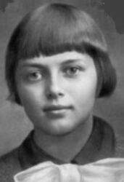

Zinaida Martynovna Portnova, (1926 - 1944) was a Russian teenager, a young Soviet guerilla and Hero of the Soviet Union (posthumously).
Zina Portnova was born in Leningrad and was a seventh grade student spending the summer in a children's camp in Vitebsk region when Nazi Germany invaded the Soviet Union. Zina could not get back to Leningrad where her father, mother and her little sister lived. Her father worked at the Kirov factory and her mother was a worker, too.
In 1942 Portnova joined the Belarusian resistance movement, becoming a member of the local underground organization in Obol, Vitebsk Voblast, named Young Avengers. The young guerilla was distributing Soviet propaganda leaflets in the German occupied Belarus and participated in a number of sabotage actions.
In August 1943 she became a scout of the guerilla unit named after Kliment Voroshilov. In October 1943 Portnova joined the Young Communist League.
Two months later she was captured by the Germans. During Gestapo interrogation in the village of Goriany, she managed to grab the investgator's pistol from the table, and shot him and two other Nazis. Recaptured while attempting to escape, she was brutally tortured, and then executed in the Vitebsk city jail.
In 1958 Zina Portnova was posthumously made Hero of the Soviet Union.
There is a monument to Zina Portnova in Byelorussia.

Leonid Golikov

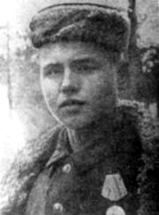

Golikov Leonid Aleksandrovich (1926 - 1943) –a pioneer, the young guerilla-scout, Hero of Soviet Union (posthumously).
Before the Great Patriotic War Lyonya Golikov lived with his father, mother and two younger sisters in the village of Lukino, not far from Novgorod. When the German fascists occupied the village, Lyonya became a young guerilla.He was only thirteen tears old then. He was a brave boy.
On the thirteenth of August a group of guerillas was waiting to attach the fascists not far from the forest. They waited many hours, but nobody came. So they decided to go back to their camp in the forest. Lyonya was walking some distance behind the group when he saw a car with two fascist officers in it. He had no time to call his friends as they were far away. Lyonya had a hand-grenade. He threw it at the car and it blew up. One of the officers was killed, and the other, a general, with a bag a tommy-gun in his hands, ran into the forest. Lyonya ran after him for a kilometer before he could shoot the general. The papers which the general had in his bag were very important and sent to Moscow.
Luonya took part in 27 raids against the invaders. He destroyed 78 hitlerite invaders,blew up two railway and twelve highway bridges, destroyed two food depots, ten trucks with ammunition.
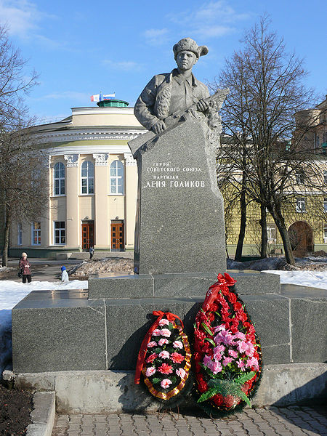

The young pioneer Lyonya Golikov gave his life for his country not far from the village of Ostraya Luka in 1943.
There are monuments to Lyonya Golikov in Moscow and on the bank of the river Poli near the village of Lukino where Lyonya was born.
We will never forget Lyonya Golikov, who gave his life for our Motherland.

Valentin Kotik

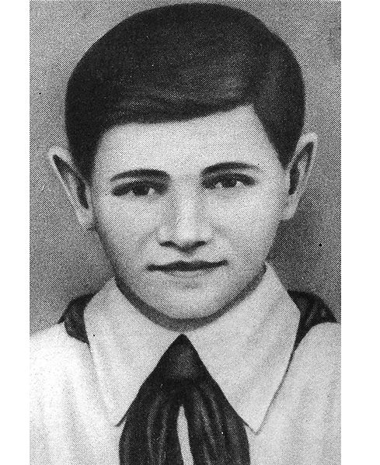

Kotyk Valentine Aleksandrovich (1930 - 1944-7) - the pioneer, the young guerilla-scout, Hero of Soviet Union (posthumously).
In 1941 the Young Pioneer Valentin Kotik, a Ukranian boy, was a pupil of the fifth form at School number 4 in the town of Shepetovka. He lived happily with his family.
On the twenty-second of June, 1941, the Great Patriotic War began. Valya’s father went to the front. When the fascists occupied Shepetovka, Valya became a guerilla. He wanted to fight the enemy. He was only eleven years old then.
During Great Patriotic War accepted active participation in guerilla movement in the Ukraine. First was coherent, then participated in fights, has been twice wounded.
One day Valentin and his friends, who were also young guerillas, blew up the fascist car with hand-grenades. The two fascists in it were killed. One of them was the fascist officer who killed many Russians. The next day the fascist newspaper said, “A large group of partisans attacked the car…” In fact it was the work of three small boys.
Valentin Kotik took part in the fighting for Shepetovka, his native town. He died in the fighting for the town of Izyaslav, not far from Shepetovka. Valya Kotik was only fourteen years old when he gave his life fo his Motherland.
In 1958 Vlya Kotik was posthumously made Hero of the Soviet Union.
There are monuments to Valya Kotik in Shepetovka and in Moscow. The Soviet people will always remember Valya Kotik.
We are grateful to the children, the young citizens of our land who fought to win the victory over fascism. We admire their courage, fearlessness, devotion to their Motherland.

http://en.wikipedia.org/wiki/Zinaida_Portnova
http://en.wikipedia.org/wiki/Kotik_Valentin
http://ru.wikipedia.org/wiki/Голиков_Леонид_Александрович
Kainov M. S. and Kainova I. V. Feat in the Name of Life. M, 1977.

