4th Grade Family Traditions Fall 2011
Mrs Bonney. Lynnwood Elementary school

September 10th 1st day of Ethiopian Calendar: Yobel A.
September 11th Ethiopian New Year: Lucas S.
Vietnamese Educator’s Day Nov 20th: Brian C.
USA Thanksgiving Nov 24th: Ainsley’s Thanksgiving Tradition
Ambralea’s Thanksgiving Tradition
Audrey’s Thanksgiving
Bella’s Tamales Tradition
Bianca’s Thanksgiving
Daniel Tran’s Thanksgiving
Isabella’s Thanksgiving
Jimmy O. with Grandpa
Sarena’s Thanksgiving
Sonia’s Thanksgiving
Thao’s Thanksgiving
Daniel Z’s Thanksgiving
Alex Song’s Korean Holiday

*Eid Al Fitr Sehar
*Eid Al Fitr Imran
*Note of explanation
There are two main holidays in Islam: Eid Al-Fitr and Eid Al-Adha. The way that holidays are recognized can vary across cultures, as well as across sects of Islam, Sunni and Shia. Muslim holidays generally follow the lunar calendar, and thus move each year relative to the solar calendar. Muharram is the first month of the Islamic calendar; This year, it started on Nov 26th
Ashura was celebrated on December 5th
Ashura is commemorated by Muslims on the ninth and tenth days of Muharram on the Islamic Calendar. Thank you to Alina and Nadejda for explaining about Ashura celebrations

FROM our LEARNING CIRCLE FRIENDS
Nadurgan Winter Solstice Celebration from Igul Murtasina,, School #10, Almetyevsk city, Tatarstan , dates of Celebration from Romania ( +presentation)
Separate presentations were also sent from Baltimore Gilman School and Tiffany in new Brunswick Canada

MY ETHIOPIAN HOLIDAY TRADITION

Hi, my name is Yobel Abraham and I’m 9 years old. I live in Lynnwood and I was born 2002 march 20th in Washington State. I go to Lynnwood elementary school and I’m in fourth grade. My cool teacher is named Mrs. Bonney. My parents are named Akberet and Issak. Issak is my dad and Akberet is my mom. My favorite sport is basketball. My favorite things to do are playing video games and playing basketball with my dad. Now here’s my holiday.

My holiday is called Yohannes. It is celebrated on Sunday September 10th. We go to church in the morning and we sing songs, say prayers and play instruments! Afterward we eat traditional food and play outside. Then we say farewell and then we go home.

When we get home we put on traditional clothes. Then we take pictures of ourselves. We usually make time for it and run to the sofa.

I love spending time with my family.

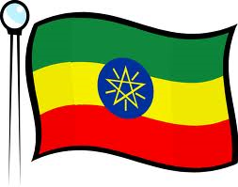

Ethiopian New Year Celebration

Hi I am Lucas S I am 10 years old. I was born on October 26, 2001. I was born in Seattle Swedish Medical Hospital . I’ve had a lot of fun in the past 10 years of my life. Right now I go to Lynnwood Elementary School [LWE]. I am in fourth grade. I have an extraordinary teacher named Mrs. Bonney.

My favorite things are sports, electronics, and my parents. My favorite sport is football it is epic! I’m really GOOD! My favorite electronic is the IPod touch. The IPod touch has 6 generations. My parents are the best of all. My parents were born in Ethiopia. My dad came to Chicago to go to university of Illinois to study to be an engineer. My mom came to Minnesota with her family, later she went to the University of Minnesota. I don’t know where my parents met but they have known each other since 1998 and I don’t know what I would do without them. I now am going to do without them. I am now going to tell you about Ethiopia New Years.

In Ethiopia, New Years is on September 11th. On that day the kids and adults sing in big groups. Then the kids go door to door and give the people at the door pictures of flowers or butterflies. Then the kids go to their home. Then the parents invite cousins and friends over. After that, they eat LUNCH and the kids go outside and have fun. Then after dinner the kids and the parents and grandparents GO OUT and STAY UNTIL MIDNIGHT watching our own fireworks and tell each other new year’s resolutions and all that

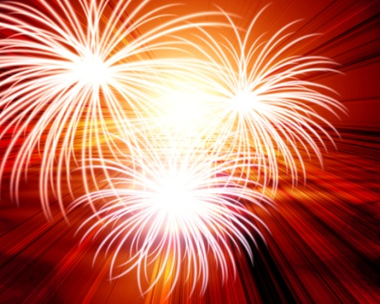 the end.

Vietnamese Educators Day

My name is Brian Cao and I am 10 years old. My favorite subject is reading. My favorite sport is Basketball. My hobbies are collecting Yu-Gi-Oh cards, reading about Greek mythology, and playing my DSI XL.

I was born in Lynnwood, Washington on October 23rd 2001. My mom, Kim and dad, Phuc came from Vietnam 14 years ago. I’m a 4th grader at Lynnwood Elementary.

My holiday is called Vietnamese Educators Day. It’s celebrated on November 20th. On this day the students give small gifts and flowers to their teachers. The teacher gives the student education so they can be successful when they grow up.

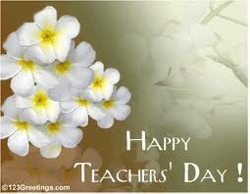

Ainsley’s Thanksgiving Traditions

Hi, my name is Ainsley. I am 9 years old.I was born in Richmond, Canada. My parents were born in the Philippines. I am in 4th grade at Lynnwood Elementary. I love to read, take pictures, and play games.

Let me tell you about what we do and eat on Thanksgiving. It is on the November 24th, 2011. The very first Thanksgiving was way back in 1621! It has something to do with pilgrims, Native Americans, and turkey (The bird). A lot of people celebrate this holiday.

On Thanksgiving, I wake up at morning and eat a special breakfast. Then I call my aunt and my grandma and wish them a happy Thanksgiving. After that I watch the Thanksgiving Parade.

After I watch the parade my mom asks me what I am thankful for. I always say that I’m thankful for family, to have what I need, my little sister Ariane, and education. Then at 6:00 pm, dad comes home from work and we go to the dining room to eat dinner.

Then at the dining table, I eat spring roll, ham, rice, and crab. After dinner, I go to my room and play with Ariane, my sister while my parents chat in the living room. Then after that, I brush my teeth and go to bed.
Thanksgiving is a very old tradition and a bit fun too. It is also a time to give. I like celebrating Thanksgiving and I hope you do too.

What do you do on Thanksgiving?

My Thanksgiving Tradition

Hi, my name is Ambralea H. I am 10 years old and I am in 4th grade. I go to Lynnwood Elementary school. I was born in Everett WA. My parents are both from America but I am Greek, Norwegian, Irish, and French. My teacher is Mrs. Bonney. She is very nice.

My tradition for Thanksgiving is that my mom’s side of the family always comes over to our house for Thanksgiving dinner.
We eat turkey, green beans, casserole, potato salad, mashed potatoes with gravy, and rolls with butter and pumpkin pie for dessert.

When we are done, the guys watch sports on T.V. the ladies talk to each other. The kids play in my room and run around the house.

Then, when some of our family members go home, the rest help clean up and hang out a little. Then we all go home and we call it a day.

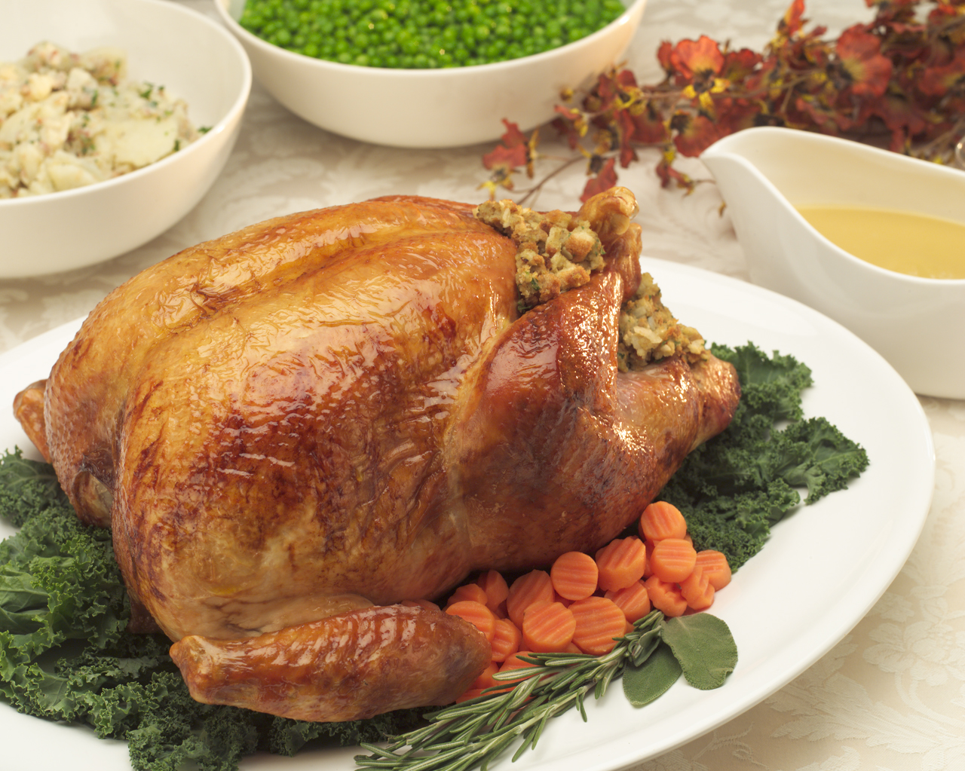

Audrey’s Traditions

My name is Audrey M, and I am 9 years old. I am in 4th grade, and I have a wonderful teacher named Mrs. Bonney, who teaches me and lots of other students at Lynnwood Elementary. I was born in Texas; my parents were both also born in America. I enjoy reading, and I love playing piano. I have long brown hair and brown eyes. I am very excited to talk to you about my traditions for fall celebrations.

My family and I, celebrate a regular American holiday called Thanksgiving on November 25th every year. We almost always go to my grandparents’ house. They live in Everett, that is not very far from where I live. We all sit at a big table in a fancy room. We also love to eat very tasty food. After dinner and before dessert, we all go around the table and say what we are truly thankful for.

I love Thanksgiving! One of the big reasons that like it so much is because the food is just delicious! My grandpa makes the best gravy for the mashed potatoes; He also makes a big yummy turkey that is the main dish. My grandma makes warm tasty rolls. My mom makes or buys delicious stuffing, and lots of different juicy drinks.

We also always pray over our food so it is blessed. My favorite part of the meal is the Dessert! My grandma and aunts make the yummiest pies. There is chocolate pie, apple pie, pumpkin pie, and different berry pies. This year I made an apple pie and it was so delicious!

Thanksgiving is a very important holiday and it is one of my favorites. We love getting together as a family and playing lots of really fun games. My family is so important to me, and I love them very much. One of the main reasons that Thanksgiving is so extremely important to me is because we have lots of time to tell God what we are truly thankful for, and that means a lot to me and everyone in my family. 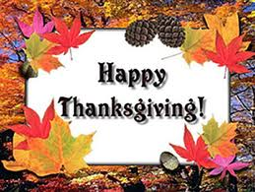

Bianca’s Thanksgiving Tradition

Hello my name is Bianca. I am really great at art. I was born in Seattle but my parents were in the Phillipines and Vietnam. I am in 4th grade. I am 9 years old and my teacher is MRS BONNEY. Oh she is so nice, fun, wonderful and always want us to be on track . I like all of the colors in the entire world, but I really much prefer black because its dark awesome and matches with anything. I like, animals stunts, climbing and danger.
Also I have so many friends to count on and to be there no matter what. I have a huge family all over the world like Mexico, Japan California, Vietnam, Phillipines, France, Northwest, East Dakota Ottowa, Canada and more.

I am going to talk about fall Thanksgiving. First the family is going to decorate the house to do the holiday. Then we all make food to bring to the house: a main food to bring is pie turkey, mashed potatoes, pumpkin pie, meat, chicken, eggrolls, pizza, fruit, soda
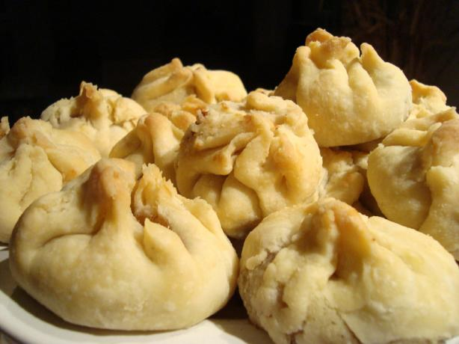 pig bun bow. those are the food you can bring.

After that, the family members or relatives and some friends com to hang out and have fun. We all eat at one house and we have a great day. It doesn’t matter whose house it is.
When the holiday party is done, the leftovers are given to the people that came, then everything is over and everyone says goodbye and hugs and thanks for the loving family I will never forget.

It is great to have loving, helpful and wonderful family at Thanksgiving.
We are thankful for what we have for that is the meaning of Thanksgiving.

MY FAMILY TRADITION:

Hi! I’m Daniel T. and I’m 9 years old. I was born in Canada, Montreal, and I’m in fourth grade with the best teacher in the world. My parents were born in Vietnam. And I go to Lynnwood Elementary school. My hobbies are doing Taekwondo, sports, and riding bikes .I came to America when I was five years old, and my birthday is December 8th, 2001.

And we celebrate Thanksgiving and we usually eat at our American grandma’s house in Oregon. But this year it’s different because my mom, grandma, aunts made Thanksgiving in my house for the first time! And the cooks made mashed potatoes, turkey and gravy and they made some Vietnamese food like chow and these different types of rice that I don’t know what it’s called.

And when the adults are eating, the kids go and play with board games like Checkers, Cranium and Monopoly and we play games like the DS Xbox and sometimes the game cube.

I feel special because I can play with my uncles, aunts, cousins and my parents. I hope you had a good Thanksgiving too.

Isabella’s tradition

Hello, my name is Isabella S. I am 10 years old in 4th grade going to Lynnwood Elementary School. I was born in Washington along with my mom , although my dad was born in Japan he’s still American along with me, my mom, my brother, and my 3 sisters. My mom works at the police station, and my dad is a fireman. My favorite hobbies to do are cooking with my mom, building with my dad, and playing volleyball with my friends! And my favorite color is Blue!

On thanksgiving my family drives over to my aunt and uncle’s house. Also my other aunts and uncles come along with my cousins. And usually my great grandma and grandpa would come but they died last year, and usually my grandma and my single uncle would come but they moved a couple of months ago, so they can’t come.

The food we eat is a cooked turkey, stuffing, fruit salad, gravy, mashed potatoes, Brussels sprouts, yams, green beans, and usually for like a little appetizer we eat chicken wrapped in bacon with syrup drizzled on top of it and put in the oven, but we didn’t have that this year. And always we never forget to pray before we eat and thank God for the food we have to eat, the roof over our head, and a warm bed to sleep in at night!

What we do is all of the kids go into a separate room and play with the toys we brought with us and just talk with our sisters and cousins and brother, and the adults talk about what’s been happening since the last time we saw them.

The reason I LOVE thanksgiving is because I’m just with my family and able to talk and play with them while I still have them, though thanksgiving will never be the same without my great grandma and grandpa.

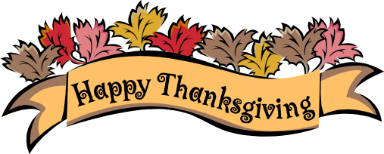
Jimmy O's traditions

Hi my name is Jimmy. I am nine years old. My mom is from New York. My dad is from Washington. I am from Arizona. I am in the fourth grade from Lynnwood Elementary School. My hobbies are making paper things. We are a typical American family. You are reading something that will teach you about what my family does for Thanksgiving.

On Thanksgiving, we go to my grandpa’s nursing home. Before we eat mom makes the food, and we eat it in the spare room with a table and chairs. We eat turkey, stuffing, cranberry sauce, mashed potatoes, and sweet potatoes. This year it was just our family went. We eat in a special room they set up for us.

While we are waiting for the juice cart, food and other family members. The children play games and have fun while the adults talk and visit.

When we are done eating we play board games, guessing games, and many more. Until they kick us out. Then we pack our stuff, put that stuff in the car, go home, unpack, put on our P.J.’s, go to sleep, and that is my thanksgiving tradition.

I don’t know how long we will get to do this with him. He is losing his memory. But for now I’m just happy that he is alive and we all can have a happy thanksgiving.
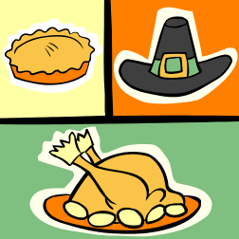

Thanksgiving by Sarena M.

Hi my name is Sarena. I am nine years old almost ten. My parents were born in Washington. My dad’s name is Shane. I am in the fourth grade, my teacher’s name is Mrs. Bonney and I go to school at Lynnwood Elementary. My favorite thing to do is play with my dogs. I was born in Spokane.

My family celebrates Thanksgiving so we can say thanks to our family and to the wonderful food that we have and the roof over our heads. We celebrate Thanksgiving in the fall. We eat turkey, beets, mashed potatoes, salad, cookies, pumpkin pie and my grandma’s secret recipe for her marsh mellow fruit salad which is super yummy! My family mostly goes to other relative’s houses for Thanksgiving like my Auntie Jenny’s house or my Uncle Pete’s house or both houses this year.

Before we eat we say thanks to all the wonderful things about our family. After we say our thanks we eat and it’s so much fun and everybody talks. Also, Madison goes around copying me. After we eat at Pete’s house we go to my Auntie Jenney’s house to eat dessert.

Once we get to Jenney’s house we have dessert. Then all of the kids go down stairs and have balloon fights with fat and skinny balloons and other toys too. Then the kids settle down on the couch and watch a movie and sometimes the younger kids fall asleep.

This is what I do for Thanksgiving every year. We always eat turkey and grandma’s fruit salad. I hope I can hear your Thanksgiving story also.



Sonia’s Tradition

Hello my name is Sonia I am 9 years old and I am in 4th grade in the school Lynnwood Elementary school. I was born in Swedish Hospital on 01/10/2002 in Washington. I have a brother named Sina and a sister named Sanaz and my mom and dad both come from Iran and my whole family has the same hobby called volleyball.

My family’s American tradition is Thanksgiving because in Iran we do not celebrate Thanksgiving because there is no such thing as thanksgiving. On this thanksgiving we had a party, we invited friends and played a fun wii game and then I played on the computer alone.

The next thing we do is go to the dinner table and we wait for the food and before I ate the food my dad told me what kind of food and drinks there were for the drinks, there was juice, gatorade, milk, and soda for the food, there was ham, cheese, eggplant, and the best of all the foods was the turkey.

After my dad told me what food and drinks there were I decided to get some cheese, ham which I did not like, and the leg of the turkey and for the drinks I got gatorade. When we all finished eating we watched my dog named Nero and our friend’s dog named Zookie play together.

After every single thing we planned was done in my head I wished my grandma could have stayed longer so she could celebrate one holiday with us but she had to go back home before she could celebrate anything with me and my family
Thao’s Traditions

Hi my name is Thao and my last name is Le. I was born in Vietnam on May 13th, 2001. I am 10 year old. My hobby is art because when I was a little kid I loved to draw so much.

Now let me tell you more about myself: My favorite color are black and purple. My family was born in Vietnam but my mom was born near Vietnam but I don’t know what is it called. I am in fourth grade in Lynnwood Elementary.

Now I will tell you how we celebrate our family Thanksgiving. Each mom and dad has to make a food to bring to my aunt’s house. We celebrate Thanksgiving at my aunt’s house. When the food is done, we get ready by wearing new clothes on. We go to my aunt’s house at 12.00pm.

Before we celebrate Thanksgiving, we wait for everyone to come to my aunt’s house. We come there to talk until the other people come.
When everybody comes the grownups lets us eat first, then they tell us to go upstairs and play but the kids keep on going downstairs. The grownups said that we can play downstairs a little then later go upstairs again.

Now let me tell you how we celebrate Thanksgiving. We eat noodles, mashed potatoes, bread, turkey, ham, fish, meat and dessert. After we eat the grownups sing and drink beer for like 5 hours before we sleep. Before we go home we pray before the picture of our Grandma and Grandpa.
THE END

Daniel’s Traditions

My name is Daniel Z. I’m in the 4th grade at Lynnwood Elementary School. My age is ten and my parents were born in Alberta, Canada but my mom was from China and my dad was from Hungary and my hobbies are gaming, art, technology, and Greek mythology.

My tradition is Thanksgiving. It all started way back when the pilgrims sailed to a new a different land and they found other people so they helped each other out and then they had a big feast so they called it Thanksgiving.

We eat turkey, mashed potatoes, stuffing, and pumpkin pie. We all help serve the food and we eat in our dining room.

After we eat we play board games football and baseball after we’re done playing we put on our pajamas brush our teeth and go to bed.

This is what I do for Thanksgiving I hope I get to know what’s your tradition or holiday. I love Thanksgiving because I get to be with my family
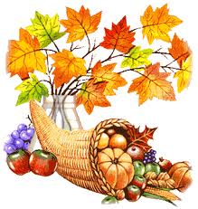

Alex Song’s tradition

Hi! My name is Alex Song, and I am 9 years old. I’m in Lynnwood Elementary School. I am a 4th grader. My parents were born in South Korea. I was born in Korea, too! Also my hobbies are to play baseball, ride a bike, playing soccer. I hope you like my hobbies. I also hope that you enjoy my holiday, too!

In South Korea, we celebrate chew-suck, and chew-sue-gam-sa-gul. The c-s-g-s-g is like Thanksgiving, but we don`t eat turkey. But instead of turkey, we eat some fruit. Sometimes we eat rice, or rice cake. At chew-suck, we eat soup, chicken, always rice, meat. I will introduce what we do we do at chew-suck, and chew-sue-gam-sa-gul.

At chew-suck, we play 1880’s game. It’s old, but it’s still fun. We always do chew-suck party at our great-grand parent’s house. It’s kind of small, but almost 30 people fit in there. Our family always tries to go there every year. At chew-sue-gam-sa-gul, we celebrate for our own. So we do it at our house. We just pray, and eat some good foods. The most interesting is no school for both traditions!

I will tell you more about my holiday. At chew-suck, we always go to giant restaurant. After we eat, it’s time to say Goodbye. Oh! Also chew-suck is in August, chew-sue-gam-sa-gul is in November. Also, I hope you enjoyed my holiday!

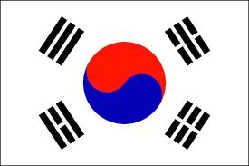

My Muslim Tradition
My Special Holiday

Hi, my name Sehar Sial, And I am nine years old. I am in fourth grade, in Lynnwood Elementary school. My parents were born in Pakistan. I live with my Grandma and two brothers. All three of us were born in America, Washington. My hobbies are to draw and color pictures.

A holiday we celebrate in the fall is called EID. Eid is celebrated in the month of Ramadhan. It’s celebrated by moon’s position. All Muslims celebrate Eid around the world. It is perhaps the most joyful of Muslims holidays. It is when family’s gather up, together they pray and eat and just have fun. Muslims have Eid twice a year. It is celebrated because they are breaking a very strict fast, kids do not have to fast, but adults should try to fast for the whole month until Eid.

On Eid for breakfast we eat oatmeal, cake, Ice-cream, and other sweets. At lunch when we are at the mosque we eat rice, naan, yogurt, lamb, chicken, noodles, lentils, soups, veggies, salads, macaroni, sandwiches, mashed potatoes, and bread. For dessert we eat cake, cupcakes, ice-cream, milk with sugar, almonds, and noodles, and lots of other sweets!

What we do on Eid is go to our Mosque at 10:00 am. We pray and then we go around and hug each other, while the others are getting ready for the food. When we are done with foods, we pray agai and clean up. Usually people are going with friends. When we go home, we play board games until midnight and we go to sleep.

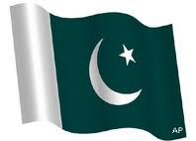

Muslim Eid Holiday

Hi my name is Imran P. I am 9 years old. I was born March 13th, 2002. I am a fourth grader at Lynnwood Elementary school. My parents were born in Afghanistan. I have 2 brothers that I love. They are so sweet.

My hobbies are to play soccer and basketball. I have been all around Europe: I have been to Italy, Germany, Vienna, Switzerland, France, Holland, England, and Belgium. I went to all these countries because my dad was the secretary of the ambassador.

I celebrate Eid because after the month of Ramadan, we celebrate the thirty days we fasted. Usually every Muslim here goes to the Lynnwood Convention Center, everyone prays, then they talk to Muslims they know, and the kids get candy. Then we go to our grandpa’s house, eat lunch and dessert and the kids play a game while adult talk about family.

We celebrate Eid on a typical day according to the moon. In Islam there is Eid alhada and Eid ulfitr. They are recognized by two cultures Shia and Suni muslims. I am Suni.
I hope you learned a little about my holiday.

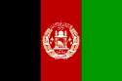

We learned a lot from our class, but also from the other schools

Contribution from Igul Murtasina,, School #10, Almetyevsk city, Tatarstan
Nardugan.
Nardugan - the winter solstice.
The winter solstice - December 25, January 7 - occupied a special place. It should be noted that long before December, ending the fiscal year and preparing for winter, baptized Tatars not only take real measures to ensure the harvest of next year, but also sought to predict the future, following the signs, making certain dance moves, they would in all likelihood, to secure the welfare of the whole year.
Much of the information about the ceremony Nardugan in the second half of XIX
- beginning XX centuries. Fragmentary data do not provide adequate
understanding of the ritual dances of mummers. However, it can be argued that
Nardugan and associated dances, as a true theatrical performance represented a
ritual, refers to the magic of fertility. This was clearly evidenced proverb:
"Narduganga barmasaң, Zhitenev bulmy" (if you can not go on Nardugan will not
harvest flax).
The content of this rite is as follows: the appropriate auspicious day -December 25, but most often on the eve of his - December 24, in the evening
the rural youth in costumes and masks with cries of: "Narduganga-ah," began to
bypass the nearby homesteading (Nardugan bulyp yvriler). Thereby informing all
village entertainers that come holiday time taken for the games and dances are
being performed in ancient times in this time of year.
Dances of maskers, which were based on jumping up and jumps from side to side
were known to the entire population of the town or village.
Dances of clowns, performed during Nardugan represent a cycle of several
parts:
1) welcome dance performed in the courtyard outside the door;
2) dance at the entrance to the house;
3) spinners dance, performed narduganskoy grandmother, grandfather, and dance;
4) thanksgiving dance with the wishes of well-being;
5) farewell dance;
6) Dance, dance, associated with fortune-telling;
7) games and dances, accompanied by bonfires.
Welcome Dance - Boldyrev kyrynda biy - literally danced in front of every
house, behind the door. Performed by his costume group aged 10-15 years. The
main musical instrument that accompanied the dance entertainers, a violin,
harmonica and later. In addition, Rybakov in his book "On the poetry of the
Ural Muslims," ​​points out one more musical instrument - kurai. Kurai - an
ancient national instrument, made from the umbrella plant with hollow stems.
In order to execute dance Boldyrev kyrynda biy men dressed in women, and women
- men, their faces soiled with soot. Thus, the costume team went from house to
house, undertaken more dance and play scenes. Stopping at each house, a simple
boy-music musician svyatoshniki danced alternately. Dances usually start as
follows: a young man, dressed in female attire, dance, as he likes to dance
all causes in turn.
Welcome dance was not a strict canonical choreography. Despite the fact that
the movement of the dancers wore improvised nature, - a slight jump from one
leg to another or from one foot to two. The peasants believed that the execution of these movements will bring them a bountiful harvest.
Performing a welcome dance in every yard of the village or in the house,
costume group stopped their walk home. After some time after the first group
there is another costume. In the dance was attended by more mature boys 15-20
years. They performed a dance at the entrance to the house. The dance is
called "Өy echendәge biy." If the welcome dance involved a mixed cast, at this
stage, the girls did not participate.
The boys dressed in women's suits and began a march to their homes. Costumed
chose a manager who sets out - someone for whom to dance. According to M.
Vasiliev, dancing, believed that the artist inhabits the spirit. And as the spirits, according to the ideas of the baptized Tatars are good and bad, it was necessary in the performance of dance necessarily to please Satan.
Thus, the appeasement of Satan in the dance, the masks in the past, the Tatars
were not a simple game. This is a whole ritual action, which was directly
affected, mainly the outcome of the harvest in the future.
The last group of dances and dances closely connected to the ignition of
fires, as required and, of course, original membership of the holiday, it
occupied an important place in Nardugane. Bonfires were the center around
which the basic dance steps were carried entertainers. Campfires are usually
laid out in every yard. To do this in the middle of a fire pole stuck in the
wheel assembly in (a solar sign), which set fire to, or put on a pole burning
straw.
Baptized Tatars attributed to the heat from burning straw healing properties.
People say that if jumping through burning fire with a lighted straw, you will
not hurt the whole year.
The cycle of dance acts of the period usually starts with jumping through
burning fire of youth. After the fires jumped one by one and in pairs. Jumping
over a burning pyre, was sentenced as follows: "Let me leave every ailment."
Youth jump over the fire in pairs, tightly holding hands, it was kind of
guessing. It was believed that if their hands were not tripped or after they
fly the sparks from the fire, then they are married.
Further, should performance of songs, dances and dances that lasted all night.
Celebrating Nardugan diversified performance dances around the fire. Dances
were an integral part of the holiday. In general, they were lyrical in nature
and consisted of walking around the fire of youth. Walking around in the old
days, obviously, symbolizing the circular motion of the sun, and lighted a
fire - a solarhalo.
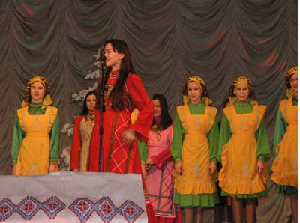

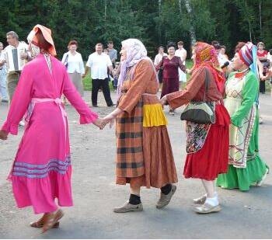
From Eforie Carmen Sylva School, Romania 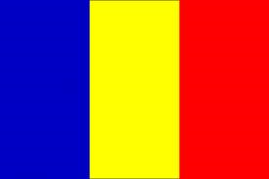

Library Night Oct 1-2nd

Oct 31st marks the International day of Black Sea each year for the countries around the black sea (Bulgaria, Georgia, Romania, Russian Federation, Turkey and Ukraine)
Oct 31 Halloween complete with carnival and pumpkins!

November 4th: Today, Muslims celebrate the first day of Bairam.
Monday and Tuesday, Muslim students in my class are exempt from classes. They go to the service to geamie/ Muslim church (boys: Ender, Akan, Nesmedin, Erol). Then they go to carols, from house to house, wishing "A Happy Bairam!" and kissing the hand of the elderly; they are rewarded with sweets (baclavalele are devoid).For all Muslims: Kurban Bayraminiz Kayirli Bolsin! / Kurban Bayraminiz Olsun Mubarek!
6-9 November is Kurban Bayan, festival of sacrifice, a Muslim Religious Holiday

December 1st is National day of Romania, also called great Union Day or Unification Day

Dec 9th is the day of Ashura, an important day in the Muslim Year.
Students served candy and juices and the Asshure dish (see recipe in Tiffany’s cookbook)

Thank you Alina for sending your Power Point presentation with all the pictures from Romania

Thank you Cecilia for sending the presentation from Baltimore Gilman School.
Thank you Nadejda for sending information from Aletyevsk and Tiffany from Canada.

Thank you for sharing your traditions and celebrations this fall.
We learned a lot!

