News of entertainments from over the world
Hello, my name’s GlebBoyko. Football, hide-and-seek, hockey, tag are my favorite games. I can play football and hockey outdoors or in specially equipped rooms. There are two teams when you are playing hockey and football. If the team shoots more goals than another team it will be the winner. We can play tag also indoors and outdoors. In this game we should choose one game leader, who runs for children and tries to touch somebody.
Our traditional Belarusian games are associated with our national holidays and customs. There are more than 400 traditional games in our country. Such games as “Proso” (“Millet”), “Redka” (“Radish”), “Wolf” , “Moose”, “Cuckoo”. These games are typical for countryside. And people try to save them for descendant.

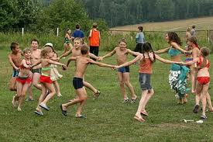
Hi, My name’s Akim. My favorite game is “Square”. This is a game with a ball. You should draw a big square with four sections on the ground. There is a little circle in the center of the square. You throw a ball in this circle other participants try to return a ball. I like play sports.

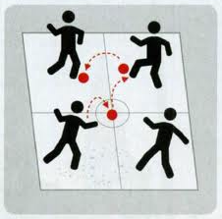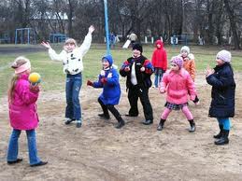
Hi, My name’s Liza. My favorite game is “hot potatoes”. It’s very popular game among pupils. Some children make a circle and pass the ball very quickly around. The person who holds the ball more than others sits in the center of the circle. I like this game very much.

News from Belarus

News from Pakistan

The most popular game in your country is Cricket
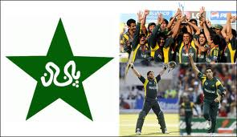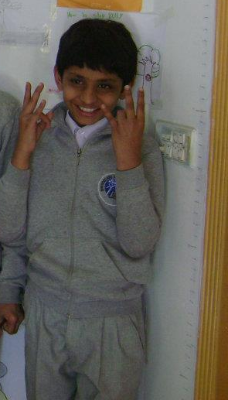
Hussain – Class 5

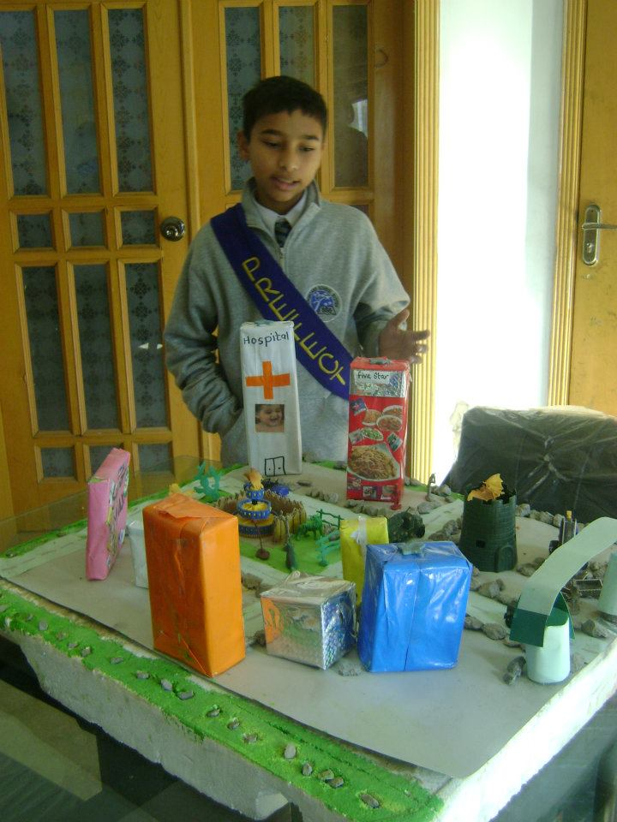
Zariyaab Hussain Ghouri – Class 6
My favorite Indoor Games: Computer"car games"
Outdoor Games: Football, Cricket, Dodge the ball.
Traditional games of our country are (1) Kabadi (2) Polo (3) Shatapu (Hopscotch) (4) Gulli Danda. I like to play Outdoor games because it's fun to play with my friends. We joke, we laugh and we are always active. The most popular game of our country is Cricket

Traditional games of our country: Kabadi 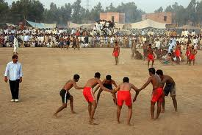
Shatapu (also known as Hopscotch)
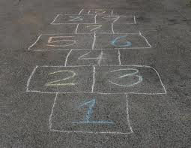
Chaupar
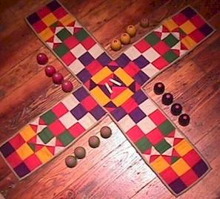

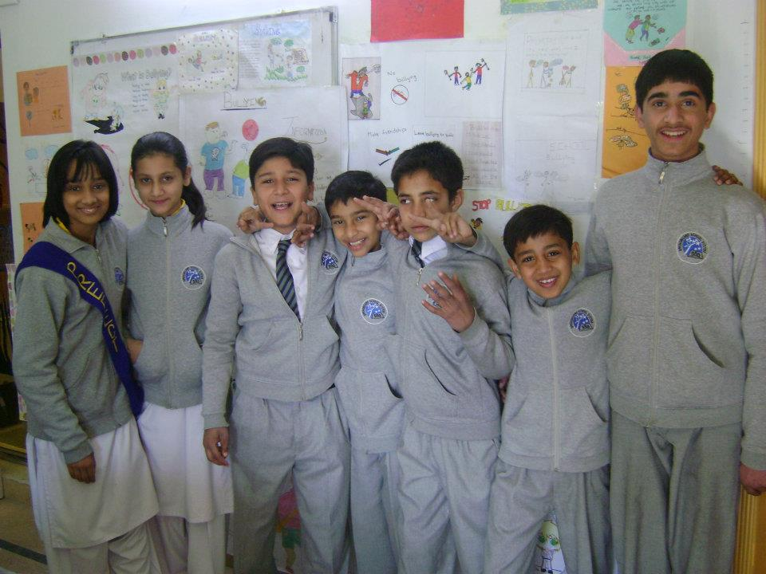
Nouman Khan – Class 6
My favorite INDOOR games: computer game GTA and NFS.
Outdoor games: football and cricket.

Aleezay Raza – Class 6
My favorite Indoor Games: Line up 4, Barboe Dress up and make over games, Carom Board
Outdoor Games: Football, Badminton, Basket Ball.
Traditional games of our country are (1) Polo (2) Shatapu (Hopscotch) (3) Hockey.

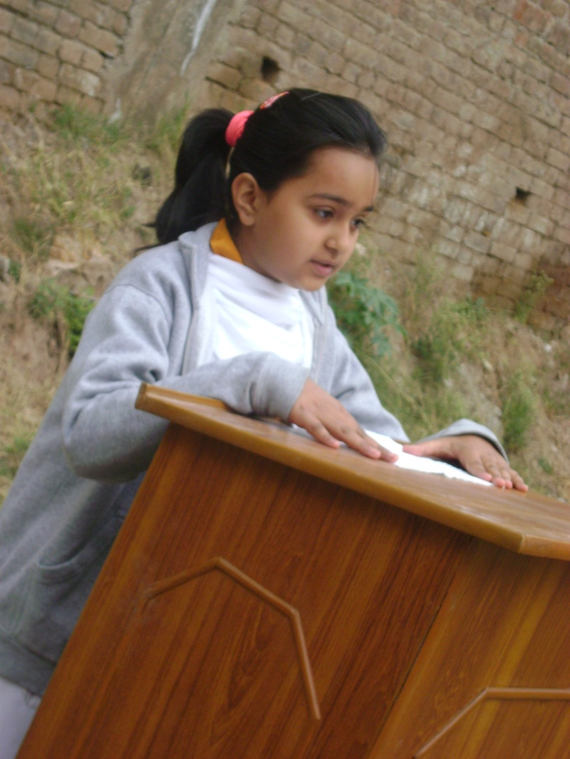
Mahnoor Fatima - Class 6
My favorite Indoor Games: Ludo
Outdoor Games: Volleyball.
Traditional games of our country are (1) Polo (2) Shatapu (Hopscotch)

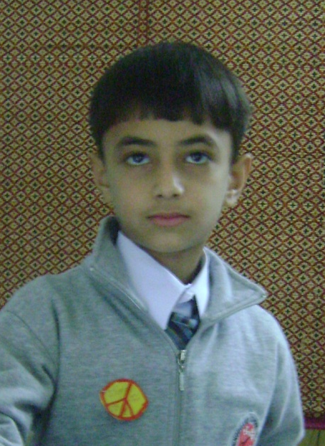
Bilal ul Haq – Class 4
My favorite Indoor Games:- Car games, Bike games
Outdoor Games:- Football, Hockey, Cricket.
Traditional games of our country are (1) Polo (2) Shatapu (Hopscotch) (3) Hockey.

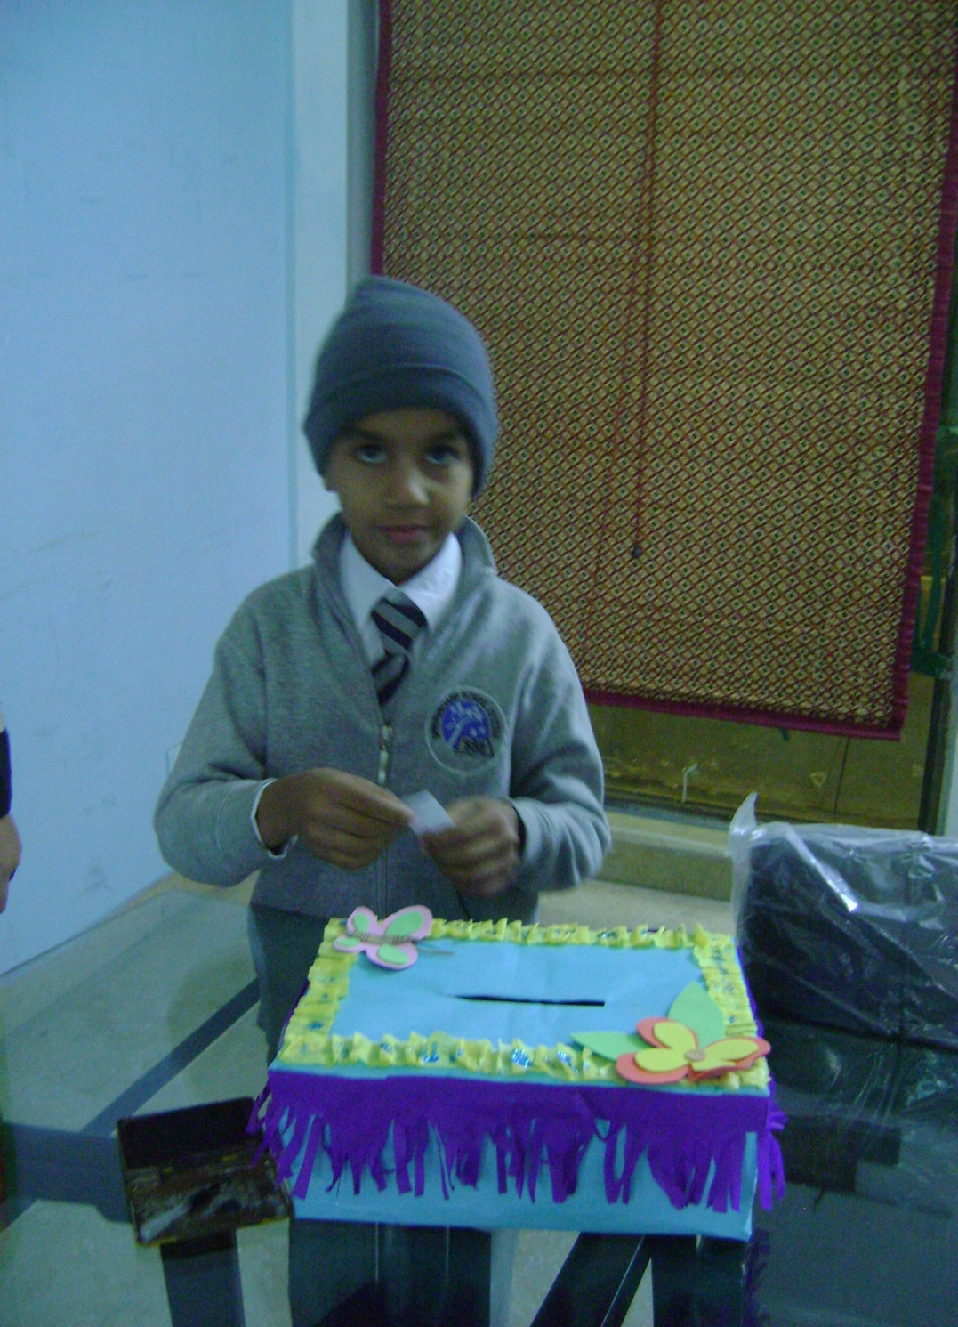
Abdul Basit – Class 5
My favorite Indoor Games: Ludo
Outdoor Games:- Football, Cricket, Volleyball.
Traditional games of our country are (1) Polo (2) Kabbadi (3) Hockey.

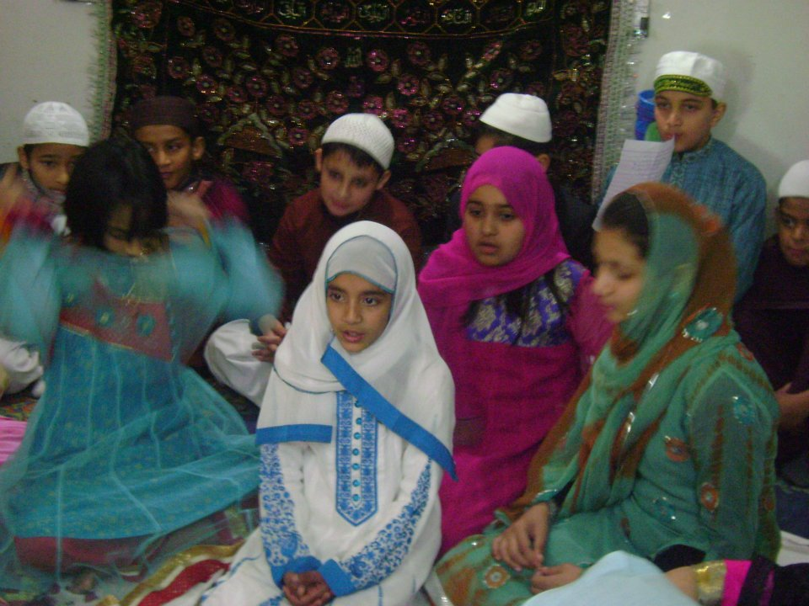 Aamna Haroon - Class 6 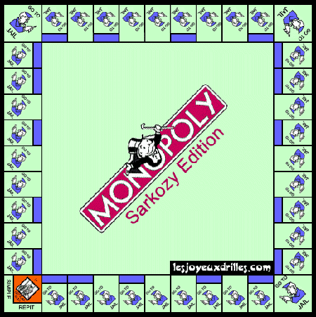
My favorite outdoor game is: Volleyball
My favorite indoor games are:
Monopoly and Carrom Board.


The game most played by our Teenagers is Football
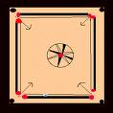
I like to play board games like ludo, snake game, monopoly because it is fun to play and I have a lot of interest in it.

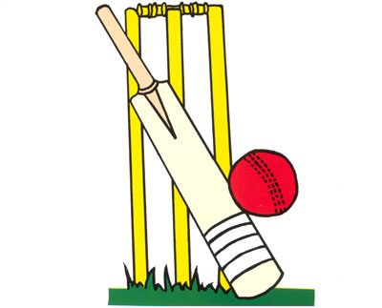
The most popular game of our country is cricket.

News from ohio

My name is Eiman and I am a third grade at Dover Elementary, in Westlake, Ohio. Games are tons and fun and I really enjoy playing them. The xbox is one of my favorite video games. I like to play games on it and also watch movies. I also enjoy playing board games like Candy Land and Monopoly. It is really fun to play games with my family on a rainy day!

Hi, my name is Domenica and I like playing games. Playing games outside is one of my favorite things to do. One game I enjoy is climbing a small tree in my front yard. I am the lookout, and my sister and I like to play spy. I also like to play hide and seek outside. My next door neighbor comes over a lot and we climb trees and play spies. Playing games outside is lots of fun!

I am Xavier and I am a third grader at Dover Elementary. I enjoy playing many fun games on the computer. I enjoy going to a site called Cool Math. I also like to play Club Penguin on the computer. My favorite video game is the Xbox. My brother’s and I play tons of games and get lots of exercise, or at least that’s what we tell my mom!!!

News from Texas

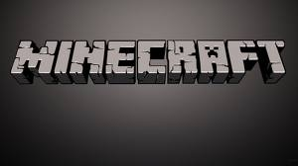
Lucas
it is a computer game in which you build, destroy and just do whatever is on your mind, with, of course, the help of Steve. Who is this Steve fellow, you ask? Well, he is the person you are in the game (that is, until download a new skin). In every mode there are villages and villagers. Villages are generated structures that you can turn on or off in the start menu. They usually have 3 wheat farms, a blacksmith shop and sometimes a guardhouse. Another generated structure is the dungeon. Very rare, dungeons are have maze-like interiors and multiple levels. They even have a mysterious End portal that transports you into a strange floating island made out of Endstone and has five gigantic spires of black obsidian sticking out of the ground.

Inhabited only by the terrible ENDER DRAGON and his underlings, the endermen, he proceeds to kill you unless you kill him first. The end is a forbidding place, made out of pale endstone with black obsidian spires. Another exciting feature is bunch different terrains: winterland, forests, deserts, oceans, swamps, grasslands and even caves. complete with three exciting game modes; Creative, Survival and Hardcore, this game has almost EVERYTHING you ever wished for in a game, even some special surprises, but you’ll have to see those yourself!


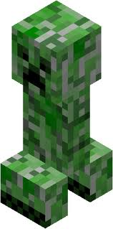 Sam
Minecraft is also my favorite game. It’s just like he described it; Fun, Awesome, and the best game ever! Creative mode is a mode where you have unlimited blocks and can instantly destroy blocks of any kind. Survival is a mode where you have to collect all the blocks you use, and a mode where you break blocks at a rate according to the density of the block. Hardcore is survival locked on the hardest level. All of these modes include monsters. One thing that you should know about Minecraft monsters is that they are called mobs. Another thing that you should know about Minecraft monsters is that there are nine of them;
Blazes, Endermen, Slimes, Magma Cubes, Zombies, Zombie Pigmen,

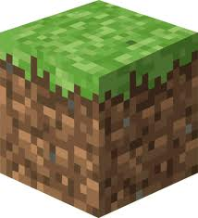

Ghasts, Skeletons, Spiders, Cave Spiders and Creepers. One thing you should also know is that there are 3 monster types; Neutral, Aggressive, and Peaceful. Another thing you might want to know is the history of monsters. Creepers were created when a pig that the creator made didn’t turn out right. Another is that when a pig was struck by lightning, the pig became a horrible ZOMBIE PIGMAN! The Endermen started out as a normal villager,

News from Russia

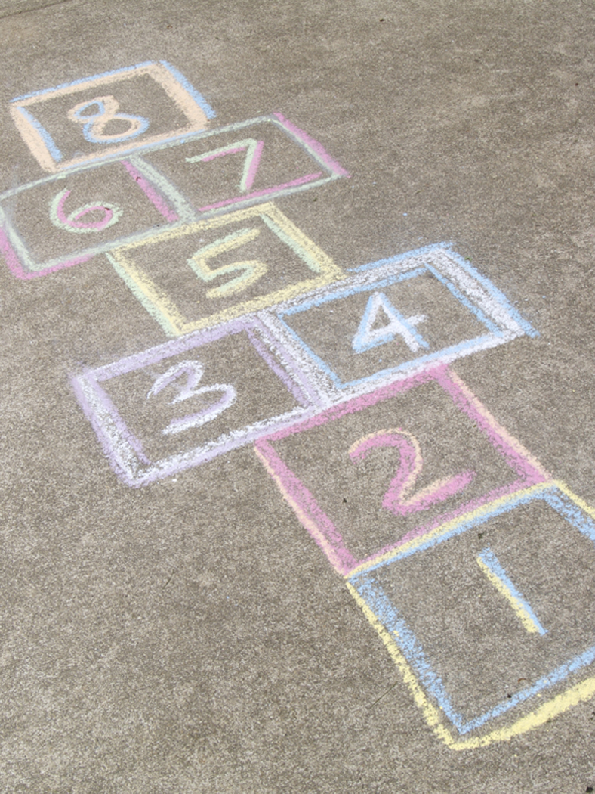
Hopscotch
Each player begins with throwing a stone in the first square. Then, jumping on one foot, it pushes a stone from the first square into the second, from the second one into the third etc. At the same time with pushing through of a stone it is necessary to jump from a square into a square, without touching a line. From the last square it is necessary to push a stone out of field boundaries. After the successful termination of the first game the player throws a stone into the second square, and so on.

Blind-man's-buff –жмурки
Zhmurka (it), chosen by lot, is put in the center of a playground and blindfolded, and it is turned several times. Then the dialogue follows: «Where are you?» — «On the bridge». — «That are you selling?» — "Kvass". — «Look for three years for us». Participants of game disperse about the room, the zhmurka goes to look for them.
While the zhmurka looks for them, nobody descends from the place, but all can squat, kneel, exchange clothes details that, to outwit the zhmurka.
The participant called by name, becomes a zhmurka.
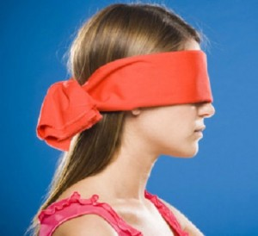

Streamlet
Our great-grandmothers knew and loved this game. There is no need to be strong, dexterous or fast, this game is emotional, it creates cheerful mood. The rules are simple. Playing there is one after another in pairs, usually a boy and a girl, join hands and hold them highly over the head.

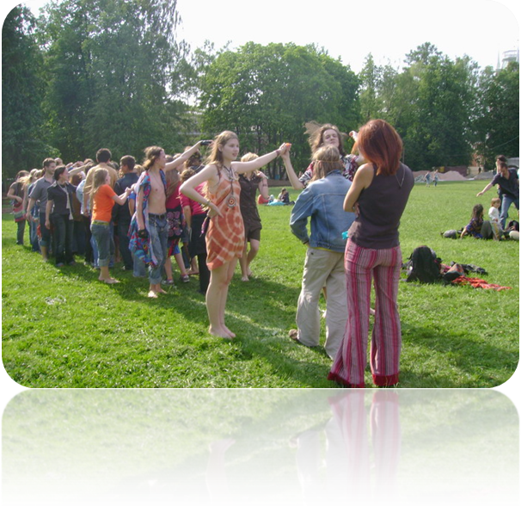

With the linked hands a long corridor is formed. The player with no pair, goes to a mouth of "streamlet" and, passing under the linked hands, looks for the pair fot itself. Having joined hands, the new pair makes the way in the corridor end, and the broken pair goes forward to the "streamlet" beginning... And, passing under the linked hands, fetches the one who it likes most with itself. So "streamlet" moves along, continuously - the more participants, more cheerful is the game.

News from Machulishchi

There are a lot of different games around the world. It is very interesting to know that on different continents people play the same games. But at the same time each country has its national and unique games and this is wonderful to have opportunity to acquaint each other with games that we like. All students – Class 3
There are a lot of different games around world. It is very interesting to know that on different continents people play the same games. But at the same time each country has its national and unique games and this is wonderful to have opportunity to acquaint each other with games that we like.
Hi, my name’s Arina. I would like to tell you about our national game – Planting of potatoes. Two teams on five people are formed. The player standing first — the captain, it holds a sack with five potatoes (stones). At distance of twenty — thirty steps from each column five circles are drawn. On a signal captains run to circles and put a potato on one in each circle, then come back and transfer a sack to the following player whom, having taken a sack, runs to collect a potato etc. Rules of the game. Captains start on a signal. Players don't leave for the line without a sack.If the potato fell, it should be lifted and then to run. To run up to team it is necessary on the left side.
Hello, my name’s Sergey. I would like to tell you about our national game – Mill. All playing become in a circle at distance not less than 2 m from each other. One of the playing receives a ball and transfers to another, that to the third and etc. around. Gradually speed of transfer increases. Each player tries to catch a ball.
Rules of the game. The player who missed a ball or threw it incorrectly, leaves game. The one who remains in game by the last is the winner.


