We are from Tarakan, Indonesia want to give our report about our heritage and a glimpse of our city history. On 31st March, 2012 our group went to do some research about Tarakam History. The first place we visited is a district called “Jembatan Besi” , in English it’s called “Iron Bridge” . Although it’s called iron bridge, it wasn’t a bridge at all. Now it just became a residential area. In the past Australia army are getting ready to fight Japan army at that place, but they have a misperception and Japan army didn’t came from there but came from Amal Beach instead. The resident said there is a giant iron ship buried under there that’s why it was called “Jembatan Besi”. Near the Iron Bridge the is ditch around there. Well our guide said that ditch used to be a big river where ship pass by to go to the port.
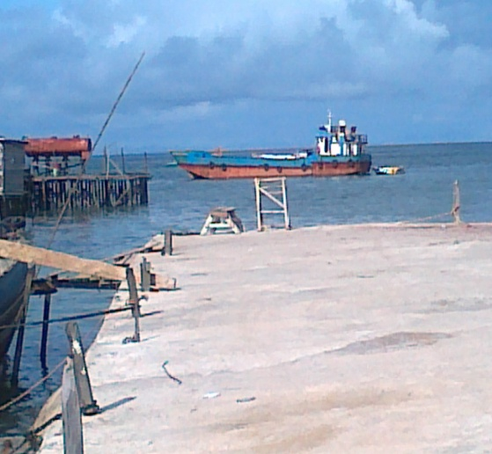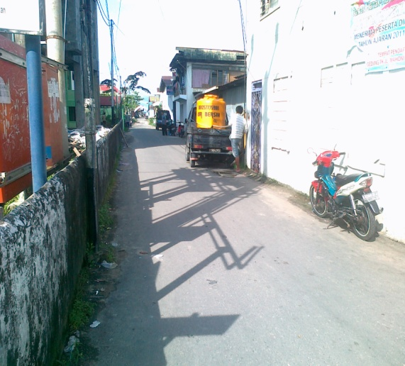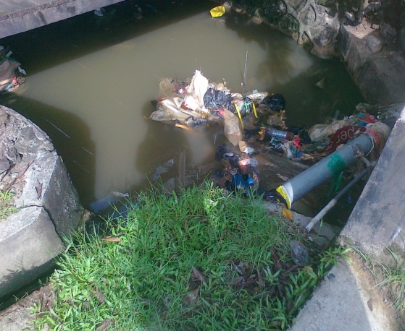

The second destination is a place that called “GOR” . There’s nothing now except for a parking place for truck, but in the past there is a storage there. In that storage Japan army store some goods from the ports. So how the transport the goods? There used to be a rail that connect the port and the storage. There is no train though , but Japan army used their slaves to do the job. The slaves pull the wagon with their goods inside.
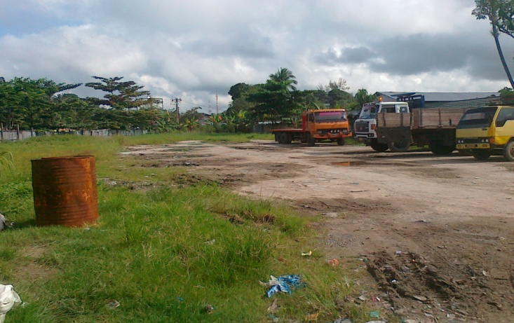
The third destination is Japanese Grave. It’s called grave not literary. There is no corpse there just a stone and a place to put the ash of the burned corpse. Creepy isn’t it? In this place the corpse of Japanese army burned down and not buried. It was their culture that the human are going back to their original form. The ash are sent back to Japan, sent to their family. There is a big stone that used as a place to do a prayer.
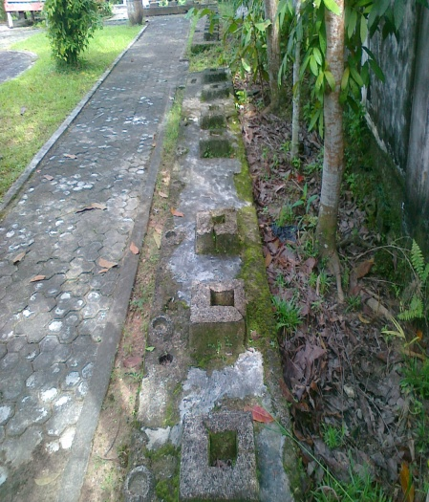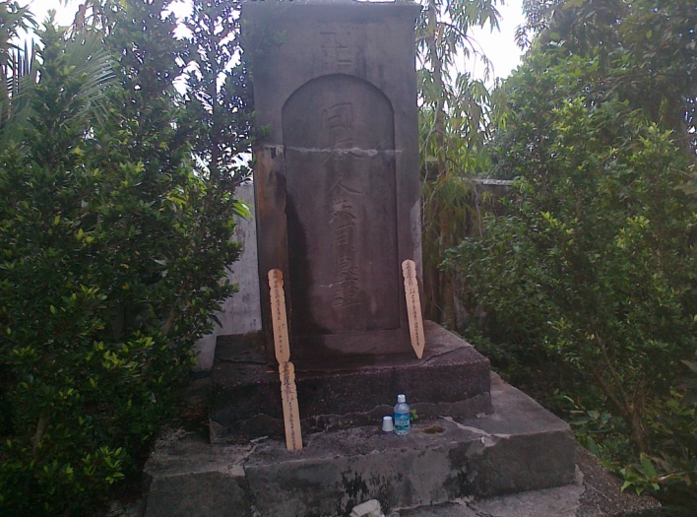

Next is a place called “Wash Tank”. It was the evidence that there was a war in Tarakan. In the past there is an airship that fall down and crash the tank. As you can see the tank was dent because it was crushed by the airship.
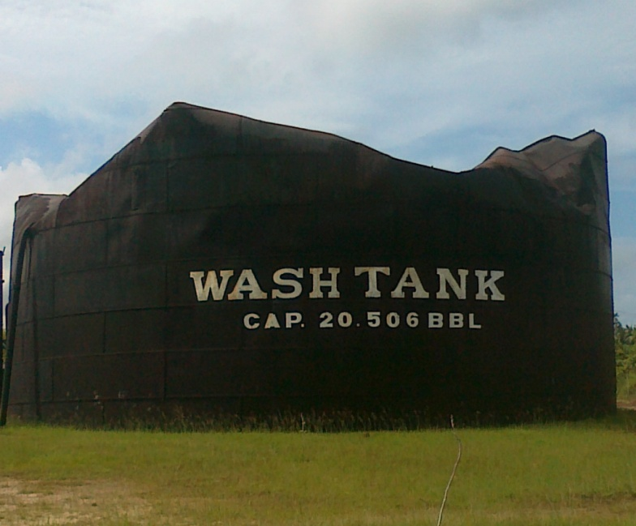
The next place is called “The Monument of Australia”. That place used to be a grave for Australia army that fighting with Japan army. But now the corpse are transferred to Sabah, Malaysia. 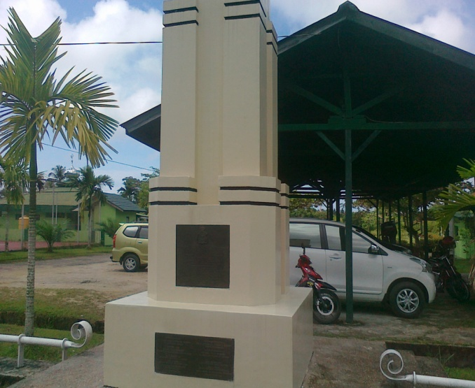

The next destination is a place called “Bunker” . That place used to be a place where Japan army to rest and get ready for war. In that place Japanese army slept, ate and living there in the past. 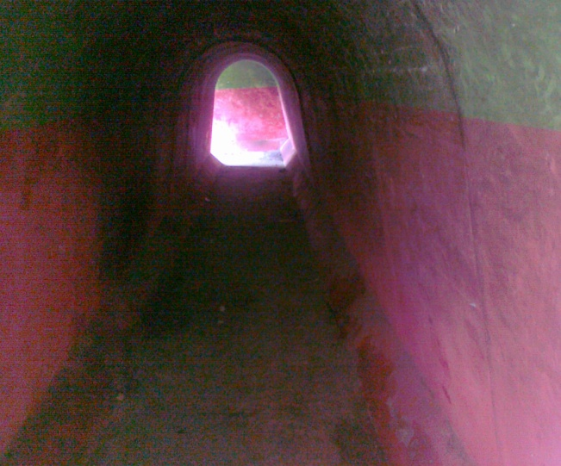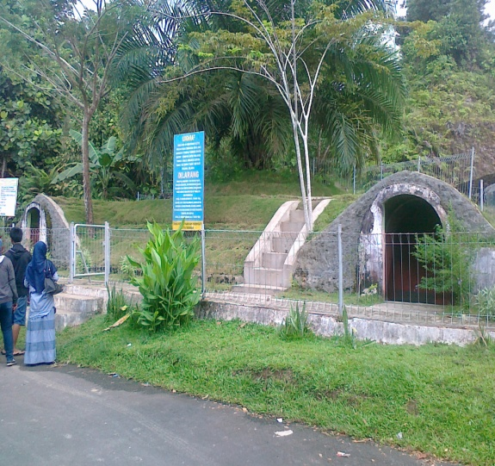
Now for the last destination, we went to the mangrove forest. Mangrove is a place where mangrove tree plant and grew. There is some animal too in there. This place is quite amazing that it is located in the center of the city.
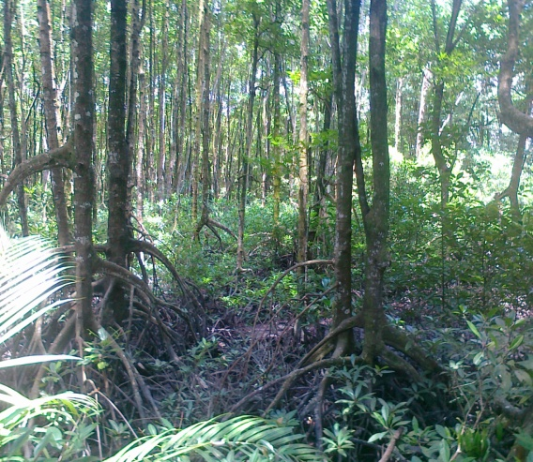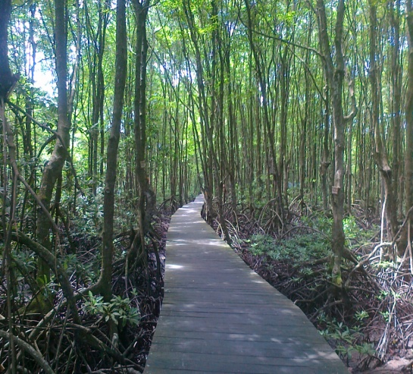

That’s all the report we can say. I hope it will be useful and beneficial, thank you.

