The View From My Window

"Let nature be your teacher"
- William Wordsworth
The "My Vision" Team

Let's take a look out there...Let's try to really see through our window - it's a simple exercise, but it may entirely affect our perspective.
For example, most of us can't even remember the smell of the air that gets inside our homes every time we open our window, maybe because most of us got used to it...though, I can't help but wonder - why don't we care about the usual things that surround us daily? "They aren't so important", some may answer.

I know that we are too busy to notice every plastic bag on the street and pick it up in order to throuw it in a recycle bin. But if we don't, why do we think it's okay to leave our gum wrapper on the street, expecting someone will pick that up for us? Even if we think it's not a big deal, it's actually an important and destroying gesture which may lead us to a tragic disease, called indifference.

The view from my window it's as important for me as it is to brush my teeth...it represents me, it is the moving picture that I see each morning when I wake up. The view that we see at school every time we want to breathe some fresh air when we have a break, that affects us too: it may change our day or it helps us to be ready for the next lesson.
So, what we see through our window it's a piece of the outside world that can make us happy, it can improve our concentration due to the fresh air that it should provide, it can put a smile on our face so we may forgot some of our problems.

Let's try to imagine a world without any escapes to nature, where the houses have no windows, the schools are just walls and doors, the buses are all dark and crowded. It won't be quite a nice place, right? So, by this way, we may be able to realize: Nature is like our family, like the air we breathe, like a glass of water in a sunny day - indispensable.

So, if for the moment we are still able to enjoy trees and soft grass and a somewhat fresh air, until the pollution will take all these from us if we continue this way, why do we instead help the process of destroying everything that we love, by being so ignorant, so in need for material treasures?

"Humanity - a species fast in developing, but slow in maturing."(David Baylisss)

In conclusion, don't walk on the street looking at the "caribbean blue" sky, thinking it will always be like that! Instead, look down and try to pick up some of the plastic packages that you may see, advise the kids who leave their candy wrappers on the alley to throw them in the recycle bin on the corner, and if you see a man who is throwing his cigarette over the hedge, tell him: "The world is not your ashtray!". By this way, you can help not just yourself, but an entire comunity, and step by step, the entire world!

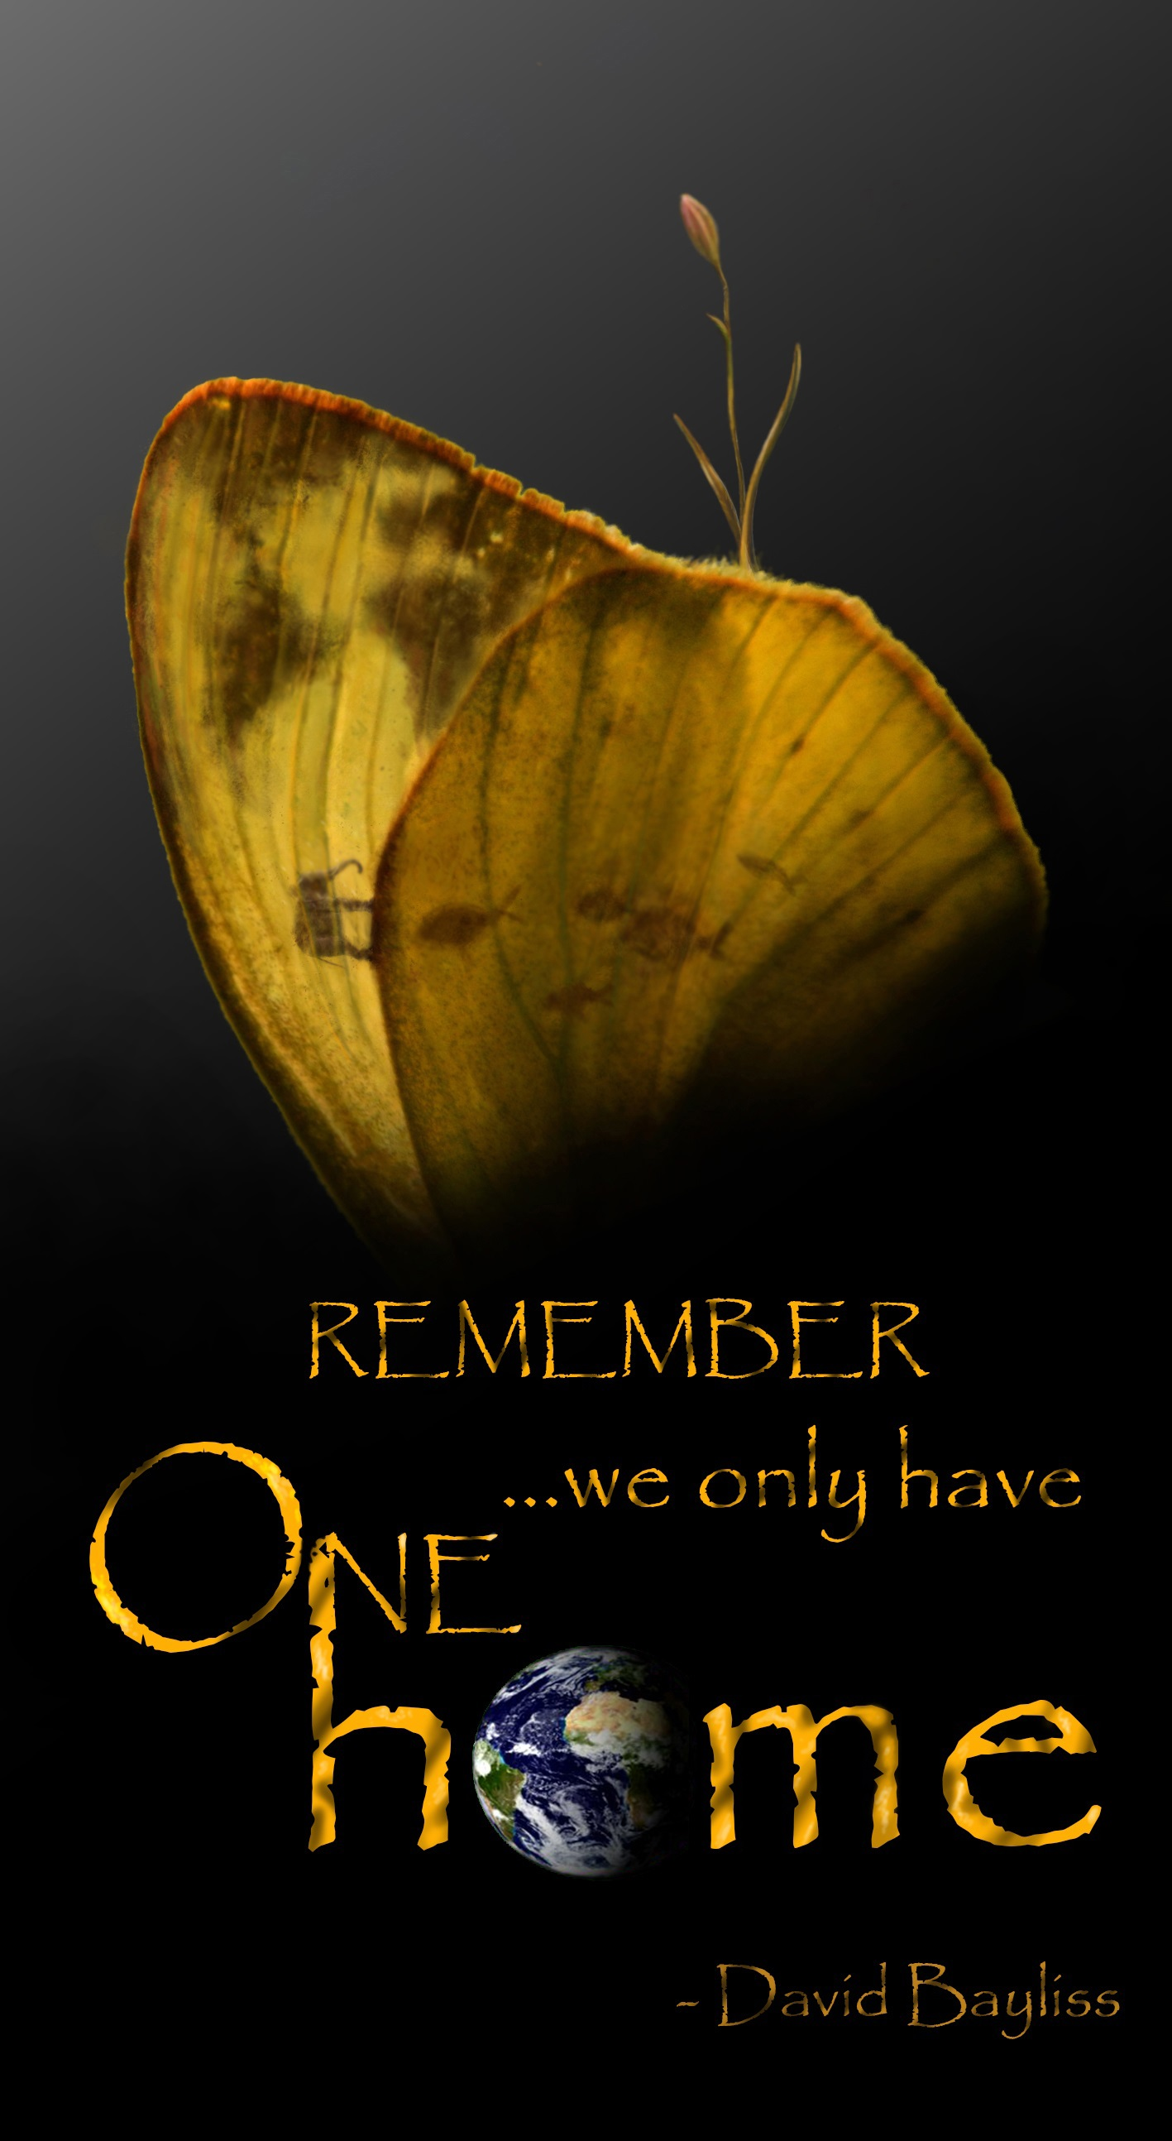
Team :
Mihai Tiu
Naina Patrascu
Catalin Blendea
Daiana Mezdrea

Coordinating Teacher :
Mihaela Runceanu

