Dacian – Economy, Medicine, Astronomy, Language, Believes, Rites
Economy
Agriculture
Like other branches Thracian and Geto-Dacian were large producers of grain: barley, rye, lentils, beans and several varieties of wheat. Basis economy formed a farming and cattle. They used plow coulter and iron knife still in sec. III BCE Iron inventory of agricultural equipment totaled on that date: sew long (for Celtic), sickles, hoes, pruning the vine cutting, shovels, axes, rakes with six tusks, etc.
Geto-Dacian intensively cultivated vines. Some terms related to this occupation Dacic remained until today in Romanian (hub, grapes, tendril). They practiced beekeeping equally intense and of course, fishing. With growing cattle, small and great; and very quick horse race of the Getae was famous. Dacia was proclaimed and its natural riches. Transylvanian forest wood was highly sought after by the Greeks to build ships. Since ancient times, Dacian course using fuel oil, but only one found on surface (for evidence of fuel oil extraction has only existed since Roman times). With rock salt (much used both for conservation of fish and meat and the hides tanning) Geto-Dacian did a busy trade, especially with the Greeks.
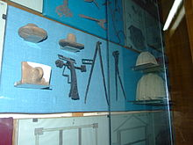

Earth Dacia was very rich in minerals. Dacians craftsmen worked iron and bronze, silver and gold. Reducing the copper ore at a temperature of 1085 ° C and mixing it with the bronze tin which included various tools and ornaments. Aflorismente not only exploit the gold (places where erosion, surface rock gold occurs), but also gold sand mountain rivers. A major development took iron processing; iron metallurgy began in Romania by the year 800 BC. During his Decebal, it seems to Sarmizegetusa and surroundings were the largest metallurgy workshops from across Europe, remained outside the Roman Empire.
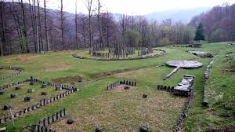 Sarmisegetusa Ruins
These workshops are made of, first, tools: massive anvils, hammers of various shapes and sizes, sledge hammers and forging hammers, files, pliers, chisels. Then iron tools and objects serving the woodworking or construction: wide or narrow cloth saws, nails and spikes, axes, staples, big knifes, drills, adzes, nails, hinges and door latches. In workshops Dacians was manufactured large quantities of weapons needed an army so numerous: lances and spears, swords straight and curved daggers, shields, spears, spikes, etc. Then, various other articles: chains, compasses, awls, hooks, rods, scissors, razor blades, large spits (with respective brackets) with two or more teeth, knives, etc. Confection and ornaments made of iron or clothing accessories (zippers, buckles, buttons, brooches, bracelets, etc.).
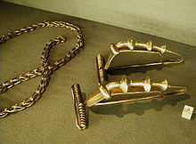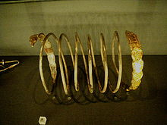

Ceramics
Dacians potters took sometimes from foreign masters some techniques, or certain forms and ornaments, imitation (for example) Greek Cups kind of Delos; but forms Dacian vessels are mostly original. And if we add to this that fine ceramics, required by wealthy customers, there was sometimes painted with motifs of animal or vegetable (less human) noted that the Dacia potters were masters in nothing inferior to the others ancient peoples which at that time were on the same stage of civilization.
Settlements
Geto-Dacian settlements lived in ordinary and cities. The cities were called Dave.
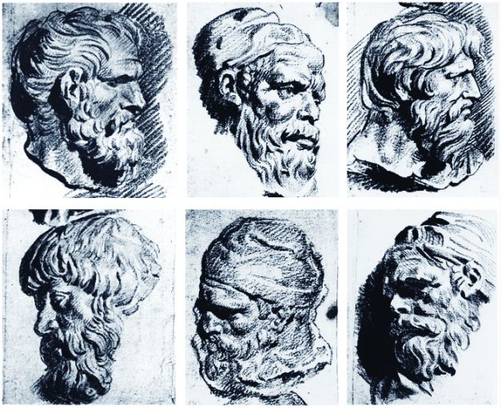
Dacilor depictions of the Trajan's Forum
Dacian Medicine
Plato, in his dialogue Harmides, 156 e - 157 b, assigns to Socrates some statements about doctors Zamolxis's Thracians, who believed that just as it should not try to cure the eyes without the head being cured, so no need to head healed without regard to the body, the more we should not try to heal the body without trying to heal soul. Arian in Fragments, III, 37, incantations and spells writes necessary to eliminate the influences of evil or, conversely, to draw against certain people. They were mastered especially by women. Geto-Dacians and pharmaceutical knowledge. Discoride, Greek physician (De materia medica, II-IV), reproduces 35 names herb if that language Pseudo-Apuleius added another 14. On Sarmizegetusa was found a medical kit, which contained, among others, a tablet of the drug Mediterranean ashes of volcanoes, ash used as absorbent wound. In Glade if you found a skull with traces of trepanations.
Dacian Astronomy
Hadrian Daicoviciu, based on theories of Constantin Daicoviciu, supposed to Sarmizegetusa, in addition to religious buildings there is a temple-calendar. His demonstration is based on the fact that the large circular sanctuary of Sarmizegetusa sacred precinct comprises three concentric circles (a circle of blocks of andesite and andesite columns one of a circle of thick wooden poles).

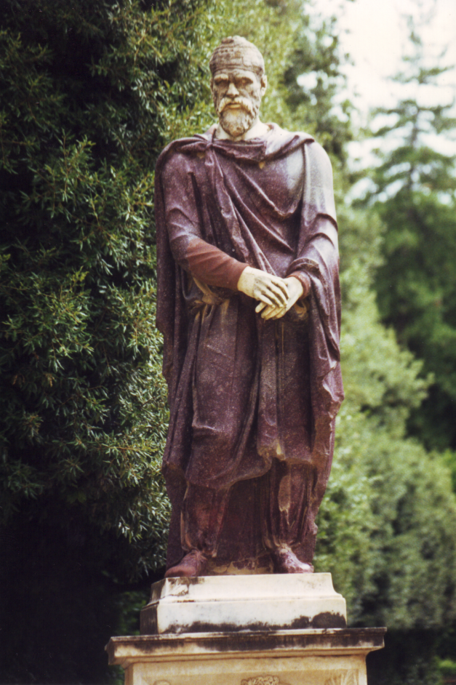 Dac, in red silk
Dacian Language
Archaeologist and historian Constantin Daicoviciu believes that the Romanian ruler Burebista, used writing was express religious, political matters using Greek letters, and Decebalus used Latin characters. Constantin Daicoviciu believes some signs on the railings of a wall Grădiştea Muncelului is an album name Kings, high priests and other dignitaries (History of Romania, I, 1969, p. 327-328).
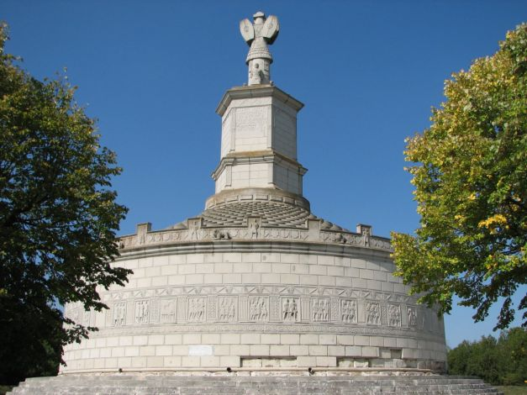 Adamclisi Monument, Romania

Dacian Believes
On 17 December 2000, the tomb was accidentally discovered by a machine embankment. The robbers then entered the tomb, damaging part of its frescoes. In 2001, archaeologist Georgi Kitov led an excavation to save tomb, revealing a round room about 3 meters in diameter, accessible through a small anteroom and a tunnel, about 6 meters long. Both the waiting room and the main room are decorated with well-preserved frescoes, which reflect the artist's knowledge of early and late Hellenistic art. The fresco in the main room shows a hunting scene where a pig is attacked by a hunter on horseback and a naked man who wields a double ax. Double ax is interpreted as representing the royal power, naked man represents Zalmoxis, corresponding trac solar god Zeus.
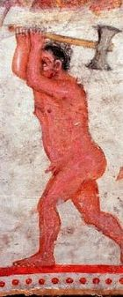
A graffito (inscription) in the room marked with the name Thracian nobleman Kozemases indicates either the owner of the tomb or its artist.
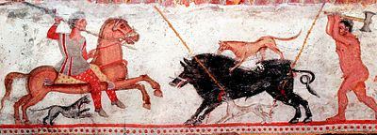
Thracian Tomb of Alexandrovo is dated to the fourth century BC .. The murals show appearance changes due to Greek influence.
Thracian tomb could be tribal.
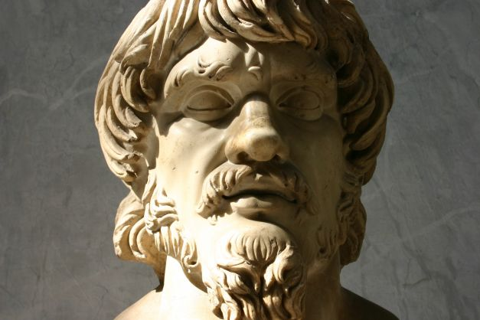 Dac Head, Vatican Museum
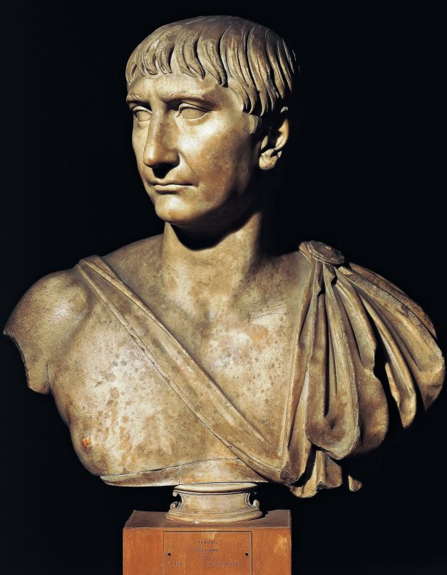 Trajan bust
Rites of birth
Herodotus (Histories, V, 4), Valerius Maximus (Facta et dicta memorable II, 6, 12) and Pomponius Mela (earth description, II, 16) reports that the Thracians were saddened at the birth of a baby, crying, sadness manifested by close relatives because they saw the earthly life than suffering and hardship.
Rites of sacrifice
Sacrificial rites were intended to attract the blessings of Gods for the community through the offering of animal, human or plants.
Legacies Geto-Dacian Romanian culture
The role that was played by the Geto-Dacians in the Romanian culture is very important. Besides that Romanian folklore, plastic arts, music, dances, rhythms, habits, Romanian pottery containing traces of Thracian civilization of this nation, Romanian lexicon contains 100-200 words of Dacian origin that call parts of the body, physiological functions, diseases, mental disorders, family relations, footwear, clothing, housing, household, flora and fauna (mostly) etc. In addition to other legacies Geto-Dacian words of Dacian origin, embraced the main fund lexical Romanian language, shows once again that the Romanian people continuer Geto-Dacians civilization and culture.
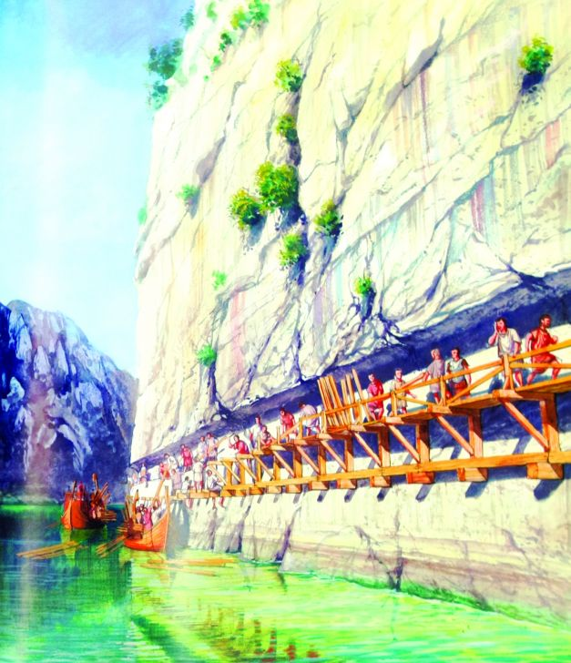
Danube to the boilers (Romanian Cazane), Roman road carved in stone ( reconstitution by Radu Oltean)
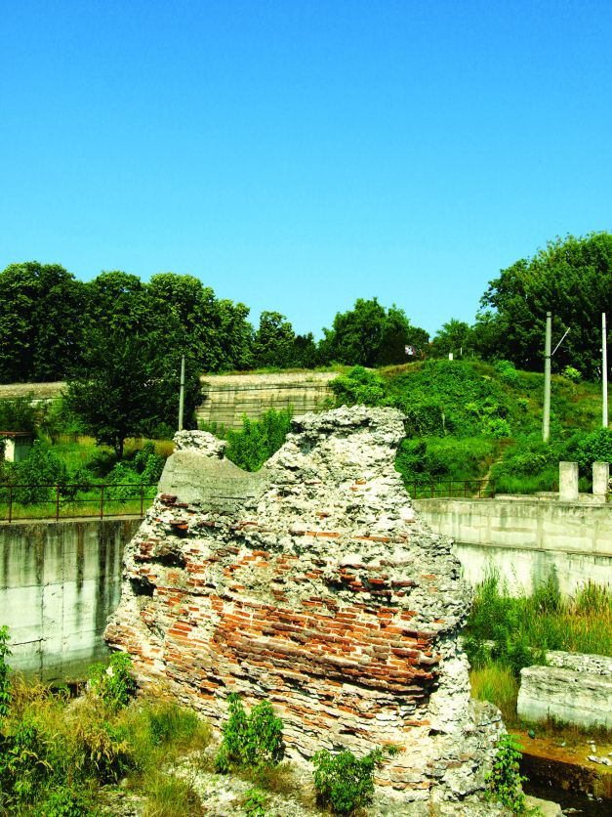 foot of Trajan bridge, Romanian bank

