Girls’ secondary school opportunities

Mary Jane
was a young and smart woman, born in Kansas 1962 to a beautiful family. She always was different from all the other girls. While they would play housewives and fantasizing about boys, she would spend her time helping her dad in the mechanics shop. She loved old cars and was a quick learner. It didn’t take long, before she knew all the parts that made them tick and how to repair them if something broke. However, that wasn’t enough for Jane. She wanted to learn, she wanted to become someone important and independent. Sadly her mother didn’t understand. She wanted her to become like all the other girls – a perfect housewife. “Mary Jane; you come here this instant!” Her mother yelled. Jane went to the kitchen, where her mother was sitting with her friends, drinking coffee. When her mother saw her she stood up “Just what do you think you’re doing? You are a lady! You can’t spend your time in a mechanics workshop fixing cars. Most of the girls your age are already getting married and here you are, your hands covered in oil. And what’s with those clothes? Just who do you think you are? You can’t be walking around dressed in jeans and shirts. That’s men’s clothes! Go change this instant or else!” Jane was shocked. Never before had she argued with her mom, but Mary wasn’t going to give up on her dreams. “I will be someone, someday!” Mary said as she was going to her room.

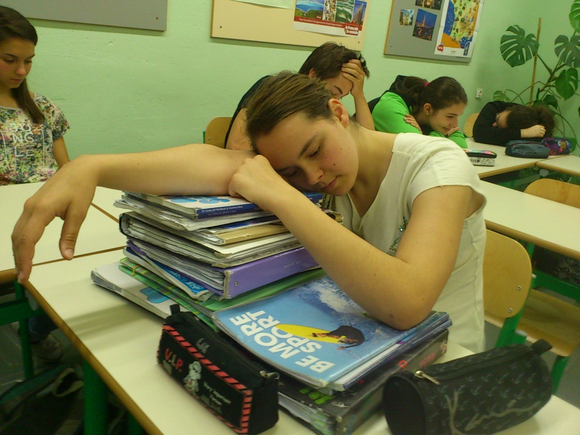
Nicky
just woke up. She looked outside and the only thing she could think of was skipping school. She called Tom, as usual, to pick her up from school. She pretended to go to school, so that her parent’s wouldn’t be mad, but as soon as they drove off, Tom would pick her up and they would go to his dad’s cabin, not far from the city and dosed off.
The world has changed. We don’t desire education anymore. We only study because we have to. School became this prison where we “kill” our youth, studying “unimportant” subjects. We all have the dream to become someone someday, but only few of us are willing to fight for them. Not so long ago , girls like Mary Jane dreamed of equality. They wanted to be equal to men, to get a job, make money and dress as they wanted and they succeeded. Nowadays women have careers, earn their money and go to school, but society has changed. The desire of building a home and having a family is being replaced with the desire of earning money and having a career but even that is disappearing. So many people nowadays live at their parent’s houses. They support them and just like Nicky these people spend their days recklessly, throwing their lives away.

Girls nowadays have the right to go to school and become whoever they want, but the desire to do so is fading.

