My Favorite Place by Lynnwood Elementary Students
My 2 Favorite Places by Aroosh

My first favorite place is my room because I’m cozy there. I can eat in my room, sleep in my room and relax in my room.. And it is nice in the summer and warm in the winter and I have a great view of outside.

My second favorite place is the Alderwood Mall in Lynnwood

The mall is really nice because you can eat, shop, rest, and hang out, My favorite places are Brookside because it has massage chairs that you can use without buying it and it has cool gadgets. Another store that i really like is Lush because it has a lot of relaxing things like bath and oils. I also like Chipotle because most the food is healthy and I like the taste.
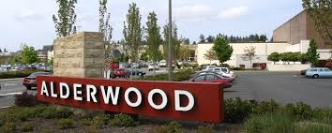 | 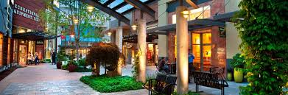

.I like Lolli and Pops because i feel like its just a candy wonderland and most kids really like candy. Cool Bliss serves crepes smoothies and Froyo and they all taste amazing
My Favorite Place by Jacqueline
My favorite place is Rattlesnake Mountain because it is very fun to hike there. And the view is very pretty: there is a very cool and beautiful lake there. Also it has a lot of wildlife there. The hike takes two hours and it is very fun
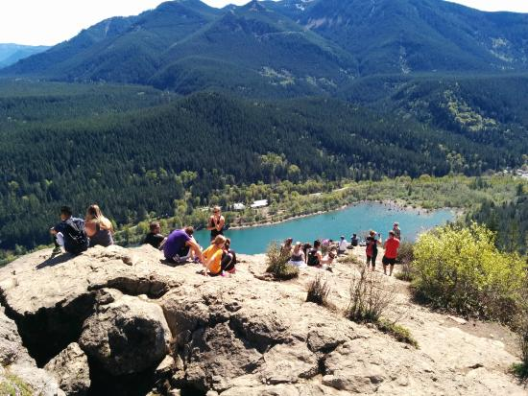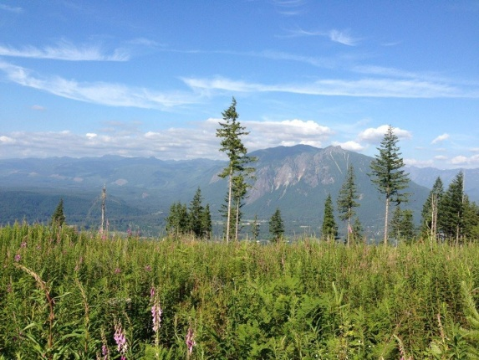https://www.alltrails.com/parks/us/washington/rattlesnake-mountain-scenic-area
My favorite Place by Shugla

My favorite place is the park that’s across from my house in Lynnwood. The park is called Wilcox park: it has a bunch of historical flags. It is a really nice place and it has slides and places to play with ladders and monkey bars. I like to have a picnic there when the weather is nice. There is a little lake with this trail and it has a huge field. It was Lynnwood’s first community park.

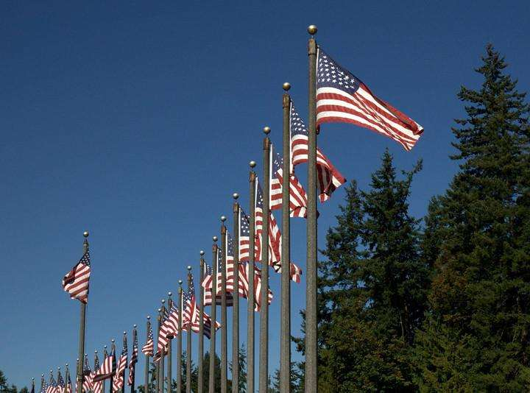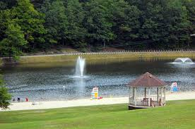

http://www.ci.lynnwood.wa.us/PlayLynnwood/Parks/Wilcox-Park.htm

My favorite Place by Jesse

I like Great Wolf Lodge because it has wizard games, Mini golf and waterslides. Great Wolf Lodge also has rooms where you can stay overnight there and they're awesome! And when it is your birth month you get one free ice cream.
The water park is indoors so it doesn’t matter what time of year you go, you will have an awesome time there because there are lots of activities.

